SafeHer Circle
An anonymous support board, a neighbour-to-neighbour donation exchange, an emergency alarm, and a directory of places to get help — under a pseudonym that is never your name.

Final-year project report
Java 21 · Spring Boot 4.1 · React 19 · PostgreSQL 18 · FastAPI
Ten modules · 47 REST endpoints · 18 database tables

Contents

If the entries below are blank, right-click and choose Update Field in Word.

1. Introduction

1.1 The problem
Tools that help women in difficulty tend to solve one piece each, and the pieces do not connect.
- Personal safety apps raise an alert to a list of contacts, but have no community behind them. The alert goes out and then nothing happens.
- Support forums offer somewhere to write, but no way to actually reach anyone, and no route from a conversation to practical help.
- Helpline directories exist, published across dozens of government and NGO websites, but they are hard to find at the moment somebody needs one.
- Donation platforms move money efficiently. They do not move the pack of sanitary pads a neighbour has spare.
Someone who needs more than one of these has to hold four applications in her head, and register separately for each one — each registration attaching her real identity to a different fragment of her situation.

1.2 What this project does
SafeHer Circle puts an anonymous board, a donation exchange, an emergency alarm and a helpline directory in one place, with location awareness so help comes from nearby, and without attaching a real name to anything published.
Two design commitments run through every module and are the substance of the work:
- A real identity is never attached to published content. Posts and donation listings use two separate generated pseudonyms, so a request for sanitary pads cannot be linked to a post about a domestic situation.
- No automated system removes anything. A report count or a machine-learning score can raise content in a moderator's queue. Only a person decides what comes down.
The second commitment is not a precaution written in advance. It is the conclusion of a measurement described in Section 6.

1.3 Scope
The application is built and working, and runs locally. It is not deployed publicly, and it does not send real SMS messages — the alert delivery interface exists with a logging implementation behind it. Section 9 sets out these and other limitations in full, because a project of this kind is more useful when it is honest about what it does not do.

2. System architecture
The system is four processes. Three are required; the fourth, the content scoring service, is optional and the platform runs without it.
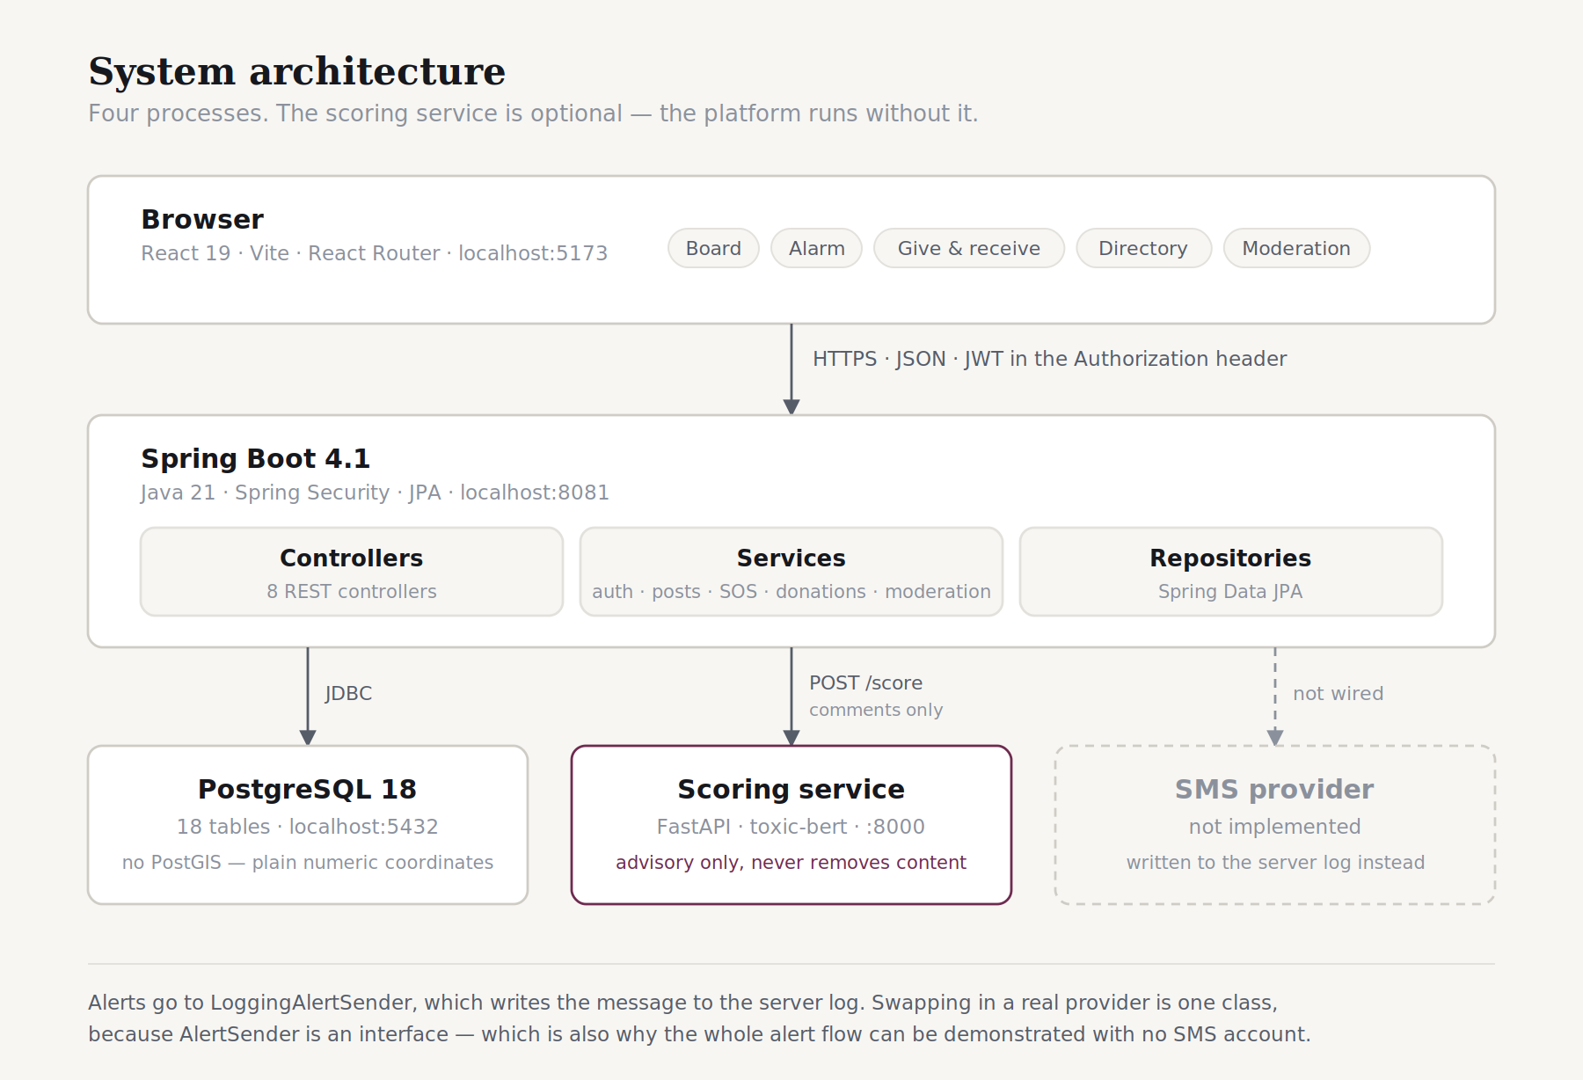
Figure 1 — System architecture

2.1 The choice of stack
Layer | Technology | Why
Frontend | React 19, Vite, React Router | Component model suits a UI with several distinct sections; Vite gives a fast development loop
Backend | Java 21, Spring Boot 4.1 | Spring Security and Spring Data JPA remove a large amount of boilerplate around authentication and persistence
Database | PostgreSQL 18 | Relational integrity matters here — a claim must belong to a listing, a comment to a post
Auth | JWT, bcrypt | Stateless tokens suit a single-page application; bcrypt is the standard for password storage
Audio | Web Audio API | Alarm sounds are synthesised in the browser, so they work with no network connection
Scoring | Python, FastAPI, Transformers | Java has no comparable machine-learning ecosystem; a separate HTTP service keeps the boundary clean

2.2 The layered backend
The Spring Boot application follows a conventional three-layer separation. Controllers handle HTTP and nothing else; services hold every decision; repositories talk to the database. A rule that matters — that accepting a response takes a listing off the board unless it is marked splittable — lives in one service method and nowhere else.

2.3 Why the scoring service is separate
The scoring model runs in a separate Python process rather than inside the Java application. Two reasons. Java has no equivalent of the Hugging Face Transformers ecosystem, so running the model in-process would mean a substantially worse model or a large amount of custom work. And the separation means the platform degrades gracefully: if the scoring service is down, slow, or was never started,
ScoringClient returns an empty result and the comment is published unscored. A board that refuses to accept a comment because an advisory classifier is unavailable has its priorities inverted.

3. Methodology
The project was built by incremental delivery: one module designed, built, tested and revised before the next began. This was chosen over a single-pass approach for a specific reason — several of the design decisions in this project could not be made correctly in advance, because they depended on things that could only be learned by building and testing.
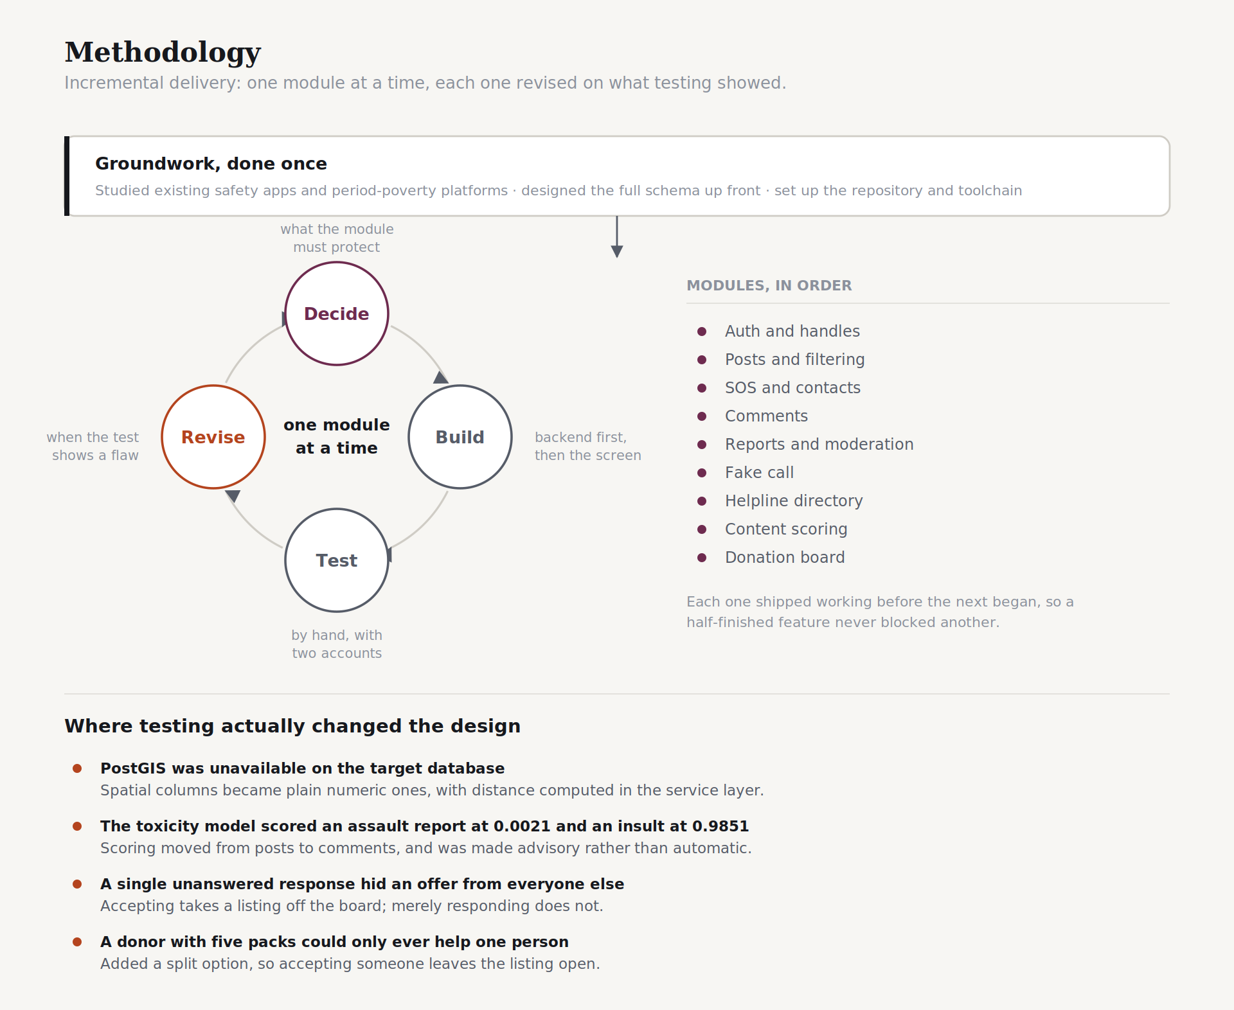
Figure 2 — Development methodology and the revisions that testing forced

3.1 The revise step
The value of the loop is in its fourth quadrant. Four times during development, testing showed that a design was wrong and it was changed. Each is documented here rather than quietly corrected, because the changes are more informative than the original designs.

PostGIS was unavailable
The schema was originally written with PostGIS geometry columns for location. The extension was not available on the target PostgreSQL installation. Rather than adding an install dependency, spatial columns became plain NUMERIC(9,6) pairs with distance computed in the service layer. At this scale the difference is not measurable, and the columns migrate to PostGIS cleanly if volume ever justifies it.

The toxicity model measured the wrong thing
Scoring was initially wired to posts, on the assumption that a toxicity classifier would surface content needing attention. Measurement showed it would surface nothing. Section 6 covers this in full.

An unanswered response hid an offer
The first implementation set a listing to MATCHED as soon as anybody responded to it. Testing with two accounts showed the consequence: one unanswered message removed an offer from the board for everyone else, indefinitely. Now only an acceptance takes a listing off the board.

A donor with five packs could help only one person
The exchange assumed one listing, one recipient. A donor with five packs of sanitary pads and two people asking for two and three could not serve both. Because quantity is free text, the system cannot do that arithmetic — so rather than pretend to, the donor is asked directly, with a checkbox that keeps the listing open until she closes it.

4. How the system is used
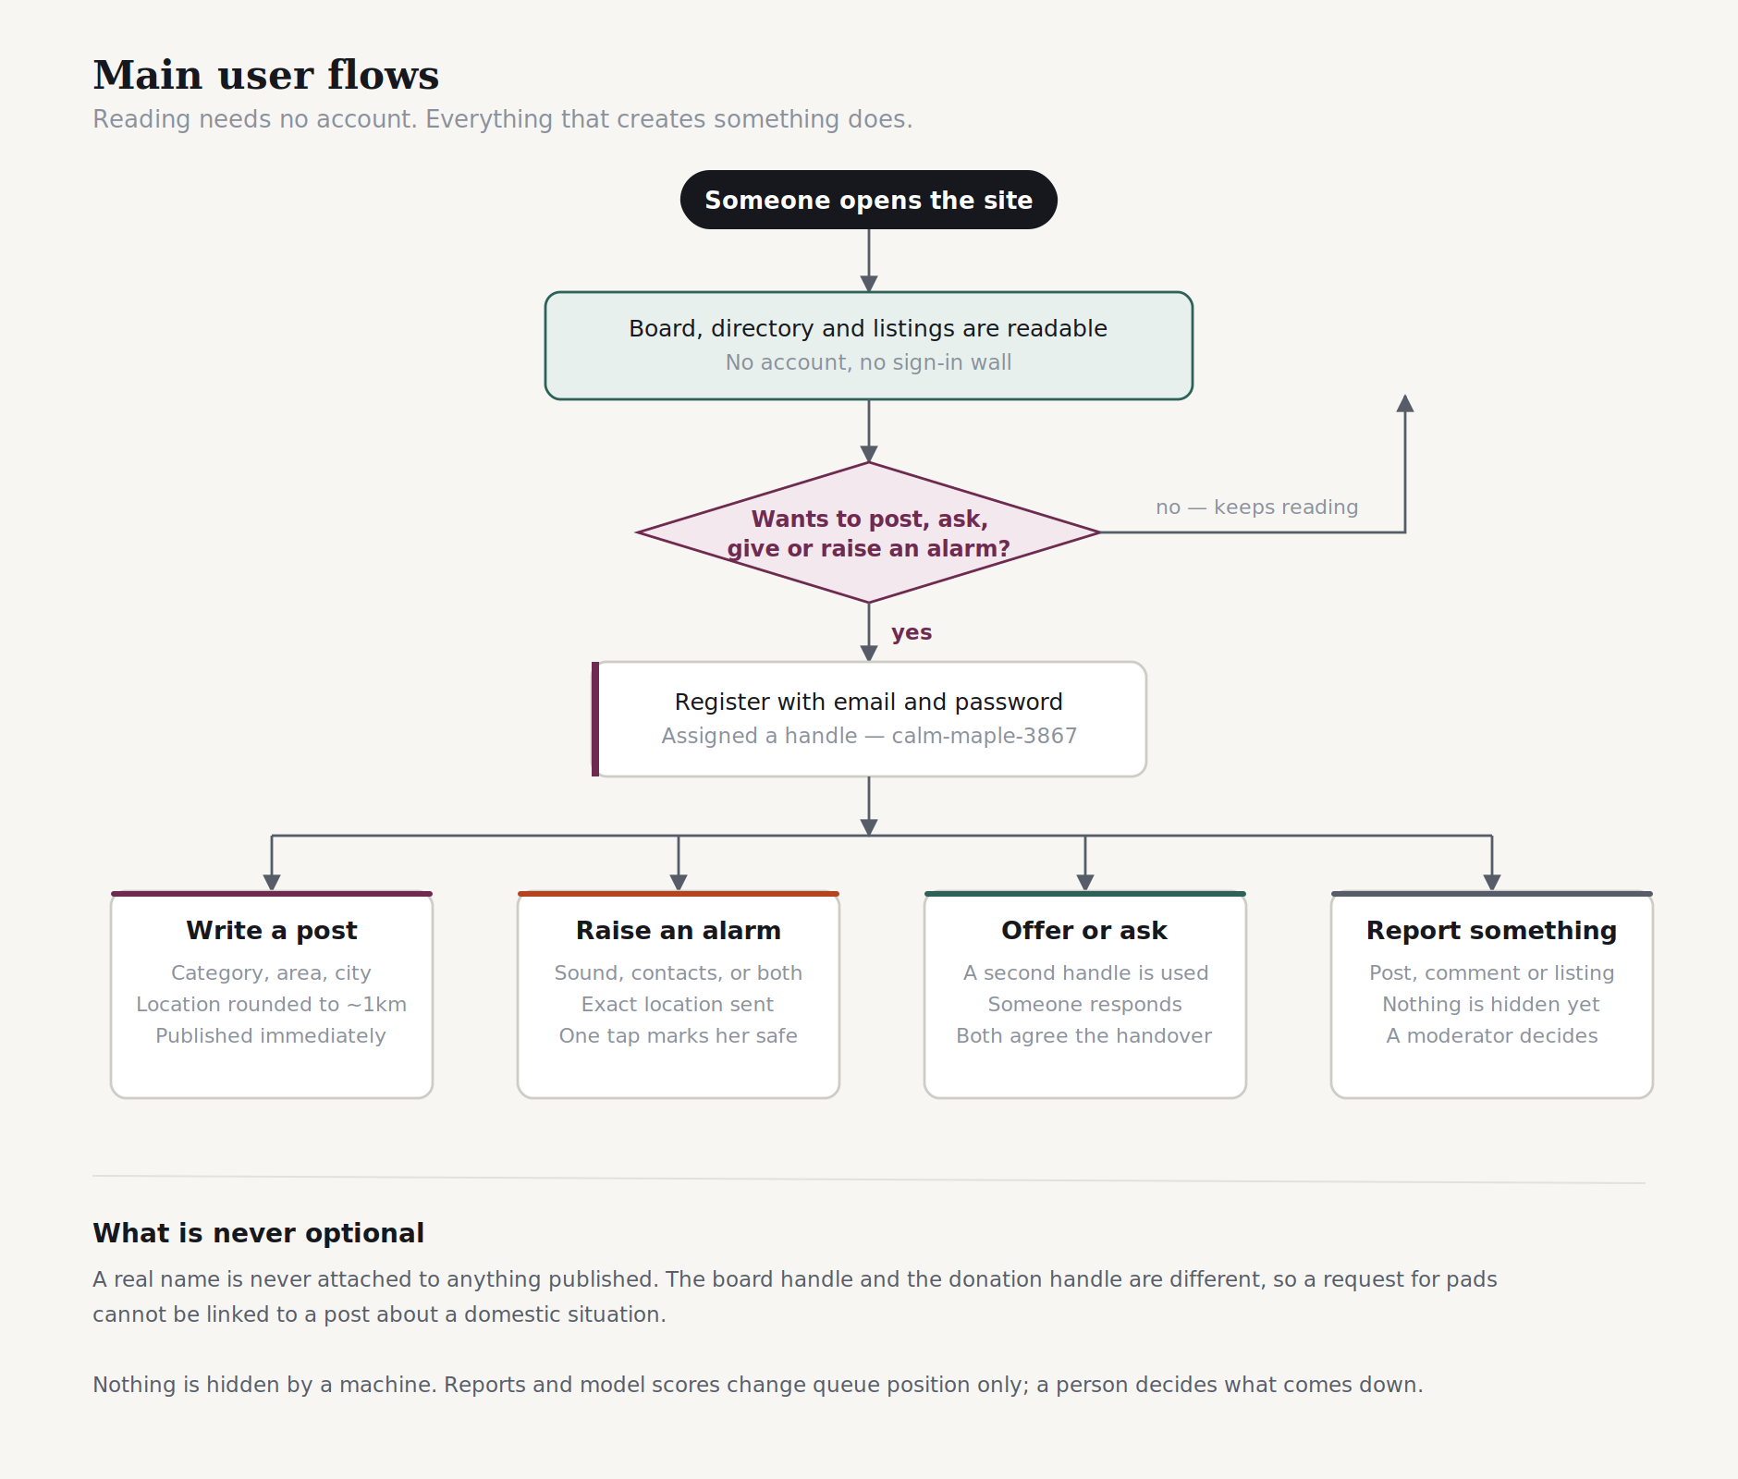
Figure 3 — Main user flows

4.1 What requires an account
Reading the board, the helpline directory and the donation listings requires no account and no sign-in wall. This is deliberate: the directory in particular is something a person might reach in an emergency, and asking her to register before showing her a phone number would be indefensible.
Everything that creates content requires an account. This is also deliberate, and for the opposite reason. Anonymous reporting sounds kinder, but it removes the only brake on mass false reporting, and a coordinated brigading campaign against a woman's post is a more likely threat on this platform than somebody being unable to register.

5. Implemented features

5.1 The anonymous board
Everyone writes under a generated handle of the form adjective-noun-number — calm-maple-3867. Posts are filed under eight categories and can be filtered by category, city, or free-text search. Replies thread one level deep.
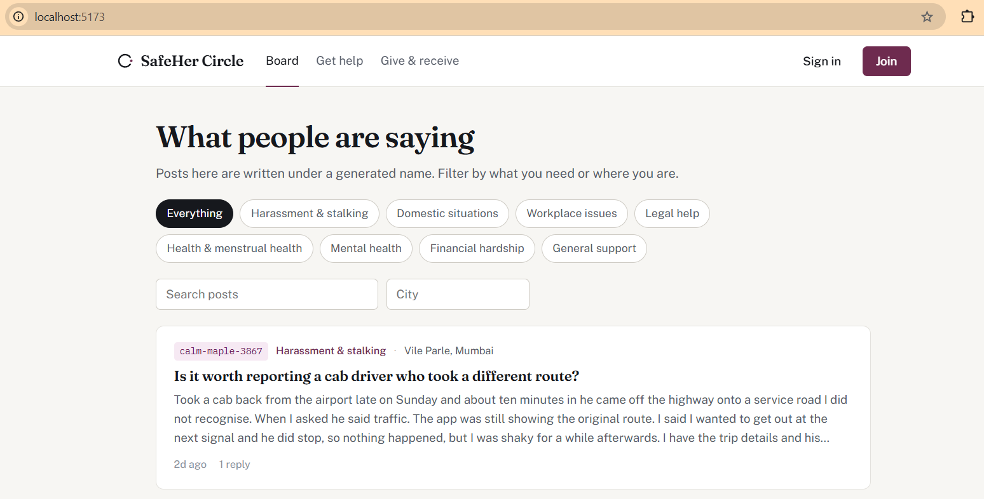
Figure 4 — The board, signed out. Reading requires no account.
Three implementation decisions are worth noting.
- The author's handle is copied onto each post rather than read through the author relation. This means a thread stays readable after somebody deletes their account, instead of gutting conversations other people took part in.
- Reply nesting stops at one level. A reply to a reply is silently re-parented to the top of that branch. Deeper threads become a column of indents on a phone, and this is a board people read on phones at night.
- The original poster is badged on her own replies. On an anonymous board there is no other way to tell that the person saying "I tried this and it worked" is the person who asked.
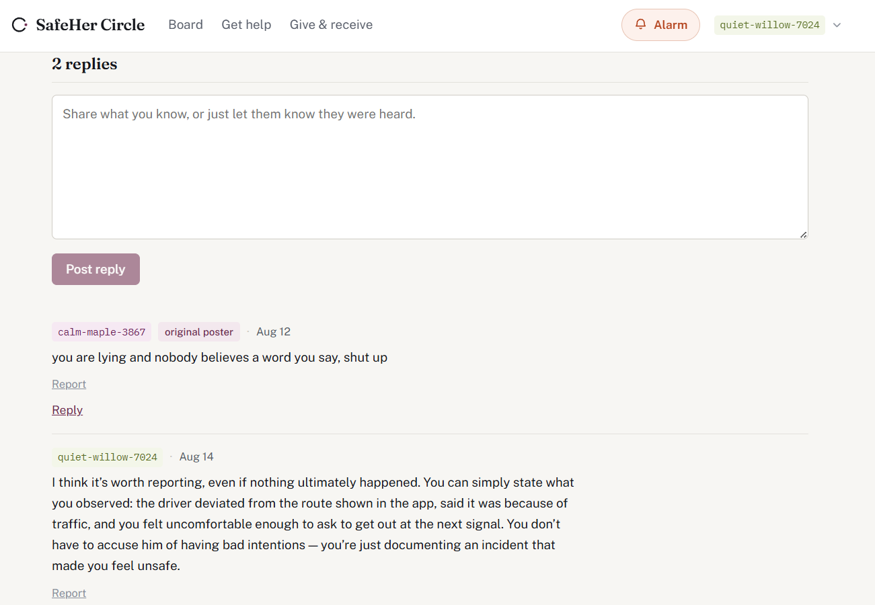
Figure 5 — A post with replies. The original-poster badge is visible on the first reply.

5.2 The emergency alarm
Three alarm sounds are generated in the browser using the Web Audio API rather than loaded as audio files, so they work with no network connection — which is precisely when somebody is most likely to need one.
Sound | Construction | When it is the right choice
Siren | Sawtooth oscillator sweeping 600–1400 Hz on a one-second cycle | Outdoors. The pitch sweep is what makes a siren carry; a steady tone is filtered out as background noise
Pulse | Two detuned square waves at 2730 and 2760 Hz, gated four times a second | Indoors. Harsh, hard to ignore, and hard to mistake for a ringtone
Low warble | 180 Hz sawtooth, frequency-modulated at 6 Hz | Through walls. Low frequencies lose less energy passing through doors and floors
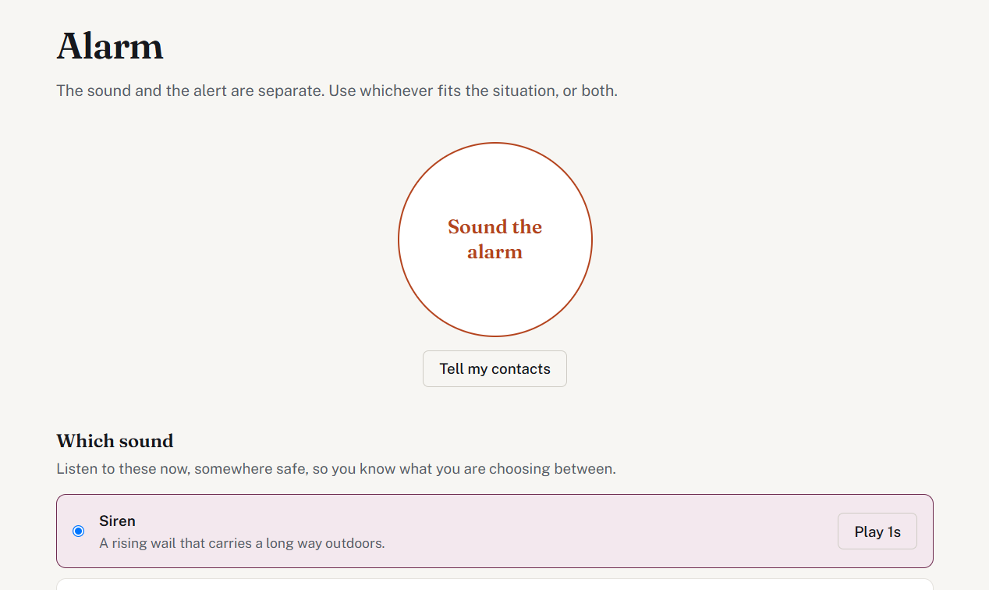
Figure 6 — The alarm page. The sound and the alert are separate controls.
The most important decision on this page is that the sound and the alert are two separate buttons rather than one. These are different situations. Somebody in a stairwell may want noise and nobody told. Somebody being followed quietly may want her sister to know without a siren announcing that she has just called for help. Combining them removes that choice at exactly the moment it matters most.
Two further details. Pressing the alert repeatedly does not raise multiple alerts — the live one is returned and its location updated, because a frightened person presses a button more than once and five alerts means five rounds of messages to the same five people. And an alarm is never blocked by a failed location fix; if the browser cannot get a position, the alert is raised without one.

5.3 The fake incoming call
Schedules the phone to ring after a chosen delay, with a full-screen call display and a synthesised ringtone. The purpose is to provide an excuse to leave a conversation without having to announce that you feel unsafe — which is frequently the thing that escalates a situation.
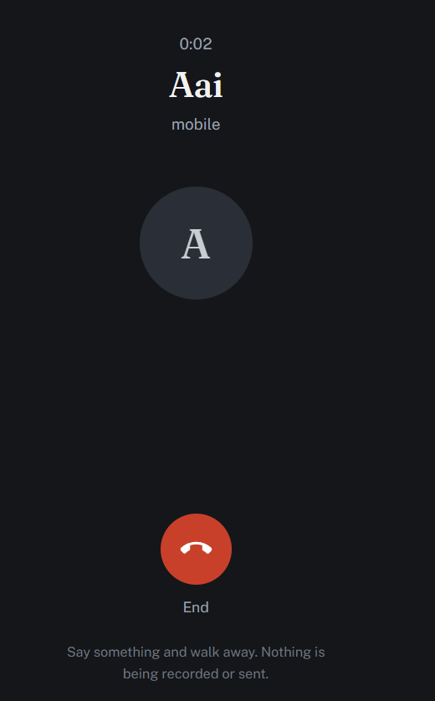
Figure 7 — The call screen, covering the entire viewport
The screen is fixed and full-bleed, covering the header and navigation entirely. The illusion fails completely if any trace of a website is visible to whoever is standing nearby. The default caller name is "Aai", and the form advises choosing a name that would not surprise anyone within earshot: a call from a parent is unremarkable, a call from "Police" is an announcement.

5.4 The helpline directory
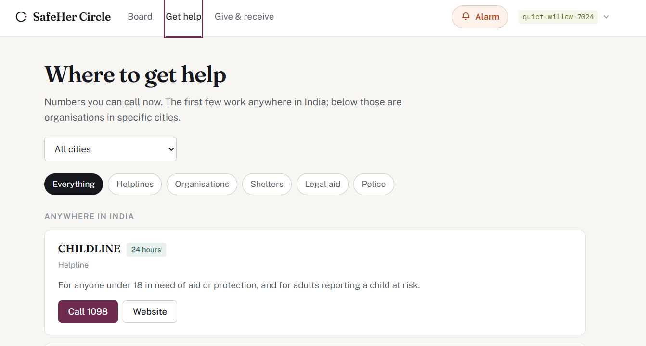
Figure 8 — The directory, with national numbers pinned above city listings
National numbers are pinned to the top and are never filtered out by a city selection, because 112 works everywhere in India.
Every entry carries a verification status. The five national numbers were taken from the National Commission for Women's own published list and are marked verified. Organisation entries are real organisations whose direct numbers have not been independently confirmed, and each card says so in plain language rather than in small print.
This distinction is the substance of the feature. A directory that presents a stale number with the same confidence as a checked one is actively dangerous: somebody dials it at two in the morning, gets a disconnected tone, and has lost time she may not have had.

5.5 The donation exchange
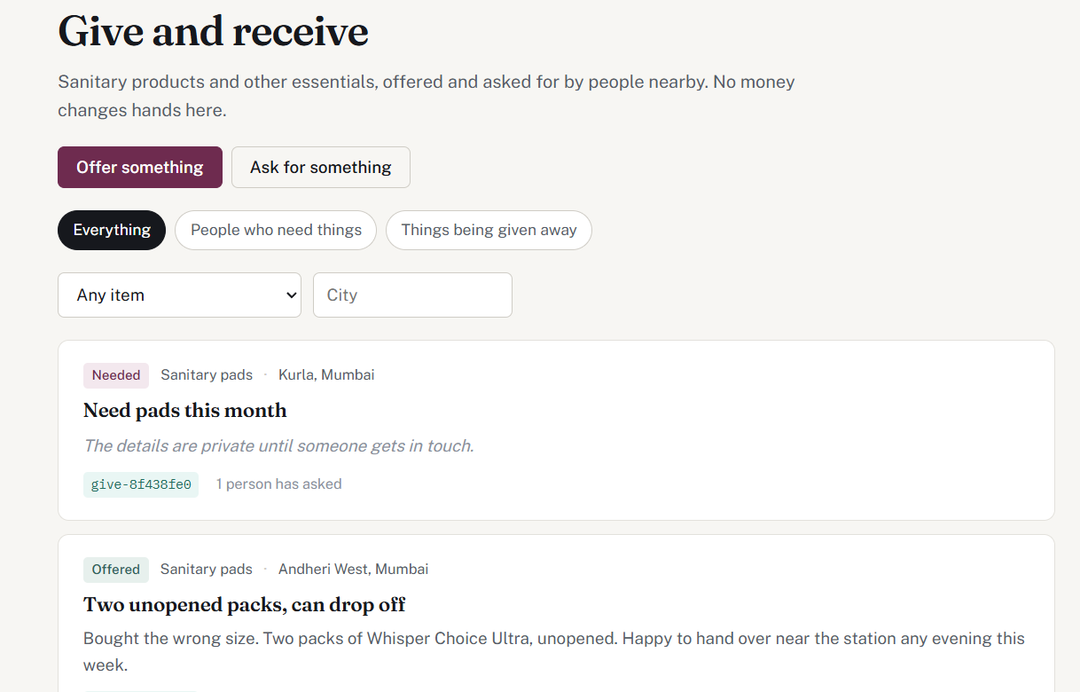
Figure 9 — Give and receive. The first listing has withheld its description.
A board for sanitary products and other essentials. Somebody posts an offer or a request, somebody else responds, and the two arrange a handover in a private thread without either publishing a phone number. No money changes hands anywhere in this feature — deliberately, because the moment payments enter, so do fraud, know-your-customer requirements, and payment regulation.
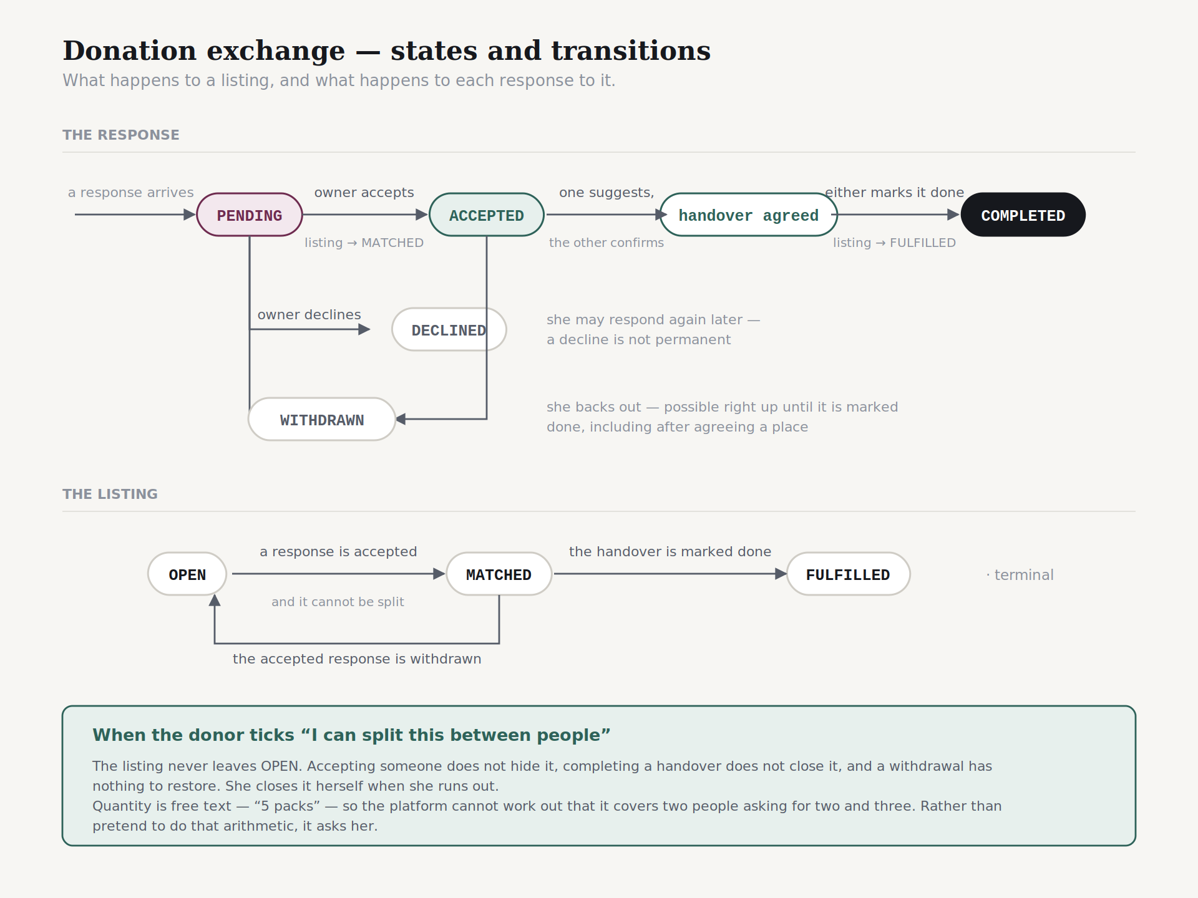
Figure 10 — States and transitions for a listing and its responses

Why requests are public
An early design hid requests from anybody without an active offer, to protect people disclosing financial hardship. This was wrong, and abandoning it improved the feature. If requests are hidden, nobody knows what is needed, so nobody offers, and the exchange has no reason to exist. More importantly, seeing that three people nearby need sanitary pads this month is precisely the thing that prompts somebody to buy a pack she was not otherwise going to buy.
The privacy cost this creates is addressed two other ways: the separate donation pseudonym described in Section 7, and an option to withhold a request's description until somebody makes contact. The item, area and title stay visible, so the board still shows what is needed.

Arranging the handover
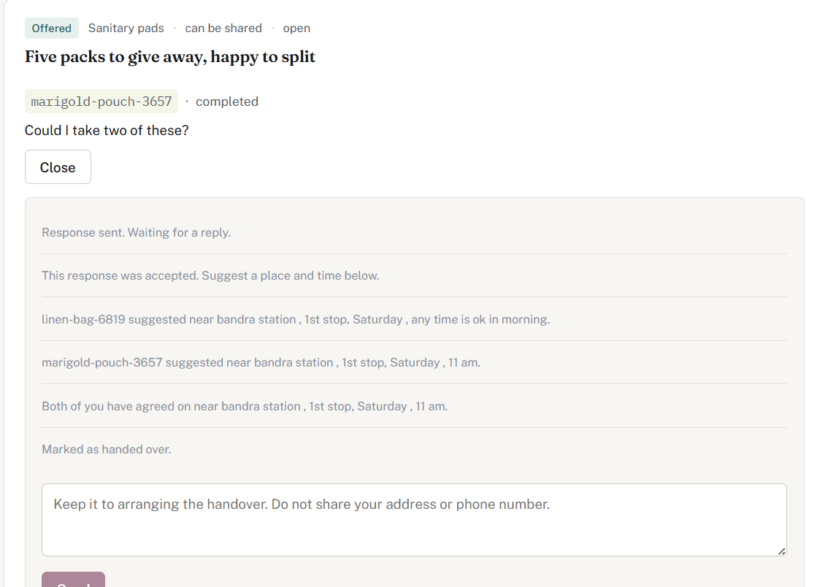
Figure 11 — A completed exchange, with the full system-message trail
Either party may propose a place and time; only the other party may confirm it. This is not symmetric by accident. If the person giving could set the meeting point alone, somebody who has just posted that she cannot afford sanitary pads could be sent to a location she cannot afford to reach, or does not feel safe going to, with no say in the matter. Whoever proposes is recorded, and the confirm button appears only for the other side.
A proposal can be replaced at any point, including after both have agreed, and a response can be withdrawn right up until the handover is marked done. Changing your mind about meeting a stranger should never be made difficult.
Every event in an exchange — a response sent, accepted, declined, withdrawn, a place suggested, agreed, completed — writes a system message into the thread. These are stored in the same table as the messages people write, so the entire history of an exchange reads as one conversation in order rather than being split between a chat and an event log.

5.6 Reporting and moderation
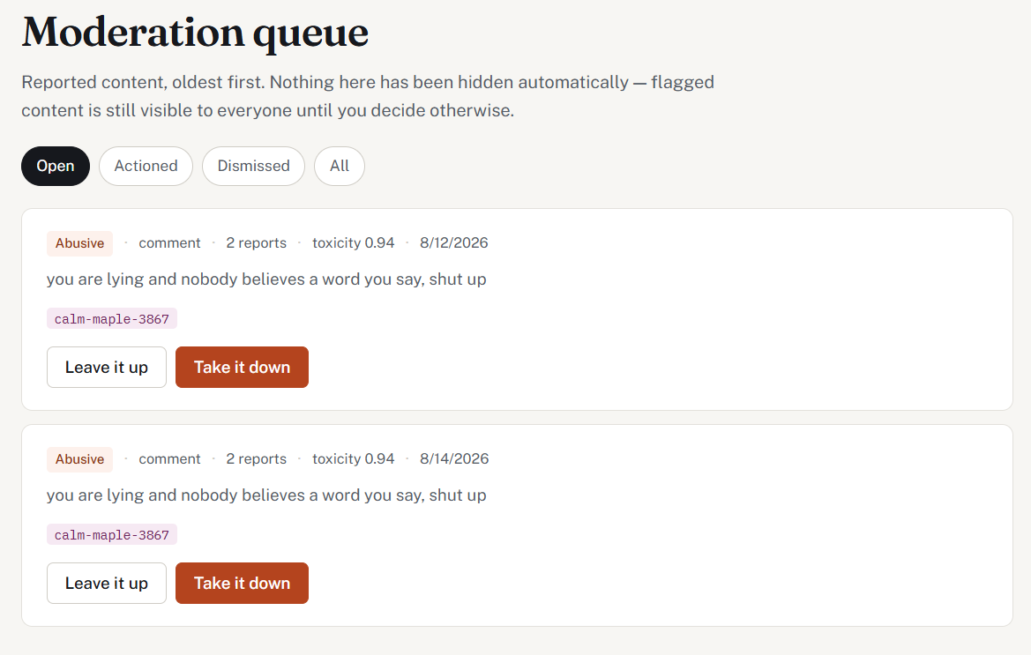
Figure 12 — The moderation queue. The model score appears as a number.
Any post, comment or listing can be reported. Three separate reports from three different accounts mark content as flagged, which raises it in the moderator's queue and changes nothing that a reader sees.
The alternative — automatically hiding content at a report threshold — was considered and rejected. It hands any three coordinated accounts a mute button, and the women most likely to be targeted by a coordinated campaign are precisely the ones this platform exists for.
Moderators never see who reported something. A moderator judges the content, not the objection, and keeping the reporter out of the response means the information cannot leak through the API even by accident. On a board where women write about abusive partners, "who reported me" is a question that gets people hurt.
Content that is taken down has its status changed; the row is never deleted. A wrong decision can be undone, and a repeat offender leaves a trail.

6. Automated content scoring
A separate FastAPI service scores content using unitary/toxic-bert, a BERT model fine-tuned for toxicity detection. This section describes what was measured, what the measurement showed, and how the design changed as a result.

6.1 The original design
The intended design was conventional: route new posts through a toxicity classifier and use the score to prioritise the moderation queue, on the assumption that content needing attention would score highly.

6.2 What was measured
Before wiring the classifier into the posting flow, it was tested against four pieces of content representative of this platform.
Content | Toxicity | Suggested action
First-person account of workplace harassment | 0.0007 | NONE
First-person account of a sexual assault | 0.0021 | NONE
Notice about a free sanitary pad distribution | 0.0006 | NONE
A reply reading "you are a stupid liar… shut up" | 0.9851 | FLAG

6.3 What the measurement shows
The model detects abusive language directed at a person. It has no representation of whether a situation is distressing.
An account of a sexual assault and a notice about free sanitary pads differ by 0.0015 — indistinguishable, and well within noise. Either differs from an insult by three orders of magnitude.
This is not a defect. The model is doing exactly what it was trained to do. But it means the design in Section 6.1 would have surfaced nobody who needed help, while confidently policing the tone of people who were merely rude. A moderation queue ordered by these scores would be ordered by nothing.
It is worth being precise about the failure mode, because the intuitive worry is the opposite one. The common concern with toxicity classifiers on platforms like this is over-flagging: that a survivor describing harassment will be silenced because her description contains the same vocabulary as the abuse itself. The measurement shows something different and, for a naive design, worse. The classifier does not silence her. It ignores her entirely.

6.4 The revised design
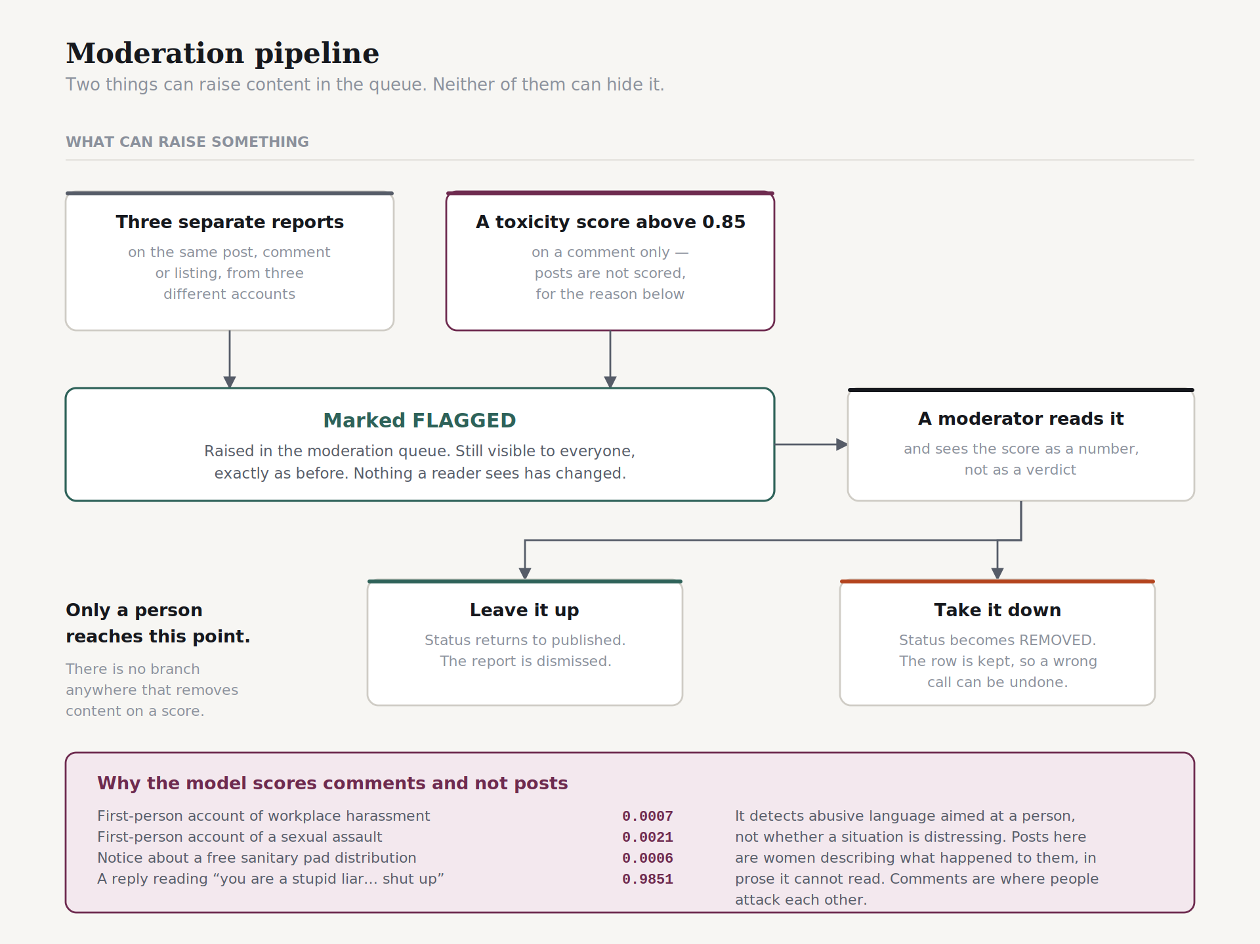
Figure 13 — The moderation pipeline. Two inputs can raise content; neither can hide it.
- Scoring runs on comments, not posts. Posts on this platform are women describing what happened to them, in measured prose the model cannot read. Comments are where people attack each other, which it reads accurately — the insult above scored 0.9851 with labels "toxic" and "insult".
- Nothing is hidden automatically. A high score marks a comment FLAGGED, which raises it in the moderation queue. FLAGGED content remains visible to every reader. There is no branch anywhere in the codebase that removes content on the basis of a score.
- The moderator sees the number, not a verdict. The queue displays "toxicity 0.94" rather than "flagged by AI". A number invites a moderator to judge the model; a verdict invites her to defer to it, and the measurement above shows why deferring would be a mistake.

6.5 Urgency scoring
A second score estimates whether the writer appears to be in danger now rather than describing something past. This is implemented as transparent keyword and phrase rules, not as a model.
This was a deliberate choice rather than a shortcut. There is no reliable pretrained classifier for "is this person in immediate danger", and an unreliable one here would be worse than rules a moderator can read and reason about. Being able to state why a post was ranked highly matters more, in this context, than a marginal gain in accuracy that nobody can audit.

6.6 Known limitations of the scoring service
- The model is trained on English. Hinglish, Marathi and Devanagari script score unpredictably. On a platform aimed at Indian users this is a serious gap, not a footnote.
- Category prediction is keyword matching, not machine learning. A trained classifier requires labelled posts from this platform, which do not yet exist. Describing the current implementation as a model would be dishonest.
- The model runs on CPU, taking a few hundred milliseconds per request. Adequate at this scale, inadequate at thousands of posts per minute.

7. Privacy design
Five decisions, each with a specific threat behind it.

7.1 Two pseudonyms, one person
Posts use one generated handle; the donation board uses a different one drawn from a different word list. calm-maple-3867 writes on the board; cotton-basket-4471 offers and asks on the exchange. They are the same account.
The threat is profiling. "I cannot afford sanitary pads this month" is a disclosure of poverty. If it carried the same handle as that person's posts about a domestic situation, anybody reading the site could assemble a profile of a woman at her most vulnerable — her financial position, her home circumstances, and her approximate location, all under one name.
The second handle is generated lazily, on first use of the donation board, so accounts that never touch it never acquire a second identifier.

7.2 Location is coarse on posts and exact on alerts
A post's coordinates are rounded to two decimal places before storage — roughly a 1.1 kilometre square. An emergency alert's coordinates are stored exactly.
The same application, opposite defaults, for the same reason. A post about a domestic situation, tagged with an exact coordinate and a timestamp, has effectively published a home address. An alert with a coarse coordinate is useless to somebody trying to reach her.

7.3 Login errors are deliberately identical
"No such account" and "wrong password" return the same message and the same status code. If they differed, the login form could be used to discover which women have accounts on this platform — a form of enumeration attack that is a genuine risk here rather than a theoretical one.

7.4 A withheld description is never transmitted
When a request withholds its details, the description field is null in the API response rather than present and hidden by the browser. A field that the client is trusted not to render is a field that leaks — through the browser's developer tools, through a direct API call, or through any client that is not the official one.
This is verifiable from outside the application: requesting the listings endpoint while signed out returns no description for a withheld request.

7.5 Handles are denormalised onto content
Each post, comment and listing stores the author's handle as a column rather than reading it through the author relation. Deleting an account therefore leaves threads readable, instead of removing one side of a conversation that other people took part in. Their words survive her departure.

8. Testing
Testing was manual and scenario-based, performed with two or three concurrent accounts in separate browser sessions. Every module was exercised in both its success and its failure paths before the next module was started.

8.1 Representative scenarios
Scenario | Expected | Result
Register, then request a protected endpoint with the returned token | 200 with the user's handle | Pass
Request a protected endpoint with a malformed token | 401, no stack trace | Pass after fix
Sign in with a wrong password and with an unregistered email | Identical message in both cases | Pass
Create a post with coordinates 19.136751, 72.826508 | Stored and returned as 19.14, 72.83 | Pass
Read a withheld request description while signed out | Field absent from the API response | Pass
Respond to an offer, then reload the board | Listing still visible | Pass after fix
Accept a response on a non-splittable offer | Listing leaves the board | Pass
Accept two responses on a splittable offer | Listing stays on the board | Pass
Withdraw an accepted response | Listing returns to the board | Pass
Confirm a handover proposal made by oneself | Rejected with an explanatory message | Pass
Respond again after being declined | Permitted | Pass
Post an abusive comment with scoring enabled | Scored 0.98, flagged, still visible | Pass
Open the moderation queue as a non-moderator | 403 | Pass
Raise an alert twice in succession | One alert, location updated | Pass
Raise an alert with location permission denied | Alert raised without coordinates | Pass

8.2 Defects found and corrected
Three defects found during testing are worth recording, because each revealed a design assumption rather than a coding error.
- A malformed UUID in a path parameter produced a 500 with a full stack trace. This matters beyond tidiness: 500-class responses are what an operator monitors, and client-supplied nonsense polluting that channel makes genuine failures harder to see. Corrected with a dedicated exception handler returning 400.
- The /me endpoint was reachable without authentication because the security matcher used a wildcard over the whole auth path. Corrected by matching the register and login endpoints explicitly.
- A pending response removed a listing from the board, as described in Section 3.1.

9. Limitations
Stated in full rather than omitted. A reviewer who discovers these independently concludes the author did not know; a reviewer who reads them here concludes the author did.

9.1 No alerts are actually delivered
LoggingAlertSender writes the alert message to the server log. No SMS is sent and no contact is reached. The AlertSender interface exists so that substituting a real provider is a single class, and so that the entire alert flow can be demonstrated without a paid messaging account — but as it stands, the alarm's notification path terminates in a log file.

9.2 The system is not deployed
The application runs locally. Deployment was investigated and deliberately not completed: the available free hosting tiers spin a backend down after a period of inactivity, with cold starts of thirty to sixty seconds. For most applications that is an inconvenience. For a panic button it is disqualifying, and presenting it as a working safety service would be worse than not deploying it at all.

9.3 Language coverage
The interface is English-only, and the scoring model is trained on English. On a platform intended for Indian users, where a great deal of authentic writing is Hinglish or in Devanagari script, this is a substantial gap. Multilingual support is the single most valuable extension available.

9.4 Trust between strangers
Two people arranging to meet is the riskiest action this platform enables, and nobody on it is verified. The system mitigates rather than solves: it recommends public places in daylight, keeps phone numbers out of the conversation, allows either party to withdraw at any point, and states plainly on three separate screens that it cannot vouch for anyone. This is the honest position, not a solved problem.

9.5 Directory verification
Only the five national helpline numbers have been checked against a primary source. The organisation entries are real organisations whose current direct numbers have not been confirmed, and are labelled accordingly.

9.6 Moderation does not scale
The moderation model assumes a small number of moderators reviewing a manageable queue by hand. At volume this fails, and the honest answer is that the automated component measured in Section 6 cannot substitute for the human one.

10. Conclusion
Ten modules were delivered: authentication with generated pseudonyms, an anonymous board with category and location filtering, threaded comments, an emergency alarm with synthesised sounds, trusted contacts and alerts, reporting and moderation, a fake incoming call, a helpline directory, an automated scoring service, and a donation exchange with a negotiated handover flow.

10.1 What the project contributes
The technical work is conventional: a layered Spring Boot application, a React single-page frontend, a relational schema, token authentication. None of that is novel.
What the project does contribute is a set of design decisions made against measured evidence rather than assumption, and documented including the cases where the initial assumption was wrong. The clearest example is Section 6. A toxicity classifier was integrated on the standard assumption that it would help identify content needing attention. Measurement showed it scored an account of a sexual assault at 0.0021 and an insult at 0.9851 — that it detects abusive language rather than distressing situations, and would identify nobody who needed help. The design changed in response: scoring moved to comments, where the model is accurate, and was made advisory in a system where only a person removes anything.
That sequence — integrate, measure, find the assumption wrong, redesign around the finding — is the substance of the work. It is also the part that generalises. The specific finding about toxic-bert is a known limitation of toxicity classifiers; rediscovering it independently, with four measurements against this platform's own content, is what made the design defensible rather than merely plausible.

10.2 Future work
- Multilingual support, beginning with Hinglish and Devanagari input, and a scoring model that handles them.
- A real messaging provider for alert delivery, which the existing interface accommodates without changes elsewhere.
- A verified-organisation programme, so that donation handovers can be routed through a known intermediary as a default rather than an option.
- A category classifier trained on this platform's own labelled posts, replacing the current keyword matching.
- Deployment on infrastructure that does not cold-start, if the alarm is ever to be more than a demonstration.

Source code, database schema, migrations and the full set of diagrams are available in the project repository. A recorded walkthrough demonstrates the application in operation.

