SPRING DATA JPA HANDSON
ADDITIONAL

OUTPUT SCREESHOTS

- Implement services for managing Country

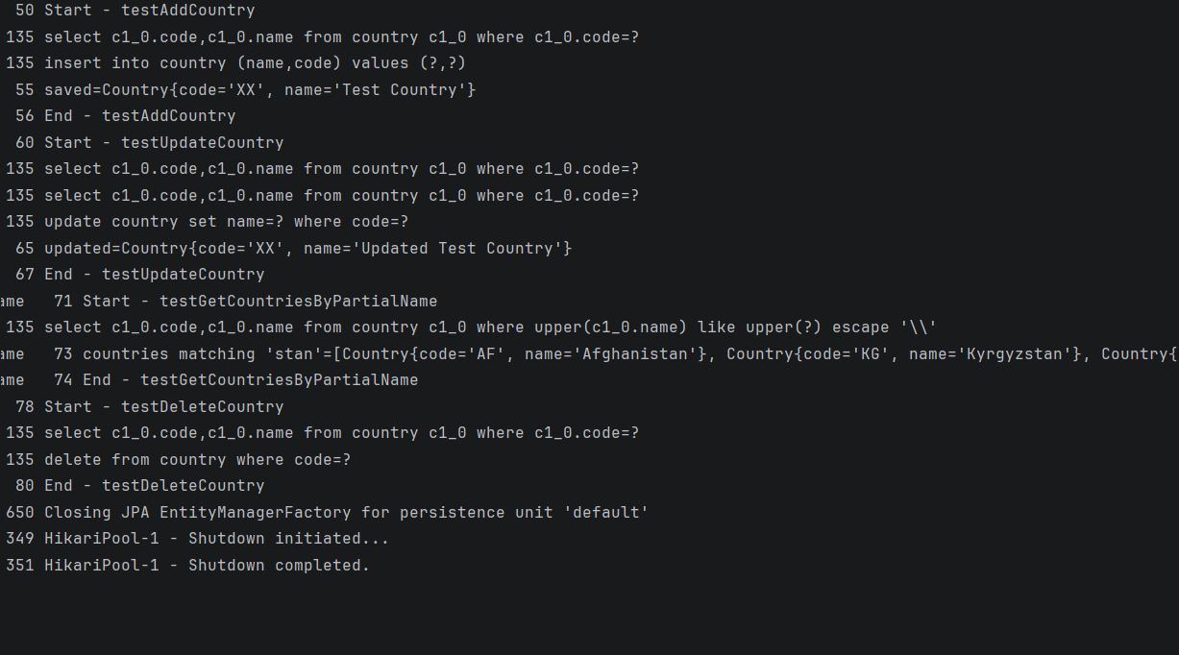
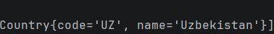

- Find a country based on country code:

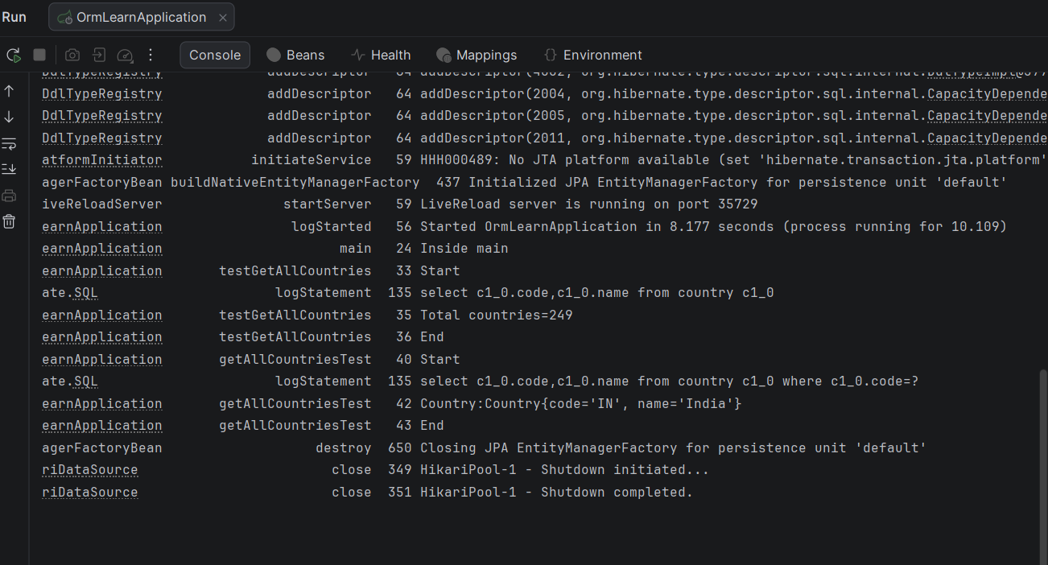

- Add a new country

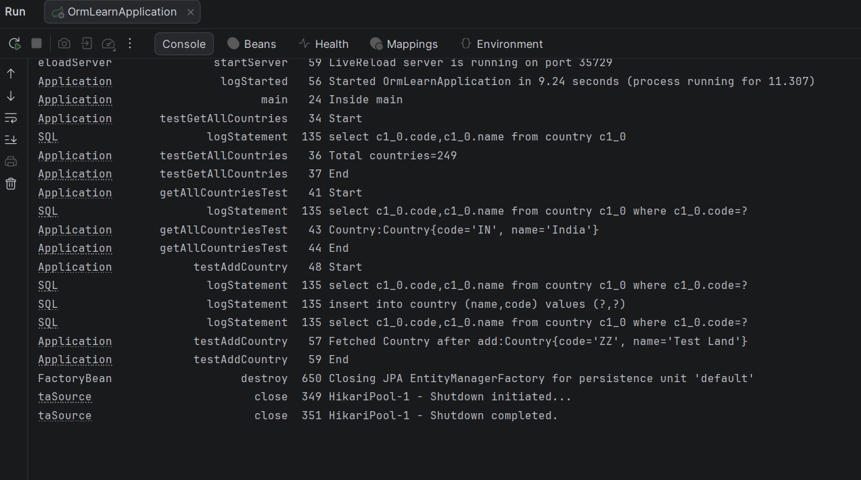

- QUERY METHODS FEATURE OF JPA

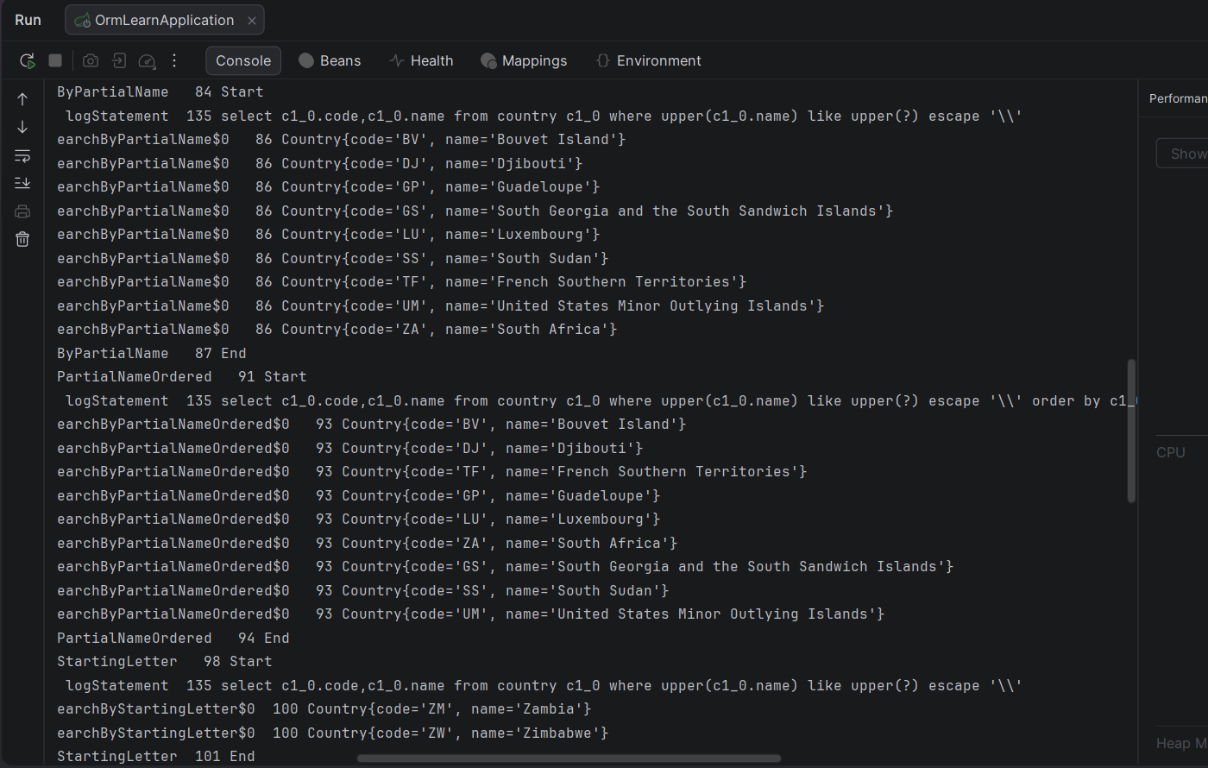

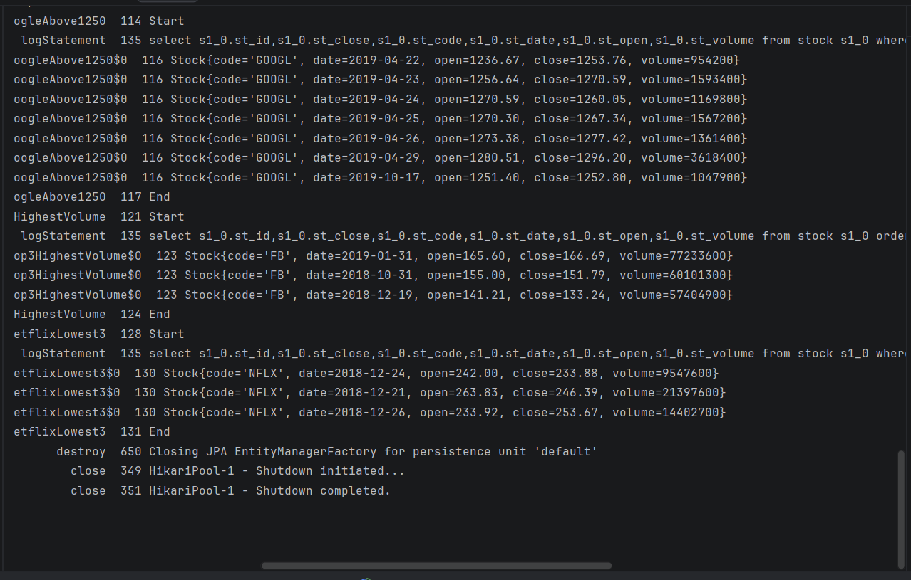

- IMPLEMENTING OF O/R MAPPING

