SPRING DATA JPA HANDSON
MANDATORY

OUTPUT SCREENSHOTS

- Spring Data JPA - Quick Example

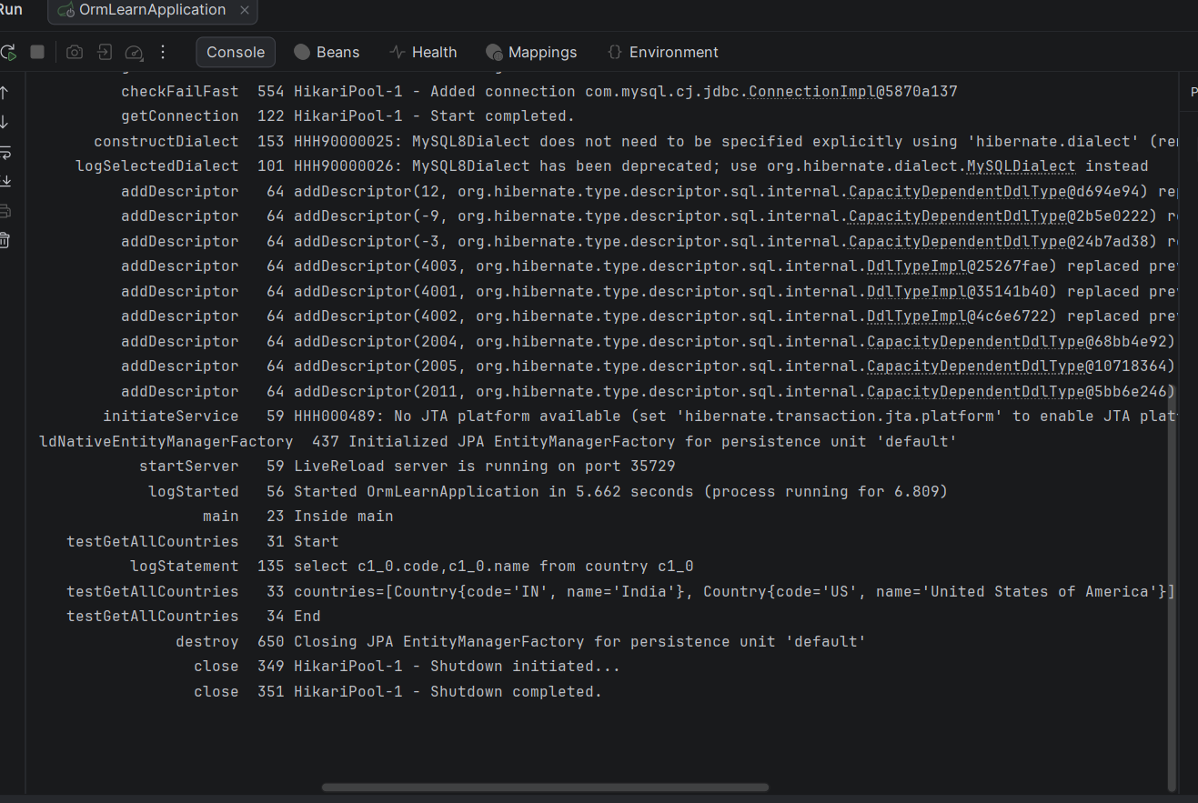

- Difference between JPA, Hibernate and Spring Data JPA

