REACT
ADDITIONAL HANDSON
OUTPUT SCRRENSHOTS
6. ReactJS-HOL

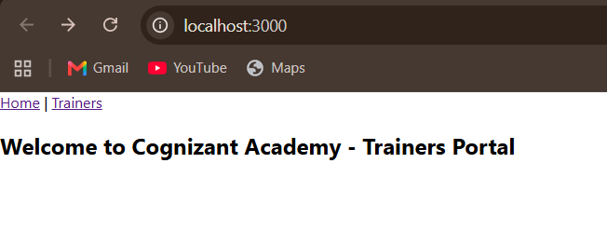

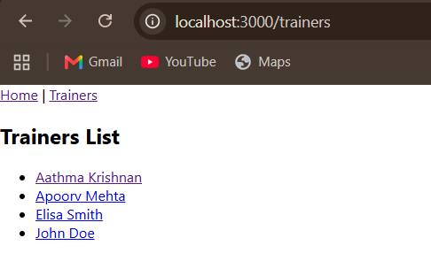

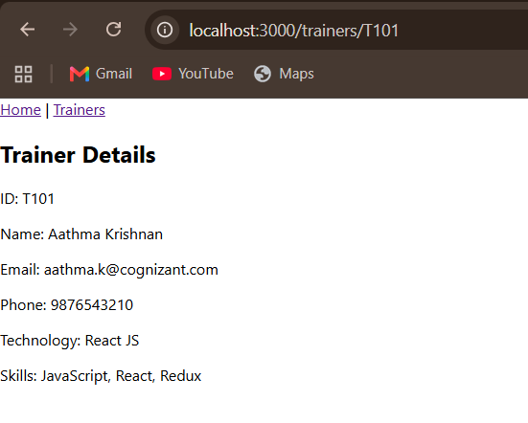

- ReactJS-HOL

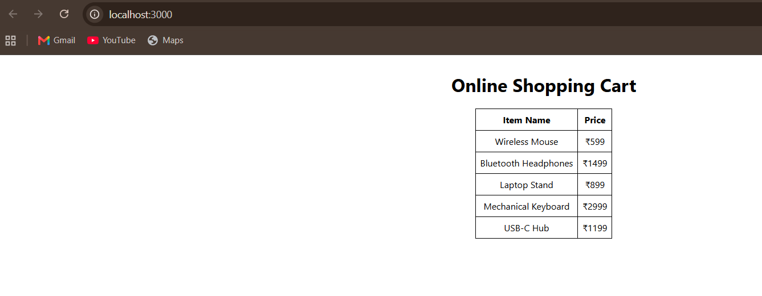

- ReactJS-HOL

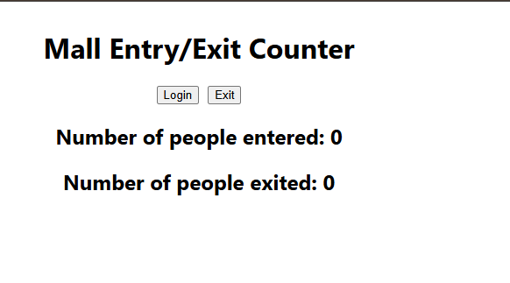
On clicking login:

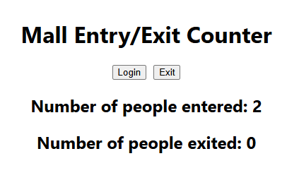

- ReactJS-HOL

Before toggling theme:

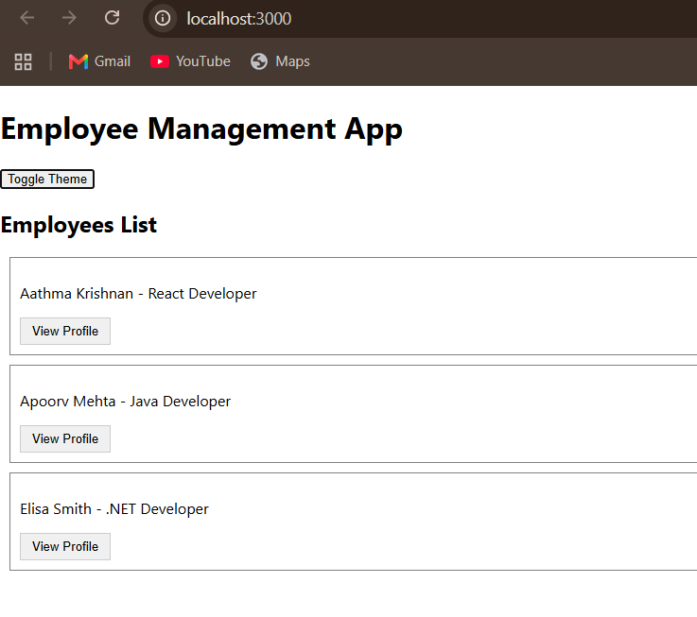
After the theme change:

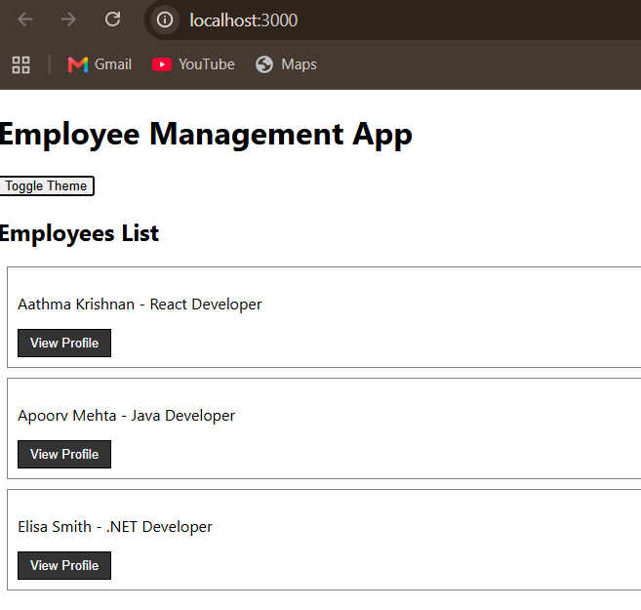

- ReactJS-HOL

Before submitting :

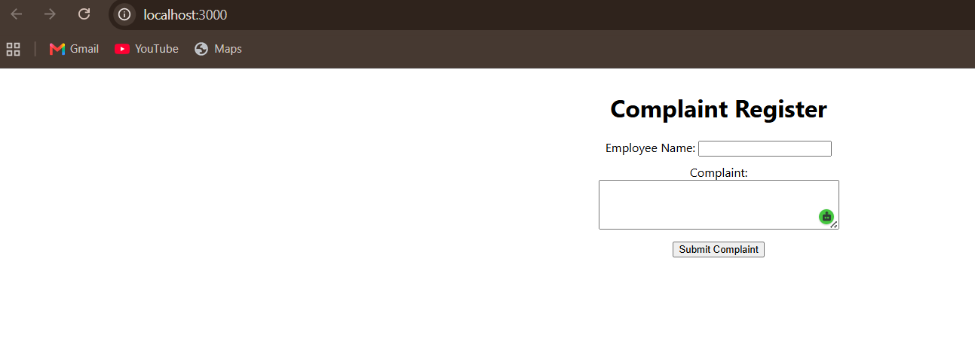

After submitting :

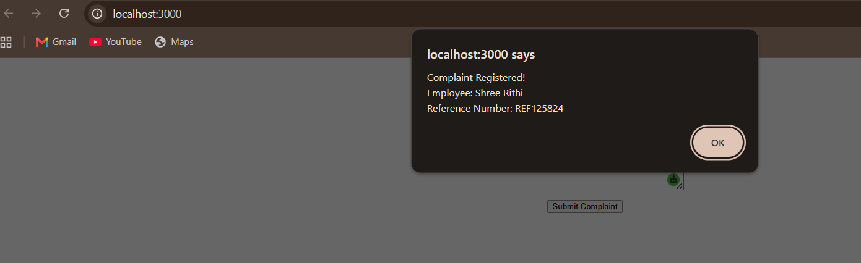

- ReactJS-HOL

Before registeration :

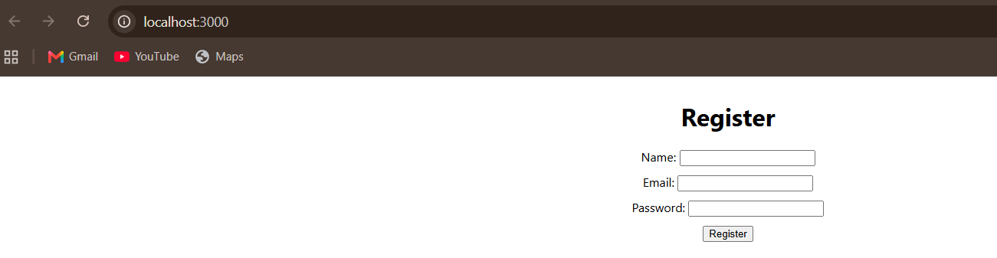

After submission :

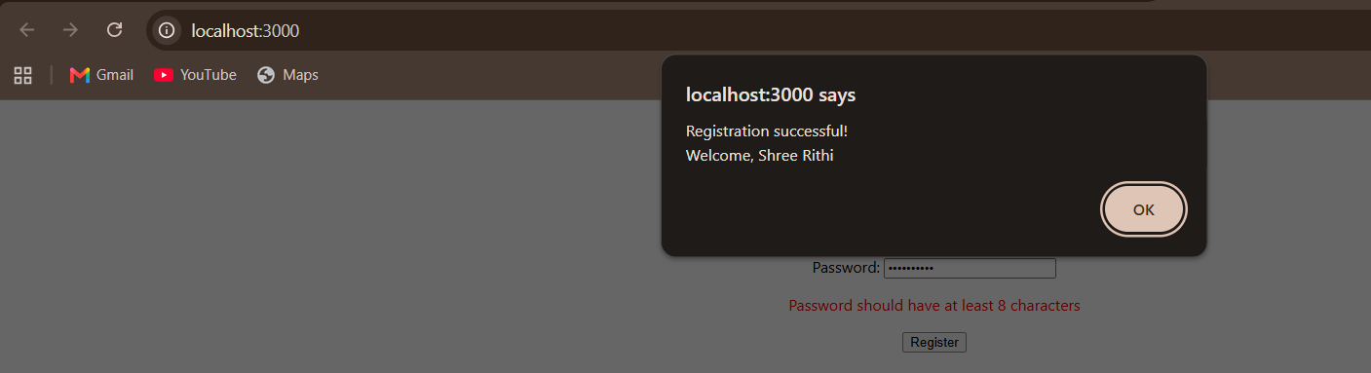

- ReactJS-HOL

