WEEK - 4
Microservices with API gateway

OUTPUT SCREENSHOTS

- Creating Microservices for account and loan

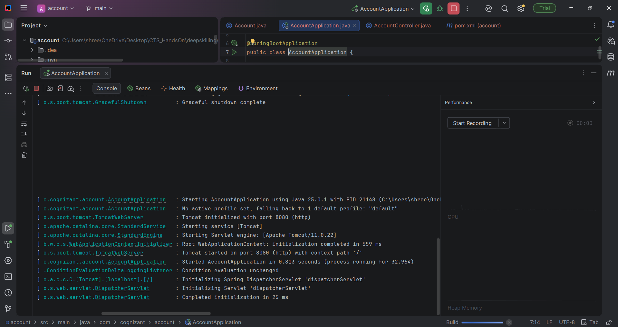

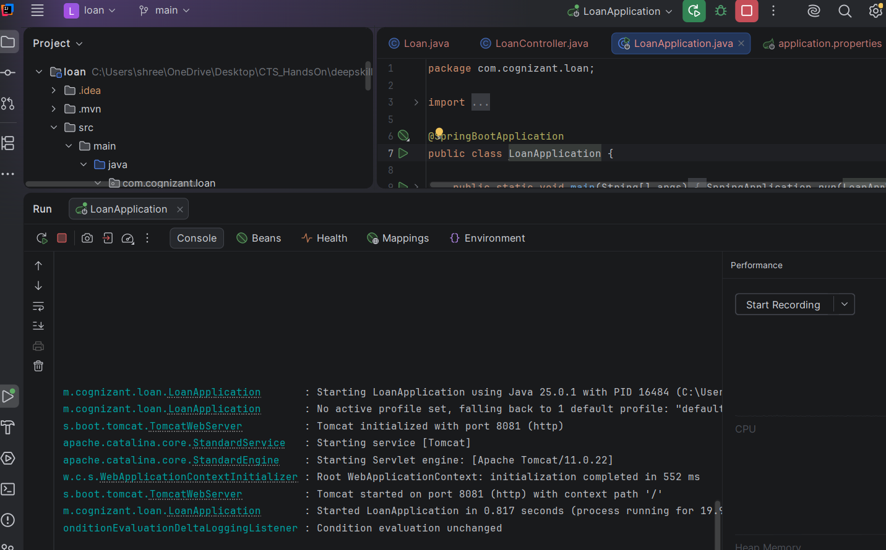

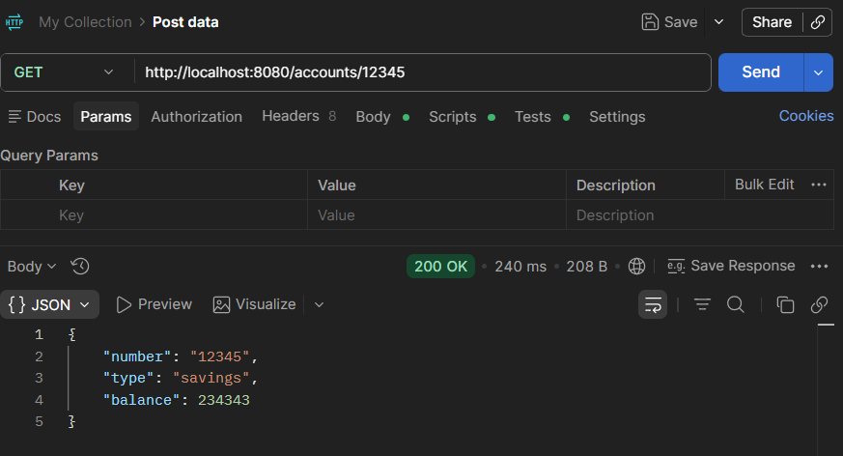

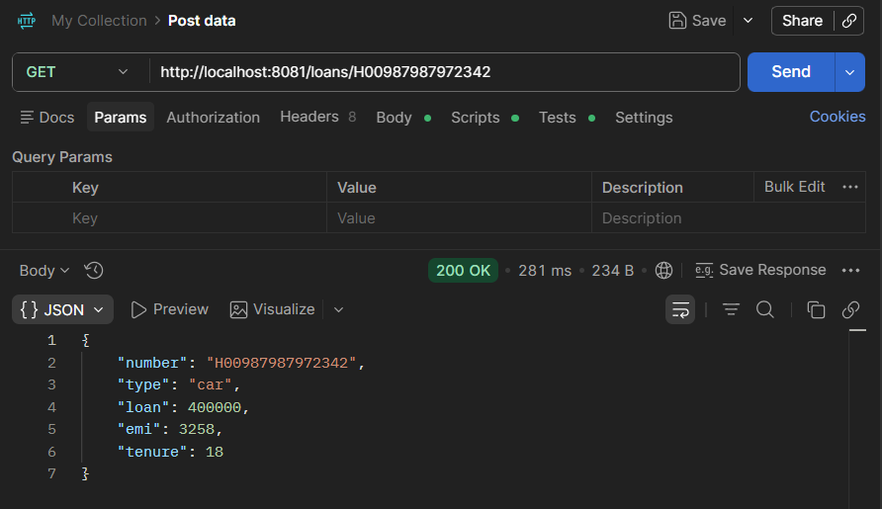

- Create Eureka Discovery Server and register

JUST RUNNING THE EurekaDiscoveryServerApplication.java

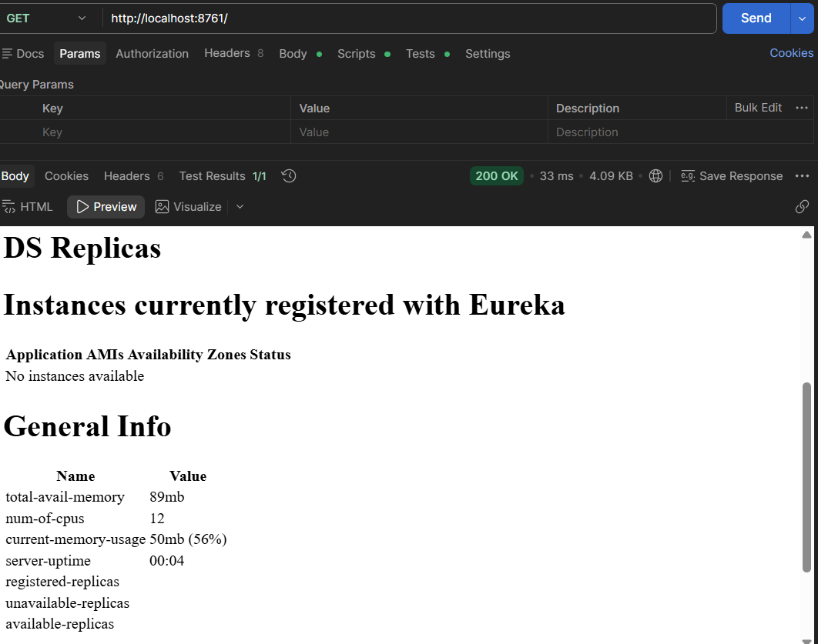

AFTER RUNNING THE AccountApplication , LoanApplication.java , GatewayApplication.java :

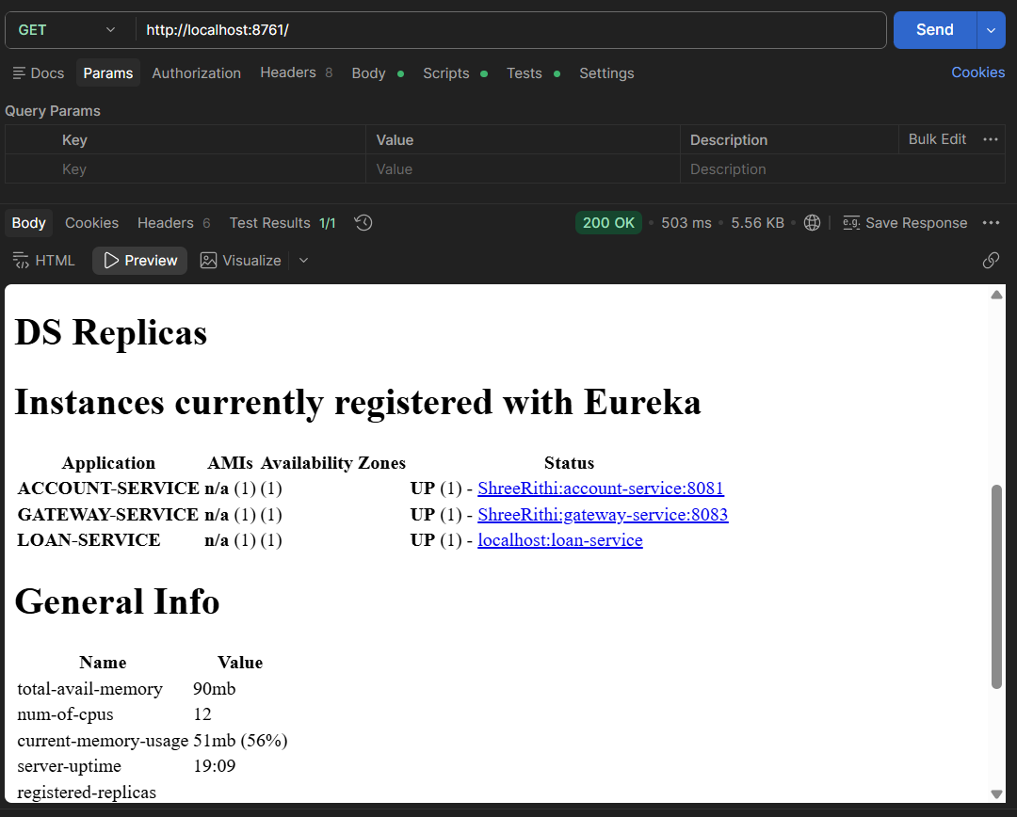

GREET SERVICES :

