Rectifier Validation Report

1. Objective
To evaluate the performance, efficiency and thermal behavior of the rectifier under specified operating conditions.

2. Test Setup
The rectifier DUT was tested using the validation test setup. Electrical parameters such as voltage, current, power and temperature were monitored and recorded throughout the test duration.

3. Validation Summary
Maximum Efficiency : 97.96%
Minimum Efficiency : 94.76%
Average Efficiency : 95.37%
Maximum Output Power : 27.03 kW
Average Output Power : 25.42 kW
Maximum Temperature : 39.80 °C
Average Temperature : 38.57 °C
Average Output Voltage : 698.82 V

4. Test Evaluation
Efficiency Result : PASS
Temperature Result : PASS
Overall Result : PASS

5. Observations
The rectifier achieved an average efficiency of 95.37% which meets the acceptance criteria.
Thermal performance was satisfactory with a maximum temperature of 39.80 °C.
The maximum output power delivered during the test was 27.03 kW.
The average output voltage during the test was 698.82 V.

6. Graphs
Efficiency Graph
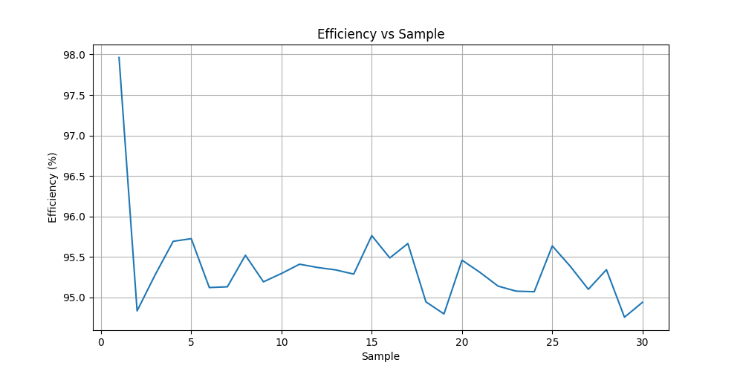
Output Voltage Graph
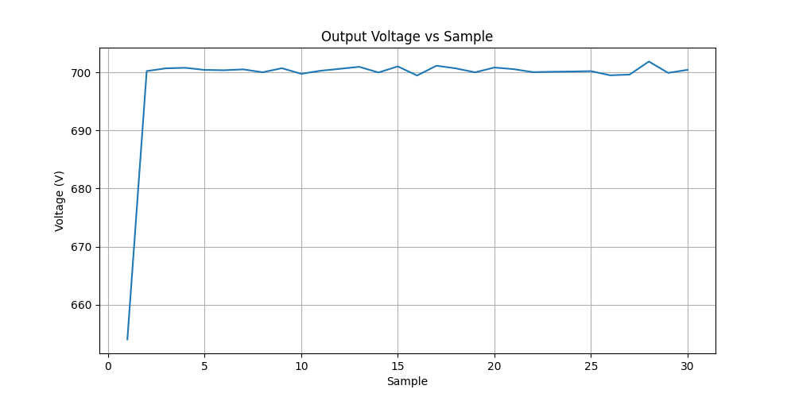
Temperature Graph
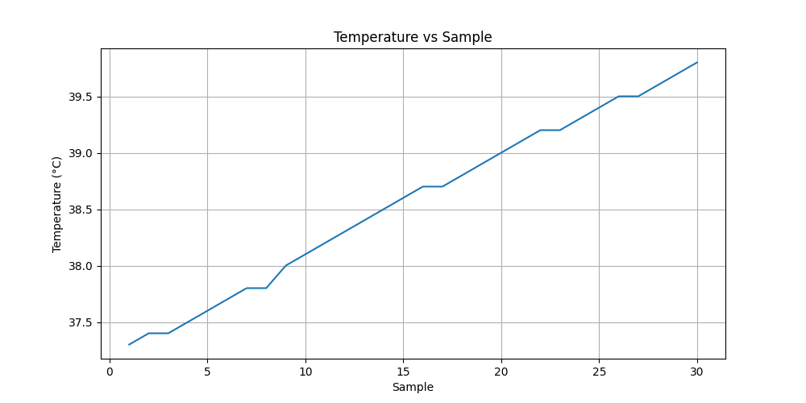
Output Power Graph
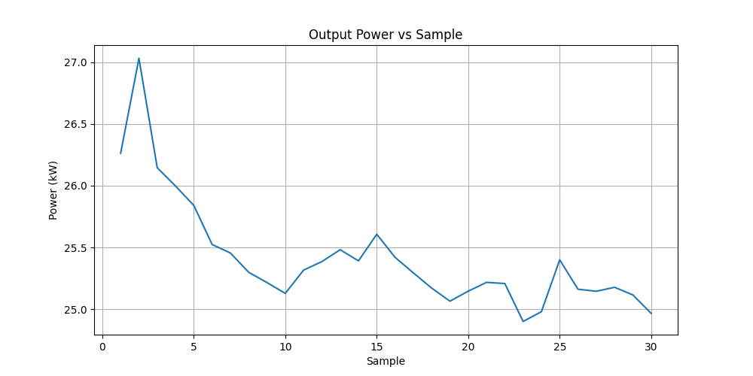

7. Conclusion
The rectifier successfully passed the validation test. The average efficiency was 95.37% and the maximum temperature remained within acceptable limits. The DUT is considered suitable for operation under the tested conditions.

