**Module-4**

1. **What are the main factors that can affect PPC bidding?**

* **Keyword Competition** – Highly competitive keywords have higher bid prices due to increased demand.

**Ad Rank**– Determines the position of your ad in search results. The bid amount, Quality Score, and expected impact of ad extensions influence it.

**Quality Score** – Google Ads considers CTR (Click-Through Rate), ad relevance, and landing page experience to determine the Quality Score. A higher Quality Score can lower costs.

**Bid Strategy** – Manual vs. automated bidding strategies can impact how much you pay per click.

**Target Audience & Location** – Bidding costs vary based on geographic location, demographics, and user intent.

**Device Type** – Costs can differ between mobile, desktop, and tablet users.

**Industry & Seasonality** – Some industries have higher CPC (Cost-Per-Click) rates, and seasonal trends can increase competition.

**Ad Schedule** – The time and day your ads are shown can influence bid prices due to varying user activity.

**Landing Page Experience** – A well-optimized landing page with a good user experience can improve the Quality Score and reduce CPC.

**Competitor Bidding** – If competitors increase their bids, it can drive up the cost of winning ad placements.

1. **How does a search engine calculate actual CPC?**

* A search engine calculates actual CPC (Cost-Per-Click) based on the Ad Rank of the next highest competitor and your Quality Score. The formula for actual CPC is:

**Formula:**

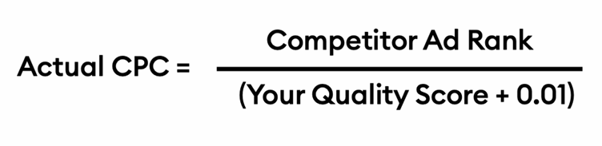

**Key Factors Affecting CPC:**

1. Industry Type – Some industries, like real estate, finance, and education, have higher CPCs.
2. Competition – More advertisers bidding on the same keyword increase CPC.
3. Geographic Targeting – CPC varies between metro cities (Delhi, Mumbai, Bangalore) and smaller towns.
4. Device Targeting – Mobile vs. desktop bids may differ.
5. Quality Score – Higher CTR (Click-Through Rate), ad relevance, and landing page experience reduce CPC.
6. Seasonal Demand – Festive seasons like Diwali, New Year, and wedding season may increase CPC due to higher demand.

**Example**

● Your Ad Rank = 40

● Competitor’s Ad Rank = 30

● Your Quality Score = 6

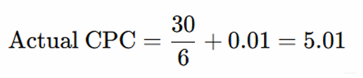

1. **What is a quality score and why it is important for Ads?**

* **Quality Score** is a rating given by Google Ads (or other search engines) that measures the relevance and quality of your keywords, ads, and landing pages. It is scored from 1 to 10, with 10 being the highest.

**Why is Quality Score important:**

Lower Cost-Per-Click (CPC) – A higher Quality Score reduces the amount you pay per click.

Better Ad Placement – Ads with a higher Quality Score get better positions in search results.

Higher Ad Rank – Ad Rank = Quality Score × Max Bid, meaning a high Quality Score helps you rank higher even with a lower bid.

Better ROI (Return on Investment) – With lower costs and better placements, you get more value from your ad budget.

1. **Create an ad for your website/ blog in Google Ads that display on the display network with the properly targeted audience.**

**INSTRUCTIONS:**

**• Create an ad forwww.tops-int.com to get the maximum Clicks**

**• Create an ad for** [**www.tops-int.com**](http://www.tops-int.com)

**• Create an ad for the display network.**

**• Choose a proper Target audience.**

**• Expected conversion: need maximum user engagement within the budget.**

**• Budget: 5000.**

* What's your campaign objective?

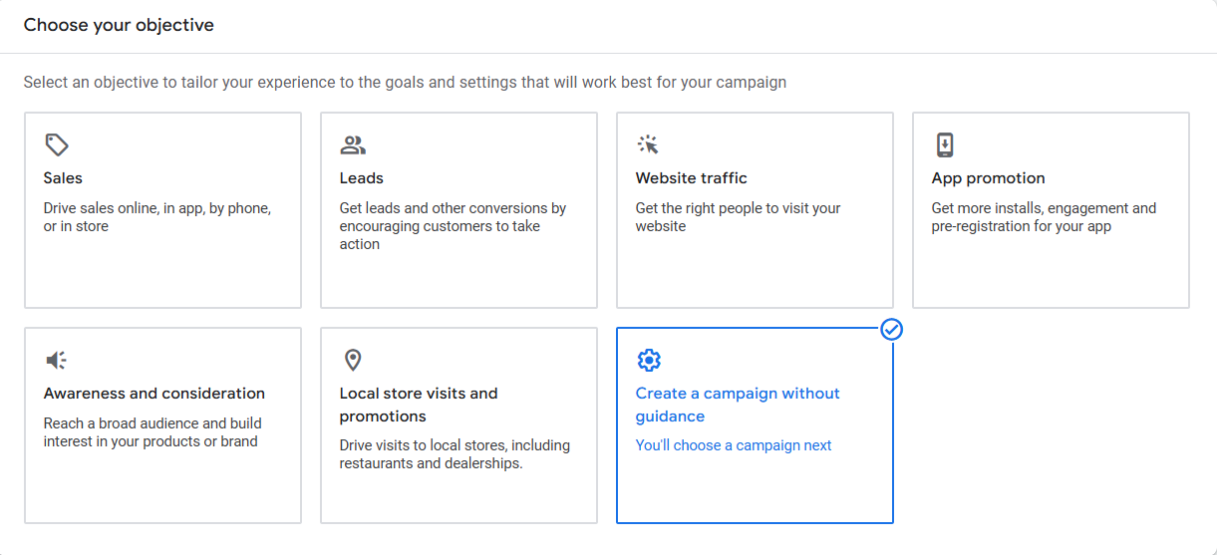

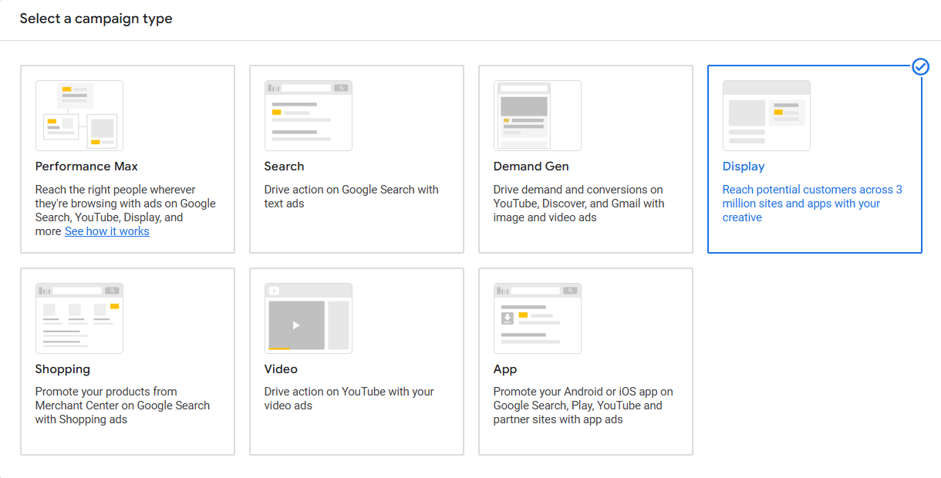



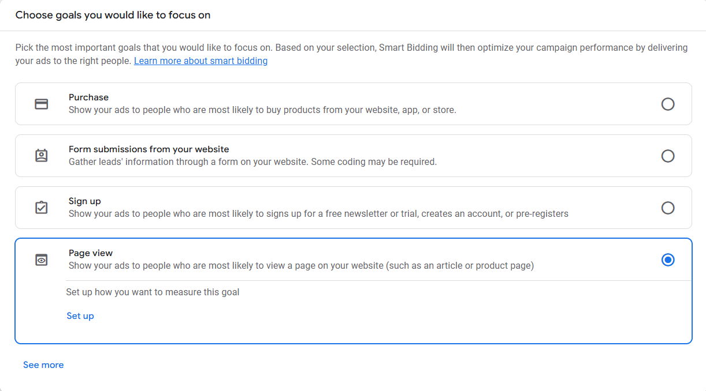

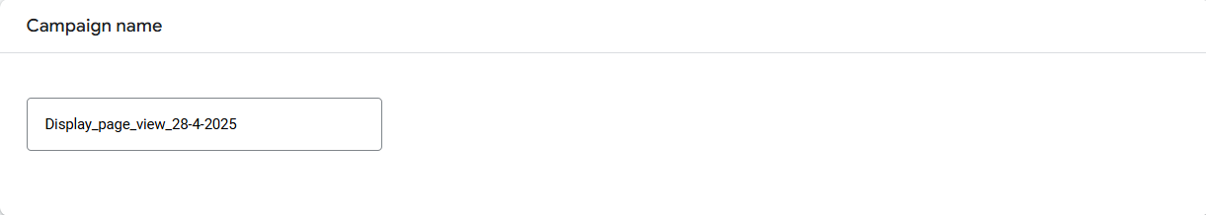

Campaign settings

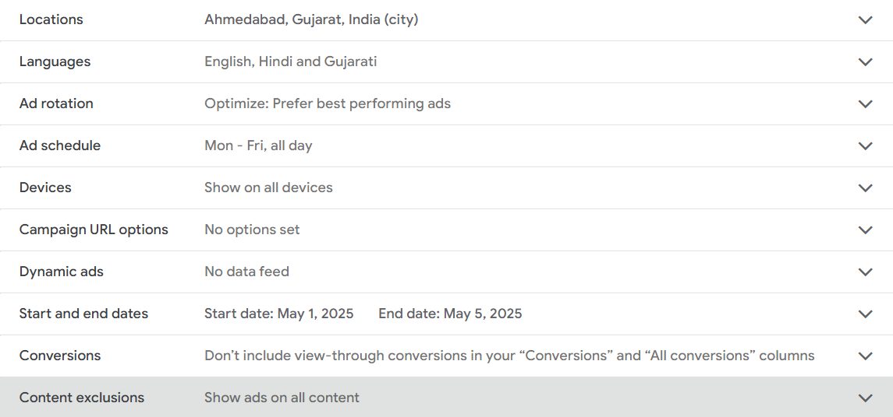

Budget and bidding

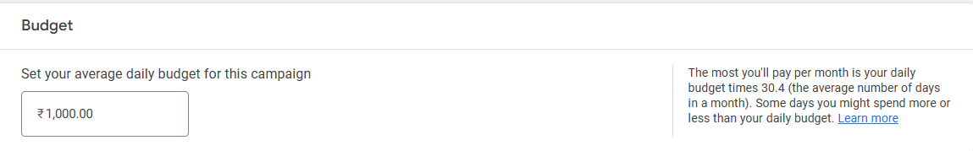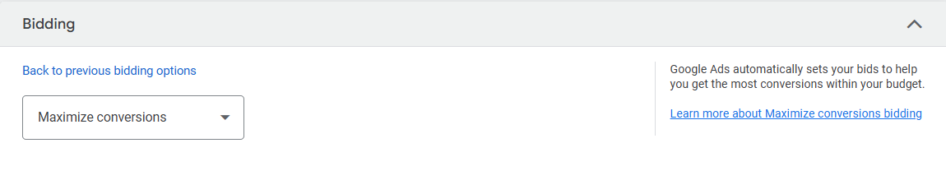

Targeting

