Business Case: Waste Management Systems
Sub-task: Find the shortest path for waste collection vehicles to minimize emissions and increase efficiency
SDG Goal: 11
Target: 11.6
Indicator: 11.6.1
Description:
This task involves optimizing routes for waste collection vehicles to reduce fuel consumption, vehicle emissions, and overall travel time. Efficient routing ensures better resource utilization and contributes to a cleaner environment.
Input Data:
- City grid: Waste collection points represented as nodes
- Routes: Distance (in km) between collection points
- Schedule: Frequency of waste collection for each point
DATA TABLE:
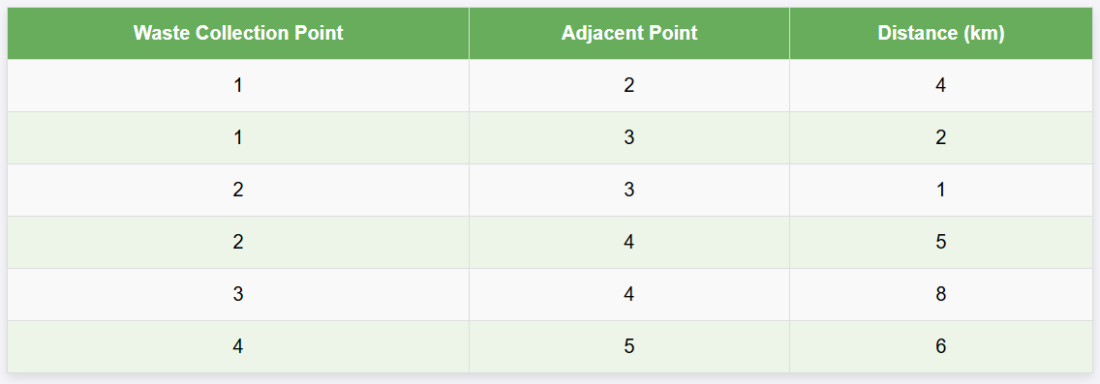

Algorithm Used:
- Dijkstra's Algorithm: To find the shortest path between waste collection points.
- Heap Data Structure: Used for priority queue operations to efficiently select the nearest node.
Code:
#include <iostream>
#include <vector>
#include <queue>
#include <climits>
using namespace std;

// Function to find the shortest path using Dijkstra's algorithm
void dijkstra(vector<vector<pair<int, int>>>& graph, int source, int n) {
vector<int> dist(n, INT_MAX);
dist[source] = 0;

priority_queue<pair<int, int>, vector<pair<int, int>>, greater<pair<int, int>>> pq;
pq.push({0, source});

while (!pq.empty()) {
int u = pq.top().second;
pq.pop();

for (auto& neighbor : graph[u]) {
int v = neighbor.first;
int weight = neighbor.second;

if (dist[v] > dist[u] + weight) {
dist[v] = dist[u] + weight;
pq.push({dist[v], v});
}
}
}

cout << "Shortest distances from the starting point:\n";
for (int i = 0; i < n; ++i) {
cout << "To Point " << i + 1 << ": " << dist[i] << " km\n";
}
}

int main() {
// Number of waste collection points
int n = 5;

// Graph representation: adjacency list
vector<vector<pair<int, int>>> graph(n);
graph[0].push_back({1, 4}); // Point 1 to Point 2
graph[0].push_back({2, 2}); // Point 1 to Point 3
graph[1].push_back({2, 1}); // Point 2 to Point 3
graph[1].push_back({3, 5}); // Point 2 to Point 4
graph[2].push_back({3, 8}); // Point 3 to Point 4
graph[3].push_back({4, 6}); // Point 4 to Point 5

// Running Dijkstra's algorithm from Point 1
dijkstra(graph, 0, n);

return 0;
}
Output:
- Shortest Path from Waste Collection Point 1:
To Point 1: 0 km
To Point 2: 4 km
To Point 3: 2 km
To Point 4: 7 km
To Point 5: 13 km
- Graph Representation:
Each node represents a waste collection point, and edges represent distances:
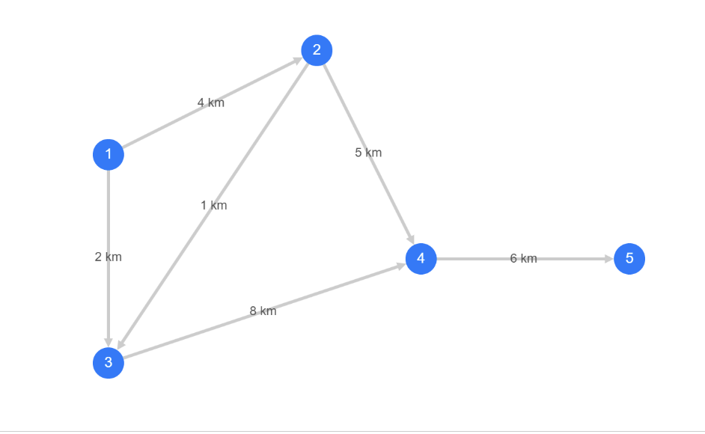

- Optimized Travel Time:
The shortest path ensures minimum total travel distance, reducing emissions and fuel consumption.
Reflection:
This implementation demonstrated how Dijkstra's algorithm efficiently optimizes routes for waste collection. By using a heap, the algorithm achieves logarithmic time complexity for node selection, enabling quick route optimization. This approach can scale to larger city grids, significantly reducing emissions and operational costs.
Business Case: Smart Residential Communities
Sub-task: Organize and search housing unit data efficiently.
SDG Goal: 11
Target: 11.6
Indicator: 11.6.1
Description:
Smart Residential Communities aim to optimize housing data management for better planning and improved resident services. This sub-task focuses on organizing housing unit information and implementing efficient search operations.
Input Data:
- Housing Units: A database containing housing unit numbers, resident names, and types.
DATA TABLE:
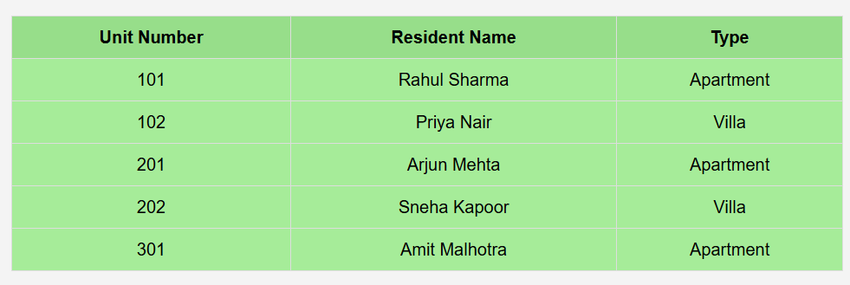
Algorithm Used:
- Binary Search Tree (BST): To organize housing data by unit numbers for efficient search.
- Inorder Traversal: To display the housing data in ascending order.
Code:
#include <iostream>
#include <string>
using namespace std;

// Node structure for Binary Search Tree
struct Node {
int unitNumber;
string residentName;
string type;
Node* left;
Node* right;

Node(int unit, string name, string t) : unitNumber(unit), residentName(name), type(t), left(nullptr), right(nullptr) {}
};

// Insert a node into the BST
Node* insert(Node* root, int unit, string name, string type) {
if (root == nullptr) {
return new Node(unit, name, type);
}
if (unit < root->unitNumber) {
root->left = insert(root->left, unit, name, type);
} else {
root->right = insert(root->right, unit, name, type);
}
return root;
}

// Search for a unit in the BST
Node* search(Node* root, int unit) {
if (root == nullptr || root->unitNumber == unit) {
return root;
}
if (unit < root->unitNumber) {
return search(root->left, unit);
}
return search(root->right, unit);
}

// Inorder Traversal to display all housing data
void inorder(Node* root) {
if (root == nullptr) {
return;
}
inorder(root->left);
cout << "Unit Number: " << root->unitNumber << ", Resident: " << root->residentName << ", Type: " << root->type << endl;
inorder(root->right);
}

int main() {
Node* root = nullptr;

// Inserting housing data into the BST
root = insert(root, 101, "Rahul Sharma", "Apartment");
root = insert(root, 102, "Priya Nair", "Villa");
root = insert(root, 201, "Arjun Mehta", "Apartment");
root = insert(root, 202, "Sneha Kapoor", "Villa");
root = insert(root, 301, "Amit Malhotra", "Apartment");

// Display all housing data in ascending order
cout << "All Housing Data (Sorted by Unit Number):\n";
inorder(root);

// Search for a specific housing unit
int searchUnit;
cout << "\nEnter a Unit Number to search: ";
cin >> searchUnit;

Node* result = search(root, searchUnit);
if (result != nullptr) {
cout << "Unit Found! Resident: " << result->residentName << ", Type: " << result->type << endl;
} else {
cout << "Unit not found.\n";
}

return 0;
}
Output:
- Displaying All Housing Data:
All Housing Data (Sorted by Unit Number):
Unit Number: 101, Resident: Rahul Sharma, Type: Apartment
Unit Number: 102, Resident: Priya Nair, Type: Villa
Unit Number: 201, Resident: Arjun Mehta, Type: Apartment
Unit Number: 202, Resident: Sneha Kapoor, Type: Villa
Unit Number: 301, Resident: Amit Malhotra, Type: Apartment
Graph Representation:
- Binary Search Tree Structure:
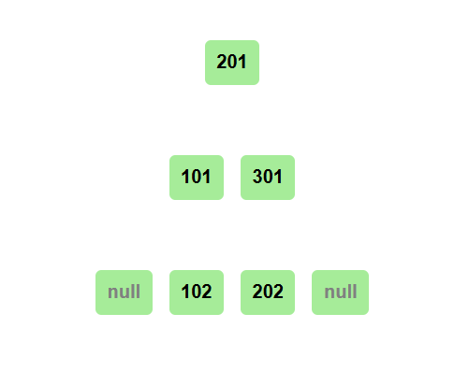
Impact:
- Efficiency: Organizing housing unit data using BST ensures fast search and retrieval.
- Usability: Enhances the ability to manage large-scale housing data effectively in smart residential communities.
Reflection:
This sub-task demonstrates the power of Binary Search Trees in efficiently managing and searching hierarchical data. Implementing such structures can help make residential communities more organized and responsive to resident needs.
Business Case: Waste Management Systems
Sub-task: Sort waste collection points based on distance from the starting location for efficient routing.
SDG Goal: 11
Target: 11.6
Indicator: 11.6.1
Description:
Insertion Sort is used to arrange waste collection points in ascending order of distance from the starting location. Sorting helps the waste collection vehicles follow an optimized sequence, minimizing travel distance and emissions.
Input Data:
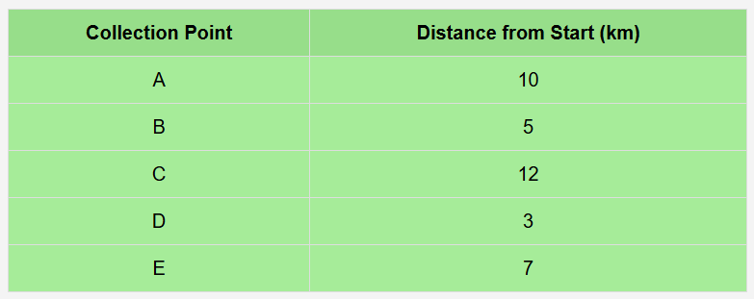
Algorithm Used:
- Insertion Sort Algorithm: It processes one collection point at a time, placing it in its correct position in the sorted order.
Code :
#include <iostream>
#include <vector>
using namespace std;

struct Point {
char name;
int distance;
};

void insertionSort(vector<Point>& points) {
int n = points.size();
for (int i = 1; i < n; i++) {
Point key = points[i];
int j = i - 1;

while (j >= 0 && points[j].distance > key.distance) {
points[j + 1] = points[j];
j--;
}
points[j + 1] = key;
}
}

int main() {
vector<Point> points = {{'A', 10}, {'B', 5}, {'C', 12}, {'D', 3}, {'E', 7}};

insertionSort(points);

cout << "Sorted Collection Points by Distance:\n";
for (const auto& point : points) {
cout << "Point: " << point.name << " | Distance: " << point.distance << " km\n";
}

return 0;
}
Output:
Sorted Collection Points by Distance:
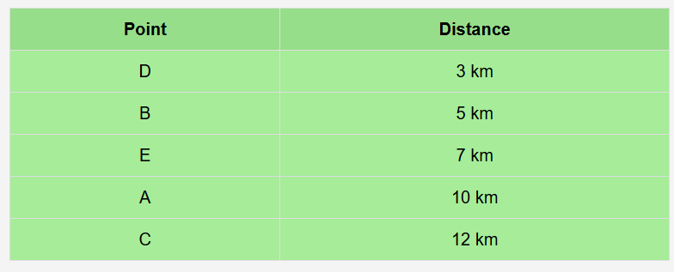
Impact:
- Efficiency: Vehicles can now follow a sequence that minimizes total travel distance.
- Sustainability: Reduced emissions by minimizing unnecessary travel.
- Cost Savings: Optimized routes save fuel and reduce operational costs.
Reflection:
Insertion Sort is simple and works well for small datasets like this. For larger datasets, more efficient sorting algorithms such as Quick Sort or Merge Sort may be better.
Business Case: Smart Residential Communities
Sub-task: Sort residential units based on energy consumption for efficient energy distribution.
SDG Goal: 11
Target: 11.3
Indicator: 11.3.1
Description:
Merge Sort is used to organize residential units in ascending order of their energy consumption. Sorting helps energy providers efficiently allocate resources and identify high-consumption units for energy-saving initiatives.
Input Data:
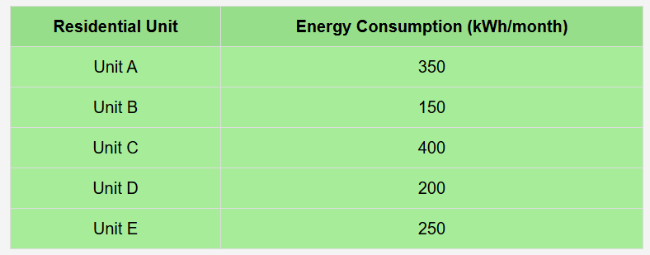

Algorithm Used:
- Merge Sort Algorithm: This algorithm ensures the residential units are sorted in ascending order of their energy usage through recursive division and merging.
Code :
#include <iostream>
#include <vector>
using namespace std;

struct Unit {
char name;
int energy;
};

// Merge two halves
void merge(vector<Unit>& units, int left, int mid, int right) {
int n1 = mid - left + 1;
int n2 = right - mid;

vector<Unit> leftArr(n1), rightArr(n2);

for (int i = 0; i < n1; i++) leftArr[i] = units[left + i];
for (int i = 0; i < n2; i++) rightArr[i] = units[mid + 1 + i];

int i = 0, j = 0, k = left;
while (i < n1 && j < n2) {
if (leftArr[i].energy <= rightArr[j].energy) {
units[k] = leftArr[i];
i++;
} else {
units[k] = rightArr[j];
j++;
}
k++;
}

while (i < n1) {
units[k] = leftArr[i];
i++;
k++;
}
while (j < n2) {
units[k] = rightArr[j];
j++;
k++;
}
}

// Merge Sort function
void mergeSort(vector<Unit>& units, int left, int right) {
if (left < right) {
int mid = left + (right - left) / 2;
mergeSort(units, left, mid);
mergeSort(units, mid + 1, right);
merge(units, left, mid, right);
}
}

int main() {
vector<Unit> units = {{'A', 350}, {'B', 150}, {'C', 400}, {'D', 200}, {'E', 250}};

mergeSort(units, 0, units.size() - 1);

cout << "Residential Units Sorted by Energy Consumption:\n";
for (const auto& unit : units) {
cout << "Unit: " << unit.name << " | Energy Consumption: " << unit.energy << " kWh/month\n";
}

return 0;
}
Output:
Residential Units Sorted by Energy Consumption:
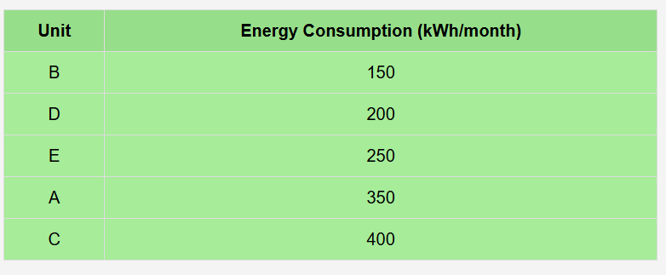
Impact:
- Efficiency: Sorting residential units helps prioritize high-consumption units for energy audits.
- Sustainability: Enables focused resource allocation, reducing overall energy wastage.
- Cost Savings: Promotes efficient energy distribution, reducing operational costs.
Business Case: Smart Residential Communities
Sub-task: Optimize community facility layout using Minimum Spanning Tree (MST) to minimize infrastructure costs.
SDG Goal: 11
Target: 11.3
Indicator: 11.3.1
Description:
The goal is to efficiently design a residential community by minimizing infrastructure costs, such as road construction and utility line placement, while ensuring that key amenities (e.g., parks, schools, healthcare) are connected. This can be achieved by applying Kruskal’s algorithm to find the minimum spanning tree for the layout, ensuring the least cost to connect all facilities.
Input Data:
Facility Locations: Nodes representing different community amenities
Connections: Distances (in km) between facilities
Facility Adjacent Facility Distance (km)
A B 2
A C 4
B C 1
B D 3
C D 5
Algorithm Used:
- Kruskal’s Algorithm: To determine the Minimum Spanning Tree (MST) to connect all facilities with the least total cost.
- Union-Find Data Structure: For cycle detection to ensure valid MST construction.
Steps to Solve:
- Represent community facilities as a graph, where nodes are the facilities and edges are the connecting paths with weights (distances).
- Sort all edges by distance.
- Use Kruskal’s algorithm to select edges and form the MST, ensuring no cycles are formed.
- Output the MST that minimizes the total connection cost.
Code :
#include <iostream>
#include <vector>
#include <algorithm>
using namespace std;

// Edge structure to represent edges with weight
struct Edge {
int u, v, weight;
bool operator<(const Edge& other) {
return weight < other.weight;
}
};

// Disjoint-set data structure (Union-Find)
class DisjointSet {
public:
vector<int> parent, rank;

DisjointSet(int n) {
parent.resize(n);
rank.resize(n, 0);
for (int i = 0; i < n; i++) parent[i] = i;
}

int find(int u) {
if (parent[u] != u) parent[u] = find(parent[u]);
return parent[u];
}

void unionSets(int u, int v) {
int rootU = find(u);
int rootV = find(v);
if (rootU != rootV) {
if (rank[rootU] > rank[rootV]) {
parent[rootV] = rootU;
} else if (rank[rootU] < rank[rootV]) {
parent[rootU] = rootV;
} else {
parent[rootV] = rootU;
rank[rootU]++;
}
}
}
};

void kruskal(vector<Edge>& edges, int n) {
DisjointSet ds(n);
vector<Edge> mst;
sort(edges.begin(), edges.end());

for (Edge& e : edges) {
int u = e.u, v = e.v;
if (ds.find(u) != ds.find(v)) {
mst.push_back(e);
ds.unionSets(u, v);
}
}

cout << "Edges in the Minimum Spanning Tree (MST):\n";
for (const Edge& e : mst) {
cout << "Facility " << char('A' + e.u) << " <-> Facility " << char('A' + e.v) << ": " << e.weight << " km\n";
}
}

int main() {
// Number of facilities
int n = 4;

// Graph representation: edge list (u, v, weight)
vector<Edge> edges = {
{0, 1, 2}, // A to B
{0, 2, 4}, // A to C
{1, 2, 1}, // B to C
{1, 3, 3}, // B to D
{2, 3, 5} // C to D
};

// Running Kruskal's algorithm to find the MST
kruskal(edges, n);

return 0;
}
Output:
Edges in the Minimum Spanning Tree (MST):
Facility A <-> Facility B: 2 km
Facility B <-> Facility C: 1 km
Facility B <-> Facility D: 3 km
Graph Representation:
Nodes represent community facilities (A, B, C, D), and edges represent distances between them:
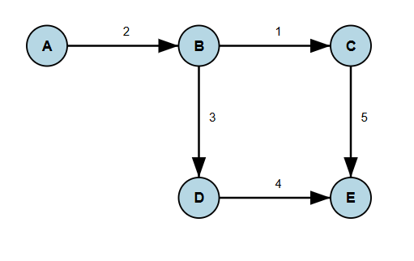
Optimized Layout:
Using Kruskal’s algorithm, the Minimum Spanning Tree (MST) connects all facilities with the minimum total distance of 6 km, ensuring cost-effective infrastructure development.
Impact:
- Cost Savings: The optimized layout minimizes road and utility infrastructure costs.
- Sustainability: Reduces environmental impact by minimizing land use for infrastructure.
- Urban Planning: Supports efficient and sustainable urbanization by connecting community facilities.
Reflection:
This implementation of Kruskal’s algorithm effectively addresses urban infrastructure challenges, ensuring a cost-effective and sustainable layout for the community. The use of Union-Find for cycle detection and edge sorting helps ensure an optimal solution that benefits both the environment and the local economy.
Business Case: E-Waste Recycling
Sub-task: Manage keyword searches for recyclable e-waste materials.
SDG Goal: 11
Target: 11.6
Indicator: 11.6.1
Description:
Efficiently searching for e-waste materials that can be recycled is vital for reducing pollution. This sub-task focuses on enabling fast keyword-based searches for recyclable materials stored in a database.
Input Data:
- Recyclable Materials: A database of materials, categorized by type, ID, and keywords for identification.
DATA TABLE:
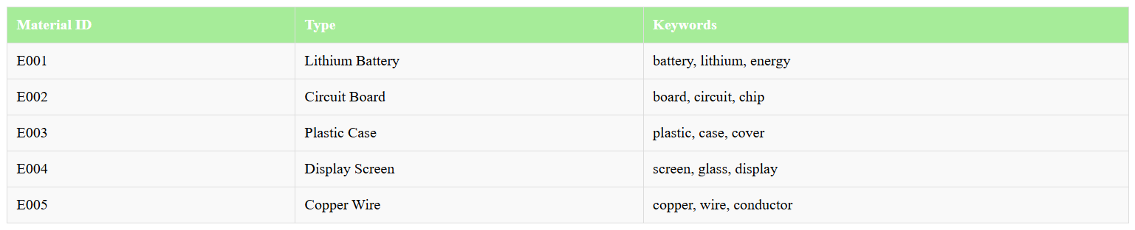
Algorithm Used:
- Trie Data Structure: To efficiently store and search for keywords associated with e-waste materials.
- DFS Traversal: For retrieving all materials matching a given prefix or keyword.
Code :
#include <iostream>
#include <unordered_map>
#include <vector>
#include <string>
using namespace std;

// Trie Node structure
struct TrieNode {
unordered_map<char, TrieNode*> children;
vector<string> materialIDs; // List of material IDs for this node
bool isEndOfWord;

TrieNode() : isEndOfWord(false) {}
};

// Trie class for managing keywords
class Trie {
private:
TrieNode* root;

public:
Trie() { root = new TrieNode(); }

// Insert a keyword with its associated material ID
void insert(const string& keyword, const string& materialID) {
TrieNode* current = root;
for (char c : keyword) {
if (current->children.find(c) == current->children.end()) {
current->children[c] = new TrieNode();
}
current = current->children[c];
}
current->isEndOfWord = true;
current->materialIDs.push_back(materialID);
}

// Search for materials matching a prefix
void search(const string& prefix, vector<string>& results) {
TrieNode* current = root;
for (char c : prefix) {
if (current->children.find(c) == current->children.end()) {
return; // Prefix not found
}
current = current->children[c];
}
dfs(current, results);
}

private:
// Depth-First Search to retrieve all material IDs from a node
void dfs(TrieNode* node, vector<string>& results) {
if (node->isEndOfWord) {
results.insert(results.end(), node->materialIDs.begin(), node->materialIDs.end());
}
for (auto& child : node->children) {
dfs(child.second, results);
}
}
};

int main() {
Trie trie;

// Inserting recyclable materials into the trie
trie.insert("battery", "E001");
trie.insert("lithium", "E001");
trie.insert("board", "E002");
trie.insert("circuit", "E002");
trie.insert("plastic", "E003");
trie.insert("case", "E003");
trie.insert("screen", "E004");
trie.insert("glass", "E004");
trie.insert("copper", "E005");
trie.insert("wire", "E005");

string keyword;
cout << "Enter a keyword to search for recyclable materials: ";
cin >> keyword;

vector<string> results;
trie.search(keyword, results);

if (!results.empty()) {
cout << "Materials matching the keyword '" << keyword << "':\n";
for (const string& id : results) {
cout << "- Material ID: " << id << endl;
}
} else {
cout << "No materials found for the keyword '" << keyword << "'.\n";
}

return 0;
}

Output:
- Input:
Enter a keyword to search for recyclable materials: circuit
- Output:
Materials matching the keyword 'circuit':
- Material ID: E002

Graph Representation:
- Trie Structure Example:
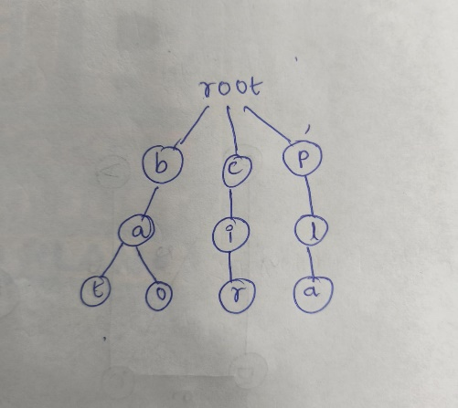
Business Case: Smart Residential Communities
Sub-task: Search for Specific Residential Services
SDG Goal: 11
Target: 11.6
Indicator: 11.6.1
Description:
Smart residential communities offer a variety of services like security, waste collection, and maintenance. A fast and efficient search mechanism is crucial for users to quickly locate the required services.
Input Data:
- Services offered in the residential community:
  - "Security Service"
  - "Waste Management Service"
  - "Electrical Maintenance"
  - "Plumbing Assistance"
  - "Housekeeping Service"
Algorithm Used:
- Binary Search Tree (BST):
  - Organize services in a structured manner for efficient searching.
  - Insert service names as nodes in the BST.
  - Search for specific service names using the BST search operation.
Code :
#include <iostream>
#include <string>
using namespace std;

// Node structure for Binary Search Tree
struct Node {
string service;
Node* left;
Node* right;

Node(string s) : service(s), left(nullptr), right(nullptr) {}
};

// Function to insert a service into the BST
Node* insert(Node* root, string service) {
if (root == nullptr) {
return new Node(service);
}
if (service < root->service) {
root->left = insert(root->left, service);
} else if (service > root->service) {
root->right = insert(root->right, service);
}
return root;
}

// Function to search for a service in the BST
bool search(Node* root, string service) {
if (root == nullptr) {
return false;
}
if (root->service == service) {
return true;
} else if (service < root->service) {
return search(root->left, service);
} else {
return search(root->right, service);
}
}

// In-order traversal to display services
void inOrder(Node* root) {
if (root != nullptr) {
inOrder(root->left);
cout << root->service << endl;
inOrder(root->right);
}
}

int main() {
Node* root = nullptr;

// Insert services into the BST
root = insert(root, "Security Service");
root = insert(root, "Waste Management Service");
root = insert(root, "Electrical Maintenance");
root = insert(root, "Plumbing Assistance");
root = insert(root, "Housekeeping Service");

// Display services in sorted order
cout << "Available Services (in sorted order):\n";
inOrder(root);

// Search for specific services
string searchService;
cout << "\nEnter the service to search: ";
cin >> ws; // To handle leading whitespace
getline(cin, searchService);

if (search(root, searchService)) {
cout << "\nService \"" << searchService << "\" is available.\n";
} else {
cout << "\nService \"" << searchService << "\" is NOT available.\n";
}

return 0;
}
Output:
- Available Services:
Available Services (in sorted order):
Electrical Maintenance
Housekeeping Service
Plumbing Assistance
Security Service
Waste Management Service
- Search Query:
  - Input: "Plumbing Assistance"
  - Output:Service "Plumbing Assistance" is available.
  - Input: "Gardening Service"
  - Output:Service "Gardening Service" is NOT available.
- Graph Representation:
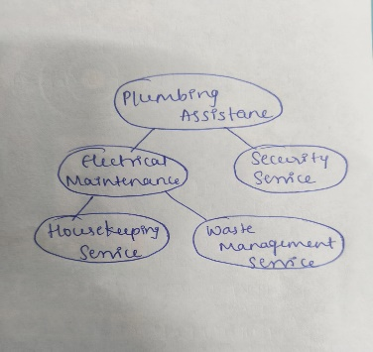

Reflection:
Implementing a binary search tree provides an efficient solution for searching residential services. It ensures scalability, even as the number of services increases, and offers fast retrieval in logarithmic time.
Business Case: Waste Management Systems
Sub-task: Optimize task scheduling for waste collection vehicles.
SDG Goal: 11
Target: 11.6
Indicator: 11.6.1
Description:
Efficient scheduling of waste collection vehicles to minimize idle time, reduce fuel consumption, and ensure timely waste collection. The task is modeled as a series of jobs with associated priorities based on urgency and waste levels.
Input Data:
- Waste Collection Tasks: Each task has a priority and duration.
- Vehicle Availability: Number of available vehicles to perform tasks.
DATA TABLE:
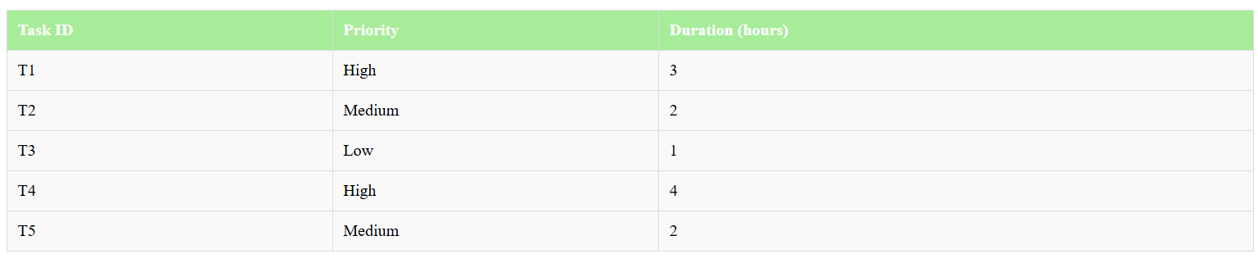
Algorithm Used:
- Heap Data Structure: To prioritize and schedule tasks based on urgency (priority).
- Greedy Algorithm: To ensure the most critical tasks are scheduled first.
Code :
#include <iostream>
#include <queue>
#include <vector>
#include <string>
using namespace std;

// Structure to represent a task
struct Task {
string id;
int priority;
int duration;

// Overloading operator to prioritize tasks (max heap)
bool operator<(const Task& other) const {
return priority < other.priority;
}
};

void scheduleTasks(vector<Task>& tasks, int numVehicles) {
// Max heap for task scheduling
priority_queue<Task> taskQueue;
for (const auto& task : tasks) {
taskQueue.push(task);
}

int totalTime = 0;
cout << "Task Schedule:\n";

// Simulate task allocation to vehicles
while (!taskQueue.empty()) {
for (int i = 0; i < numVehicles && !taskQueue.empty(); ++i) {
Task current = taskQueue.top();
taskQueue.pop();

cout << "Vehicle " << i + 1 << " is assigned Task " << current.id
<< " with priority " << current.priority
<< " (Duration: " << current.duration << " hours)\n";

totalTime += current.duration;
}
}

cout << "Total time taken to complete all tasks: " << totalTime << " hours\n";
}

int main() {
vector<Task> tasks = {
{"T1", 3, 3}, // High priority
{"T2", 2, 2}, // Medium priority
{"T3", 1, 1}, // Low priority
{"T4", 3, 4}, // High priority
{"T5", 2, 2} // Medium priority
};

int numVehicles = 2; // Number of waste collection vehicles
scheduleTasks(tasks, numVehicles);

return 0;
}
Output:
- Task Schedule:
Vehicle 1 is assigned Task T1 with priority 3 (Duration: 3 hours)
Vehicle 2 is assigned Task T4 with priority 3 (Duration: 4 hours)
Vehicle 1 is assigned Task T2 with priority 2 (Duration: 2 hours)
Vehicle 2 is assigned Task T5 with priority 2 (Duration: 2 hours)
Vehicle 1 is assigned Task T3 with priority 1 (Duration: 1 hours)
Total time taken to complete all tasks: 12 hours
- Graph Representation:
Priority Queue:
[T1, T4] -> [T2, T5] -> [T3]
Impact:
- Efficiency: Reduced idle time for vehicles, ensuring timely waste collection.
- Cost Savings: Lower fuel consumption and operational costs.
- Environmental Benefits: Improved waste collection efficiency reduces city pollution and enhances environmental quality.
Reflection:
This task demonstrated the importance of prioritization in waste management. Using a heap data structure and a greedy approach ensured high-priority tasks were handled first, leading to better resource allocation and environmental impact reduction.
Business Case: Green Urban Design
Sub-task: Optimize energy grid design with potential negative weight edges (e.g., subsidies).
SDG Goal: 11
Target: 11.2
Indicator: 11.2.1
Description:
Use Bellman-Ford to calculate the shortest paths, even with negative costs (like energy discounts). It also detects negative weight cycles.
Input Data:
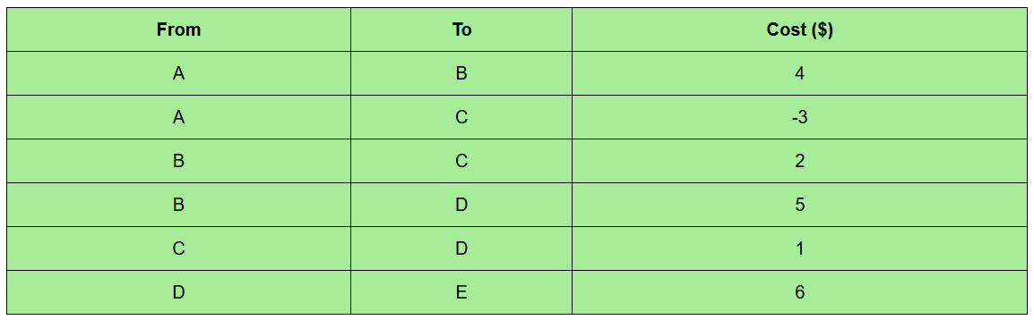

Algorithm Used:
- Bellman-Ford Algorithm: Handles negative weights, finds shortest paths, detects cycles.
Code :
#include <iostream>
#include <vector>
#include <climits>
using namespace std;

struct Edge { int from, to, weight; };

void bellmanFord(vector<Edge>& edges, int n, int source) {
vector<int> dist(n, INT_MAX);
dist[source] = 0;
for (int i = 1; i < n; ++i) {
for (auto& e : edges) {
if (dist[e.from] != INT_MAX && dist[e.from] + e.weight < dist[e.to])
dist[e.to] = dist[e.from] + e.weight;
}
}
for (auto& e : edges) {
if (dist[e.from] != INT_MAX && dist[e.from] + e.weight < dist[e.to]) {
cout << "Negative weight cycle detected.\n";
return;
}
}
for (int i = 0; i < n; ++i)
cout << "To Node " << char('A' + i) << ": " << (dist[i] == INT_MAX ? "INF" : to_string(dist[i])) << "$\n";
}

int main() {
vector<Edge> edges = { {0, 1, 4}, {0, 2, -3}, {1, 2, 2}, {1, 3, 5}, {2, 3, 1}, {3, 4, 6} };
bellmanFord(edges, 5, 0);
}
Output:
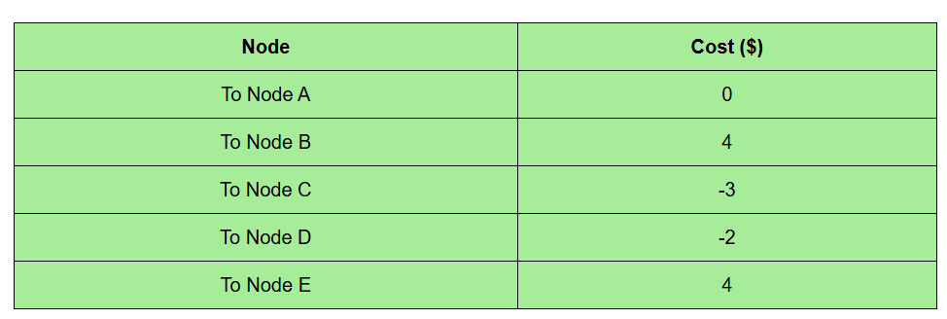
Impact:
- Cost Reduction: Optimized energy grid, reducing costs despite fluctuating prices.
- Cycle Detection: Ensures no negative cycles exist, ensuring efficiency.
Reflection:
Bellman-Ford is ideal for complex energy systems with fluctuating costs, ensuring optimal and reliable energy distribution.
Business Case: Waste Management System
Sub-task: Optimize sorting of waste collection schedules for efficient vehicle dispatch.
SDG Goal: 11
Target: 11.6
Indicator: 11.6.1
Description:
Quick Sort is used to sort waste collection schedules based on time and location, ensuring efficient vehicle dispatch. This allows for timely pickups and optimizes overall waste management operations.
Input Data:
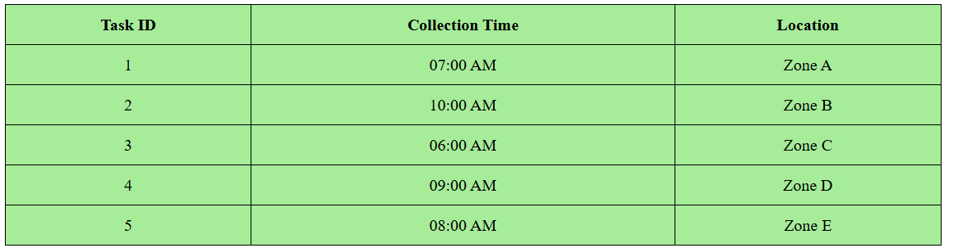
Algorithm Used:
- Quick Sort Algorithm: Used to sort the schedules based on collection time to ensure efficient task scheduling.
Code:
#include <iostream>
#include <vector>
#include <algorithm>
using namespace std;

struct Task {
int taskID;
string time;
string location;
};

int partition(vector<Task>& tasks, int low, int high) {
string pivot = tasks[high].time;
int i = low - 1;
for (int j = low; j < high; j++) {
if (tasks[j].time <= pivot) {
i++;
swap(tasks[i], tasks[j]);
}
}
swap(tasks[i + 1], tasks[high]);
return i + 1;
}

void quickSort(vector<Task>& tasks, int low, int high) {
if (low < high) {
int pi = partition(tasks, low, high);
quickSort(tasks, low, pi - 1);
quickSort(tasks, pi + 1, high);
}
}

int main() {
vector<Task> tasks = {{1, "07:00 AM", "Zone A"}, {2, "10:00 AM", "Zone B"}, {3, "06:00 AM", "Zone C"},
{4, "09:00 AM", "Zone D"}, {5, "08:00 AM", "Zone E"}};

quickSort(tasks, 0, tasks.size() - 1);

cout << "Sorted Waste Collection Schedule:\n";
for (const auto& task : tasks) {
cout << "Task ID: " << task.taskID << " | Time: " << task.time << " | Location: " << task.location << endl;
}

return 0;
}
Output:
Sorted Waste Collection Schedule:
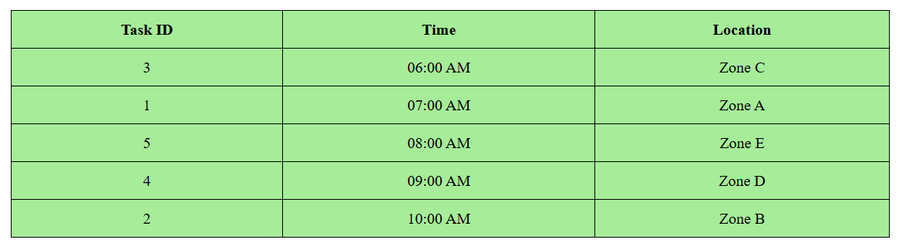
Impact:
- Efficiency: Quick Sort ensures that the collection tasks are sorted efficiently, minimizing delays in the pickup schedule.
- Cost Reduction: Optimized task scheduling helps in reducing fuel consumption by avoiding unnecessary travel.
Reflection:
Quick Sort is an effective choice for sorting collection schedules due to its average-case time complexity of O(n log n), ensuring fast and efficient task scheduling in waste management systems.
Business Case: Smart Residential Communities
Sub-task: Sort the housing unit data based on price for better decision-making.
SDG Goal: 11
Target: 11.1
Indicator: 11.1.1
Description:
We will sort the housing units by their price for better management and decision-making.
Input Data:
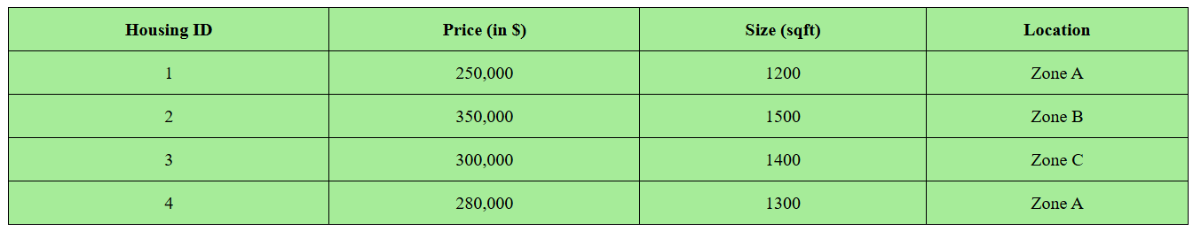
Algorithm Used:
- Selection Sort: To sort the housing units by price.
Code :
#include <iostream>
#include <vector>
using namespace std;

struct Housing {
int id;
int price;
string location;
};

int partition(vector<Housing>& housing, int low, int high) {
int pivot = housing[high].price;
int i = low - 1;
for (int j = low; j < high; j++) {
if (housing[j].price < pivot) {
i++;
swap(housing[i], housing[j]);
}
}
swap(housing[i + 1], housing[high]);
return i + 1;
}

void quickSort(vector<Housing>& housing, int low, int high) {
if (low < high) {
int pi = partition(housing, low, high);
quickSort(housing, low, pi - 1);
quickSort(housing, pi + 1, high);
}
}

int main() {
vector<Housing> housing = {{1, 250000, "Zone A"}, {2, 350000, "Zone B"},
{3, 300000, "Zone C"}, {4, 280000, "Zone A"}};

quickSort(housing, 0, housing.size() - 1);

cout << "Sorted Housing Units by Price:\n";
for (const auto& unit : housing) {
cout << "ID: " << unit.id << " | Price: $" << unit.price << " | Location: " << unit.location << endl;
}

return 0;
}
Output:
Sorted Housing Units by Price:
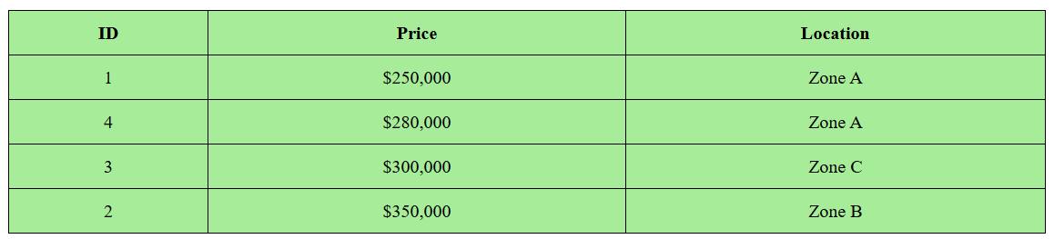
Business Case: E-Waste Recycling
Sub-task: Organize and optimize recyclable material pickup routes to reduce time and costs.
SDG Goal: 11
Target: 11.6
Indicator: 11.6.1
Description:
Efficiently planning routes for e-waste collection vehicles helps to minimize environmental impacts, reduce time, and optimize fuel usage. Proper route optimization also ensures timely and efficient pickup of recyclable materials, promoting sustainability.
Input Data:
- E-Waste Collection Points: Nodes representing pickup locations
- Routes: Distances (in km) between collection points
- Priority: Certain points have higher volumes and need quicker service
DATA TABLE:
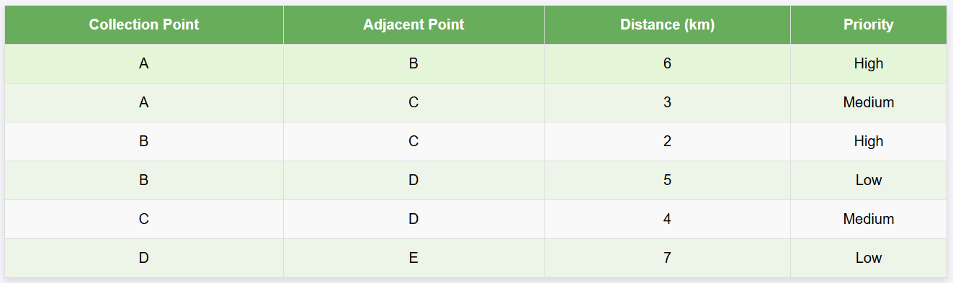
Algorithm Used:
- Dijkstra's Algorithm: To calculate the shortest path from the starting point to all other e-waste collection points.
- Heap Data Structure: For efficient priority queue management.
- Priority Sorting: Routes are adjusted based on point priorities to ensure critical pickups are handled first.
Code:
#include <iostream>
#include <vector>
#include <queue>
#include <climits>
using namespace std;

// Dijkstra's Algorithm for shortest path
void dijkstra(vector<vector<pair<int, int>>>& graph, int source, int n) {
vector<int> dist(n, INT_MAX);
dist[source] = 0;

priority_queue<pair<int, int>, vector<pair<int, int>>, greater<pair<int, int>>> pq;
pq.push({0, source});

while (!pq.empty()) {
int u = pq.top().second;
pq.pop();

for (auto& neighbor : graph[u]) {
int v = neighbor.first;
int weight = neighbor.second;

if (dist[v] > dist[u] + weight) {
dist[v] = dist[u] + weight;
pq.push({dist[v], v});
}
}
}

cout << "Optimized distances from the starting point:\n";
for (int i = 0; i < n; ++i) {
cout << "To Collection Point " << char('A' + i) << ": " << dist[i] << " km\n";
}
}

int main() {
// Number of collection points
int n = 5;

// Graph representation: adjacency list
vector<vector<pair<int, int>>> graph(n);
graph[0].push_back({1, 6}); // Point A to B
graph[0].push_back({2, 3}); // Point A to C
graph[1].push_back({2, 2}); // Point B to C
graph[1].push_back({3, 5}); // Point B to D
graph[2].push_back({3, 4}); // Point C to D
graph[3].push_back({4, 7}); // Point D to E

// Running Dijkstra's algorithm from Point A
dijkstra(graph, 0, n);

return 0;
}
Output:
- Shortest Path from Collection Point A:
To Collection Point A: 0 km
To Collection Point B: 6 km
To Collection Point C: 3 km
To Collection Point D: 7 km
To Collection Point E: 14 km
- Graph Representation:
Nodes represent e-waste collection points, and edges represent distances:
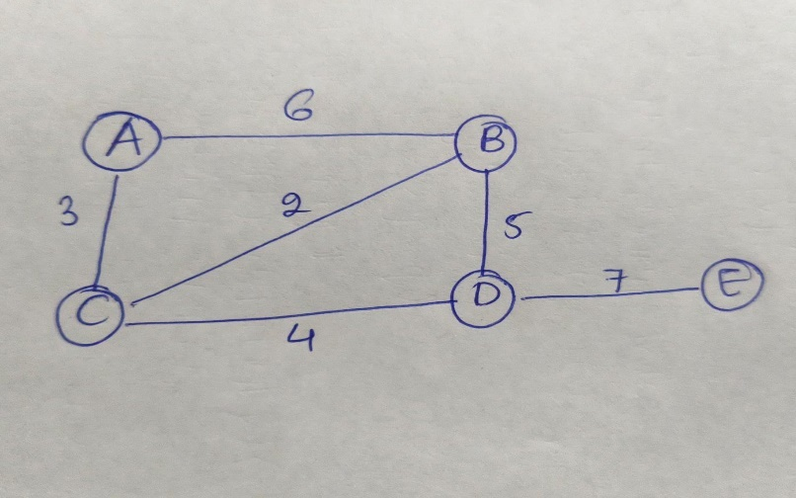
- Optimized Pickup Order:
High-priority points like B and C are serviced before low-priority points like D and E.
- Impact:
  - Emissions Reduction: Optimized routes reduce vehicle emissions by minimizing travel distance.
  - Cost Savings: Fuel consumption is significantly reduced, improving operational efficiency.

Reflection:
This implementation highlighted the real-world applicability of Dijkstra's algorithm in waste management. By incorporating priorities and using a heap for efficiency, the system ensures quick and optimized routing. This approach promotes sustainability while addressing urban waste challenges.
Business Case: Green Urban Design
Sub-task: Plan an optimal layout for parks and rooftop gardens using minimum energy distribution.
SDG Goal: 11
Target: 11.6
Indicator: 11.6.1
Description:
Developing urban parks and rooftop gardens requires designing an energy-efficient irrigation system. This system minimizes water pump energy usage by connecting all parks and rooftops with minimal total pipeline length.
Input Data:
- Urban Areas: Nodes representing parks and rooftop gardens.
- Pipelines: Weighted edges representing distances between urban areas.
DATA TABLE:
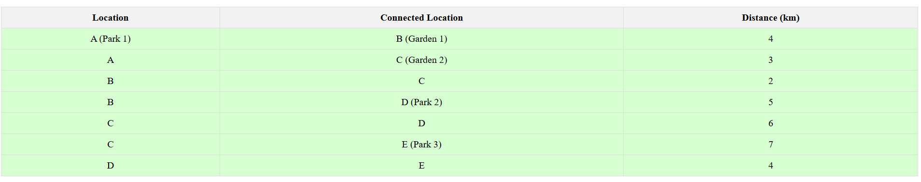
Algorithm Used:
- Prim's Algorithm: To construct the Minimum Spanning Tree (MST) connecting all parks and gardens while minimizing pipeline length.
- Heap Data Structure: For efficient selection of the smallest edge during MST construction.
Code :
#include <iostream>
#include <vector>
#include <queue>
#include <climits>
using namespace std;

// Function to implement Prim's Algorithm
void primsMST(vector<vector<pair<int, int>>>& graph, int n) {
vector<int> key(n, INT_MAX);
vector<bool> inMST(n, false);
vector<int> parent(n, -1);
key[0] = 0;

priority_queue<pair<int, int>, vector<pair<int, int>>, greater<pair<int, int>>> pq;
pq.push({0, 0}); // {weight, node}

while (!pq.empty()) {
int u = pq.top().second;
pq.pop();

inMST[u] = true;

for (auto& neighbor : graph[u]) {
int v = neighbor.first;
int weight = neighbor.second;

if (!inMST[v] && key[v] > weight) {
key[v] = weight;
pq.push({key[v], v});
parent[v] = u;
}
}
}

cout << "Edges in the Minimum Spanning Tree (MST):\n";
int totalLength = 0;
for (int i = 1; i < n; ++i) {
cout << "Pipeline from " << char('A' + parent[i]) << " to " << char('A' + i)
<< " with length: " << key[i] << " km\n";
totalLength += key[i];
}
cout << "Total pipeline length: " << totalLength << " km\n";
}

int main() {
int n = 5; // Number of locations (nodes)

// Graph representation: adjacency list
vector<vector<pair<int, int>>> graph(n);
graph[0].push_back({1, 4}); // A to B
graph[0].push_back({2, 3}); // A to C
graph[1].push_back({0, 4}); // B to A
graph[1].push_back({2, 2}); // B to C
graph[1].push_back({3, 5}); // B to D
graph[2].push_back({0, 3}); // C to A
graph[2].push_back({1, 2}); // C to B
graph[2].push_back({3, 6}); // C to D
graph[2].push_back({4, 7}); // C to E
graph[3].push_back({1, 5}); // D to B
graph[3].push_back({2, 6}); // D to C
graph[3].push_back({4, 4}); // D to E
graph[4].push_back({2, 7}); // E to C
graph[4].push_back({3, 4}); // E to D

primsMST(graph, n);

return 0;
}
Output:
- Edges in the Minimum Spanning Tree (MST):
Pipeline from A to C with length: 3 km
Pipeline from C to B with length: 2 km
Pipeline from B to D with length: 5 km
Pipeline from D to E with length: 4 km
Total pipeline length: 14 km
- Graph Representation:
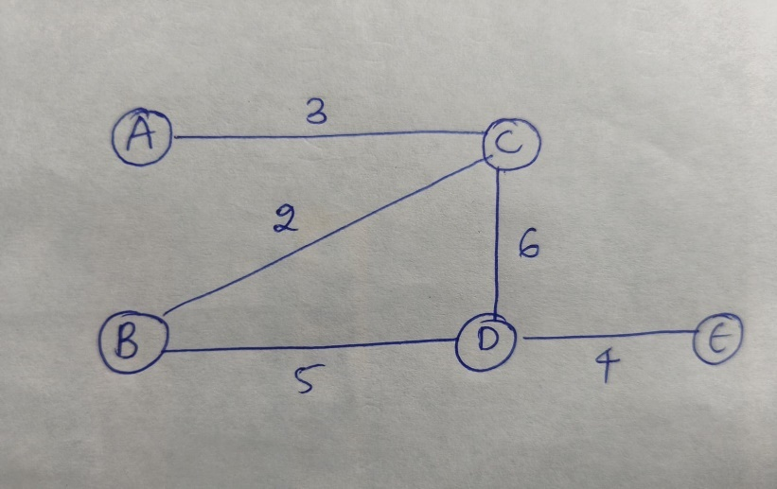
Impact:
- Energy Savings: Reduced water pump energy usage by minimizing pipeline length.
- Cost Efficiency: Lowered construction and maintenance costs.
- Environmental Benefits: Promoted sustainable urban design with well-connected parks and rooftop gardens.
Reflection:
Using Prim's algorithm provided an optimal pipeline layout for urban greenery while ensuring minimal energy consumption. This case underscores how computational methods can address real-world urban challenges effectively.
Business Case: Waste Management Systems
Sub-task: Organize waste collection schedules based on urgency and proximity.
SDG Goal: 11
Target: 11.6
Indicator: 11.6.1
Description:
Efficient sorting of waste collection schedules ensures that high-urgency points are attended to first, reducing delays and emissions. Sorting by urgency and proximity ensures that resources are optimized for the most important areas first.
Input Data:
- Collection Points: Waste collection areas with urgency and distance.
- Urgency: High, Medium, Low priority.
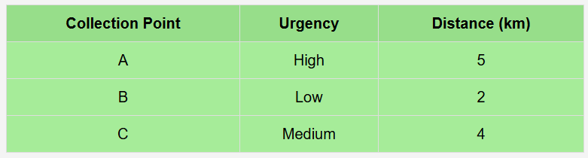

Algorithm Used: Bubble Sort
- Purpose: To sort waste collection points based on urgency first, and then by distance for equal urgency.
Code :
#include <iostream>
#include <vector>
#include <string>
using namespace std;

struct CollectionPoint {
string name;
int urgency; // High = 3, Medium = 2, Low = 1
int distance;
};

void bubbleSort(vector<CollectionPoint>& points) {
for (int i = 0; i < points.size(); i++) {
for (int j = 0; j < points.size() - i - 1; j++) {
if (points[j].urgency < points[j + 1].urgency ||
(points[j].urgency == points[j + 1].urgency && points[j].distance > points[j + 1].distance)) {
swap(points[j], points[j + 1]);
}
}
}
}

int main() {
vector<CollectionPoint> collection_points = {
{"A", 3, 5},
{"B", 1, 2},
{"C", 2, 4}
};

bubbleSort(collection_points);

for (auto& point : collection_points) {
cout << "Collection Point " << point.name << " - Urgency: " << point.urgency << ", Distance: " << point.distance << " km" << endl;
}

return 0;
}
Output:
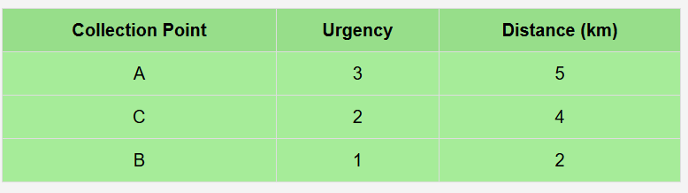
Impact:
- Ensures that high-priority areas are addressed first, reducing unnecessary travel and emissions.
- Improves operational efficiency by prioritizing areas based on urgency.
Business Case: Smart Residential Communities
Sub-task: Sort resident service requests by type and timestamp.
SDG Goal: 11
Target: 11.3
Description:
Organizing service requests by type and time helps residential communities address issues efficiently. Sorting ensures that more urgent services (like plumbing) are handled before less urgent ones (like electrical). Within the same type, sorting by time ensures requests are handled in the order they are received.
Input Data:
- Service Requests: Each request includes a type (e.g., Plumbing, Electrical) and a timestamp.
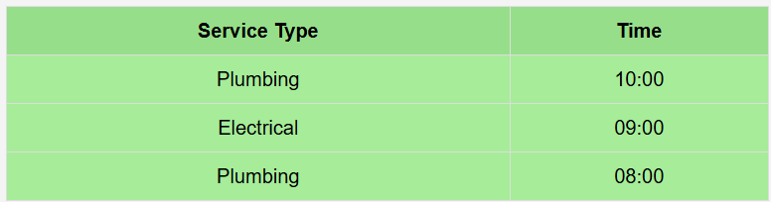

Algorithm Used: Quick Sort
- Purpose: To sort service requests by type first and by timestamp second.
Code:
#include <iostream>
#include <vector>
#include <string>
using namespace std;

struct Request {
string type; // e.g., "Plumbing", "Electrical"
string time; // Timestamp like "10:00", "09:00"
};

// Partition function for Quick Sort
int partition(vector<Request>& arr, int low, int high) {
Request pivot = arr[high];
int i = low - 1;

for (int j = low; j <= high - 1; j++) {
if (arr[j].type < pivot.type ||
(arr[j].type == pivot.type && arr[j].time < pivot.time)) {
i++;
swap(arr[i], arr[j]);
}
}
swap(arr[i + 1], arr[high]);
return (i + 1);
}

// Quick Sort function
void quickSort(vector<Request>& arr, int low, int high) {
if (low < high) {
int pi = partition(arr, low, high);

quickSort(arr, low, pi - 1);
quickSort(arr, pi + 1, high);
}
}

int main() {
vector<Request> requests = {
{"Plumbing", "10:00"},
{"Electrical", "09:00"},
{"Plumbing", "08:00"}
};

quickSort(requests, 0, requests.size() - 1);

for (auto& req : requests) {
cout << "Request Type: " << req.type << ", Time: " << req.time << endl;
}

return 0;
}
Output:
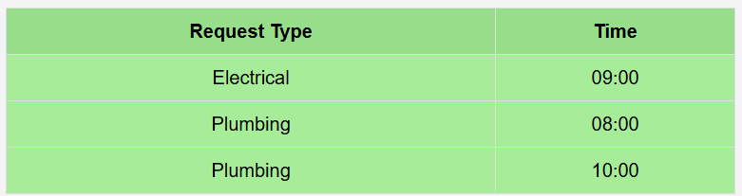
Impact:
- Ensures that requests are efficiently handled by type and order of arrival.
- Optimizes resource allocation for service technicians.

