[1]

Fake News Detection (2022)

Anirudh Aswal, Dev Vardhan Chauhan, Shreya Bose

Abstract

Information is easily accessible and abundantly available on the internet and on all social media platforms. Social Media is low cost and easily accessible. It allows the dispersion of information due to the abundance of internet. However not all that glitters is gold. This has led to falsification of facts and propagation of false information alongside the truth. Hence, biased, falsified propaganda is passed off as news and gets widespread in society. Therefore, it is crucial to be able to differentiate between false and true information. In fact, fake news detection on social media has emerged as a research topic that is attracting tremendous attention. It is now a challenge to categorize news as real or fake. Fake News Detection on the internet presents unique challenges that have rendered earlier detection algorithms from traditional news media ineffective or unusable. Being able to correctly classify news as real or fake would help us to be better informed and form our ideologies and mindsets based on the truth rather than lies. In this report we have built a Logistic Regression Model which uses various methods of Natural Language Processing (NLP) to classify real time news as real or fake. We have selected and combined various famous datasets that have been used earlier in this field to try and develop the best possible model for classification.

1. **INTRODUCTION**

Information, with the rise of technology, is easily available and accessible to more people than ever before. The average human being spends around 2.5 hours on social media. This means that we spend a considerable amount of our life interacting online through social media platforms and thus more and more people tend to seek out and consume news from social media rather than traditional news organizations. With increasing number of people on social media and the ease of sharing information it brings to the masses, an age-old problem of fake news continues to plague our society.

Fake news has caused a lot of problems in recent times. With the ease of internet and with it increase in news channels and number of users in the internet world. The

consumption of information and with-it news have become very vast. With the increase in the content available it becomes very difficult to differentiate between real news and fake news. The English language is very vast and if even one word, or sentence is misused then it can create a very different meaning.

Convincingly written non-factual information that promotes propaganda, biased opinions and misinformation of events is more likely to be shared across social media more than factual and validated information. The traditional method of validating any Information relies heavily upon the reader. This undermines our societies’ efforts to educate people with correct information and lead to misinformation and bias. The goal of this research is to create highly effective Artificial Intelligence tools to detect fake news using efficient algorithms like Logistic Regression and Deep Learning and comparing the accuracy between them to determine which algorithm can more accurately detect fake news. Use of NLP to understand Intent and Sentiment can help improve the accuracy of the model, as used in some spam detection techniques.

Logistic Regression is a predictive analytics method that computes the likelihood of an event happening or of a choice. Binary logistic regression, the method we propose, has only two categorial outcomes.

NLP: Natural Language Processing is a field of Machine Learning and AI the helps machines process and

understand human language. It uses syntax and semantic analysis to understand context, grammar and word ambiguities in a language. It involves the following processes.

* Tokenization
* Part-of-speech tagging
* Steaming & Lemmatization
* Stop word removal.

1. **RELATED WORK**

*Table 3: Past research on fake news*

|  |  |  |  |  |
| --- | --- | --- | --- | --- |
| Name | Authors | Work | Model | Conclusion |
|  |  |  |  |  |
| Fake News Detection  ISSN: 2454-132X | Manish Gahirwal, Sanjana Moghe, Tanvi Kulkarni, Devansh Khakhar, and Jayesh Bhatia | This paper proposes a new model for fake news detection using Stance Detection and IF-TDF method. It uses Random Forest classifier for classifying the output into four classes namely: True, Fake, Mostly True, and Mostly Fake. | Random Forest Classifier | Their classifier takes input from an URL or existing database and classifies it as real or fake. To implement this various NLP and Machine Learning techniques have been used. |
| Fake News or Truth?  Using Satirical Cues to Detect Potentially Misleading News. | Victoria L. Rubin, Niall J. Conroy, Yimin Chen, and Sarah Cornwell | This paper proposes a unique way of classifying news. They use 5 predictive features i.e. Absurdity, Humour, Grammar, Negative Effect and Punctuation along with satirical cues to detect misleading news. The paper translates theories of humour, irony and satire into a predictive model with surprisingly high accuracy of 87%. | SVM-based Classification Algorithm | Their algorithm translates theories of humour, irony and satire for developing a predictive model for satire detection which reaches relatively high accuracy rates. (90% precision, 84% recall, 87% F-score) |
| Automatic Deception Detection: Methods for Finding Fake News | Nadia K. Conroy, Victoria L. Rubin, and Yimin Chen | This paper provides a typology of several varieties veracity assessment techniques emerging from – linguistic cue approaches and network analysis approaches. They draft a basic typology of methods available for further refinement and evaluation. They suggest multilayer linguistic processing and addition of network behaviour. | Hybrid model combining linguistic cues and machine learning | Linguistic and network-based approaches have shown high accuracy results in classification tasks within limited domains. This discussion drafts a basic typology of methods available for further refinement and evaluation, and provides a basis for the design of a comprehensive fake news detection tool. Techniques arising from disparate approaches may be utilized together in a hybrid system. |
| Fake News Detection | Sahil Chawla, Nitin Mumtani, Rohan Jadhav, Prof. Charusheela Nehete | This paper uses and compares various classification algorithms like Naïve-Bayes, Logistic Regression, SVM, Random Forests. For classifying news as real or fake. They provide detailed summary of data pre-processing and methodology that has been used. | Logistic Regression, Naïve-Bayes, Random Forests, SVM, Stochastic Gradient Descent | Multiple classification algorithms have been used with their respective accuracies as shown below:   1. Naïve-Bayes = 76% 2. Logistic Regression = 90–94% 3. SVM = 87% 4. SGD = 82% 5. Random Forests = 89% |

1. **METHODOLOGY**

The working of this project starts from taking collection of the textual data and the data we are using is a labeled data. We are using the labeled data as several thousand of news articles will be labeled as either it is real news or fake news. It contains other details such as the author of that particular news, the title of the news etc. Once we have this data set we need to pre-process this data. We convert this text into meaningful numbers so, we need to split the dataset into training and test data. We train our machine learning model with the training data set and uh once we train our machine learning model, so we need to evaluate our model using the test data. We feed this training data which is preprocessed to our logistic regression model because of its binary classification project, means we are going to classify the result into two types it's either real or fake. We find the accuracy score of this model using the test data. Once that is done, we have a trained logistic regression model so in this trained regulation model we feed new data to this model. Okay so for those who don't know whether the news is real or fake so once we give the data to our model it can predict whether the news is real or fake. Various models are used such as logistic regression, Support vector machine and naive bayes. Also, we have removed unnecessary words using stop words and stemming for getting to the root value using the natural language library. We want to remove labels out of data frame so, we remove this label and store all these data in one variable and then store this label alone in one variable so this drop function basically removes the label column from our data frame okay so you need to mention the column name here and you need to mention the axis is equal to 1 if you are removing a column so if you are removing a row from a data frame you need to mention as access is equal to 0 as in this case we are removing a column by mentioning the axis is equal to 1. Another variable called y which stores all the labels so the news data set label will load all the label values to my new variable called y. Also using Tfid vectorizer, we are converting text data to numerical data. The best model after all these steps would be chosen as the final model which would be used for predicting data.

Equation 1

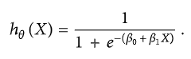

The cost function is calculated as shown in

Equation 2

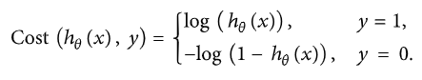

A mathematical representation of the cost function for the SVM model is defined as given in and shown in

Equation 3

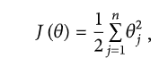

Equation 4

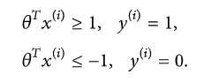

Logistic regression is a type of machine learning model used to quantify the relationship between one or more independent variable and a target variable. Unlike linear regression, which is used when the response variable is a continuous value like height, price, etc; logistic regression is used to determine categorical value such as Yes and No or Real and Fake. For the purposes of this research, identifying a news body as Real or Fake, we have processed data in 2 ways; first data set contains news title (title) and the news body (text) as one independent variable while the second data set contains only the title. Hereafter, for the sake of convenience we will call the first data set as “TT” and the second data set as “T”. Next, we have used two different NLP techniques on both TT and T, stemming and lemmatization. Now from each of the four processed text we generate Bag of Words and TF-IDF. This leaves us with eight differently processed data that we will feed to the logistic regression model with default parameters and evaluate the eight results against each other to see which yields maximum accuracy.

We also made models using LSTM where we used TensorFlow and imported Embedding, pad sequences, Dense. We did models of Stacked LSTM and Bidirectional model. Firstly, we added Embedding, Dense, activation to be Sigmoid and print the model summary. Then we did the training and testing on the models and using the confusion matrix and accuracy score, we found the accuracy of different models.

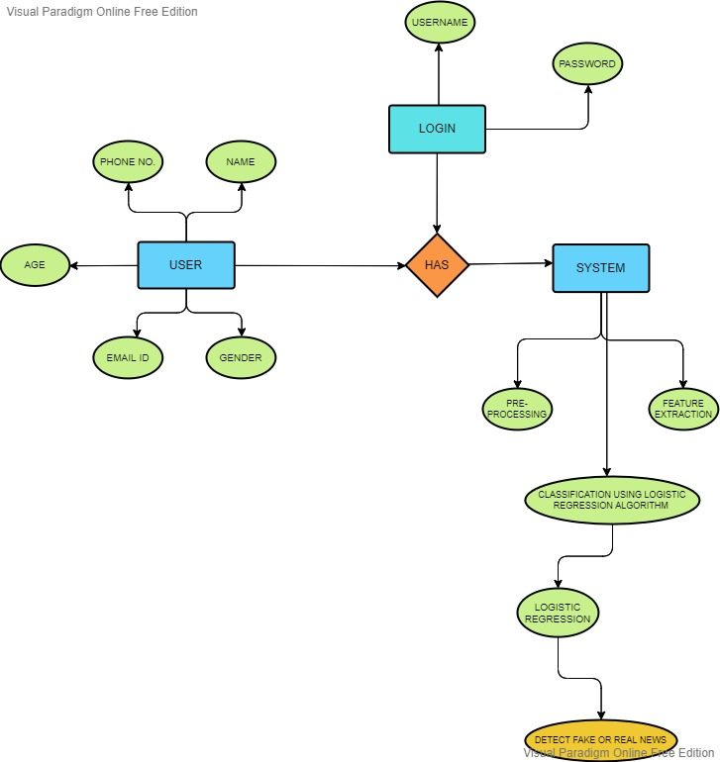

Figure 1:Flow Chart depicting the working of the model

1. **DATASET DESCRIPTION**

We have used multiple datasets that were available on Kaggle.com. For example, the Fake-News-Dataset which comprises of a vast dataset containing news articles about six different domains: tech, education, business, sports, politics and entertainment. The legitimate news was collected from a variety of mainstream media. Also, there is a “Fake and real news dataset” by Clement Bisaillon which includes a large amount of data on news during the Trump presidential campaign. We combined the similarities of these major datasets along with some smaller datasets, so as to generate a giant pool of data which included news about majority of the topics and in abundant quantity.

The final dataset contains 4 columns i.e., author, title, text and label. Most of the author column is empty as most news articles have been mentioned without any source. Hence it had been dropped for more accuracy.

1. **PREPROCESSING**

The data that we had gathered cannot be used directly for building the model. It needs to be preprocessed before it is of any value to us. In preprocessing we remove any redundant data, remove excess features, and convert the data into an easier format that can be used easily for training and testing. There are many methods for data pre-processing in NLP some of them are [1]:

1) Removing punctuations

2) Lowering the text

3) Tokenization

4) Stop word removal

5) Stemming

6) Lemmatization

1. **FEATURE EXTRACTION**

There are two methods of feature extraction in NLP:

### Bag of words: In this method we transform tokens in a set of features, we use this method in document classification. Words in a sentence are used as features to train the classifier. First step is to convert the text in lower case and remove all the punctuations and unnecessary symbols. Then we take all the unique words to create vocabulary. Next, we create a matrix of these features where each word is placed in a column and rows consists of reviews, this is called text vectorization.’

### TF-IDF Vectorizer: we highlight particular issues which have low frequency but high importance in our dataset. The TF-IFD value increases with how frequent a word appears in our dataset and is inversely proportional to the number of documents in the dataset contain that word.

1. **RESULT ANALYSIS**

After the detection of real or fake news, we came to the result that the accuracy of the logistic regression model came out to be 0.9528076002162663. Also, the Stacked LSTM model gave us the accuracy of 0.9192136604964845. the Bidirectional model gave us the accuracy of 0.9229444683598794. The dataset is self-made, and it consists of more than 60,000 rows of data.

The results of lemmatization along with TF-IDF are as follows:

TT has an accuracy of 96.87 and T has an accuracy of 97.18.

The results of stemming along with TF-IDF are as follows: TT has an accuracy of 96.84 and T has an accuracy of 95.18.

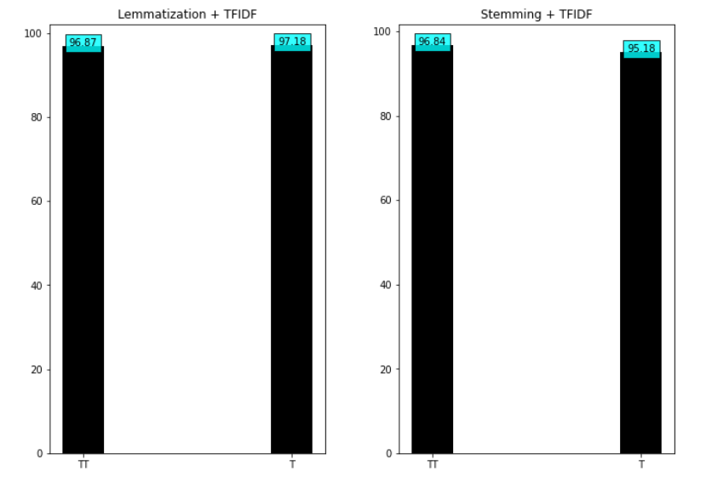

Figure 2:(a) Accuracy comparison result of Lemmatization with TFIDF (b)Accuracy comparison of Stemming with TFIDF

The results of lemmatization along with BoW are as follows: TT has an accuracy of 97.65 and T has an accuracy of 95.30

The results of stemming along with BoW are as follows: TT has an accuracy of 97.52 and T has an accuracy of 95.41

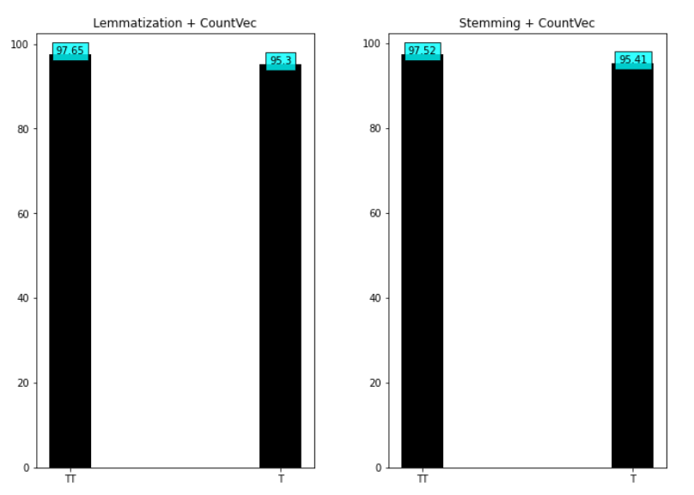

Figure 3:(a) Accuracy comparison result of Lemmatization with Count Vectorization (b)Accuracy comparison of Stemming with Count Vectorization

All eight differently processed data set produce similar results with TT performing slightly better in each case. The highest accuracy was produced by processing TT with lemmatization and BoW although it does not differ much from the other results

*Table 2: Accuracy produced by different models*

|  |  |
| --- | --- |
| Model | Accuracy |
| Logistic Regression | 0.9528 |
| Stacked LSTM | 0.9192 |
| Bidirectional LSTM | 0.9229 |

*Table 3: Accuracy produced by LR model using different techniques*

|  |  |  |  |  |
| --- | --- | --- | --- | --- |
|  | Lemmatization | | Stemming | |
|  | TF-IDF | BoW | TF-IDF | BoW |
| Title only | 97.18 | 95.30 | 95.18 | 95.41 |
| Title + Text | 96.87 | 97.65 | 96.84 | 97.52 |

1. **CONCLUSION**

As social media gets more and more popular, and more people start consuming their daily news from social media instead of traditional media sources like newspaper and television. There would be a widespread of information. This information may not be fact checked and also may be from suspicious sources. Propagation and consumption of fake news has strong negative impacts on the society. In this article we discussed about developing a logistic regression classifier which can be used to classify news as fake or real, it can be used on real world news and contribute in shielding the society from the plague like spread of fake news.

1. **FUTURE SCOPE**

Fake News Detection aims to providing an environment free from spam, phish, abusive and fake news on the social platforms. This project will not only search for the fake news on different platforms but also help to eradicate that information so that people don’t have to go through a ton of news before clarifying which one is real.

TF-IDF classifiers worked well in this project but there are still possibilities of exploring other features to improve the model and make it more fitting.

This project focused on text-based news articles. AI can also be used to analyze other features like images and video-based content. Also developing a model which can trace the source from which fake news was propagated would be a huge leap forward in this field.

1. **REFERENCES**
2. Sadia Afroz, Michael Brennan, and Rachel Greenstadt. Detecting hoaxes, frauds, and deception in writing style online. In ISSP’12.
3. Hunt Allcott and Matthew Gentzkow. Social media and fake news in the 2016 election. Technical report, National Bureau of Economic Research, 2017.
4. Michela Del Vicario, Gianna Vivaldo, Alessandro Bessi, Fabiana Zollo, Antonio Scala, Guido Caldarelli, and Walter Quattrociocchi. Echo chambers: Emotional contagion and group polarization on facebook. Scientific Reports, 6, 2016.
5. Matthew Gentzkow, Jesse M Shapiro, and Daniel F Stone. Media bias in the marketplace: Theory. Technical report, National Bureau of Economic Research, 2014.
6. Manish Gupta, Peixiang Zhao, and Jiawei Han. Evaluating event credibility on twitter. In PSDM’12.
7. Xia Hu, Jiliang Tang, and Huan Liu. Online social spammer detection. In AAAI’14, pages 59–65, 2014.
8. Liang Wu, Jundong Li, Xia Hu, and Huan Liu. Gleaning wisdom from the past: Early detection of emerging rumors in social media. In SDM’17.
9. Chengcheng Shao, Giovanni Luca Ciampaglia, Alessandro Flammini, and Filippo Menczer. Hoaxy: A platform for tracking online misinformation. In WWW’16.
10. **SEQUENTIALDIAGRAM**

Figure 4:Sequential Diagram of the working of the model

1.