CYCLE 2

Computer Networks Lab

Shreyas K S

1BM18CS04

# Write a program for error detecting code using CRC-CCITT (16-bits).

## Program :

def xor1(a, b): x = ""

# print(len(a),len(b)) for i in range(1, len(a)):

if a[i] == b[i]: x += "0"

else:

x += "1"

return x

def modulo2(divident, divisor): divlen = len(divisor)

temp = divident[0:divlen] # print(temp)

while(divlen < len(divident)): if temp[0] == "1":

temp = xor1(temp, divisor)+divident[divlen] else:

temp = temp[1:divlen]+divident[divlen] # print(temp)

divlen += 1 # print(temp)

if temp[0] == "1":

temp = xor1(temp, divisor) # return "0"+temp

# print(len(temp),)

if len(temp) < len(divisor): return "0"+temp

return temp

def encode(data, key):

append = data+"0"*(len(key)) # print(code)

rem = modulo2(append, key) print("remaindar="+rem) code = data+rem print("code="+code)

# Checking the logic:

rem = modulo2(code, key)

print("Remaindar we get when we do not have error="+rem) code = code.replace("011", "101")

rem = modulo2(code, key)

print("Remaindar we get when we have error="+rem)

def polytobin(string): keys = []

key = ""

for i in string: if i == '+':

keys.append(int(key[1:])) key = ""

continue key += i

if key != "": keys.append(0)

bina = "" j = 0

print(keys)

for i in range(keys[0], -1, -1): if i == (keys[j]):

bina += "1"

j += 1

else:

bina += "0" print(bina) return bina

string = input("Enter the key polynomial:\n") key = polytobin(string)

string = input("Enter the data polynomial:\n") data = polytobin(string)

print(key, data) encode(data, key)

# Output:

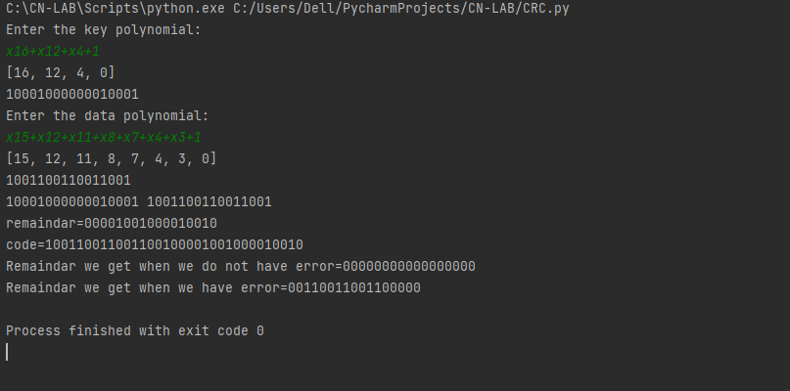

1. **Write a program for distance vector algorithm to find suitable path for transmission.**

## Program :

class Graph:

def init (self, vertices): self.V = vertices self.graph = []

def add_edge(self, s, d, w): self.graph.append([s, d, w])

def print_solution(self, dist, src, next_hop): print("Routing table for ", src) print("Dest \t Cost \t Next Hop")

for i in range(self.V):

print("{0} \t {1} \t {2}".format(i, dist[i], next_hop[i])) def bellman_ford(self, src):

dist = [99] * self.V dist[src] = 0 next_hop = {src: src}

for _ in range(self.V - 1): for s, d, w in self.graph:

if dist[s] != 99 and dist[s] + w < dist[d]: dist[d] = dist[s] + w

if s == src: next_hop[d] =d

elif s in next_hop: next_hop[d] = next_hop[s]

for s, d, w in self.graph:

if dist[s] != 99 and dist[s] + w < dist[d]: print("Graph contains negative weight cycle") return

self.print_solution(dist, src, next_hop)

def main(): matrix = []

print("Enter the no. of routers:") n = int(input())

print("Enter the adjacency matrix : Enter 99 for infinity") for i in range(0,n):

a = list(map(int, input().split(" "))) matrix.append(a)

g = Graph(n)

for i in range(0,n): for j in range(0,n):

g.add_edge(i,j,matrix[i][j])

for k in range(0, n): g.bellman_ford(k)

main()

Output:

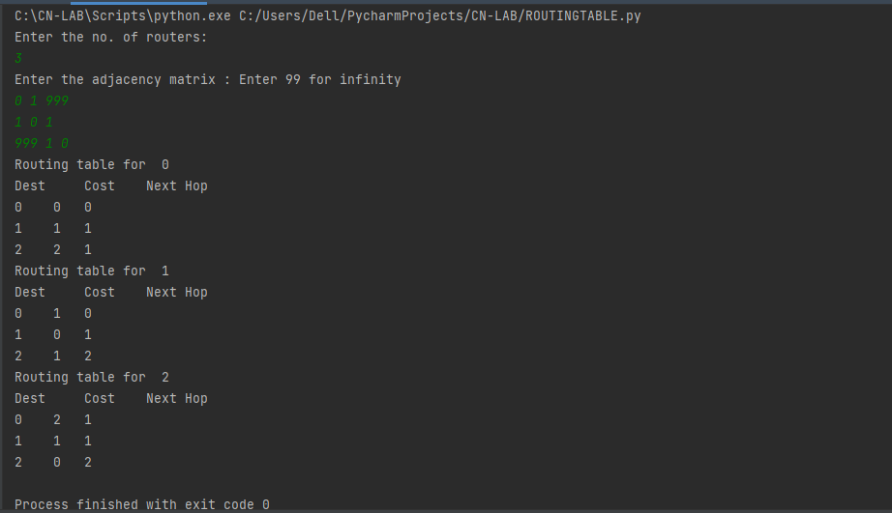

# Implement Dijkstra’s algorithm to compute the shortest path for a given topology.

## Program:

#include<bits/stdc++.h> using namespace std;

#define V 5

int minDistance(int dist[], bool sptSet[])

{

int min = 9999, min_index; for (int v = 0; v < V; v++)

if (sptSet[v] == false && dist[v] <= min) min = dist[v], min_index = v;

return min_index;

}

void printPath(int parent[], int j)

{

if (parent[j] == - 1) return;

printPath(parent, parent[j]);

cout<<j<<" ";

}

void printSolution(int dist[], int n, int parent[])

{

int src = 0;

cout<<"Vertex\t Distance\tPath"<<endl; for (int i = 1; i < V; i++)

{

cout<<"\n"<<src<<" -> "<<i<<" \t "<<dist[i]<<"\t\t"<<src<<" "; printPath(parent, i);

}

}

void dijkstra(int graph[V][V], int src)

{

int dist[V]; bool sptSet[V]; int parent[V];

for (int i = 0; i < V; i++)

{

parent[0] = -1;

dist[i] = 9999; sptSet[i] = false;

}

dist[src] = 0;

for (int count = 0; count < V - 1; count++)

{

int u = minDistance(dist, sptSet); sptSet[u] = true;

for (int v = 0; v < V; v++)

if (!sptSet[v] && graph[u][v] && dist[u] + graph[u][v] < dist[v])

{

parent[v] = u;

dist[v] = dist[u] + graph[u][v];

}

}

printSolution(dist, V, parent);

}

int main()

{

int graph[V][V];

cout<<"Enter the graph (Enter 99 for infinity): "<<endl; for(int i = 0; i<V; i++)

{

for(int j = 0; j<V; j++) cin>>graph[i][j];

}

cout<<"Enter the source: "<<endl; int src;

cin>>src;

dijkstra(graph, src); cout<<endl;

return 0;

}

# Output:

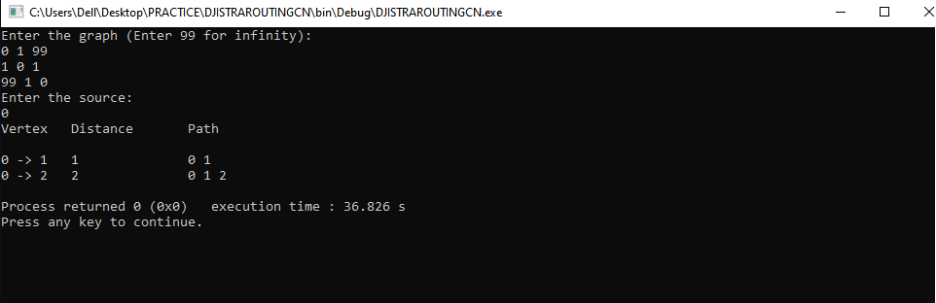

1. **Write a program for congestion control using Leaky bucket algorithm. Program :**

#include<bits/stdc++.h> #include<unistd.h>

using namespace std; #define bucketSize 500

void bucketInput(int a,int b)

{

if(a > bucketSize)

cout<<"\n\t\tBucket overflow";

else{

sleep(5); while(a > b){

cout<<"\n\t\t"<<b<<" bytes outputted."; a-=b;

sleep(5);

}

if(a > 0)

cout<<"\n\t\tLast "<<a<<" bytes sent\t"; cout<<"\n\t\tBucket output successful";

}

}

int main()

{

int op,pktSize;

cout<<"Enter output rate : "; cin>>op;

for(int i=1;i<=5;i++)

{

sleep(rand()%10); pktSize=rand()%700;

cout<<"\nPacket no "<<i<<"\tPacket size = "<<pktSize; bucketInput(pktSize,op);

}

cout<<endl; return 0;

}

# Output:

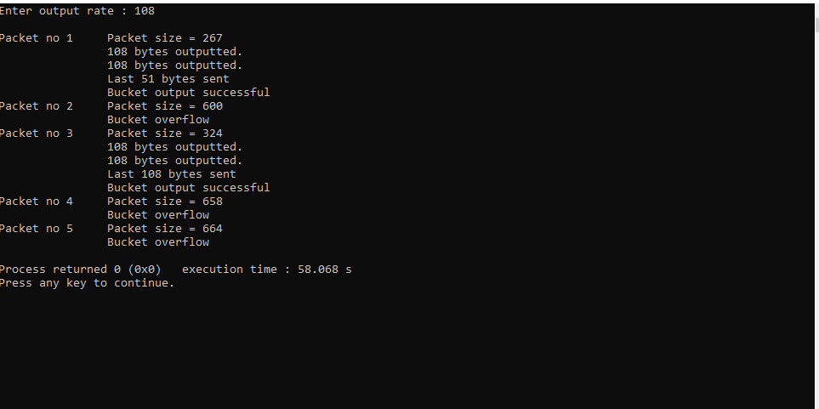

1. **Using TCP/IP sockets, write a client-server program to make client sending the file name and the server to send back the contents of the requested file if present.**

**Program:**

#Client.py

from socket import *

serverName = “127.0.0.1”

serverPort = 12000

clientSocket = socket(AF_INET, SOCK_STREAM) clientSocket.connect((serverName,serverPort)) sentence = input("Enter file name") clientSocket.send(sentence.encode()) filecontents = clientSocket.recv(1024).decode() print ('From Server:', filecontents) clientSocket.close()

#Server.py

from socket import *

serverName=”127.0.0.1”

serverPort = 12000

serverSocket = socket(AF_INET,SOCK_STREAM) serverSocket.bind((serverName,serverPort)) serverSocket.listen(1)

print ("The server is ready to receive") while 1:

connectionSocket, addr = serverSocket.accept() sentence = connectionSocket.recv(1024).decode() file=open(sentence,"r")

l=file.read(1024) connectionSocket.send(l.encode()) file.close() connectionSocket.close()

# Output:

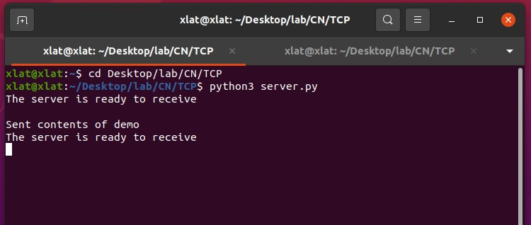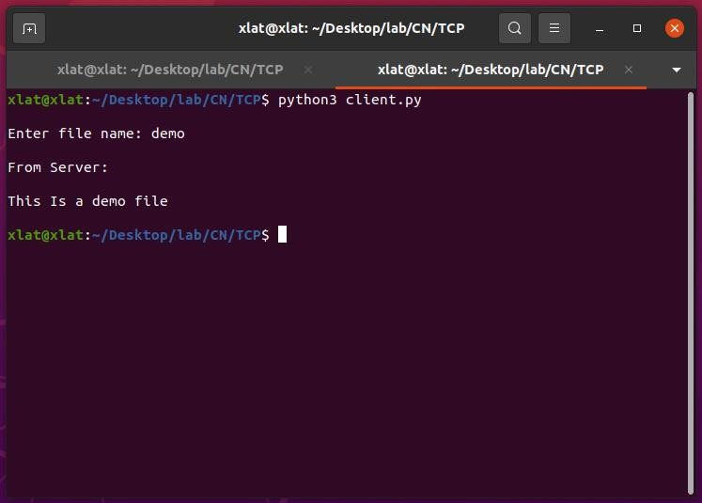

1. **Using UDP sockets, write a client-server program to make client sending the file name and the server to send back the contents of the requested file if present.**

**Program:**

#ClientUDP.py

from socket import * serverName = "127.0.0.1"

serverPort = 12000

clientSocket = socket(AF_INET, SOCK_DGRAM) sentence = input("Enter file name")

clientSocket.sendto(bytes(sentence,"utf-8"),(serverName, serverPort)) filecontents,serverAddress = clientSocket.recvfrom(2048)

print ('From Server:', filecontents) clientSocket.close()

#ServerUDP.py

from socket import * serverPort = 12000

serverSocket = socket(AF_INET, SOCK_DGRAM) serverSocket.bind(("127.0.0.1", serverPort)) print ("The server is ready to receive")

while 1:

sentence,clientAddress = serverSocket.recvfrom(2048) file=open(sentence,"r")

l=file.read(2048)

serverSocket.sendto(bytes(l,"utf-8"),clientAddress) print("sent back to client",l)

file.close()

# Output:

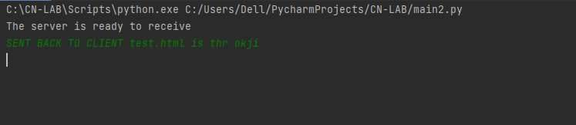

**The server.py is executed first to set up server..and file name is passed**

