ML-Based Water Level And Flow Rate Detection System

Rupali Deshmukh1, Rhea Gomez1, Aditya Dhumal1, Pramod Garhwal1 ,Disha Patil1

1Fr. Conceicao Rodrigues Institute of Technology, Vashi, Navi Mumbai, Maharashtra - 400703

**Abstract**

This research project introduces a user-friendly water management system developed using LabVIEW 2019 and machine learning techniques.In this model there would be two entities such as main tank and secondary tank.The system offers predictive capabilities that allow users to estimate the remaining hours of water supply based on the water level in a tank.By inputting the water level and the number of households in a community, the system can predict the duration of water availability.These measurements are then processed using machine learning algorithms to establish correlations between water levels and the projected time until the tank's depletion.The system includes an automatic cutoff feature that stops water supply when levels falls below/above a certain threshold, contributing to efficient water resource utilization.The system's interface provides users with real-time data visualization and projected water availability, facilitating informed decision-making in water consumption.

**Keywords: Labview, Machine learning, Prophet algorithm**

1. **Introduction**

Water is a vital resource that sustains life, agriculture, and industries, making effective water management essential. Monitoring water levels and flow rates in rivers, lakes, reservoirs, and other water bodies is crucial for efficient water resource management, flood prevention, and environmental preservation. Traditionally, this task has relied on manual measurements and outdated monitoring systems, resulting in delayed responses to changing conditions. Ml based water level and flow rate detection system is implemented using LabVIEW. LabVIEW is a powerful Graphical Programming Environment used for measurement, control, and automation.However, the integration of Machine Learning (ML) into water level and flow rate detection systems promises to revolutionize how we manage our water resources.Historically, water level and flow rate monitoring relied heavily on manual measurement techniques and legacy sensor technologies. These methods were not only labor-intensive but also susceptible to human errors and limited in their spatial and temporal coverage. ML has emerged as a game-changer in various fields, and water resource management is no exception. ML algorithms, with their ability to process vast amounts of data and discern complex patterns, offer the potential to transform how we monitor water levels and flow rates.By harnessing the power of ML, we can develop systems that provide real-time, accurate predictions and early warnings of potential water-related issues.ML based water level and flow rate detection system can successfully predict the remaining hours of supply.

* 1. **Literature Survey**

1. This paper has examined water flow and displays the water level inside the container as well as providing information to the owner via a pop message.The system helps in efficient utilization of water resources by maintaining water levels within desired limits. It prevents both overflows and shortages, minimizing water wastage.[1]
2. This paper presents a system that indicates and controls the level of water in overhead tanks. LabVIEW which is a graphical programming language that uses a dataflow model is used to program microcontroller board.Arduino UNO that is an interface between the software and the rest of the circuit components.LabVIEW provides a graphical programming environment, making it user-friendly and accessible for those with limited programming experience. [2]
3. This paper presents Arduino-Based Automatic Reservoir Monitoring and Water Filling tool uses a sensor that detects or measures the water level when it is complete and when it is reduced, which gives orders to the controller to do its job and can monitor the water level via a cellphone. This application is expected to make it better than the previous use of water pumps so that this tool can be used for the benefit of many people.LabVIEW allows users to quickly develop and test control algorithms and strategies, reducing development time and costs.[3]
4. This paper presents a system which proposes a water demand prediction using machine learning algorithms. Then a time series of water consumption is plotted. Simultaneously a SVR is plotted. Then the actual usage is compared with the predicted usage graph and the pattern is observed. This pattern is used to make dataset more precise for machine learning algorithm.[4]

**1.2 Machine Learning**

Machine learning is a subfield of artificial intelligence (AI) that focuses on developing algorithms and models that enable computers to learn from and make predictions or decisions based on data. Machine learning algorithms are designed to recognize patterns, make predictions, and improve their performance over time without being explicitly programmed for each task.

Here's how machine learning can assist in this context:

1.Data Analysis and Feature Engineering:

Gather historical data on inflow rates, outflow rates, and current water levels in the tank.

Create additional features, such as time of day, day of the week, and weather conditions, which may impact water levels.

2.Flow Control and Optimization:

Implement control algorithms that adjust inflow rates or outflow rates based on the predictions from the machine learning model.

These control strategies can be designed to maintain desired water levels within the tank.

3.Remaining Hours Prediction:

Train a machine learning model to predict the remaining hours until the tank reaches a critical or desired water level.

This prediction can be used for proactive decision-making and scheduling maintenance or refilling.

4.Real-Time Monitoring:

Continuously monitor inflow, outflow, and water level data in real-time.

Update the machine learning model with new data to improve predictions as conditions change.

Prophet Model:

Prophet is a forecasting tool developed by Facebook's Core Data Science team. It's designed for forecasting time series data that exhibits daily patterns, holidays, and seasonality. Prophet is particularly well-suited for applications like demand forecasting, weather forecasting, and stock price prediction.

**2 ML Based Water Level And Flow Rate Detection System**

The ML-Based Water Level and Flow Rate Detection System is designed to monitor, predict, and manage water resources efficiently. It integrates LabVIEW for data acquisition, Prophet for time series forecasting, and a user-friendly interface to provide real-time predictions of the remaining time for water supply.

**2.1 LabVIEW Data Acquisition**

LabVIEW is utilized to collect data from various sensors, including flow meters, water level sensors, and other relevant instruments. The data is continuously acquired and processed within the LabVIEW environment.

**2.2 Dataset Creation**

The data acquired by LabVIEW is processed and structured to create a comprehensive dataset. This dataset contains historical information, including flow in, flow out, current water level.

**2.3 Prophet Machine Learning Model**

The historical dataset is used to train a Prophet machine learning model. Prophet is chosen for its ability to handle time series data, capture trends, seasonality, and adapt to various water systems' characteristics.It will predict remaining hours of supply in the output.

**2.4 User Interface**

A user-friendly interface is developed to facilitate real-time interaction. Users can input key parameters such as the current flow in, flow out, and the current water level in the tank via this interface.And they will get reamaining hours of supply in the output.

**3 System Design**

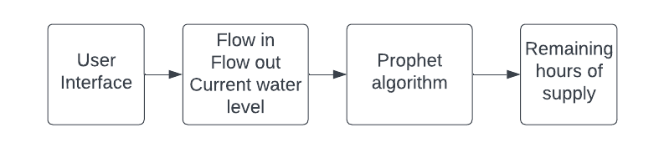

**Fig. 1.** Architectural block diagram of ML based water level and flow rate detection system

The above block diagram depicts the interaction between the three modules of the system. The inputs from User Interface module (Website) consists of flow in , flow out and current water level. Inputs interact with the prophet algorithm that predicts the reamaining hours of supply.The results are then displayed on the User Interface.

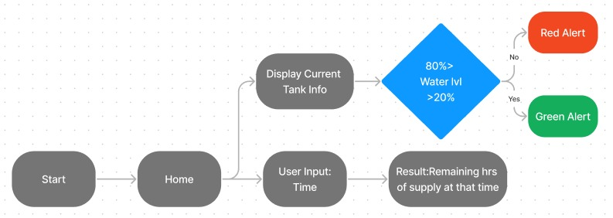

**4 Algorithms used in Machine Learning**

Prophet, developed by Facebook, is primarily designed for time series forecasting and is not typically used for real-time detection or control systems in water level and flow rate monitoring. However, you can still leverage Prophet in conjunction with other machine learning (ML) techniques to assist in the prediction and analysis of water level and flow rate data.

* Time Series Decomposition: Prophet decomposes time series data into three main components: trend, seasonality, and holidays. This decomposition helps capture complex patterns in the data.
* Flexibility: Prophet is highly flexible and can handle missing data points, outliers, and data with irregular time intervals. It also provides an easy-to-use interface for users.
* Uncertainty Estimation: The model provides uncertainty estimates for each forecast, helping users understand the range of possible outcomes.
* Customization: Users can customize seasonality and holiday effects to match the specific characteristics of their data.
* Scalability: Prophet is designed to handle large datasets efficiently, making it suitable for real-world applications.
* Open Source: Prophet is open-source software, making it accessible to a wide range of users and developers.

**5 Proof of Work**

Proof of work for an ML-based water level and flow rate detection system project involves demonstrating the successful development, implementation, and performance of the system.Proof of work in this context demonstrates that the ML-based water level and flow rate detection system not only meets its defined objectives but also functions effectively and reliably in a real-world environment. It should provide accurate predictions, continuous monitoring capabilities, and user-friendly interfaces, while also being adaptable to changing conditions and requirements.

**6 Results**

* Creation of the block diagram in labview.And then gathering the data via excel sheet.
* Training the dataset using Prophet machine learning model.
* Creating the UI which takes flow in ,flow out, current water level as input and gives remaining hours of supply in the output.

The screenshot of implemented modules is shown below:

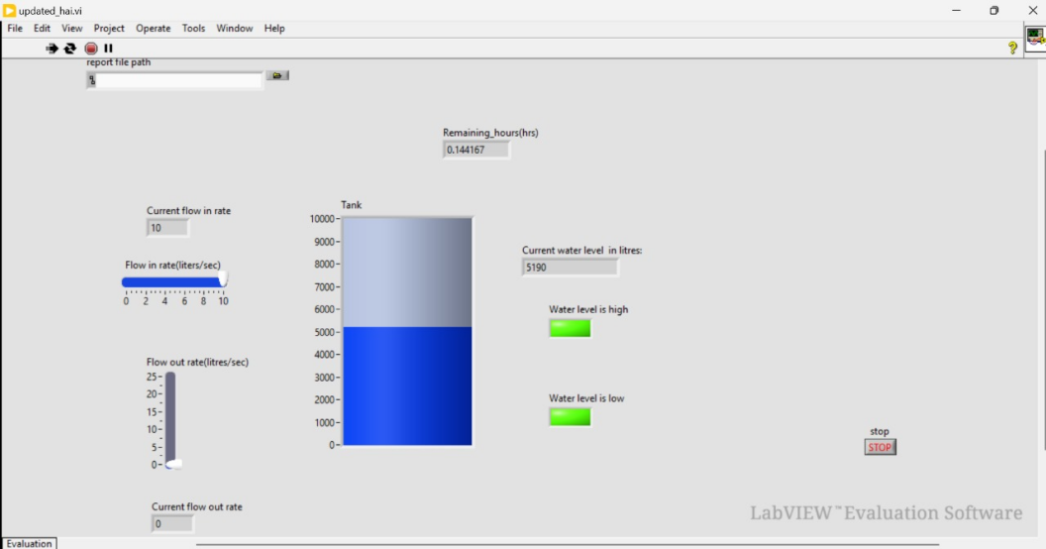

Fig4. Front panel Labview

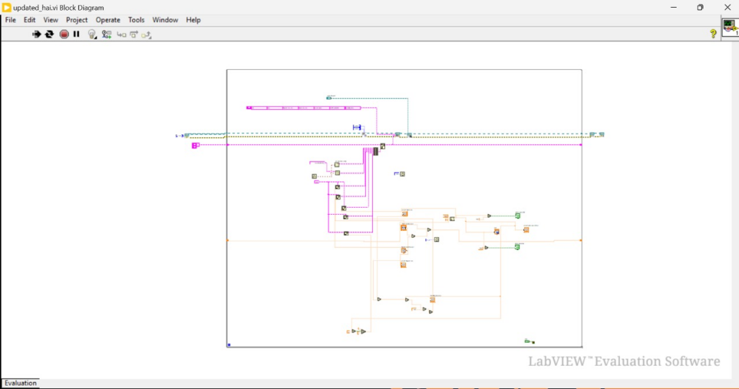

Fig5.Block diagram

**7 Conclusion**

In conclusion, the ML-based water level and flow rate detection system we've developed, which integrates LabVIEW for data acquisition, Prophet for forecasting, and a user interface for real-time interaction, offers a comprehensive solution for efficient water resource management.LabVIEW provides a versatile platform for acquiring data from sensors, including flow in, flow out, and current water level, ensuring reliable and accurate data collection. The integration of Prophet, a machine learning algorithm developed by Facebook, enables accurate and robust time series forecasting. It leverages historical data to make predictions, enhancing the system's ability to plan and make informed decisions.The user interface offers a user-friendly means of inputting critical parameters, such as flow in, flow out, and current water level, making it accessible to operators and stakeholders.The system utilizes Prophet's forecasting capabilities to provide real-time predictions of the remaining time for water supply. This real-time aspect enhances decision-making and allows for proactive responses to changing conditions.

**8 References**

ESP-32 Oriented Automated Water Level Controller System Prof. Manaswini.Parlikar1 , Chinmayi Vaidya2 , Prathamesh Pawar3 , Amaan Saiyyad4 , Shravani Mahesuni5.[1]

Automatic Water Level Control Using LabVIEW 2017

Hemin Ismael Azzez, Narongit Pimkumwong,Shih-Chung Chen.[2]

Automatic Water Tank Filling Simulation Based on LabVIEW

Agung Rizkey Jamas,Ismah Nurul Sya bani,Ryan Adam Hidyatullah,Ratnasari Didik Aribowo.[3]

Water Demand Prediction Using Support Vector Machine Regression

Amrita Tamang , Samiksha Shukla.[4]