🔬 WIRESHARK
Network Protocol Analysis
Laboratory Exercises for Beginners

Protocols Covered:
HTTP | ICMP | DNS | TCP | ARP

Introduction to Wireshark
What is Wireshark?
Wireshark is a free, open-source network protocol analyzer. It captures network packets in real time and lets you inspect them in detail — like a microscope for your network traffic.

In these exercises, you will use Wireshark to observe real network communication, understand how different protocols work, and analyze packet-level data.

Learning Objectives
- Install and navigate the Wireshark interface
- Capture live network traffic using filters
- Analyse HTTP, ICMP, DNS, TCP, and ARP packets
- Read and interpret packet headers and payloads
- Answer analysis questions and attach supporting screenshots

Software Requirements
- Wireshark 4.x (download from https://www.wireshark.org/download.html)
- Windows 10/11, macOS, or Linux
- Active internet connection
- Administrator / sudo privileges on your machine

📋 Submission Instructions
For every question marked with 📸, capture a screenshot from Wireshark that shows the relevant traffic.
Paste each screenshot directly into this document in the space provided.
Write short written answers where the question asks for one.
Submit the completed document as a .docx or .pdf file via your course portal.

Part 0 — Getting Started with Wireshark

0.1 Installing Wireshark
- Go to https://www.wireshark.org/download.html
- Download the installer for your operating system.
- Run the installer and accept all default settings (including Npcap on Windows).
- Launch Wireshark after installation.

0.2 Wireshark Interface Overview
UI Area | Description
Packet List Pane | Top panel — shows all captured packets in chronological order (No., Time, Source, Destination, Protocol, Info).
Packet Details Pane | Middle panel — shows the decoded structure of the selected packet, organized by protocol layer.
Packet Bytes Pane | Bottom panel — shows the raw hexadecimal and ASCII bytes of the selected packet.
Display Filter Bar | Bar at the top — type filters here to show only specific packets (e.g., http, icmp, dns).
Capture Interfaces | Start screen — lists available network interfaces (Wi-Fi, Ethernet, Loopback, etc.).

0.3 Starting a Capture
1 | Open Wireshark  You will see a list of network interfaces on the start screen.

2 | Choose your active interface  Select the interface that is currently active — usually Wi-Fi or Ethernet. You will see a live graph of traffic activity next to active interfaces.

3 | Double-click the interface  This immediately starts capturing all network packets on that interface.

4 | Stop the capture  Click the red Stop button (■) in the toolbar, or press Ctrl+E (Cmd+E on Mac).

5 | Use display filters  In the filter bar, type a protocol name like http or icmp and press Enter to show only those packets.

Question 1: Take a screenshot of the Wireshark home screen showing the list of available network interfaces on your computer.
📸 Attach Screenshot Here
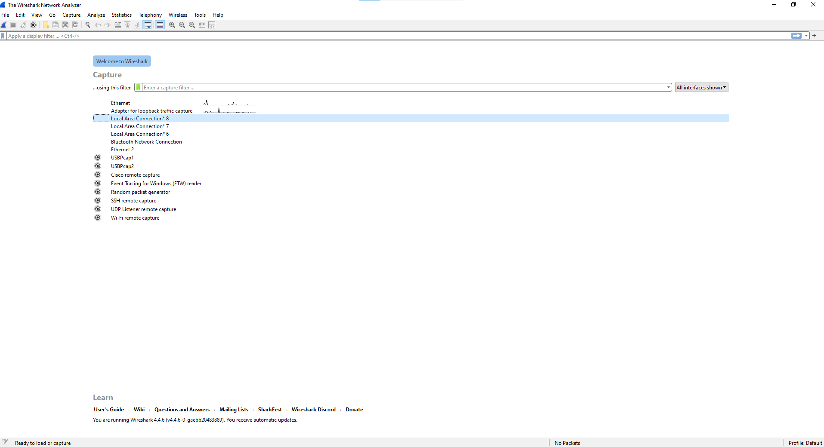

Your Answer / Observation:
_____________________________________________________________

Question 2: Start a capture on your active interface, let it run for 10 seconds, then stop it. Take a screenshot of the captured packet list. How many packets were captured? Write the number in the answer box.
📸 Attach Screenshot Here
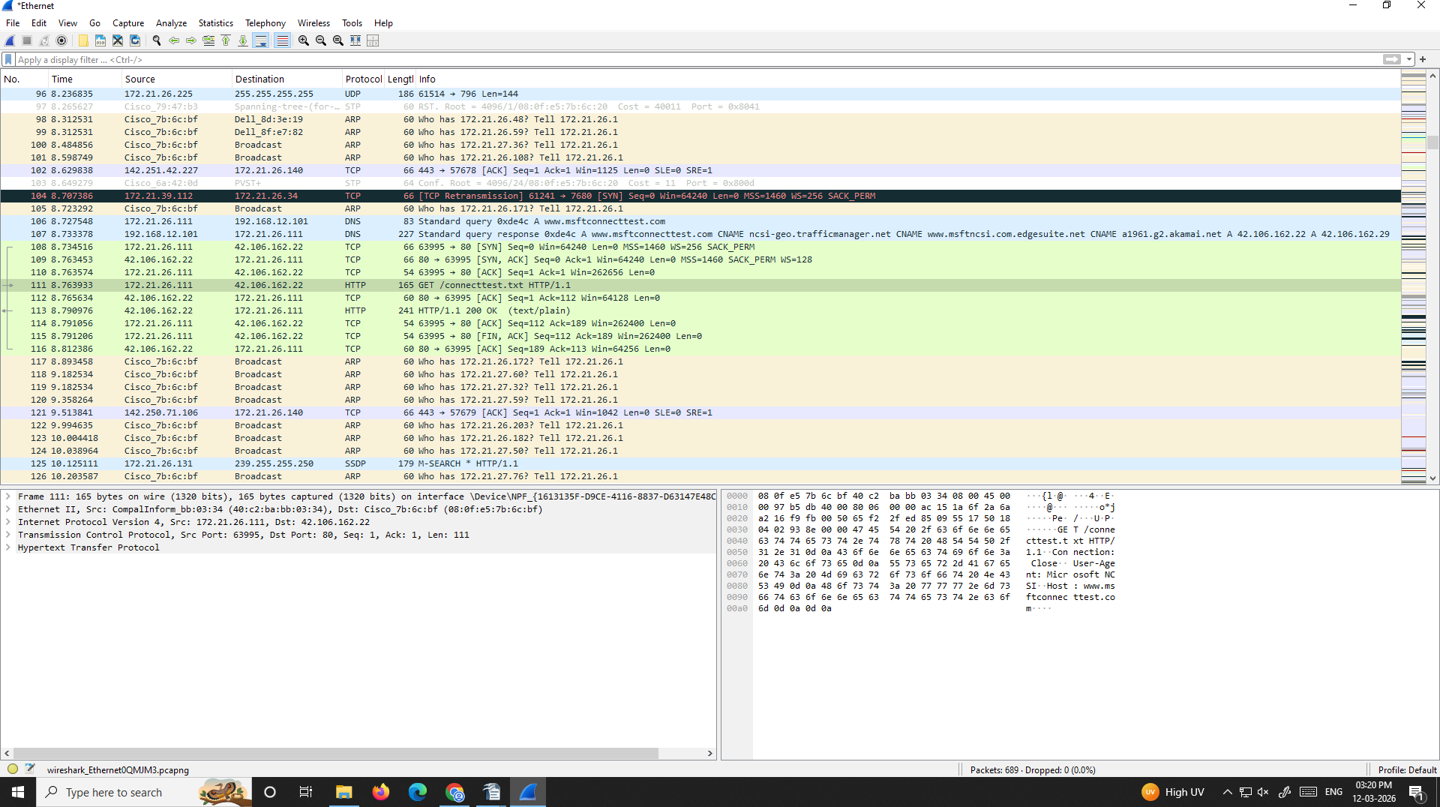

Your Answer / Observation:
_____________________________________________________________

Exercise 1 — ICMP (Internet Control Message Protocol)
What is ICMP?
ICMP (Internet Control Message Protocol) is used by network devices to send error messages and operational information.
The most familiar use of ICMP is the ping command — it sends ICMP Echo Request packets and waits for Echo Reply packets.
ICMP operates at the Network Layer (Layer 3) of the OSI model.

Key ICMP message types:
• Type 0 — Echo Reply • Type 3 — Destination Unreachable
• Type 8 — Echo Request • Type 11 — Time Exceeded

Steps — Capturing ICMP Traffic
1 | Start a new capture  Open Wireshark and start capturing on your active network interface.

2 | Open a terminal / command prompt  On Windows: press Win+R, type cmd, press Enter. On Mac/Linux: open Terminal.

3 | Run the ping command  Type the following and press Enter:  Windows: ping google.com  Mac/Linux: ping -c 4 google.com

4 | Return to Wireshark and stop the capture  Click the Stop button (■).

5 | Apply a display filter  Type icmp in the filter bar and press Enter. You should now see only ICMP packets.

Questions — ICMP Analysis
Question 3: Apply the icmp filter and take a screenshot showing the ICMP packets in the Packet List pane. You should see alternating Echo Request and Echo Reply packets.
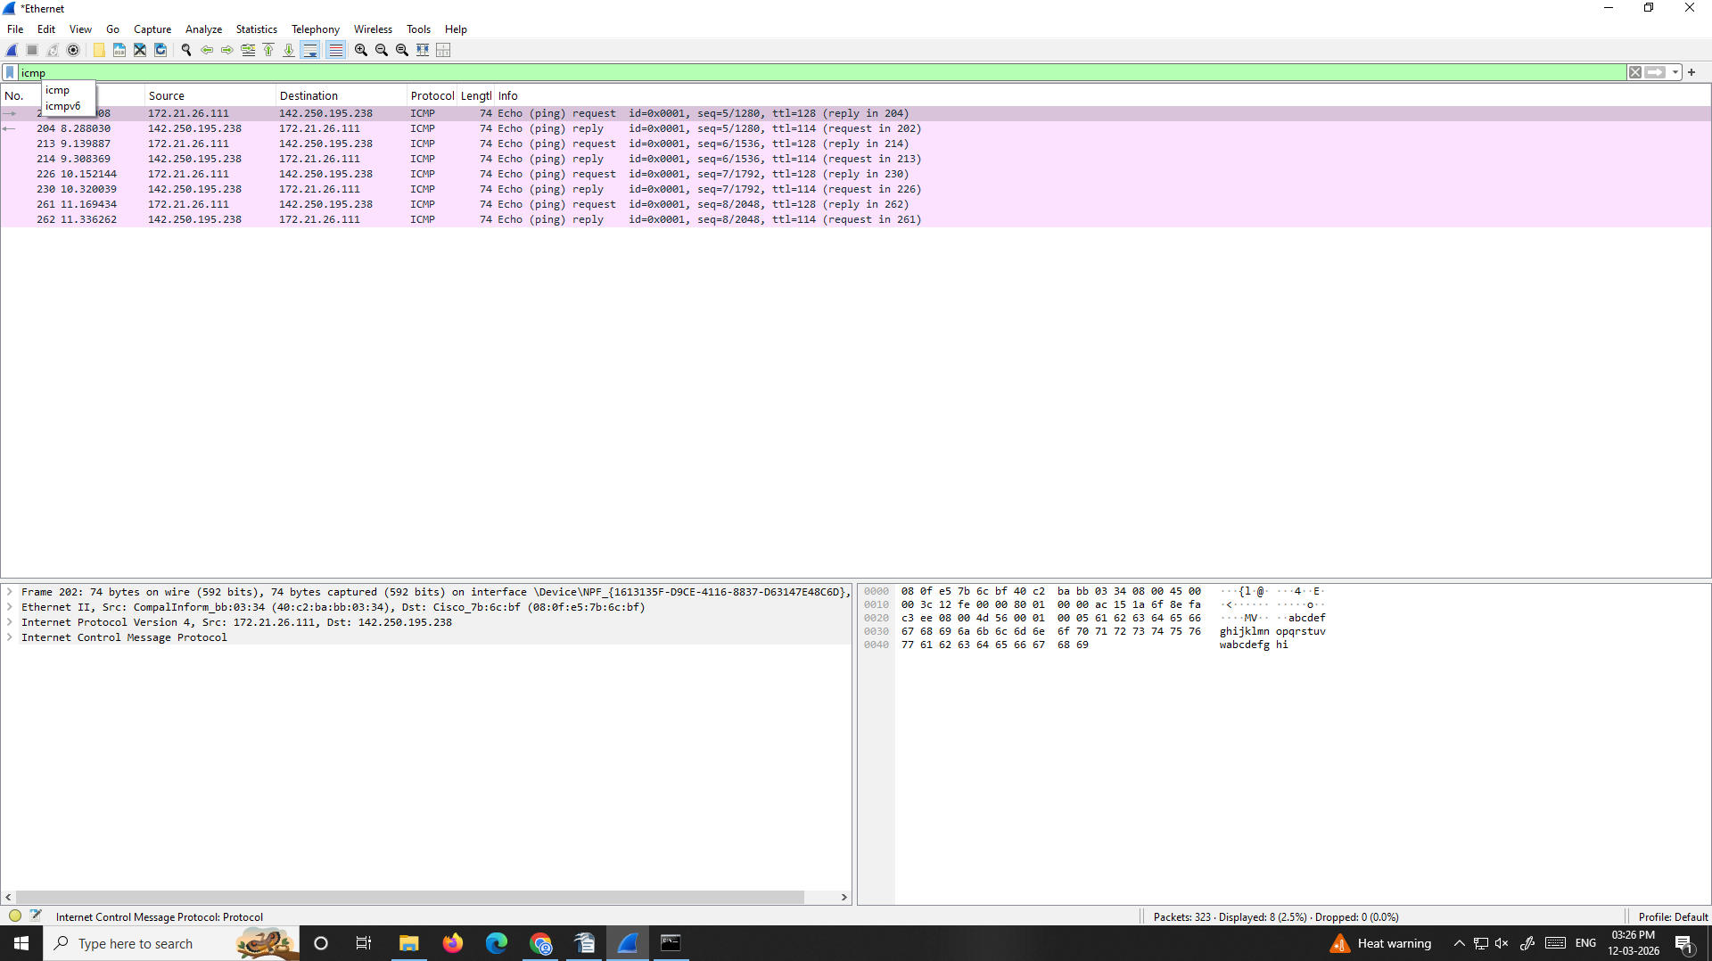

Your Answer / Observation:
_____________________________________________________________

Question 4: Click on one Echo Request packet. In the Packet Details pane, expand the 'Internet Control Message Protocol' layer. Take a screenshot. What is the Type value and what does it mean?
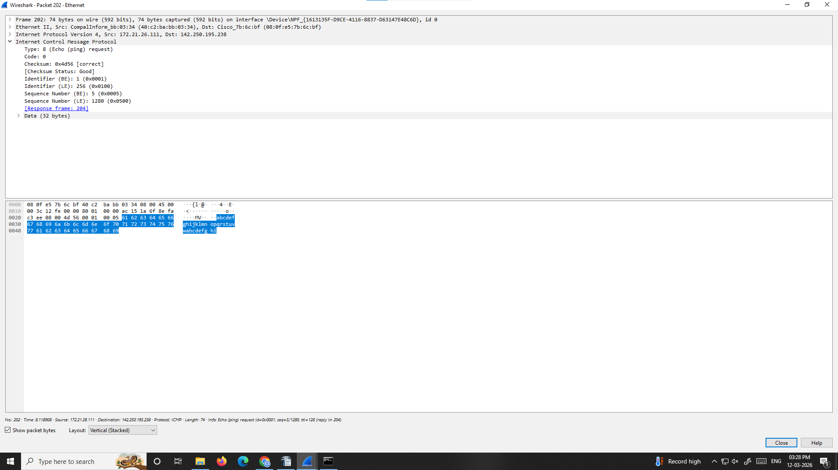
📸 Attach Screenshot Here

Your Answer / Observation:
_____________________________________________________________

Question 5: Click on one Echo Reply packet and expand the ICMP layer. Take a screenshot. What is the Type value for a Reply?
📸 Attach Screenshot Her
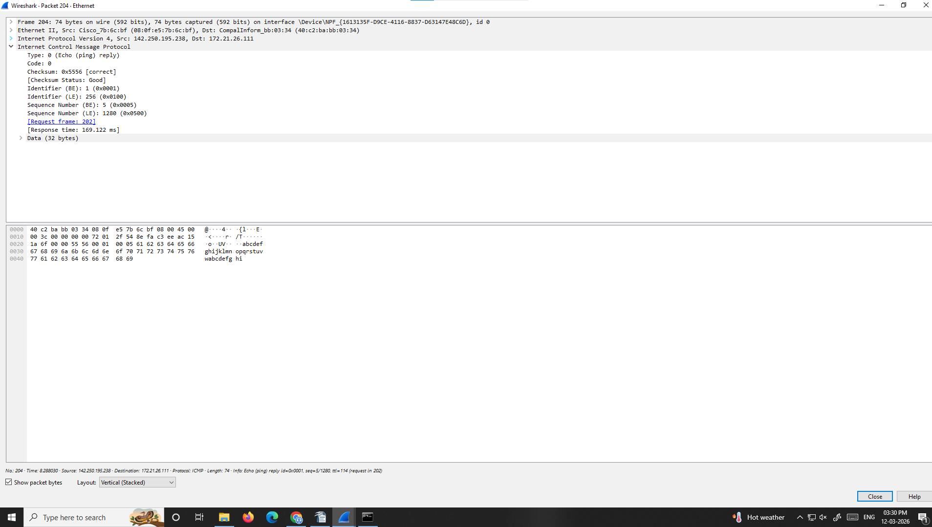

Your Answer / Observation:
_____________________________________________________________

Question 6: Look at the Source and Destination columns for the ICMP packets. What is the IP address of google.com that responded to your ping? Write it below.
📸 Attach Screenshot Here
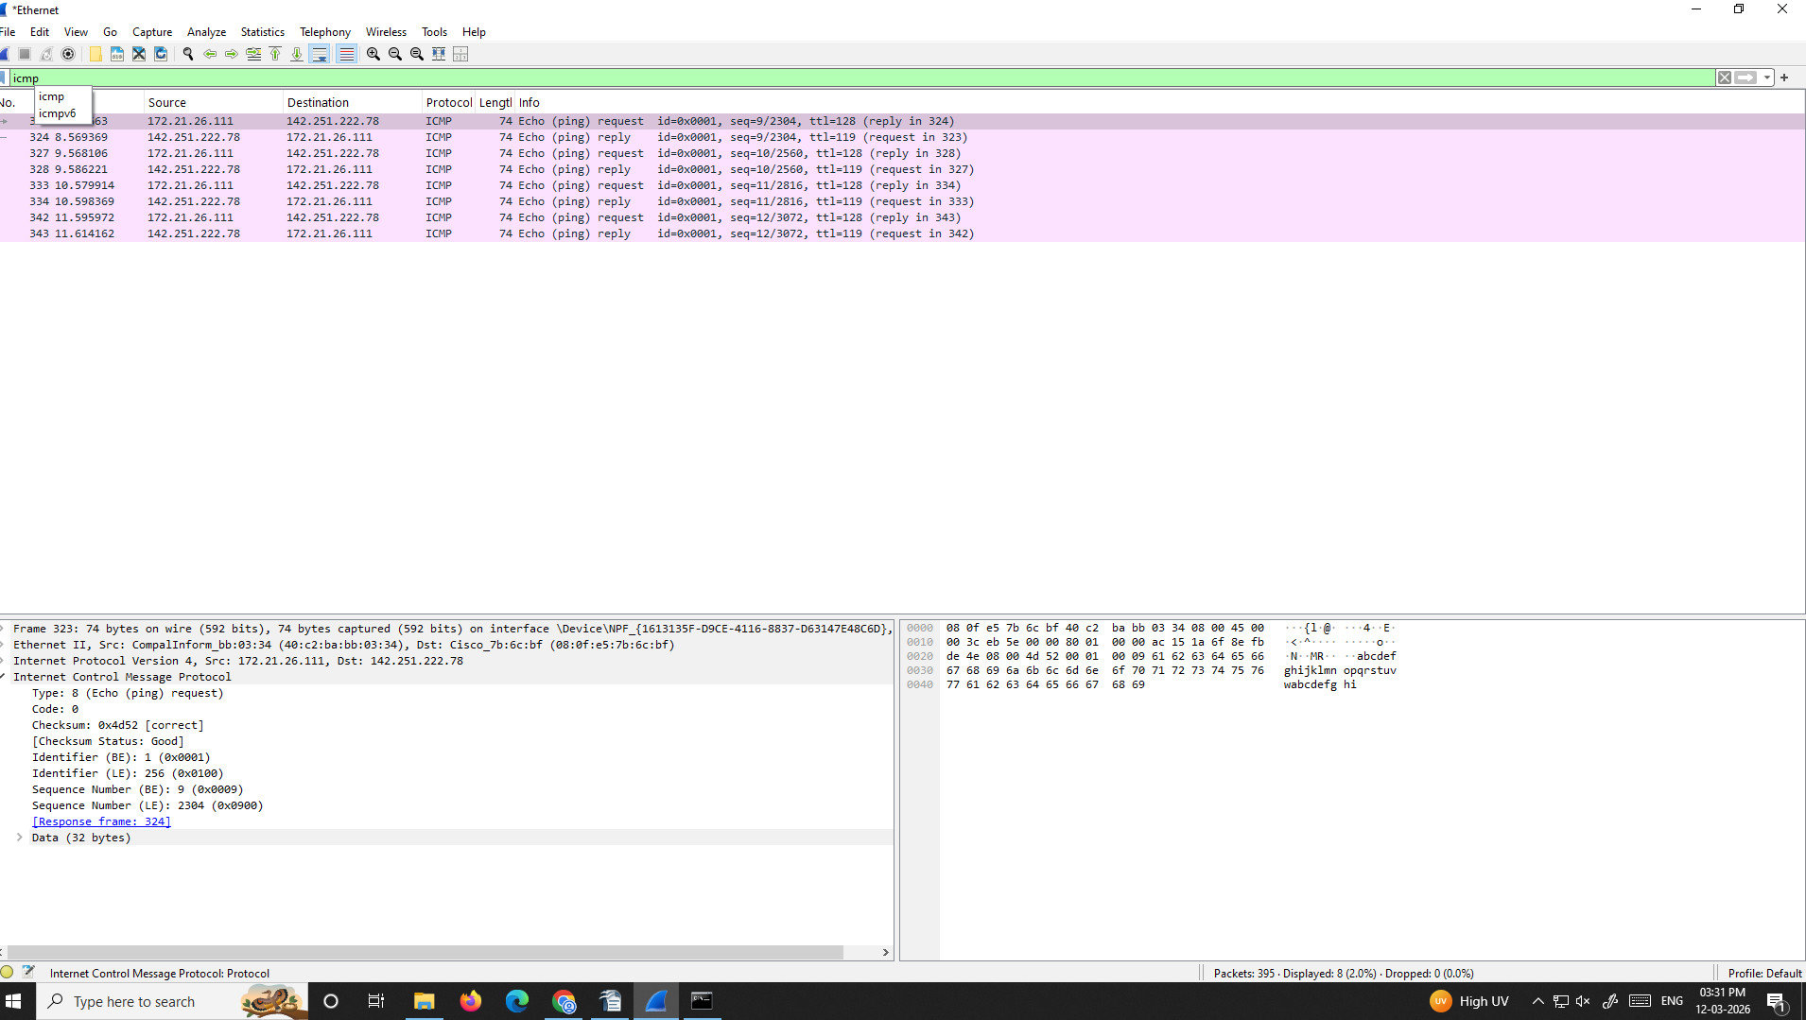

Your Answer / Observation:

Question 7: In the Packet Details pane, expand the 'Internet Protocol Version 4' layer. Take a screenshot showing the TTL (Time to Live) field. What is the TTL value of the Echo Reply you received?
📸 Attach Screenshot Here
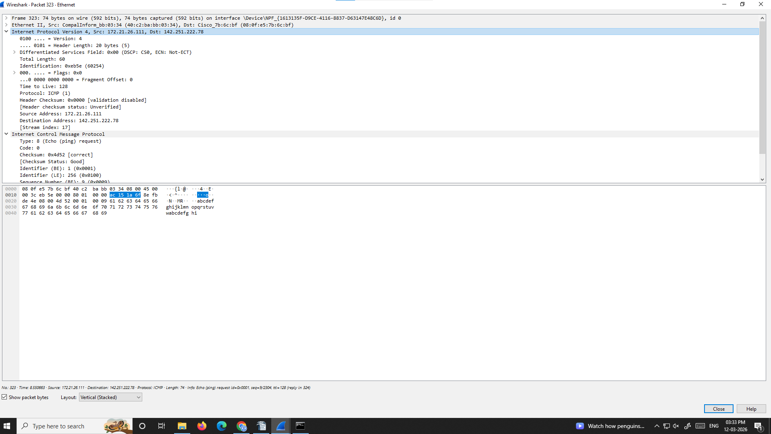

Your Answer / Observation:
_____________________________________________________________

💡 What is TTL?
TTL (Time to Live) is a field in the IP header that limits how many router hops a packet can make.
Each router decrements TTL by 1. When TTL reaches 0, the packet is discarded and an ICMP Time Exceeded message is sent back.
Common starting TTL values: Windows = 128, Linux/Mac = 64, Cisco routers = 255.

Exercise 2 — HTTP (Hypertext Transfer Protocol)
What is HTTP?
HTTP (Hypertext Transfer Protocol) is the foundation of data communication on the World Wide Web.
When you open a webpage, your browser sends an HTTP GET request to the server, and the server responds with an HTTP 200 OK response containing the page content.
HTTP operates at the Application Layer (Layer 7) of the OSI model and typically uses TCP port 80.

Common HTTP methods: GET, POST, PUT, DELETE
Common status codes: 200 OK | 301 Redirect | 404 Not Found | 500 Server Error

Note: Most modern websites use HTTPS (encrypted). We will use a plain HTTP test site for this exercise.

Steps — Capturing HTTP Traffic
1 | Start a new capture in Wireshark  Start capturing on your active network interface.

2 | Open a web browser  Open Chrome, Firefox, or Edge.

3 | Visit an HTTP test site  Navigate to: http://neverssl.com  (This site does NOT use HTTPS, so Wireshark can see the full request.)

4 | Wait for the page to load, then return to Wireshark  Stop the capture.

5 | Apply the http filter  Type http in the filter bar and press Enter.

Questions — HTTP Analysis
Question 8: After applying the http filter, take a screenshot of the Packet List pane. You should see GET requests and HTTP responses. Identify the first GET request in the list.
📸 Attach Screenshot Here
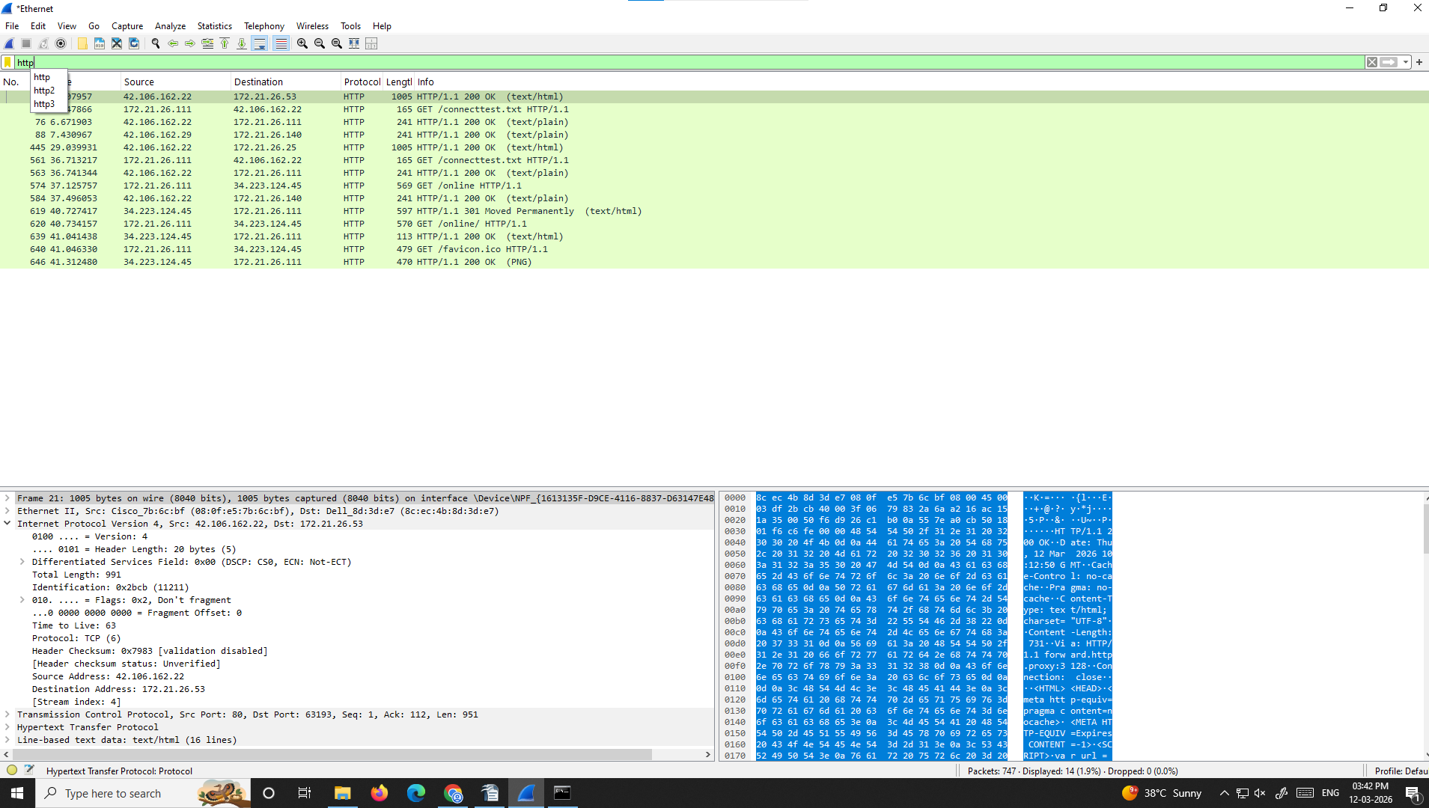

Your Answer / Observation:
_____________________________________________________________

Question 9: Click on the HTTP GET request. In the Packet Details pane, expand the 'Hypertext Transfer Protocol' layer. Take a screenshot. What Host did your browser request?
📸 Attach Screenshot Here
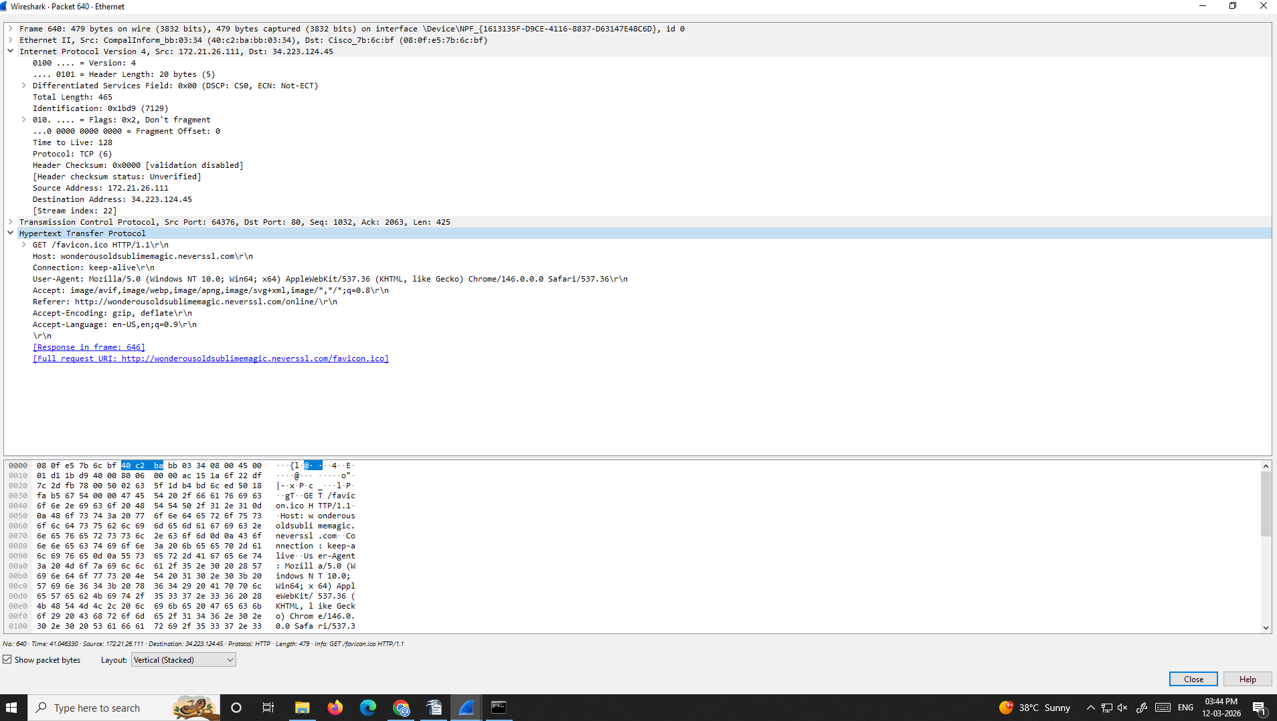

Your Answer / Observation:
_____________________________________________________________

Question 10: Find an HTTP/1.1 200 OK response packet. Click on it and expand the HTTP layer. Take a screenshot. What is the Content-Type of the response?
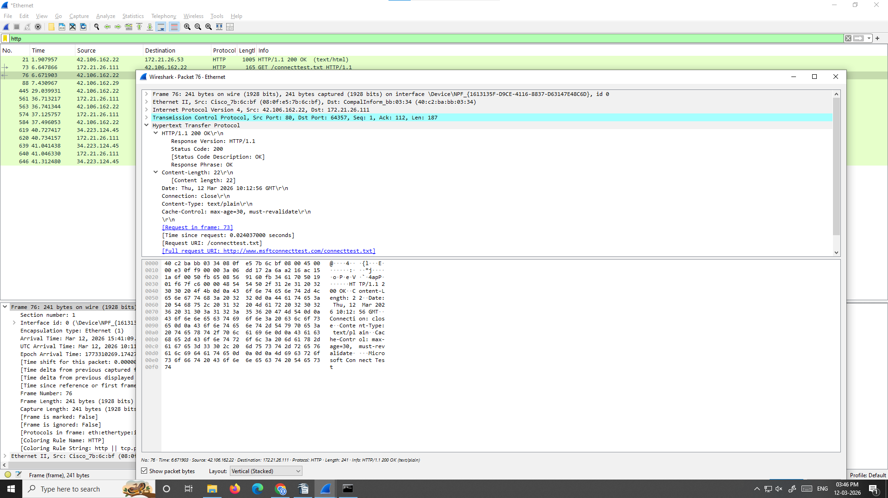
📸

Your Answer / Observation:
_____________________________________________________________

Question 11: In the Packet Details pane for the GET request, expand the 'Transmission Control Protocol' layer. Take a screenshot. What is the destination port number? What does this port number tell you about the protocol?
📸 Attach Screenshot Here
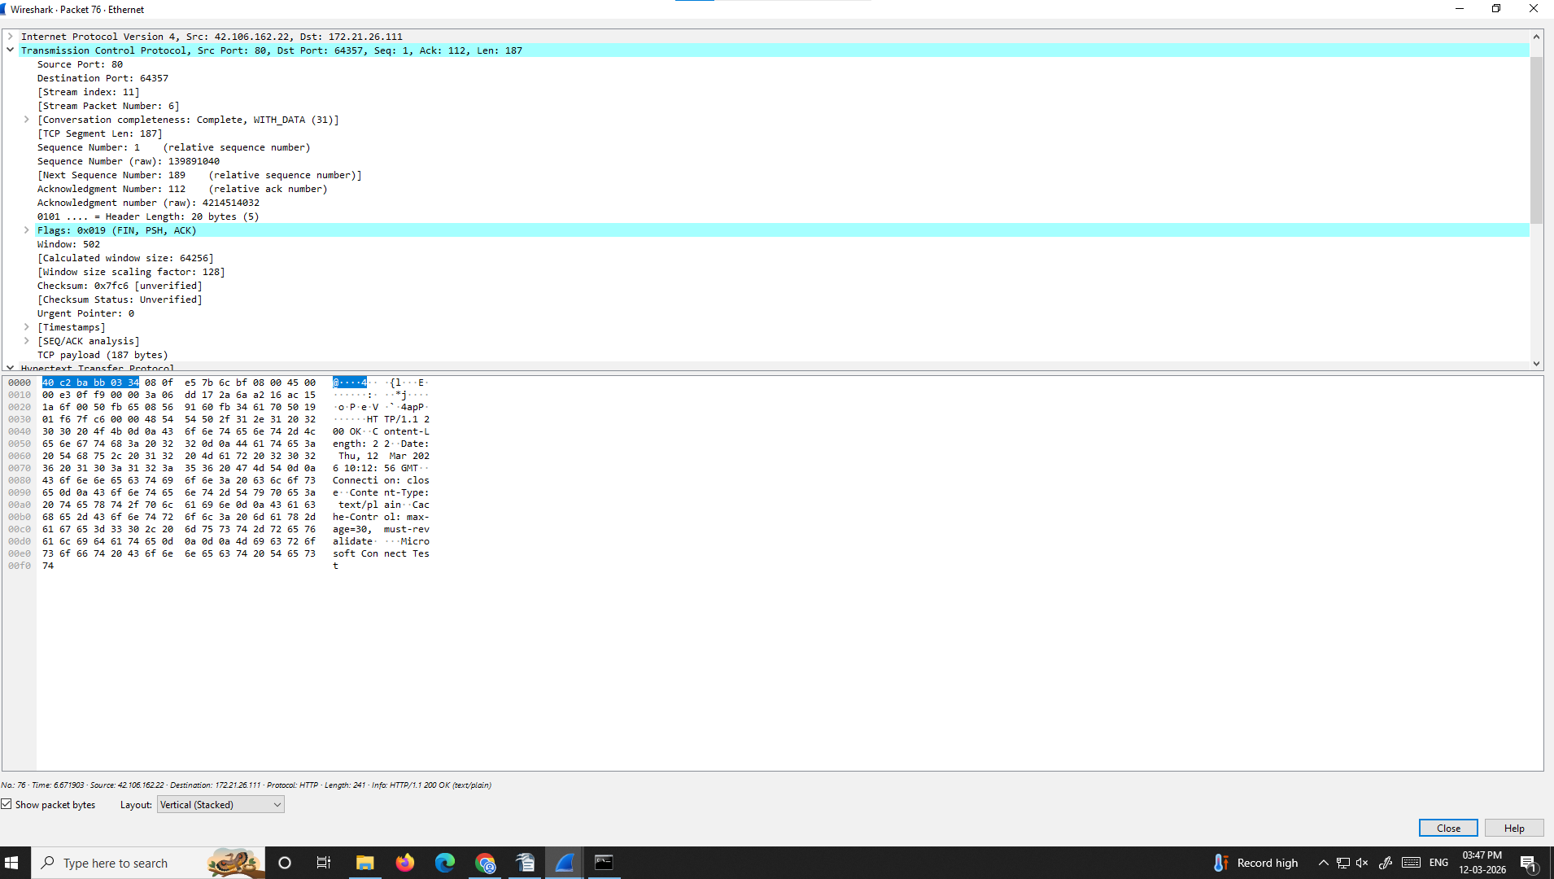

Your Answer / Observation:
_____________________________________________________________

💡 How to Follow an HTTP Stream
Right-click any HTTP packet → 'Follow' → 'TCP Stream'
This reassembles the full conversation between your browser and the server.
You can read the raw HTTP request and response in plain text!
Question 12: Right-click an HTTP packet, select Follow → TCP Stream. Take a screenshot of the TCP Stream dialog. Identify at least two HTTP request headers visible in the stream (e.g. User-Agent, Accept).
📸 Attach Screenshot Here
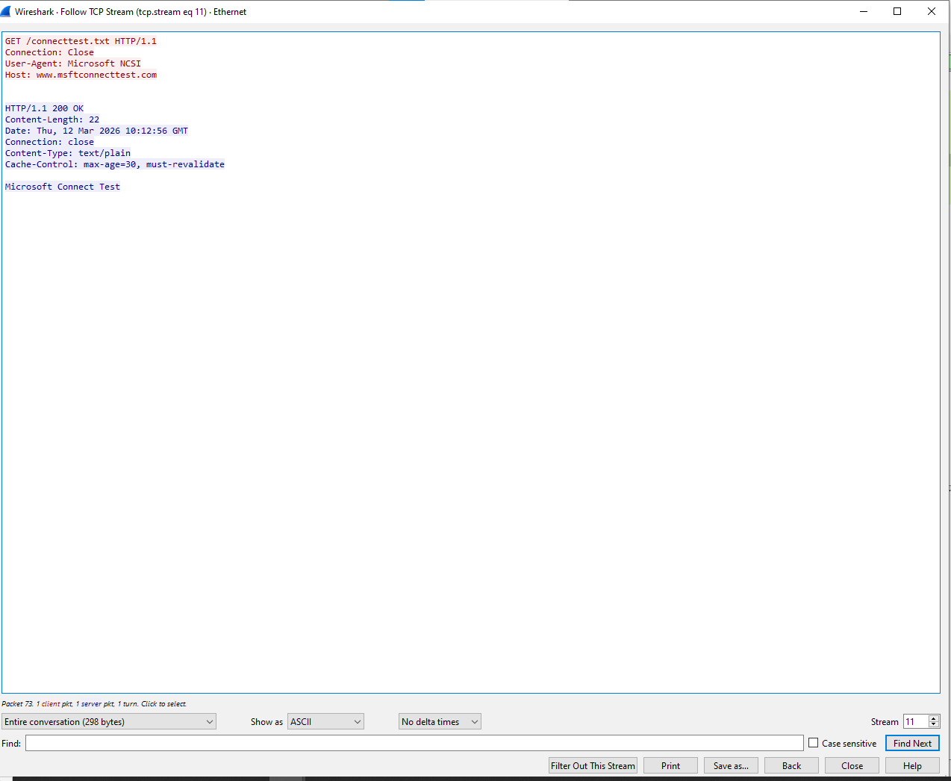

Your Answer / Observation:
_____________________________________________________________

Exercise 3 — DNS (Domain Name System)
What is DNS?
DNS (Domain Name System) translates human-readable domain names (like www.google.com) into IP addresses (like 142.250.80.36) that computers can use.
Every time you visit a website, your computer first sends a DNS query to a DNS server to look up the domain name.
DNS typically uses UDP port 53 (or TCP port 53 for large responses).

DNS record types:
• A Record — maps a domain to an IPv4 address
• AAAA Record — maps a domain to an IPv6 address
• CNAME — alias from one domain to another
• MX — mail server for a domain

Steps — Capturing DNS Traffic
1 | Start a new capture in Wireshark  Start capturing on your active network interface.

2 | Open a terminal and run the nslookup command  Type: nslookup wikipedia.org then press Enter.  Or open a browser and visit a brand new website you haven't visited today.

3 | Stop the capture  Return to Wireshark and stop capturing.

4 | Apply the dns filter  Type dns in the filter bar and press Enter.

Questions — DNS Analysis
Question 13: Apply the dns filter and take a screenshot of the Packet List pane. You should see DNS Query and DNS Response packets. How many packets are shown?
📸 Attach Screenshot Here
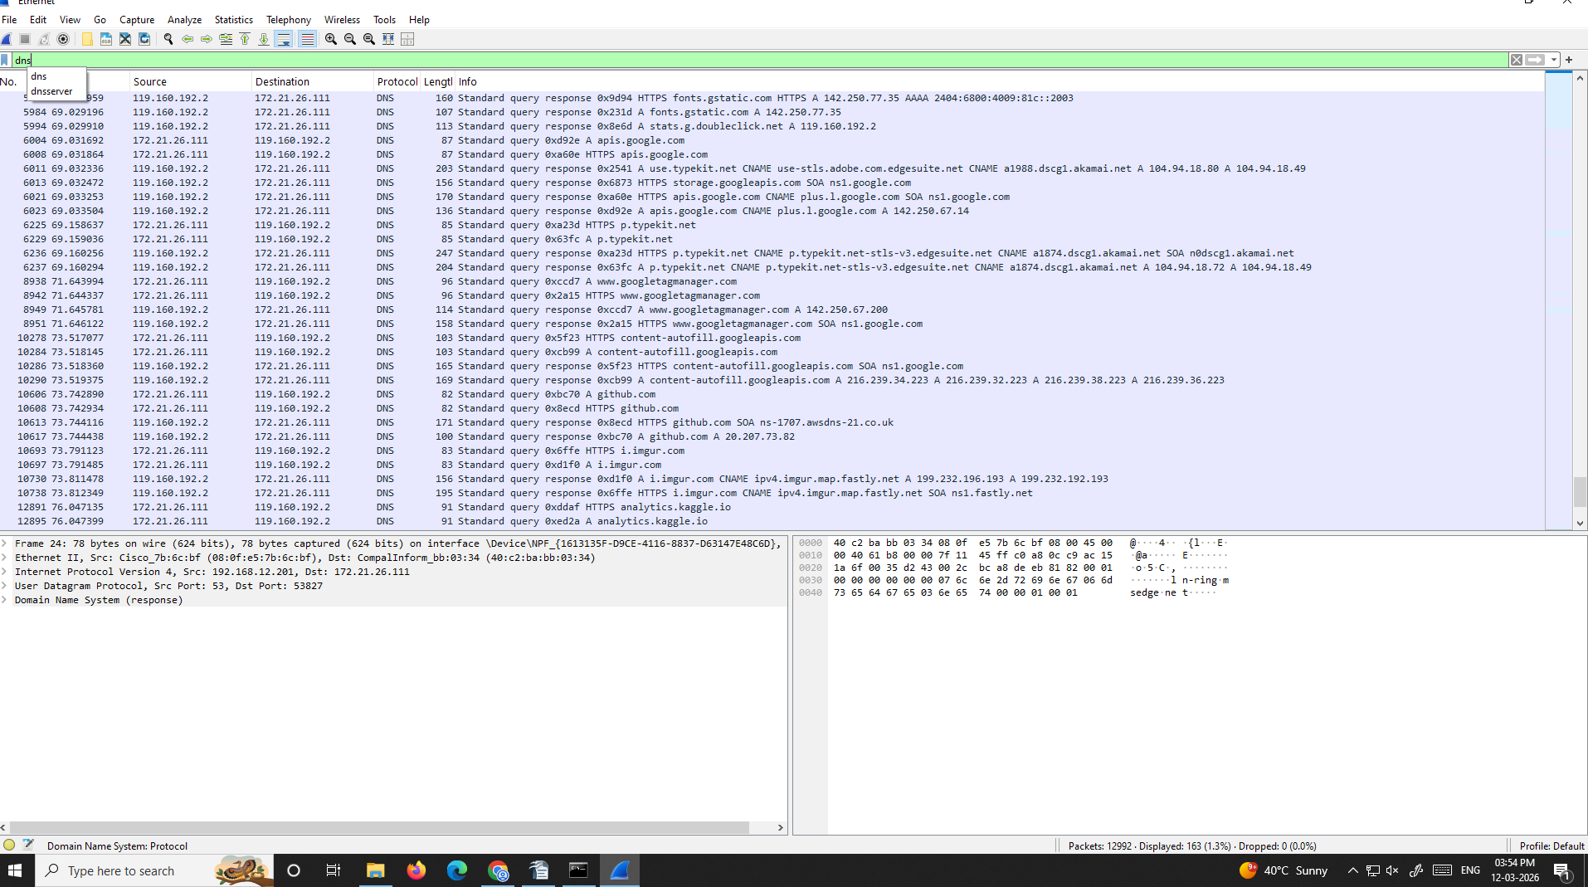

Your Answer / Observation:
_____________________________________________________________

Question 14: Click on a DNS query packet. In the Packet Details pane, expand 'Domain Name System (query)'. Take a screenshot showing the 'Queries' section. What domain name was queried?
📸 Attach Screenshot Here
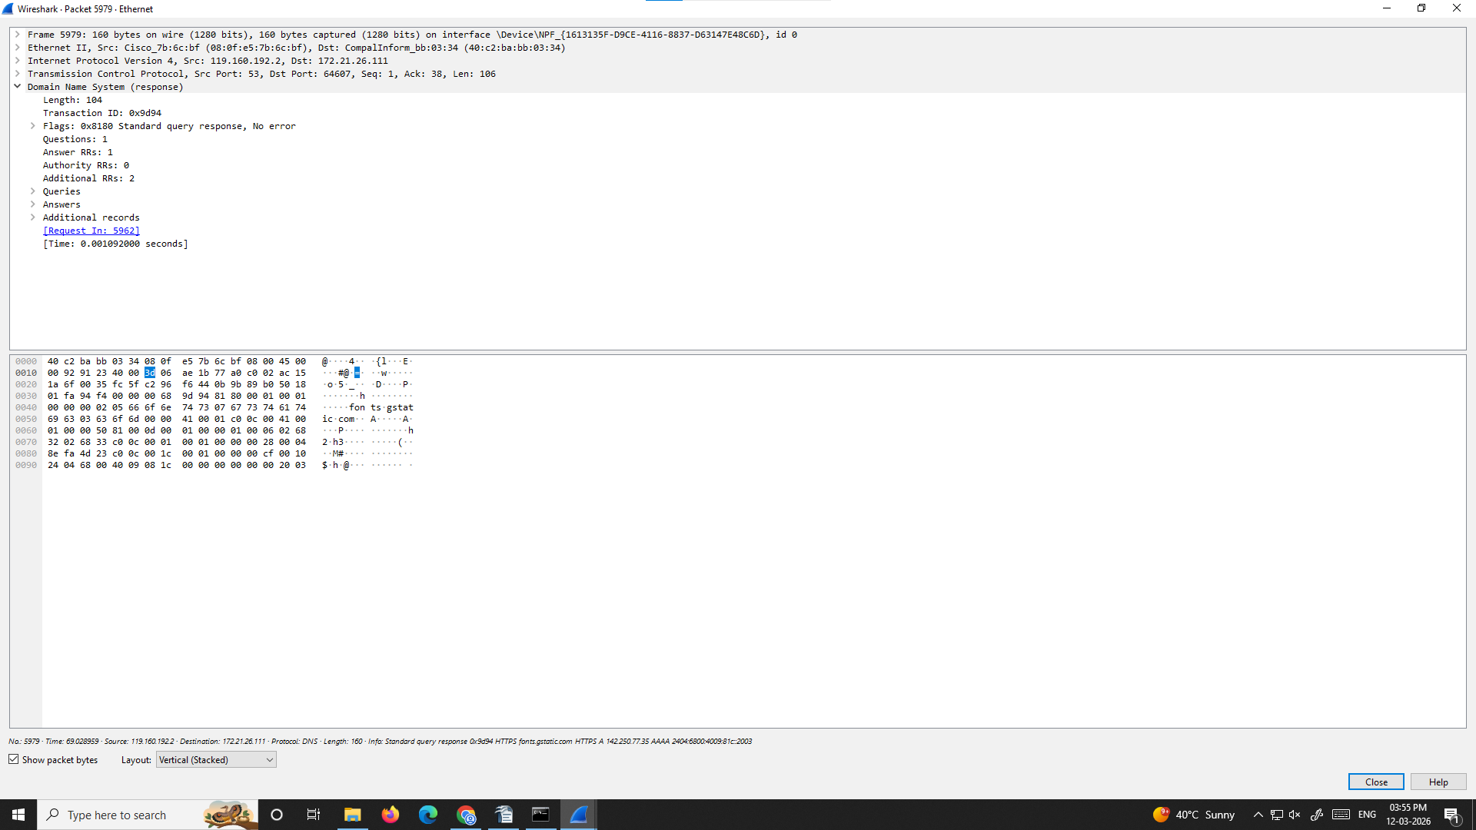

Your Answer / Observation:
_____________________________________________________________

Question 15: Click on the corresponding DNS response packet. Expand 'Domain Name System (response)' → 'Answers'. Take a screenshot. What IP address was returned for the domain?
📸 Attach Screenshot Here
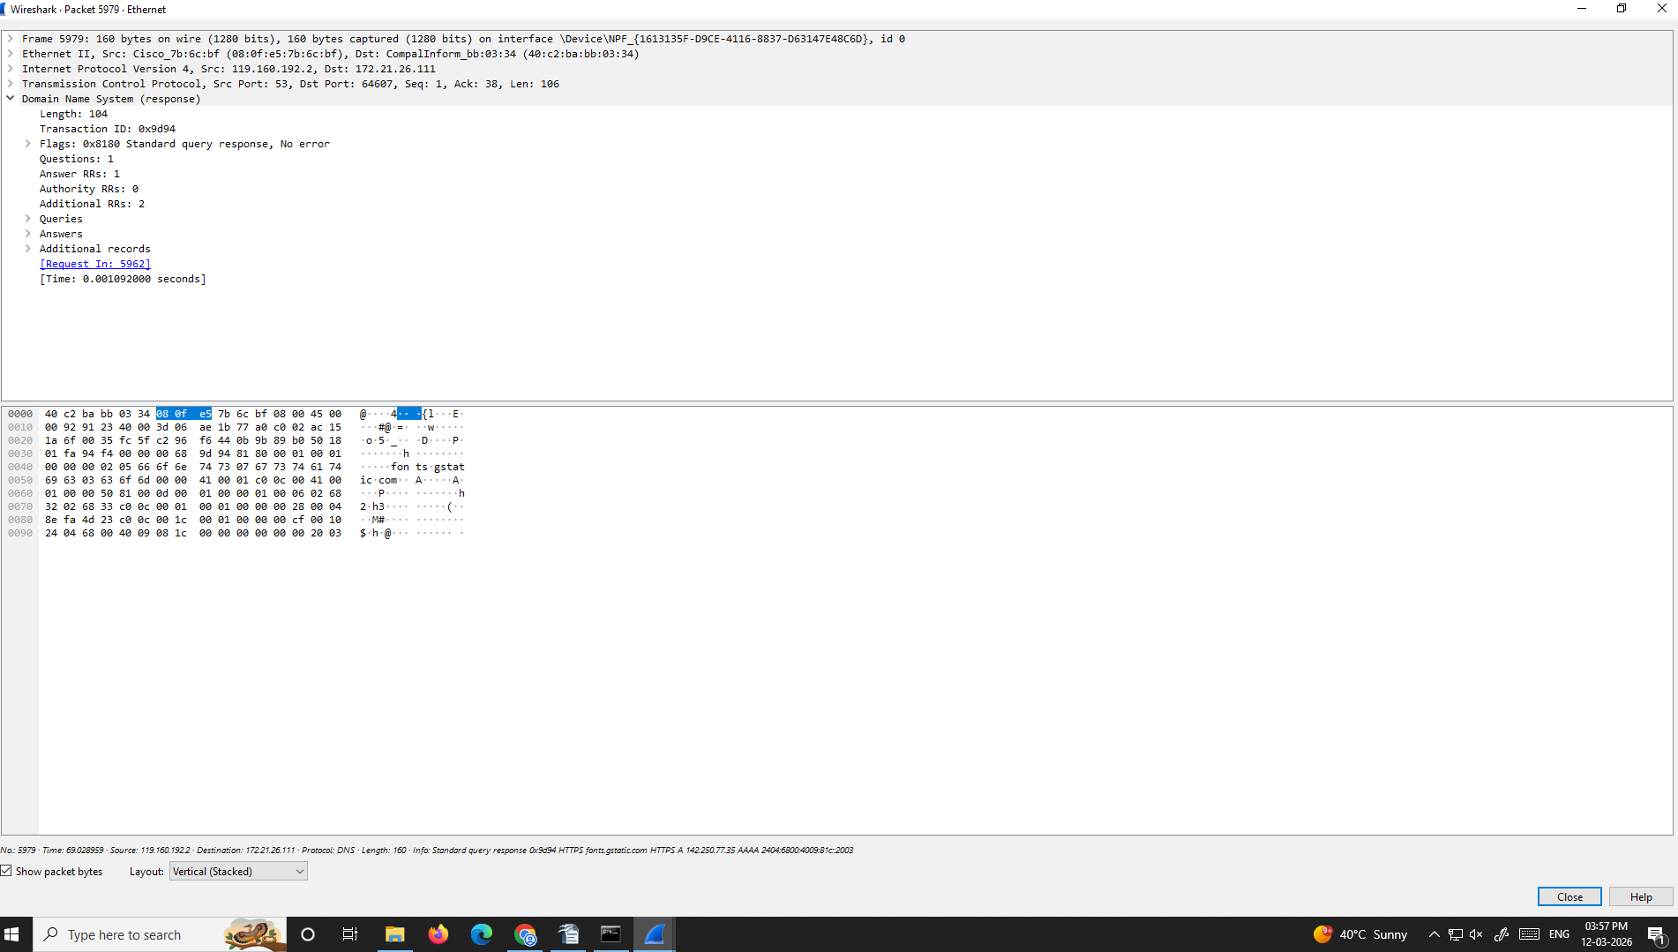

Your Answer / Observation:
_____________________________________________________________

Question 16: What protocol and port number does DNS use? Look at the 'User Datagram Protocol' layer in the Packet Details pane and take a screenshot showing the source and destination port numbers.
📸 Attach Screenshot Here
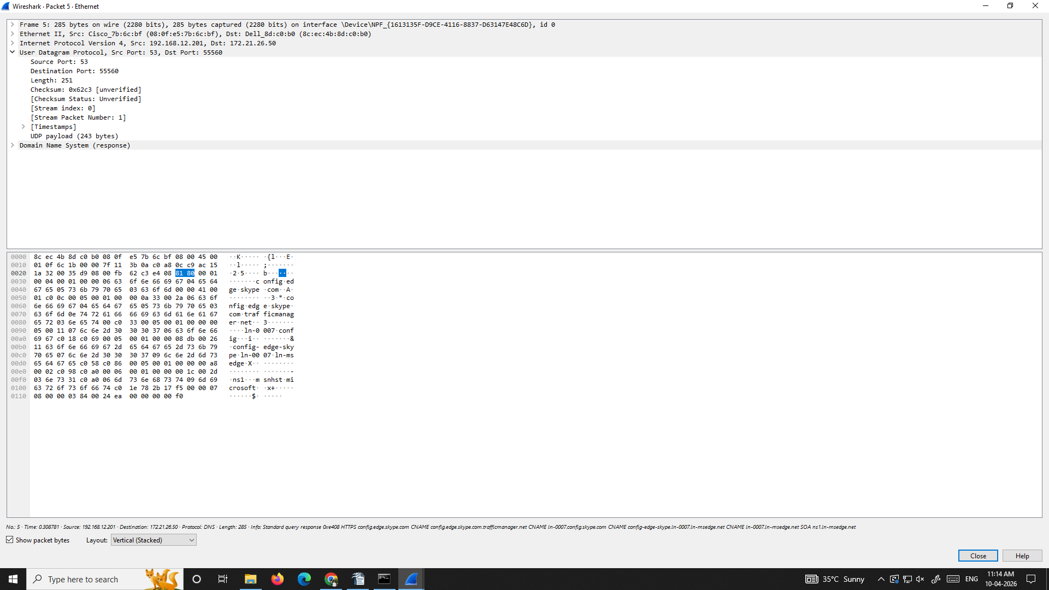

Your Answer / Observation:
_____________________________________________________________

💡 Useful DNS Filter Tips
dns.qry.name == "google.com" — filter DNS queries for a specific domain
dns.flags.response == 0 — show only DNS queries
dns.flags.response == 1 — show only DNS responses

