**NAME:** DANDGE SHRIKANT ASHOK

**ROLL NO.:** 205223006

**CLASS:** M.Tech 1st year (Data Analytics)

**SUBJECT:** Next Gen. Database System

**REPORT: HOSTEL WIFI FEEDBACK SYSTEM**

**PROBLEM STATEMENT**

**Hostel WiFi Feedback System**

**Introduction:** To address WiFi issues in our hostels, introducing a simple and efficient solution – the Hostel WiFi Feedback System. This system makes it easy for students to report problems, ensures quick resolutions, and improves internet experiences.

**Key Features:**

1. User-Friendly Portals: I have created separate logins for admins, wardens, and students.

2. Student Complaints: Students can easily report WiFi problems like slow speeds or disconnections.

3. Warden Verification: Wardens will check and confirm reported issues to avoid duplicates.

4. Fast Resolution: Admins/Hostel Chiefs will fix problems quickly and update when resolved.

**Benefits:**

* Simplicity: It's easy for everyone to use.
* Transparency: Students can track their complaints.

**COMPLETE DATABASE SCHEMA**

**1). Table: Fuser Model**

|  |  |  |
| --- | --- | --- |
| Column Name | Data Type | Constraints |
| id | INT | PRIMARY KEY |
| username | VARCHAR(150) | UNIQUE, NOT NULL |
| password | VARCHAR(128) | NOT NULL |
| first_name | VARCHAR(255) | NOT NULL |
| last_name | VARCHAR(255) | NOT NULL |
| is_warden | BOOLEAN | DEFAULT False |
| is_admin | BOOLEAN | DEFAULT False |
| hostel_id | VARCHAR(255) | DEFAULT "NULL" |
| office_id | VARCHAR(255) | DEFAULT "NULL" |

**2). Table: Complaint Model**

|  |  |  |
| --- | --- | --- |
| Column Name | Data Type | Constraints |
| Id | INT | PRIMARY KEY |
| Date_of_submission | DATE | NOT NULL |
| Roll_no | INT | NOT NULL, FOREIGN KEY |
| description | TEXT | NOT NULL |
| status | VARCHAR(50) | DEFAULT "Pending" |

**ENTITY RELATIONSHIP DIAGRAM**

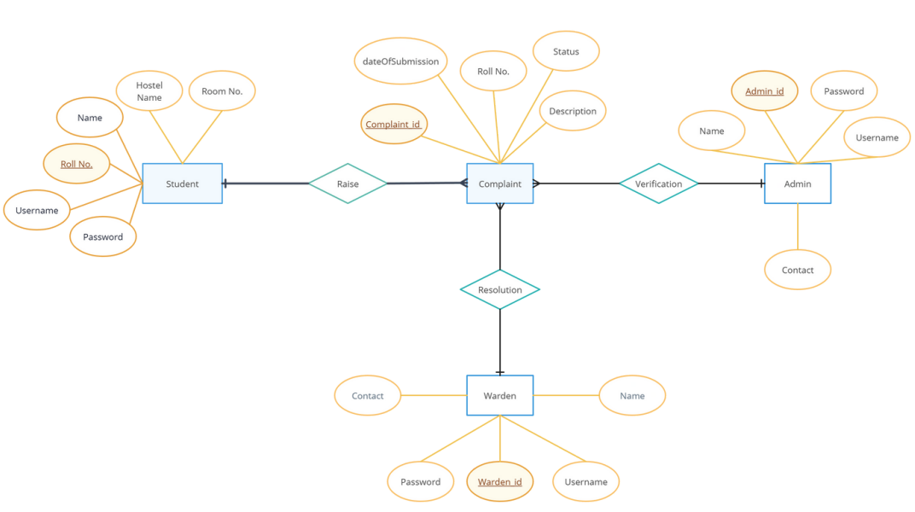

**LIST OF STAKEHOLDERS**

1. **Developer:** The Developing team or a particular individual developing the project.
2. **Admin:**
   * University Administrators
   * CSG Administrators
3. **Warden:**
   * Hostel Wardens
4. **Student:**
   * Students (End Users)
   * Student Representatives (if applicable)
   * Parents or Guardians (indirectly, as they may have concerns)

**DATABASE SCHEMA FOR EACH STAKE-HOLDER**

**Developers**:

|  |  |  |
| --- | --- | --- |
| Table Name | Fields | Description |
| Developer | **id** (Primary Key), **username**, **email**, **password** | Information about developers working on the project. |
| DeveloperTask | **id** (Primary Key), **developer_id** (Foreign Key), **task_name**, **description**, **status** | Tasks assigned to each developer. |
| BugReport | **id** (Primary Key), **developer_id** (Foreign Key), **bug_description**, **status**, **date_reported** | Records of reported bugs and issues. |

**Admins**:

|  |  |  |
| --- | --- | --- |
| Table Name | Fields | Description |
| Admin | **id** (Primary Key), **username**, **email**, **password** | Information about administrators. |
| Complaint | **id** (Primary Key), **student_id** (Foreign Key), **complaint_text**, **date_filed** | Records of student complaints. |
| Report | **id** (Primary Key), **admin_id** (Foreign Key), **report_text**, **date_generated** | Reports and analytics generated by administrators. |

**Wardens**:

|  |  |  |
| --- | --- | --- |
| Table Name | Fields | Description |
| Warden | **id** (Primary Key), **username**, **email**, **password** | Information about hostel wardens. |
| IncidentReport | **id** (Primary Key), **warden_id** (Foreign Key), **incident_description**, **date_reported** | Records of incidents reported in hostels. |
| Maintenance | **id** (Primary Key), **warden_id** (Foreign Key), **maintenance_request**, **status**, **date_requested** | Maintenance requests and tasks. |

**Students**:

|  |  |  |
| --- | --- | --- |
| Table Name | Fields | Description |
| Student | **id** (Primary Key), **username**, **email**, **password** | Information about students using the system. |
| Feedback | **id** (Primary Key), **student_id** (Foreign Key), **feedback_text**, **date_submitted** | Records of feedback provided by students. |
| Issue | **id** (Primary Key), **student_id** (Foreign Key), **issue_description**, **status**, **date_reported** | Records of technical issues reported by students. |

**DATABASE USED AND THEIR VIEWS**

**DATABASE:** Mongo DB + MySQL/Sqlite3

**DATABASE VIEWS FOR PARTICULAR STAKE-HOLDERS:**

1. **Developer:**
   * **Developers Collection:**
     + Fields:
       - **developer_id** (unique identifier)
       - **username** (developer's username)
       - **email** (developer's email)
       - **password** (hashed password)
       - Other developer-specific information
2. **Admin:**
   * **Admins Collection:**
     + Fields:
       - **admin_id** (unique identifier)
       - **username** (admin's username)
       - **email** (admin's email)
       - **password** (hashed password)
       - Other admin-specific information
3. **Warden:**
   * **Wardens Collection:**
     + Fields:
       - **warden_id** (unique identifier)
       - **username** (warden's username)
       - **email** (warden's email)
       - **password** (hashed password)
       - Other warden-specific information
4. **Student:**
   * **Students Collection:**
     + Fields:
       - **student_id** (unique identifier)
       - **username** (student's username)
       - **email** (student's email)
       - **password** (hashed password)
       - Other student-specific information

**DATABASE VIEWS FOR COMPLETE DATABASE**

**1). Fuser Model**

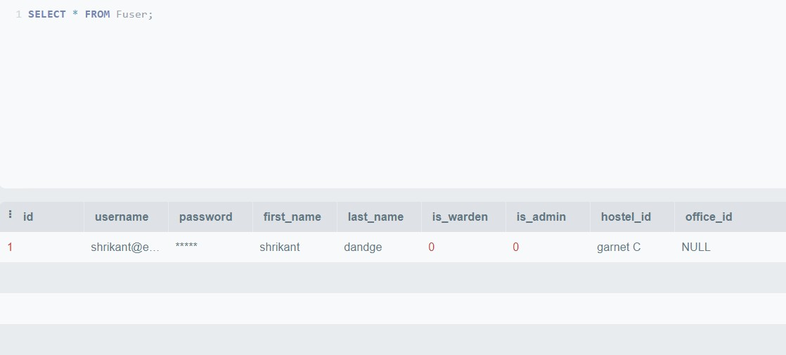

**2). Complaints**

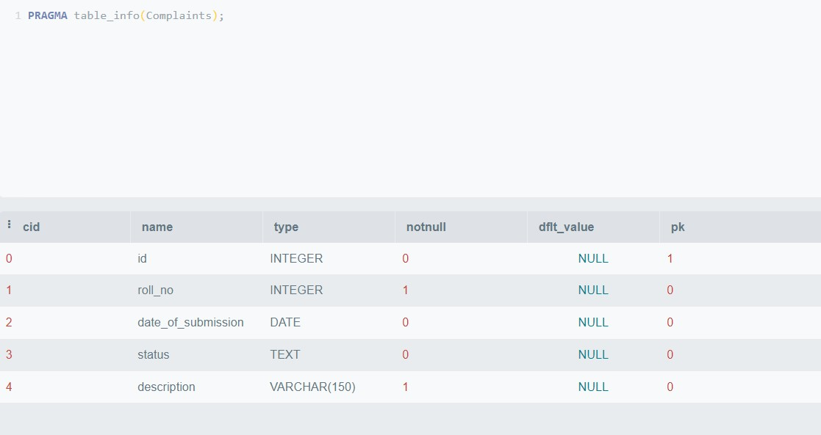

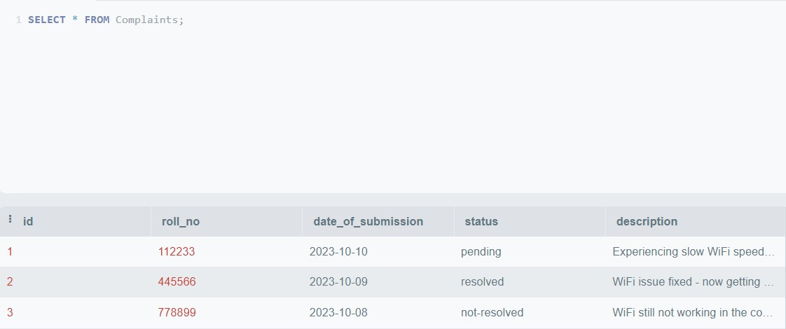

**FRONTEND SCREENSHOTS**

**1). index.html -> home**

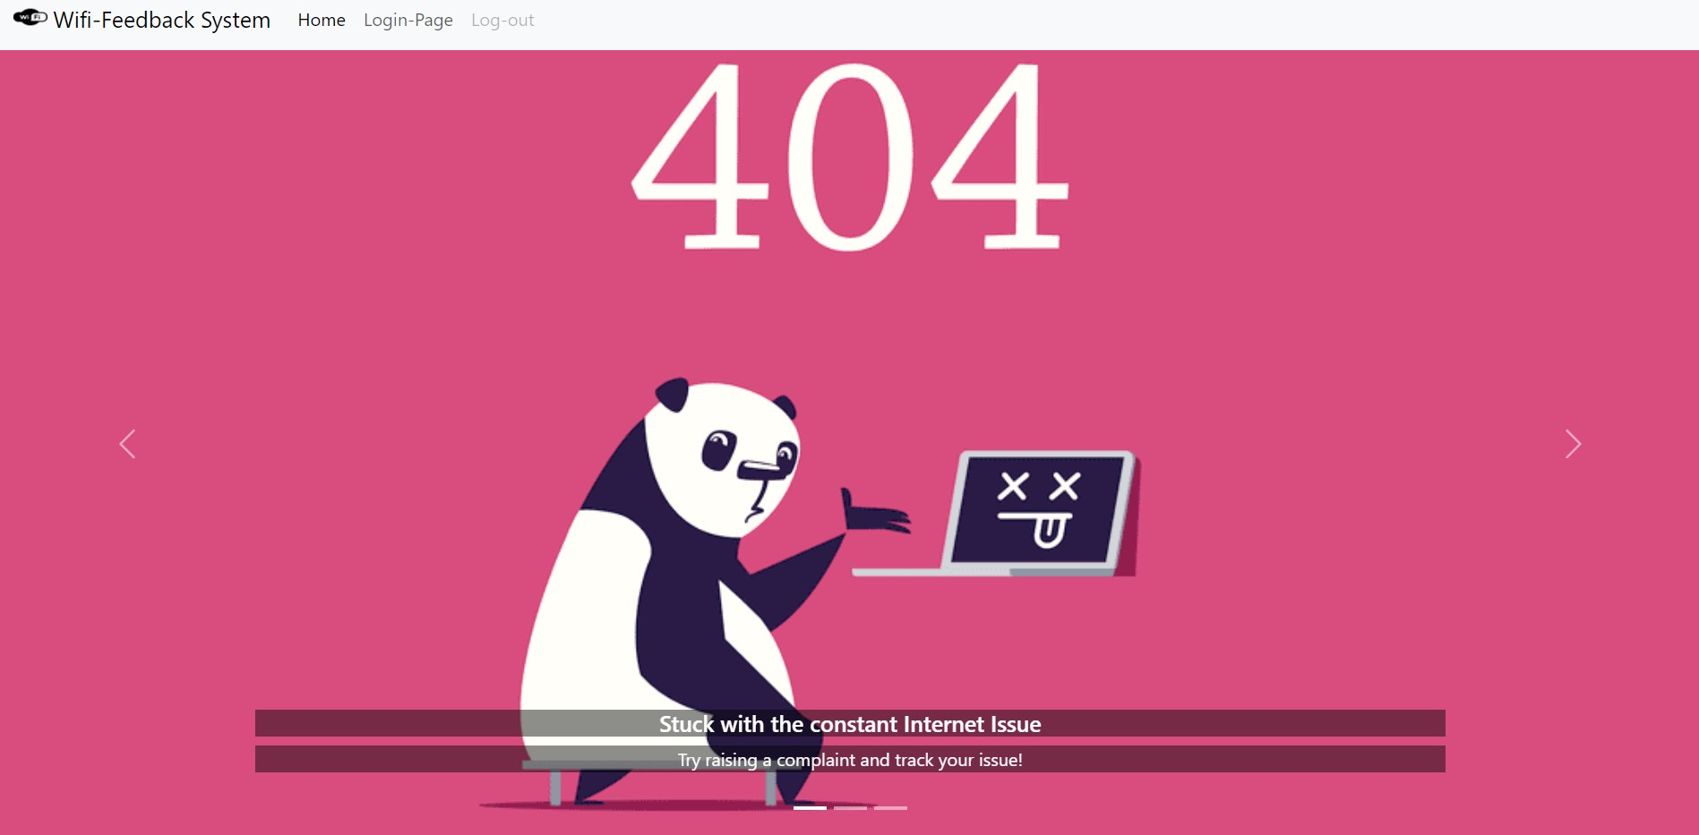

**2). Login.html -> login page**

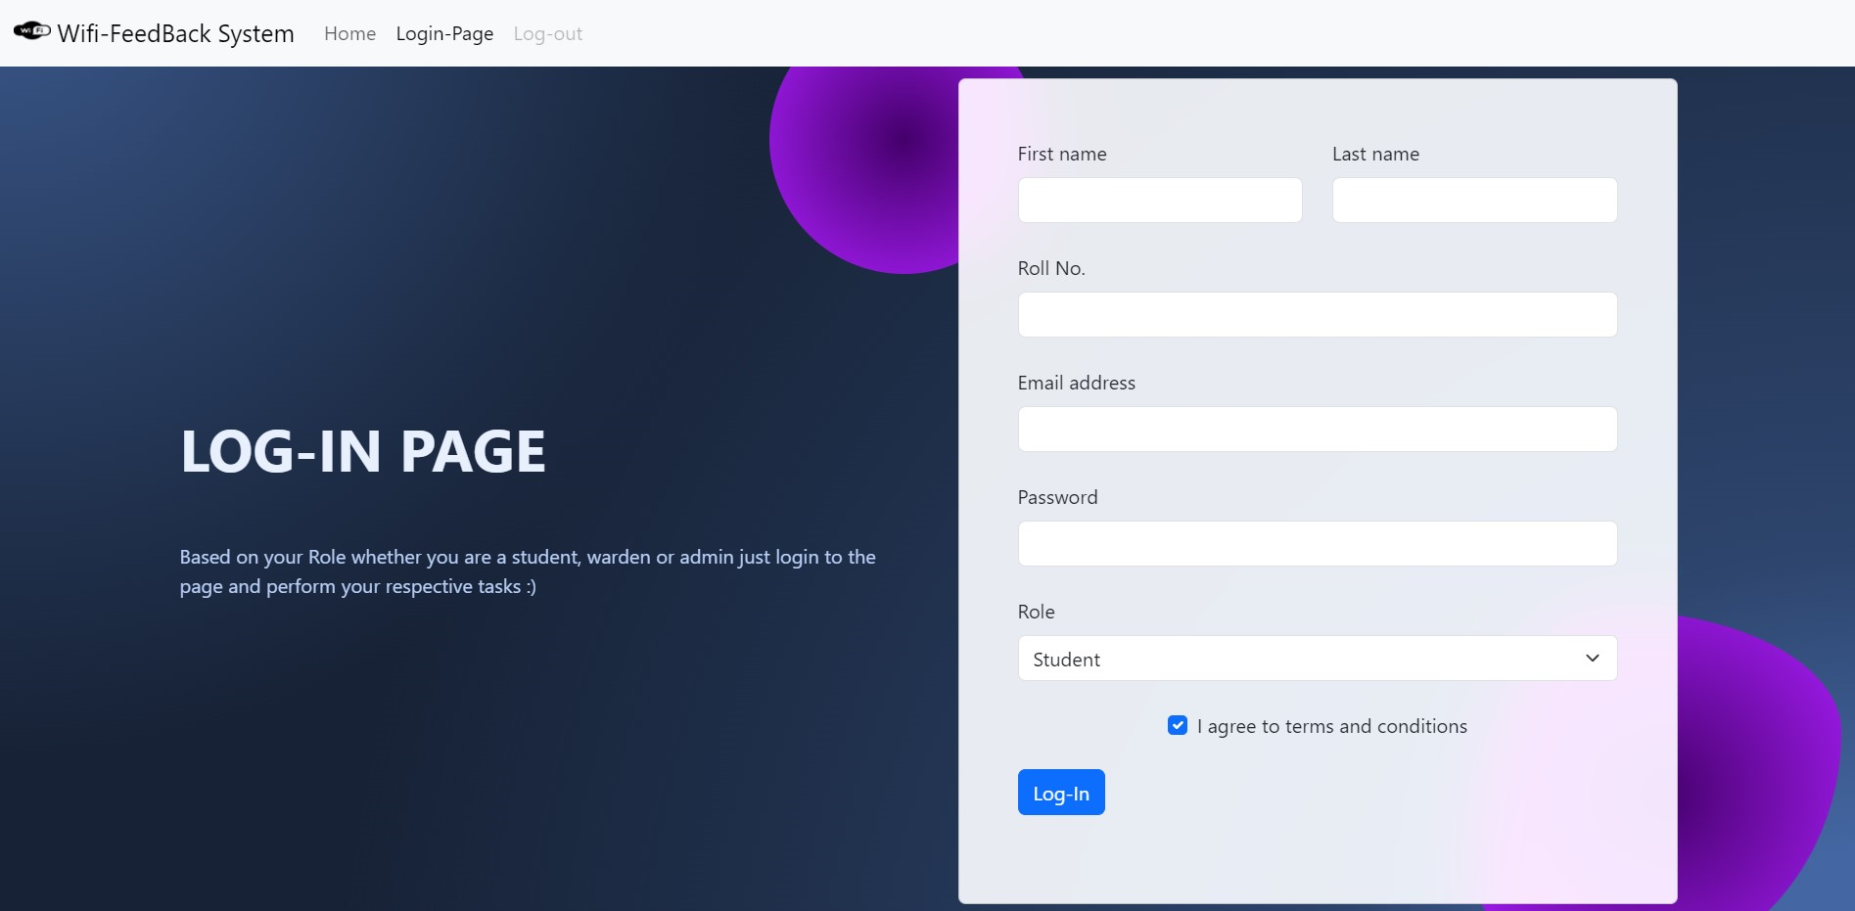

**3). raise-complaint.html**

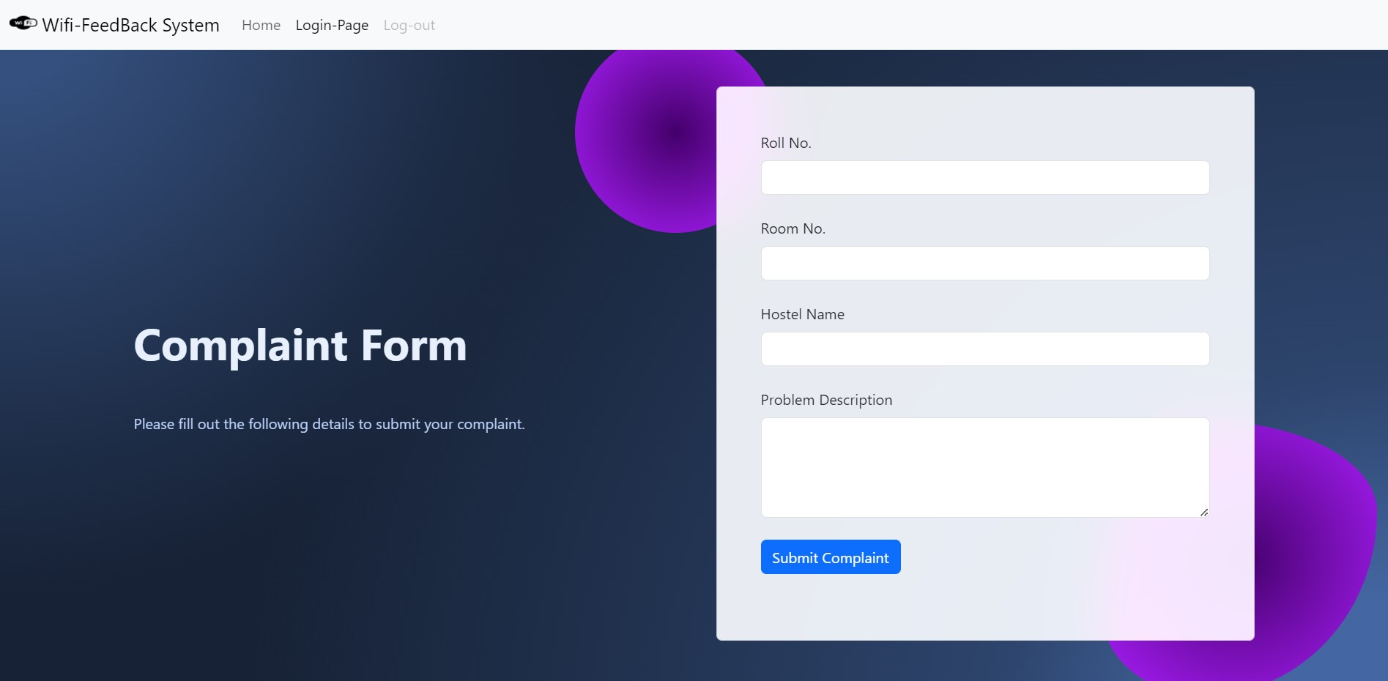

**4). Student.html -> student page**

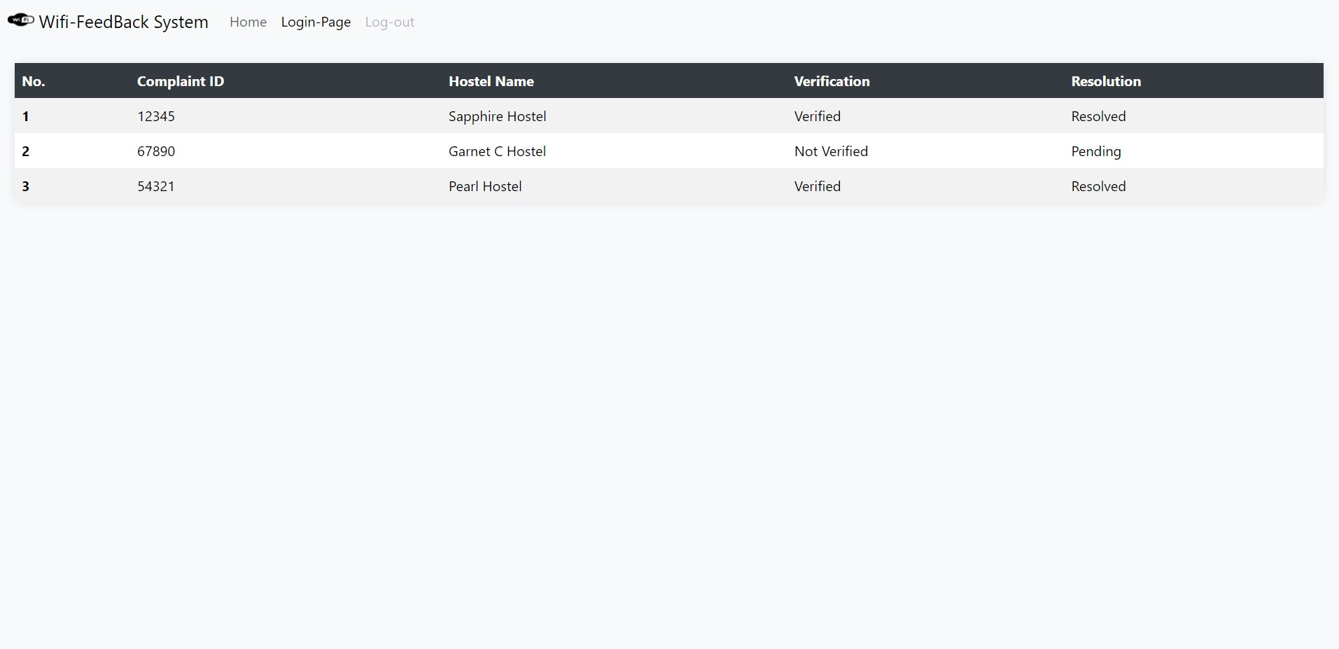

**5). Admin.html -> admin page**

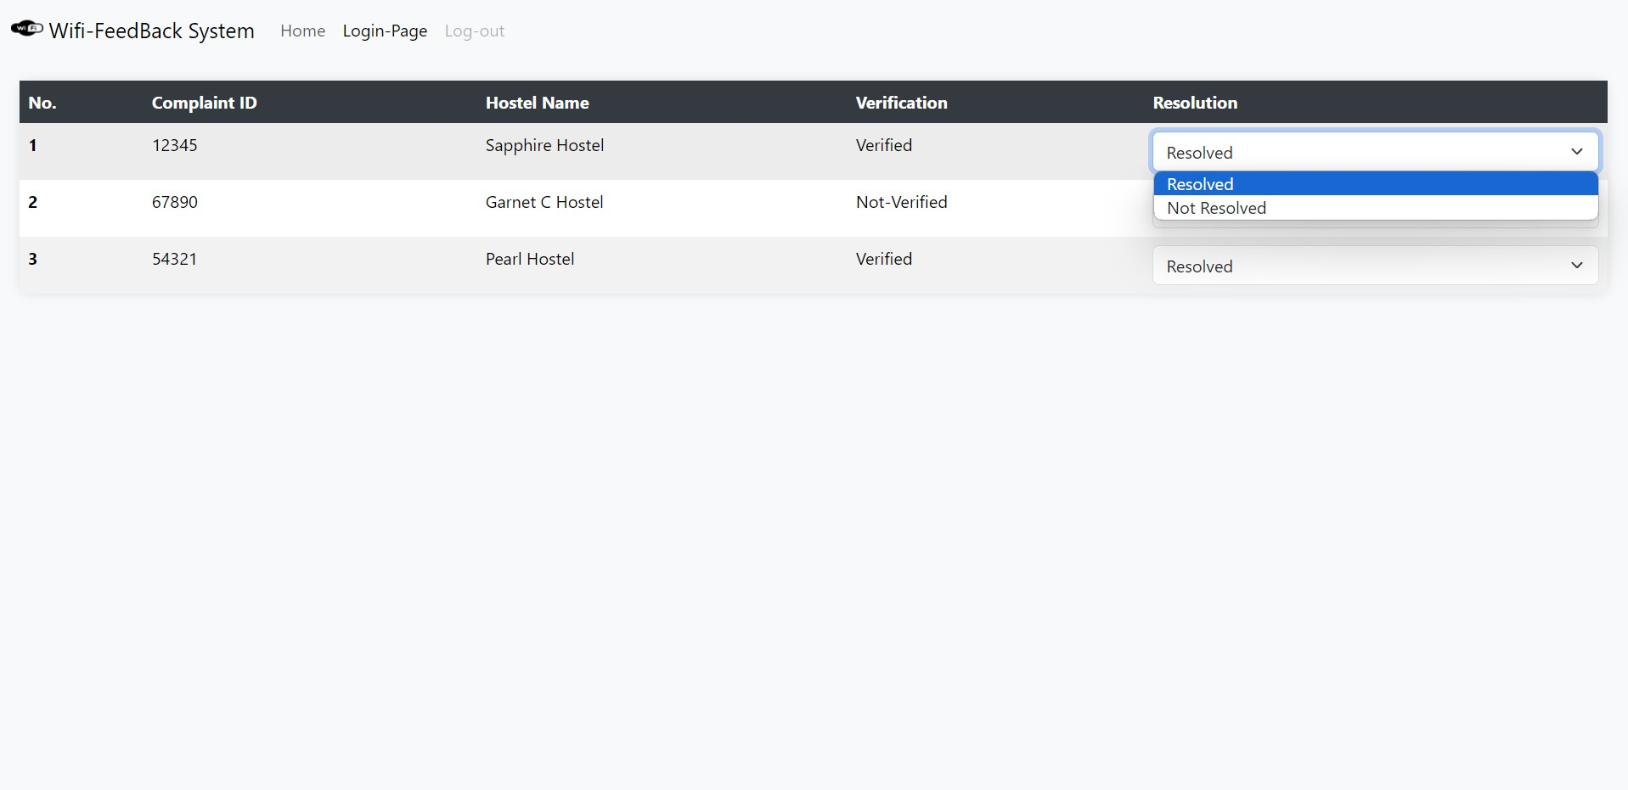

**6). Warden.html -> warden page**

