**6CS007 – Project and Professionalism**

**Milestone 2 - Literature Review**

University Id: 2330520

Group: L6CG22

Submitted by: Shrota Ghimire

Submitted on: 2nd January, 2025

# Functional Decomposition Diagram (FDD)

# Subsystem 1 – Authentication

## 2.1 Introduction

This document outlines the artifact design for the Authentication Subsystem as part of the final year project. User authentication gets secure management through this subsystem, so it protects authorized access to the Task Management System.

This subsystem provides users with secure identification procedures which offer both flexibility and defensive integrity. User registration functionality and login authentication services and role-based access control capabilities will be managed by this subsystem to realize data security and system integrity across all platform elements.

## 2.2 System Architecture and Design

## 2.2.1 Activity Diagram

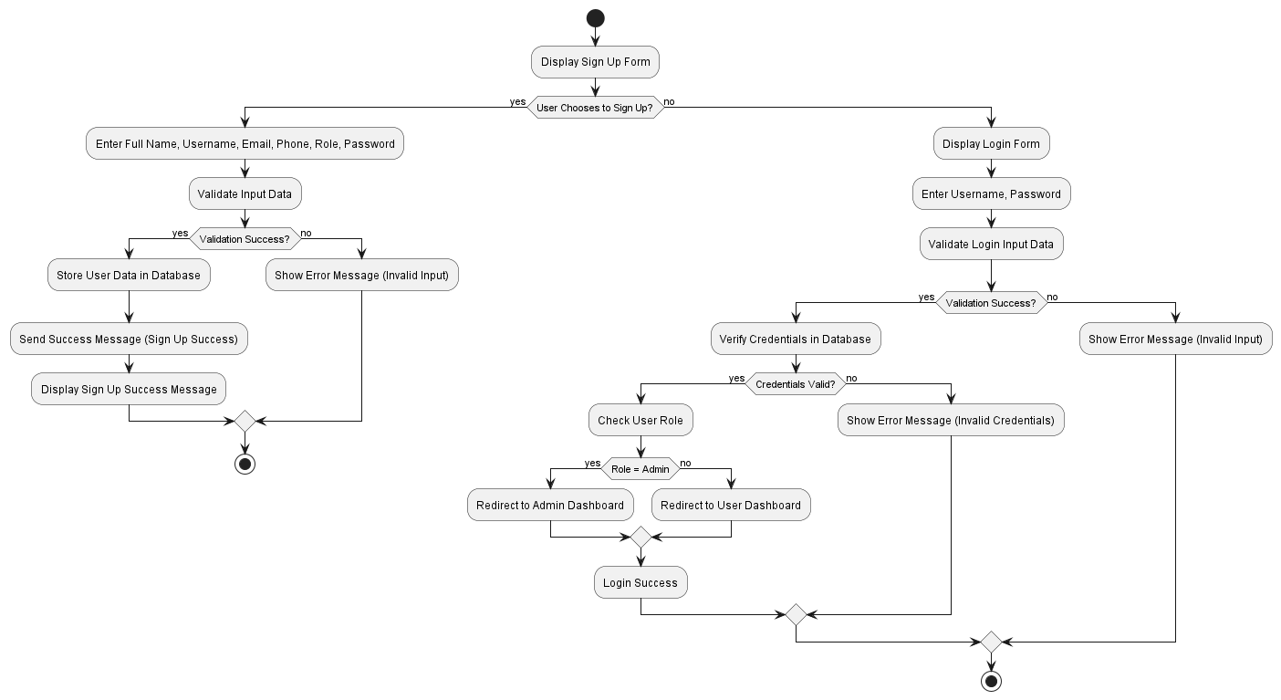

Figure 1: Activity Diagram

## 2.2.2 Use case Diagram

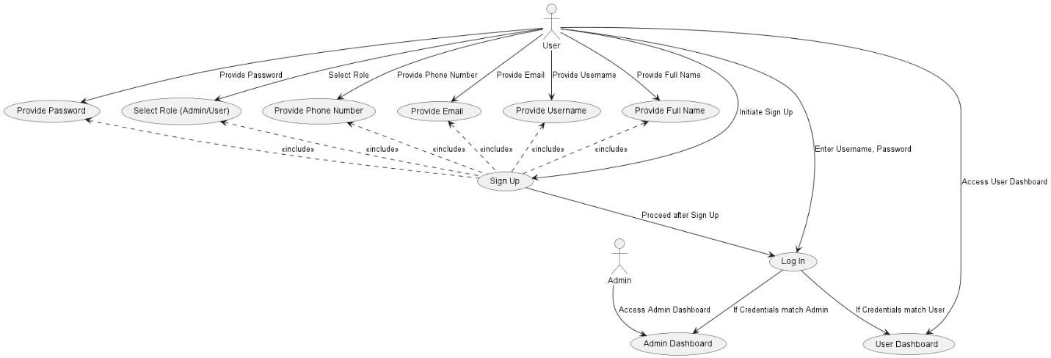

Figure 2: Use Case Diagram

## 2.2.2 Entity Relationship Diagram (ERD)

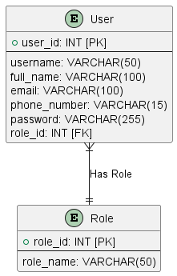

Figure 3: Entity-Relationship Diagram

## 2.2.3 Class Diagram

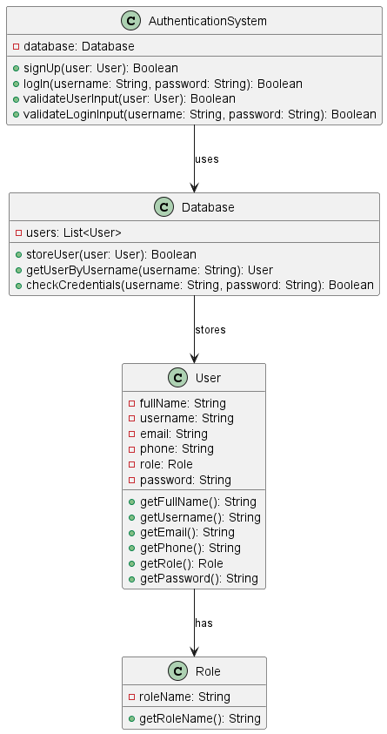

Figure 4: Class Diagram

## 2.2.4 Sequence Diagram

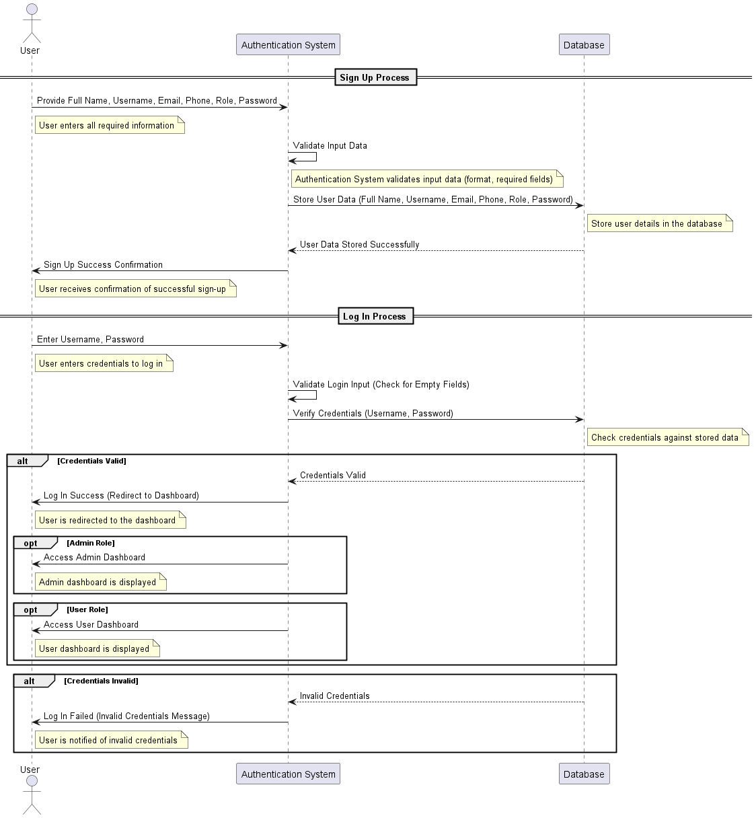

Figure 5: Sequence Diagram

## 2.3 Critical Features and Implementation

## 2.3.1 Key Functionalities

## 2.3.1.1 Feature 1: User Sign-up

**Description:**

* Through the Sign-Up interface users can establish new accounts through submitting their account information.
* Users who need system access must register while the application maintains the secure storage of their information.

**Implementation:**

* **Frontend:**
* Users need to complete a registration form containing full name, username, email, phone number, password and their designated role. Users complete a form which contains mandatory input validations to verify both mandatory field entry and proper data formatting.
* **Backend:**
* The Authentication System class processes user input before validating it for accuracy then stores user information in the database.

# 