1. 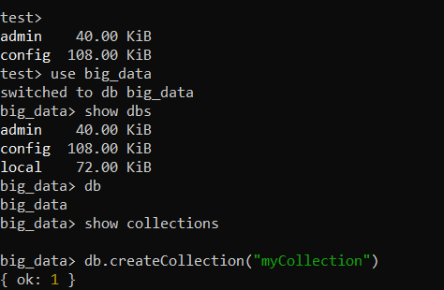
2. A computer code on a black background

   AI-generated content may be incorrect.
3. A screenshot of a computer program

   AI-generated content may be incorrect.
4. A computer screen shot of a program code

   AI-generated content may be incorrect.

