Binary Information
Binary Name => PieIsMyFav
Language => C/C++
Arch => x86x64
Platform => Unix/Linux
$ file simple
simple: ELF 64-bit LSB pie executable, x86-64, version 1 (SYSV), dynamically linked, interpreter /lib64/ld-linux-x86-64.so.2, for GNU/Linux 3.2.0, BuildID[sha1]=dae0509e4edb79719a65af37962b74e4cf2a8c2e, not stripped

Analysis

Static Analysis
gef➤ info functions
All defined functions:
Non-debugging symbols:
0x0000000000001000 _init
0x0000000000001030 puts@plt
0x0000000000001040 printf@plt
0x0000000000001050 __isoc99_scanf@plt
0x0000000000001060 __cxa_finalize@plt
0x0000000000001070 _start
0x00000000000010a0 deregister_tm_clones
0x00000000000010d0 register_tm_clones
0x0000000000001110 __do_global_dtors_aux
0x0000000000001150 frame_dummy
0x0000000000001155 main
0x00000000000011f0 __libc_csu_init
0x0000000000001260 __libc_csu_fini
0x0000000000001264 _fini
gef➤ disass main
Dump of assembler code for function main:
0x0000000000001155 <+0>: push rbp
0x0000000000001156 <+1>: mov rbp,rsp
0x0000000000001159 <+4>: sub rsp,0x10
0x000000000000115d <+8>: mov DWORD PTR [rbp-0x4],0x64
0x0000000000001164 <+15>: mov DWORD PTR [rbp-0x8],0xe
0x000000000000116b <+22>: mov DWORD PTR [rbp-0x10],0x0
0x0000000000001172 <+29>: mov DWORD PTR [rbp-0xc],0x0
0x0000000000001179 <+36>: lea rdi,[rip+0xe88] # 0x2008
0x0000000000001180 <+43>: call 0x1030 <puts@plt>
0x0000000000001185 <+48>: lea rdi,[rip+0xea8] # 0x2034
0x000000000000118c <+55>: mov eax,0x0
0x0000000000001191 <+60>: call 0x1040 <printf@plt>
0x0000000000001196 <+65>: lea rax,[rbp-0x10]
0x000000000000119a <+69>: mov rsi,rax
0x000000000000119d <+72>: lea rdi,[rip+0xea7] # 0x204b
0x00000000000011a4 <+79>: mov eax,0x0
0x00000000000011a9 <+84>: call 0x1050 <__isoc99_scanf@plt>
0x00000000000011ae <+89>: mov edx,DWORD PTR [rbp-0x4]
0x00000000000011b1 <+92>: mov eax,edx
0x00000000000011b3 <+94>: add eax,eax
0x00000000000011b5 <+96>: add edx,eax
0x00000000000011b7 <+98>: mov eax,DWORD PTR [rbp-0x8]
0x00000000000011ba <+101>: add eax,edx
0x00000000000011bc <+103>: cdq
0x00000000000011bd <+104>: idiv DWORD PTR [rbp-0x4]
0x00000000000011c0 <+107>: mov DWORD PTR [rbp-0xc],eax
0x00000000000011c3 <+110>: mov eax,DWORD PTR [rbp-0x10]
0x00000000000011c6 <+113>: cmp DWORD PTR [rbp-0xc],eax
0x00000000000011c9 <+116>: jne 0x11d9 <main+132>
0x00000000000011cb <+118>: lea rdi,[rip+0xe7c] # 0x204e
0x00000000000011d2 <+125>: call 0x1030 <puts@plt>
0x00000000000011d7 <+130>: jmp 0x11e5 <main+144>
0x00000000000011d9 <+132>: lea rdi,[rip+0xe82] # 0x2062
0x00000000000011e0 <+139>: call 0x1030 <puts@plt>
0x00000000000011e5 <+144>: mov eax,0x0
0x00000000000011ea <+149>: leave
0x00000000000011eb <+150>: ret
End of assembler dump.
gef➤ x/s 0x2034
0x2034: "Qual o numero magico? "
gef➤ x/s 0x2008
0x2008: "Welcome to the wonderful world of assembly!"
gef➤ x/s 0x204b
0x204b: "%d"
gef➤ x/s 0x204e
0x204e: "Essa eh a sua flag!"
gef➤ x/s 0x2062
0x2062: "Try harder..."
gef➤
Above is the disassembly of the main() function.

Program Workflow
- The binary takes an integer input which can be inferred because x/s 0x204b gives us %d
- If we give wrong integer then we get Try harder…
- If we give the right integer then we get Essa eh a sua flag!

Dynamic Analysis
Below is an image to demonstrate the logic behind the mathematical calculation of the program.
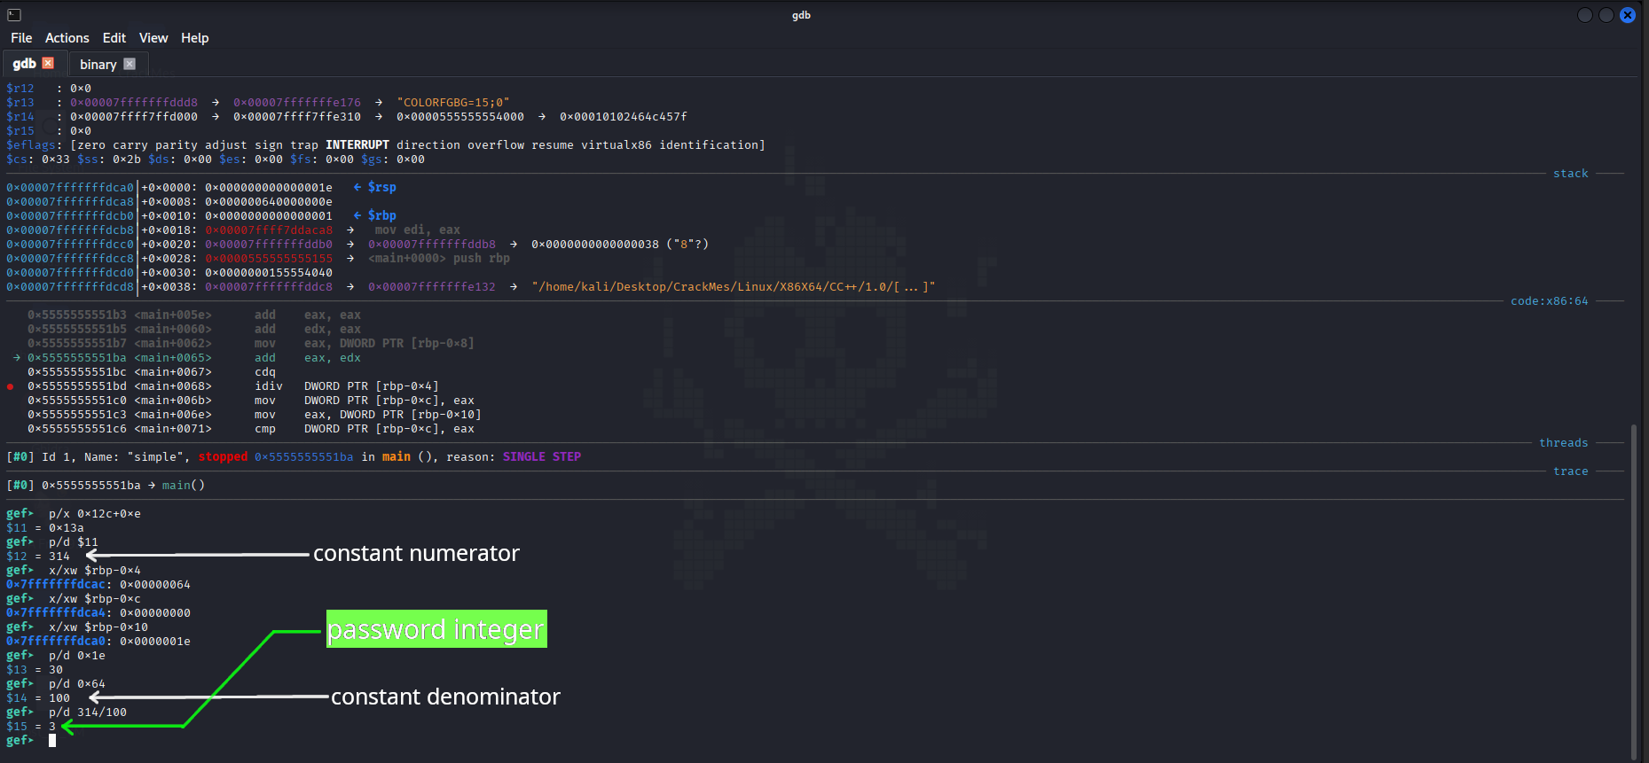
- You can set the breakpoint anywhere but set it somewhere above the instructions like I have done so that you can understand the calculation.
- I ran the program multiple times and I checked at the idiv instruction the division is always happening between 314(numerator) and 100(denominator). The numerator and denominator were in hex formats so you can change it to decimal format and verify it yourself.
- Now the result when 314 divided by 100 is 3 and the 3 is compared with our user input value at the comparison. If you look at the image properly the input I gave was 30 which is later moved to eax register before the comparison happens and then later compared with the division result i.e 3.
- Hence, I reached my conclusion that the user input should be 3.

Testing our input
$ ./simple
Welcome to the wonderful world of assembly!
Qual o numero magico? 3
Essa eh a sua flag!

