Binary Information
Binary Name => PrettyDamnEasy
Language => C/C++
Arch => x86x64
Platform => Unix/Linux
$ file crack
crack: ELF 64-bit LSB pie executable, x86-64, version 1 (SYSV), dynamically linked, interpreter /lib64/ld-linux-x86-64.so.2, for GNU/Linux 3.2.0, BuildID[sha1]=d9493670838135ebf0702a258f67982f62427900, not stripped

Analysis

Static Analysis
Below is the disassembly of the main() function of the binary and I also have examined the binary strings.
gef➤ disass main
Dump of assembler code for function main:
0x0000000000001165 <+0>: push rbp
0x0000000000001166 <+1>: mov rbp,rsp
0x0000000000001169 <+4>: sub rsp,0x20
0x000000000000116d <+8>: movabs rax,0x6361726379736165
0x0000000000001177 <+18>: mov QWORD PTR [rbp-0x14],rax
0x000000000000117b <+22>: mov WORD PTR [rbp-0xc],0x6b
0x0000000000001181 <+28>: lea rdi,[rip+0xe7c] # 0x2004
0x0000000000001188 <+35>: mov eax,0x0
0x000000000000118d <+40>: call 0x1040 <printf@plt>
0x0000000000001192 <+45>: lea rax,[rbp-0xa]
0x0000000000001196 <+49>: mov rsi,rax
0x0000000000001199 <+52>: lea rdi,[rip+0xe7a] # 0x201a
0x00000000000011a0 <+59>: mov eax,0x0
0x00000000000011a5 <+64>: call 0x1060 <__isoc99_scanf@plt>
0x00000000000011aa <+69>: lea rdx,[rbp-0x14]
0x00000000000011ae <+73>: lea rax,[rbp-0xa]
0x00000000000011b2 <+77>: mov rsi,rdx
0x00000000000011b5 <+80>: mov rdi,rax
0x00000000000011b8 <+83>: call 0x1050 <strcmp@plt>
0x00000000000011bd <+88>: test eax,eax
0x00000000000011bf <+90>: jne 0x11d4 <main+111>
0x00000000000011c1 <+92>: lea rdi,[rip+0xe55] # 0x201d
0x00000000000011c8 <+99>: mov eax,0x0
0x00000000000011cd <+104>: call 0x1040 <printf@plt>
0x00000000000011d2 <+109>: jmp 0x11e5 <main+128>
0x00000000000011d4 <+111>: lea rdi,[rip+0xe53] # 0x202e
0x00000000000011db <+118>: mov eax,0x0
0x00000000000011e0 <+123>: call 0x1040 <printf@plt>
0x00000000000011e5 <+128>: mov edi,0xa
0x00000000000011ea <+133>: call 0x1030 <putchar@plt>
0x00000000000011ef <+138>: mov eax,0x0
0x00000000000011f4 <+143>: leave
0x00000000000011f5 <+144>: ret
End of assembler dump.
gef➤ x/s 0x2004
0x2004: "\nInput the password: "
gef➤ x/s 0x201a
0x201a: "%s"
gef➤ x/s 0x201d
0x201d: "Correct password"
gef➤ x/s 0x202e
0x202e: "Wrong password, try another"
gef➤

Program Workflow
- Takes user input string (found %s by examining 0x201a).
- Checks if the string is correct or wrong.
- If string is correct then it prints Correct password else Wrong password, try another.

Dynamic Analysis
Now you need to setup to 2 breakpoints
- One breakpoint at main()
- Another breakpoint at (strcmp@plt) function.
- Make sure you have already run the main() method or the program before setting the 2nd breakpoint since the binary is dynamically linked so the addresses will not be valid if you setup breakpoint early on.
- After setting the 2 breakpoints continue the program and check the rdi and rsi registers.
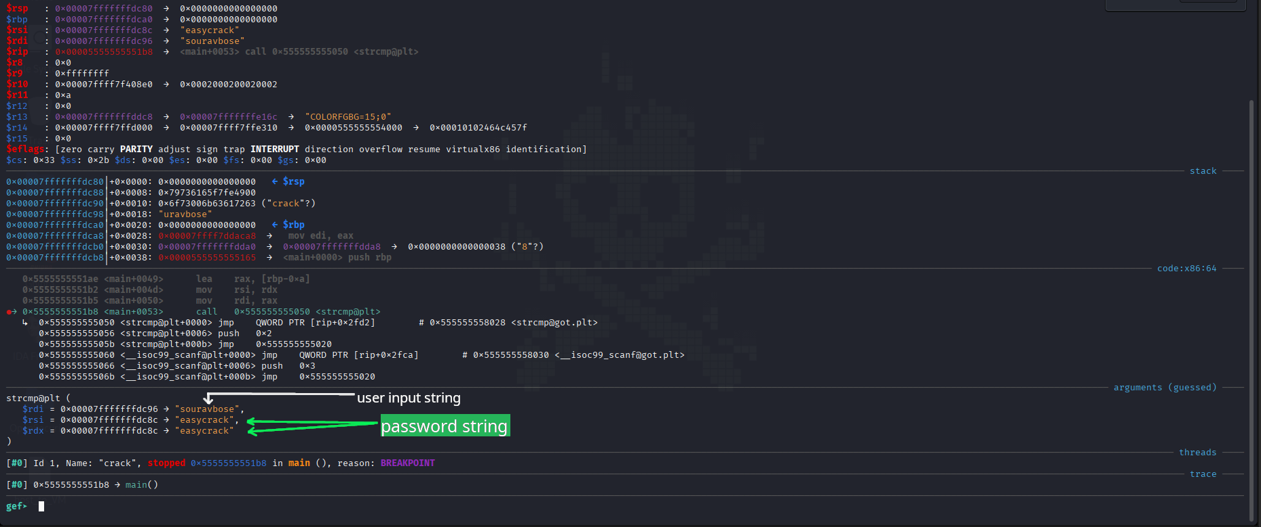

- So, we have got out password now let’s test it.

Testing our input
./crack
Input the password: easycrack
Correct password
Great!!! we were able to crack this crackme by checking the function arguments value.

