Binary Information
Binary Name => easyAF
Language => C/C++
Arch => x86x64
Platform => Unix/Linux
$ file easyAF
easyAF: ELF 64-bit LSB pie executable, x86-64, version 1 (SYSV), dynamically linked, interpreter /lib64/ld-linux-x86-64.so.2, BuildID[sha1]=c1f484166af165c71e71e8e0e5ebd8f9d6300f0a, for GNU/Linux 3.2.0, not stripped

Basic Workflow
- The program takes user string input
- Compares the user input string with its predefined string
- If our user input string is correct then WellDone! is printed otherwise Nope
Below is the picture to demonstrate the above Basic Overflow is a visual way.

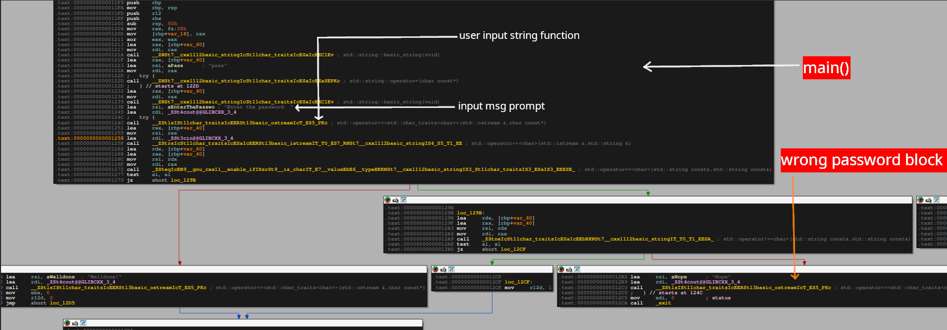

Analysis
I solved this crackme using gdb + gef(plugin).

Dynamic Analysis
The level was solved with a bit of hunch and dynamically analyzing what arguments or strings were loaded in the registers when function calls were made. Analyzing the stack gave me a pretty good idea what the password would be. Below is how I came to this conclusion.
I setup a breakpoint at main and then ran the program.
gef➤ disass main
Dump of assembler code for function main:
0x00005555555551f9 <+0>: push rbp
0x00005555555551fa <+1>: mov rbp,rsp
=> 0x00005555555551fd <+4>: push r12
0x00005555555551ff <+6>: push rbx
0x0000555555555200 <+7>: sub rsp,0x50
0x0000555555555204 <+11>: mov rax,QWORD PTR fs:0x28
0x000055555555520d <+20>: mov QWORD PTR [rbp-0x18],rax
0x0000555555555211 <+24>: xor eax,eax
0x0000555555555213 <+26>: lea rax,[rbp-0x60]
0x0000555555555217 <+30>: mov rdi,rax
0x000055555555521a <+33>: call 0x5555555550d0 <_ZNSt7__cxx1112basic_stringIcSt11char_traitsIcESaIcEEC1Ev@plt>
0x000055555555521f <+38>: lea rax,[rbp-0x60]
0x0000555555555223 <+42>: lea rsi,[rip+0xddb] # 0x555555556005
0x000055555555522a <+49>: mov rdi,rax
0x000055555555522d <+52>: call 0x5555555550c0 <_ZNSt7__cxx1112basic_stringIcSt11char_traitsIcESaIcEEaSEPKc@plt>
0x0000555555555232 <+57>: lea rax,[rbp-0x40]
0x0000555555555236 <+61>: mov rdi,rax
0x0000555555555239 <+64>: call 0x5555555550d0 <_ZNSt7__cxx1112basic_stringIcSt11char_traitsIcESaIcEEC1Ev@plt>
0x000055555555523e <+69>: lea rsi,[rip+0xdc5] # 0x55555555600a
0x0000555555555245 <+76>: lea rdi,[rip+0x2e54] # 0x5555555580a0 <_ZSt4cout@@GLIBCXX_3.4>
0x000055555555524c <+83>: call 0x555555555070 <_ZStlsISt11char_traitsIcEERSt13basic_ostreamIcT_ES5_PKc@plt>
0x0000555555555251 <+88>: lea rax,[rbp-0x40]
0x0000555555555255 <+92>: mov rsi,rax
0x0000555555555258 <+95>: lea rdi,[rip+0x2f61] # 0x5555555581c0 <_ZSt3cin@@GLIBCXX_3.4>
0x000055555555525f <+102>: call 0x5555555550a0 <_ZStrsIcSt11char_traitsIcESaIcEERSt13basic_istreamIT_T0_ES7_RNSt7__cxx1112basic_stringIS4_S5_T1_EE@plt>
0x0000555555555264 <+107>: lea rdx,[rbp-0x60]
0x0000555555555268 <+111>: lea rax,[rbp-0x40]
0x000055555555526c <+115>: mov rsi,rdx
0x000055555555526f <+118>: mov rdi,rax
0x0000555555555272 <+121>: call 0x5555555553f2 <_ZSteqIcEN9__gnu_cxx11__enable_ifIXsrSt9__is_charIT_E7__valueEbE6__typeERKNSt7__cxx1112basic_stringIS3_St11char_traitsIS3_ESaIS3_EEESE_>
0x0000555555555277 <+126>: test al,al
0x0000555555555279 <+128>: je 0x55555555529b <main+162>
0x000055555555527b <+130>: lea rsi,[rip+0xd9d] # 0x55555555601f
0x0000555555555282 <+137>: lea rdi,[rip+0x2e17] # 0x5555555580a0 <_ZSt4cout@@GLIBCXX_3.4>
0x0000555555555289 <+144>: call 0x555555555070 <_ZStlsISt11char_traitsIcEERSt13basic_ostreamIcT_ES5_PKc@plt>
0x000055555555528e <+149>: mov ebx,0x0
0x0000555555555293 <+154>: mov r12d,0x0
0x0000555555555299 <+160>: jmp 0x5555555552d5 <main+220>
0x000055555555529b <+162>: lea rdx,[rbp-0x60]
0x000055555555529f <+166>: lea rax,[rbp-0x40]
0x00005555555552a3 <+170>: mov rsi,rdx
0x00005555555552a6 <+173>: mov rdi,rax
0x00005555555552a9 <+176>: call 0x555555555476 <_ZStneIcSt11char_traitsIcESaIcEEbRKNSt7__cxx1112basic_stringIT_T0_T1_EESA_>
0x00005555555552ae <+181>: test al,al
0x00005555555552b0 <+183>: je 0x5555555552cf <main+214>
0x00005555555552b2 <+185>: lea rsi,[rip+0xd70] # 0x555555556029
0x00005555555552b9 <+192>: lea rdi,[rip+0x2de0] # 0x5555555580a0 <_ZSt4cout@@GLIBCXX_3.4>
0x00005555555552c0 <+199>: call 0x555555555070 <_ZStlsISt11char_traitsIcEERSt13basic_ostreamIcT_ES5_PKc@plt>
0x00005555555552c5 <+204>: mov edi,0x0
0x00005555555552ca <+209>: call 0x555555555090 <exit@plt>
0x00005555555552cf <+214>: mov r12d,0x1
0x00005555555552d5 <+220>: lea rax,[rbp-0x40]
0x00005555555552d9 <+224>: mov rdi,rax
0x00005555555552dc <+227>: call 0x555555555040 <_ZNSt7__cxx1112basic_stringIcSt11char_traitsIcESaIcEED1Ev@plt>
0x00005555555552e1 <+232>: cmp r12d,0x1
0x00005555555552e5 <+236>: je 0x5555555552ef <main+246>
0x00005555555552e7 <+238>: mov r12d,0x0
0x00005555555552ed <+244>: jmp 0x5555555552f5 <main+252>
0x00005555555552ef <+246>: mov r12d,0x1
0x00005555555552f5 <+252>: lea rax,[rbp-0x60]
0x00005555555552f9 <+256>: mov rdi,rax
0x00005555555552fc <+259>: call 0x555555555040 <_ZNSt7__cxx1112basic_stringIcSt11char_traitsIcESaIcEED1Ev@plt>
0x0000555555555301 <+264>: cmp r12d,0x1
0x0000555555555305 <+268>: jne 0x55555555530c <main+275>
0x0000555555555307 <+270>: mov ebx,0x0
0x000055555555530c <+275>: mov eax,ebx
0x000055555555530e <+277>: mov rcx,QWORD PTR [rbp-0x18]
0x0000555555555312 <+281>: xor rcx,QWORD PTR fs:0x28
0x000055555555531b <+290>: je 0x55555555534f <main+342>
0x000055555555531d <+292>: jmp 0x55555555534a <main+337>
0x000055555555531f <+294>: mov rbx,rax
0x0000555555555322 <+297>: lea rax,[rbp-0x40]
0x0000555555555326 <+301>: mov rdi,rax
0x0000555555555329 <+304>: call 0x555555555040 <_ZNSt7__cxx1112basic_stringIcSt11char_traitsIcESaIcEED1Ev@plt>
0x000055555555532e <+309>: jmp 0x555555555333 <main+314>
0x0000555555555330 <+311>: mov rbx,rax
0x0000555555555333 <+314>: lea rax,[rbp-0x60]
0x0000555555555337 <+318>: mov rdi,rax
0x000055555555533a <+321>: call 0x555555555040 <_ZNSt7__cxx1112basic_stringIcSt11char_traitsIcESaIcEED1Ev@plt>
0x000055555555533f <+326>: mov rax,rbx
0x0000555555555342 <+329>: mov rdi,rax
0x0000555555555345 <+332>: call 0x5555555550f0 <_Unwind_Resume@plt>
0x000055555555534a <+337>: call 0x555555555080 <__stack_chk_fail@plt>
0x000055555555534f <+342>: add rsp,0x50
0x0000555555555353 <+346>: pop rbx
0x0000555555555354 <+347>: pop r12
0x0000555555555356 <+349>: pop rbp
0x0000555555555357 <+350>: ret
End of assembler dump.
gef➤ b *0x0000555555555264
Breakpoint 2 at 0x555555555264
gef➤

I set up a breakpoint after the user input string was taken and then I figured I will check the stack for what happens next before any further function calls are made. NOTE: before setting the breakpoint make sure you have run the main() or started the program otherwise the address won’t load. This address is dynamically linked so setting breakpoint statically will be designated as invalid when the program will be executed.
After setting the breakpoint, I continued execution of the program and it prompted for password input.
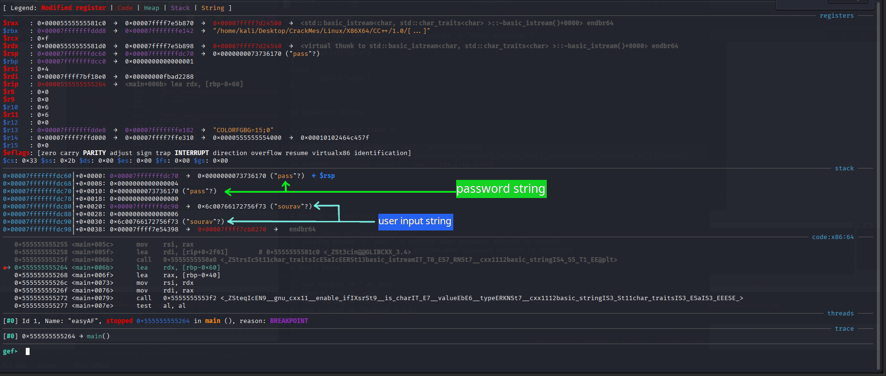

Check the stack condition and you will figure out the password by yourself only. Now after finding the password string its best to exit from the debugger and test our discovered password string.

Testing

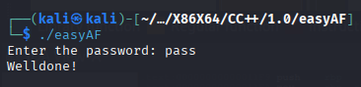

We were able to successfully crack easyAF crackme.

