Binary Information
Binary Name => eyecandylocked
Language => C/C++
Arch => x86x64
Platform => Unix/Linux
$ file EyeCandyLOCKED
EyeCandyLOCKED: ELF 64-bit LSB executable, x86-64, version 1 (SYSV), dynamically linked, interpreter /lib64/ld-linux-x86-64.so.2, for GNU/Linux 2.6.32, BuildID[sha1]=a2f07f96d62e5485980091b97aea74ddbe54648e, with debug_info, not stripped

Analysis

main() decompiled code
Below is link for the decompiled code of main() method by Ghidra.
https://gist.github.com/SHROUDSOURAV/88725fb3323fc8ddfc47555415d42ba4
Note: There are 2 files in the link main() and checkIt().

What does this Decompiled Code tells us ???
- The program uses PTRACE() which is a mechanism used for anti debugging so if we try to setup breakpoints and try to reverse engineer the program it will print “I am a 'crack me' program for God's sake.. Debugging tools like that..?some respect ;)here.” and then the program will exit.
- The program takes a user input string and calls checkIt() function where the password checking basically happens.
- If the password we enter is correct then the program prints “did it broughhh!! :D High five dude! :D.. here is your prize :3” else “password!!again fella or type "exit" to.... should I really explain this?”

checkIt() decompiled code
Below is link for the checkIt() decompiled code by Ghidra.
https://gist.github.com/SHROUDSOURAV/88725fb3323fc8ddfc47555415d42ba4
Note: There are 2 files in the link main() and checkIt().
So we have got the decompiled code for the checkIt() function, we can clearly see its comparing each character to those values. Those are hex values but the password we need to input should be in string format. I checked the disassembly of the checkIt function in IDA which clearly associated those values with the corresponding characters.

checkIt() disassembly Image

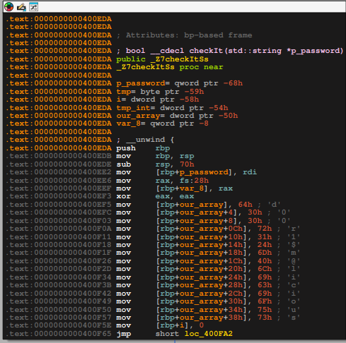

So, the password for unlocking the door is d00r1$m@licious.

Testing our input
$ ./EyeCandyLOCKED
*** THE DOOR IS LOCKED! ***
Gimme your password: d00r1$m@licious
*****************************
*** THE DOOR IS UNLOCKED! ***
*****************************
You did it broughhh!! :D High five dude! :D
Anyway.. here is your prize :3
http://cdn.business2community.com/wp-content/uploads/2014/10/Witch-Hat-Cat-Costume-For-Halloween.jpg.jpg

