Business Summary Report: Predictive Insights for Collections Strategy
Prepared for: Head of Collections, Geldium
Prepared by: AI Transformation Consultant (Tata iQ)

1. Summary of Predictive Insights
Based on the analysis of Geldium's 500-customer dataset, our predictive model has identified specific patterns indicating which customers are most likely to miss payments. Currently, 16% of the customer base is delinquent.

Figure 1: Overall Delinquency Distribution (84% Non-Delinquent vs 16% Delinquent)
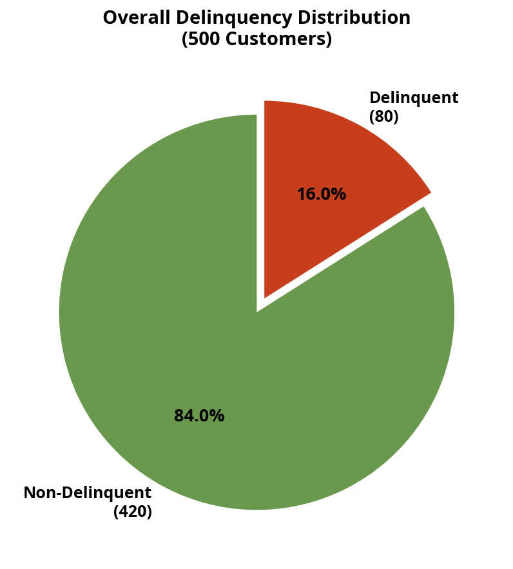
The following insights highlight the highest-risk segments, supported by the visual analysis below:
Key Insight | Customer Segment | Influencing Variables | Potential Impact
Unemployed customers face the highest default risk | Customers classified as "Unemployed" | Employment Status | The unemployed segment has a 19.4% delinquency rate (highest among all groups), indicating a need for specialized hardship support.
Young adults (Under 25) are significantly more likely to default | Customers aged 18–24 | Age | This demographic shows an 18.7% delinquency rate (vs 7.4% for 25–35 age group), suggesting financial instability early in careers.
High Debt-to-Income (DTI) ratio drives delinquency | Customers with DTI between 35% and 45% | Debt_to_Income_Ratio | Customers in the "High" DTI band have an 18.3% delinquency rate. Managing their debt burden is critical.

Figure 2: Delinquency Rate by Employment Status
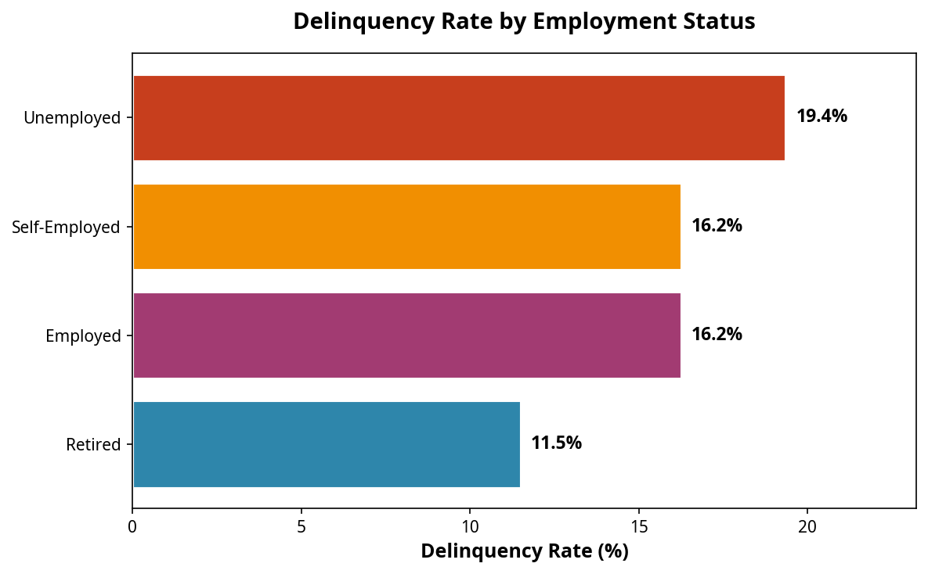

Figure 3: Delinquency Rate by Age Group (Overall Avg: 16.0%)
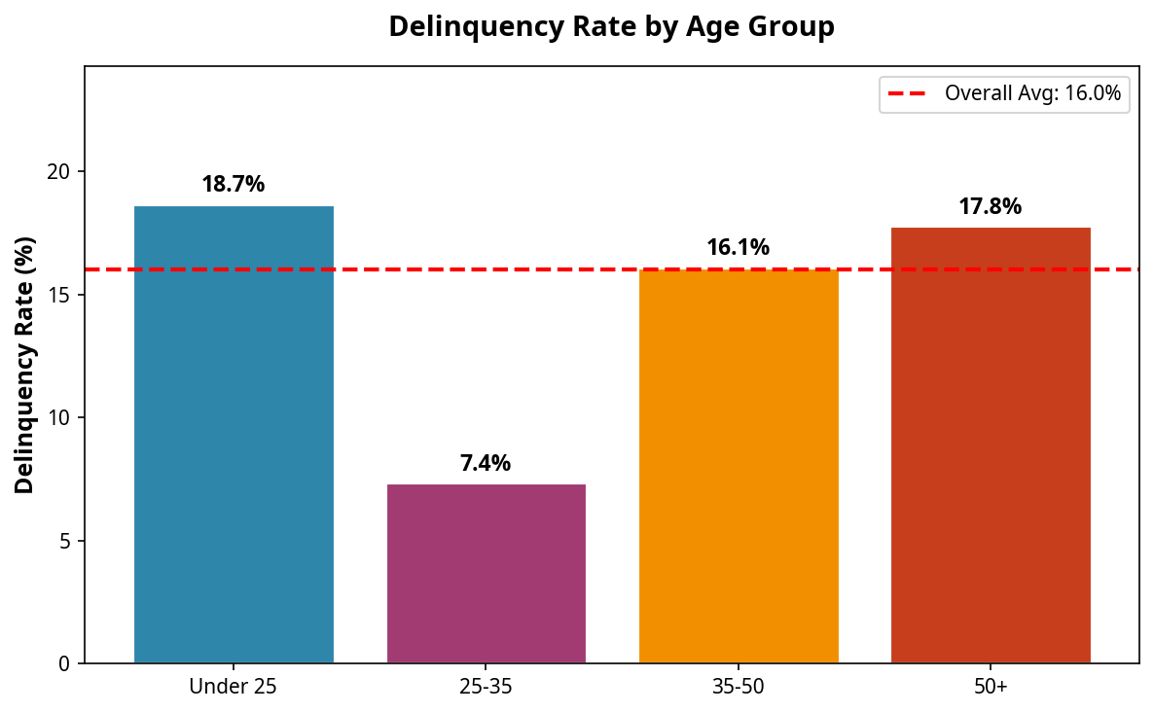

Figure 4: Delinquency Rate by Debt-to-Income Ratio
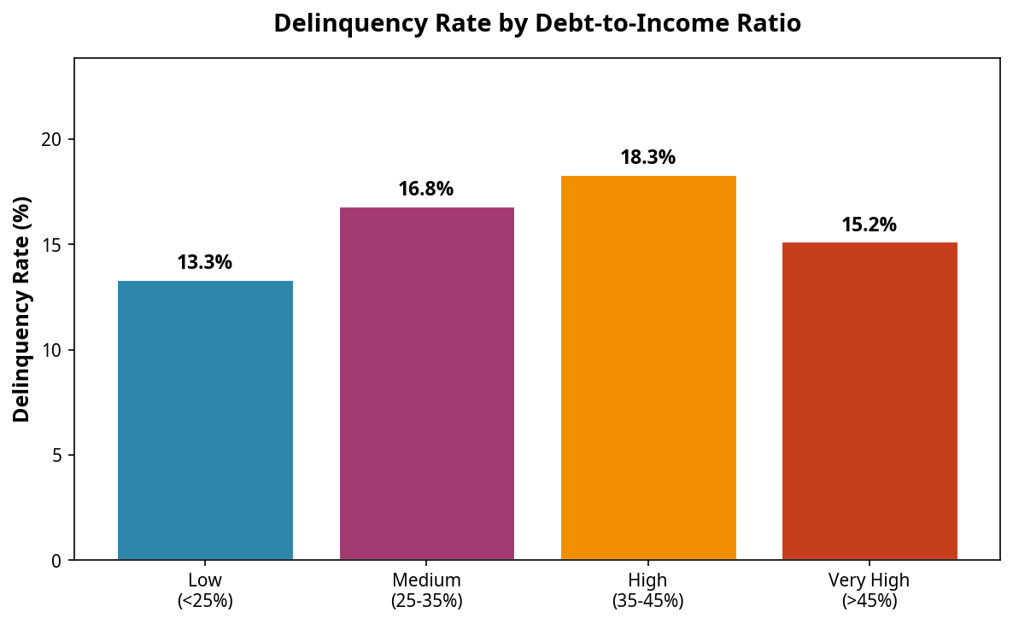

2. Recommendation Framework
Based on the insight that unemployed customers face the highest default risk (19.4%), we propose the following intervention.
Restated Insight: Unemployed customers represent the highest-risk segment for delinquency, likely due to sudden loss of cash flow.

Proposed Recommendation: Launch a targeted "Hardship Support Initiative"
Specific: The Collections team will proactively contact unemployed customers flagged by the AI model and offer them a temporary 90-day interest-only payment plan.
Measurable: The goal is to reduce the delinquency rate within the unemployed segment from 19.4% to 15% within the first quarter of implementation.
Actionable: The Collections team can execute this using existing communication channels (email/SMS) and current billing systems to apply temporary interest-only adjustments.
Relevant: This directly addresses the root cause of the high-risk segment (lack of income) while preserving the customer relationship and recovering partial debt.
Time-bound: The program will be piloted over a 6-week period, with a full review at the 90-day mark.

Justification and Business Rationale:
This recommendation is highly feasible because it utilizes existing operational resources without requiring new technology. By offering a structured hardship plan, Geldium not only reduces immediate financial loss but also builds long-term customer loyalty. Customers who receive proactive support during financial distress are more likely to return to standard payments once re-employed, aligning with Geldium's long-term growth strategy.

3. Ethical and Responsible AI Considerations
As we deploy this AI-driven model, we must ensure our decisions remain fair, transparent, and responsible.

Fairness and Bias Risks:
The model relies heavily on variables like Employment Status and Age. There is a risk that the model could unfairly penalize specific demographics. For example, if the model consistently flags younger, lower-income customers as "high risk," it could create a feedback loop that denies them access to financial products. To mitigate this, we must regularly audit the model's False Positive Rate across different demographic groups to ensure that the AI is not systematically disadvantaging any protected class.

Explainability:
For the Collections team and the customers, it is critical to understand why a specific account was flagged. We chose a Logistic Regression model specifically for its explainability. It allows us to point to exact factors—such as "your Debt-to-Income ratio is too high"—rather than relying on a "black box" AI decision. This transparency builds trust and ensures we can clearly justify our actions to stakeholders and regulators.

Responsible Decision-Making:
The recommendation to offer interest-only plans is a proportionate and empathetic response to the AI's predictions. It ensures that our automated risk scoring translates into helpful financial guidance, rather than purely punitive collection efforts.

