Insurance Healthcare Analysis
Shardha Ramlal
2026-05-17

Table of Contents

Introduction
The research questions:
1.To predict the insurance cost of patients admitted to hospitals
2.To determine the main factors affecting insurance costs

Methodology
- The dataset for analysis was downloaded from Kaggle via URL1: https://www.kaggle.com/datasets/mirichoi0218/insurance
data is also available via github2 https://github.com/stedy/Machine-Learning-with-R-datasets/blob/master/insurance.csv
inspiration - https://www.kaggle.com/code/ruslankl/health-care-cost-prediction-w-linear-regression/input3
- Duplicate rows were removed (one present) 4,5
- Missing predictor variable (charges) was removed
- Exploratory data analysis (EDA) was constructed.
- Duplicates in the features were removed
- Dataset was split into a 75-25 training-test set combination. Charges was log transformed since data was right skewed
- Statistical and Machine Learning predictive models were built using the tidymodels R framework5. The models run were:
- Linear Regression
- Lasso Regression
- Decision Trees
- Random Forest
- Gradient Boosting
- Neural Network (MLP)
- RMSE was used as the comparison metric RMSE=1ni​yi−yi2

Results

Data Description and Visualisation
age: age of primary beneficiary
sex: insurance contractor gender, female, male
bmi: Body mass index, providing an understanding of body, weights that are relatively high or low relative to height, objective index of body weight (kg / m ^ 2) using the ratio of height to weight, ideally 18.5 to 24.9
children: Number of children covered by health insurance / Number of dependents
smoker: Smoking
region: the beneficiary’s residential area in the US, northeast, southeast, southwest, northwest.
charges: Individual medical costs billed by health insurance

Exploratory Data Analysis

Histogram of Insurance Charges
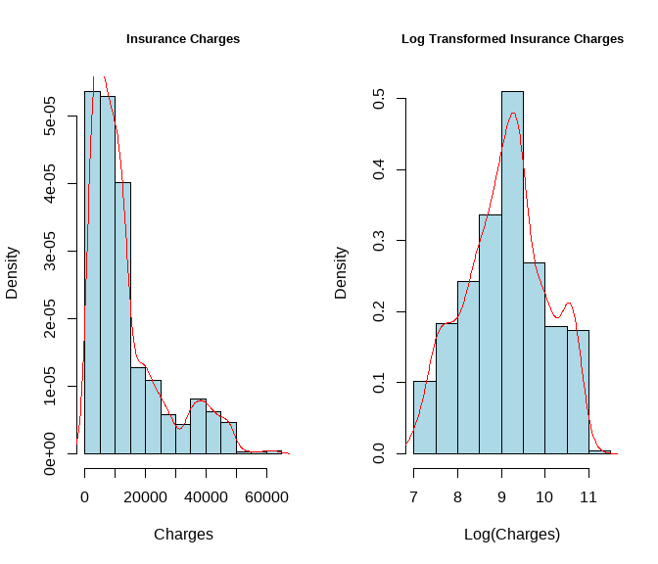
From the graph, the charges variable has a right skewed distribution - solution is to log transform, the charges variable

Summary Statistics of dataset
Characteristic | N = 1,337¹
Age | 39.22 (14.04)
Sex
female | 662 (49.5%)
male | 675 (50.5%)
BMI | 30.66 (6.10)
children
0 | 573 (42.9%)
1 | 324 (24.2%)
2 | 240 (18.0%)
3 | 157 (11.7%)
4 | 25 (1.9%)
5 | 18 (1.3%)
Smoker | 274 (20.5%)
Region
northeast | 324 (24.2%)
northwest | 324 (24.2%)
southeast | 364 (27.2%)
southwest | 325 (24.3%)
Charges | 13,279.12 (12,110.36)
Charges (Log) | 9.10 (0.92)
¹Mean (SD); n (%)

Partition and Split into Training and Test
75 % of the data was used for training, while the remaining was used for the test set.

Dimensionality Reduction
Correlation Plot
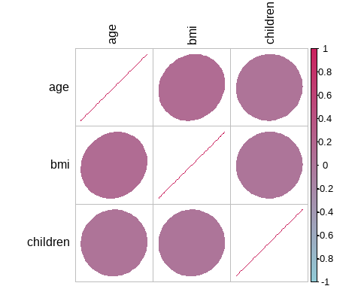
Correlation Matrix
Variable | age | bmi | children
age | 1.000 | 0.115 | 0.025
bmi | 0.115 | 1.000 | 0.017
children | 0.025 | 0.017 | 1.000

Models

Build Models using Tidymodels Workflow
The dependent variable (insurance cost) was log transformed for the training dataset, dummy variables were created for categorical variables (smoker, region, sex), numeric predictors were standardised by subtracting the mean and dividing by the standard deviation to ensure the same scale was used for analysis. Predictors with zero variance were removed.
To ensure speed in computing, models were run in parallel.
10 fold cross validation was used for tuning parameters in each model.
Model Ranking by RMSE (Training data)
model | .config | rmse | rank
mlp | pre0_mod2_post0 | 0.3566590 | 1
mlp | pre0_mod4_post0 | 0.3570474 | 2
rand_forest | pre0_mod4_post0 | 0.3611171 | 3
decision_tree | pre0_mod2_post0 | 0.3677569 | 4
boost_tree | pre0_mod5_post0 | 0.4206059 | 5
linear_reg | pre0_mod0_post0 | 0.4312260 | 6
linear_reg | pre0_mod1_post0 | 0.4312580 | 7
linear_reg | pre0_mod2_post0 | 0.4312580 | 8
linear_reg | pre0_mod3_post0 | 0.4312580 | 9
linear_reg | pre0_mod4_post0 | 0.4315851 | 10
The best model was seen to be the neural network

Autoplot of Best Model (Smallest RSME with Training data)
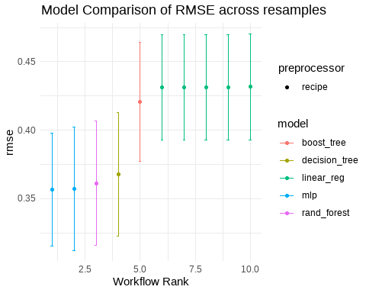
The best model is the neural network. For research question 1, the neural network models appears to fit this dataset the best.

Best Results using the test data
Best Neural Network Parameters
hidden_units | penalty | epochs | .config
3 | 1e-05 | 1000 | pre0_mod2_post0

Final Test Set Performance
.metric | .estimator | .estimate | .config
rmse | standard | 0.4229218 | pre0_mod0_post0
rsq | standard | 0.7892791 | pre0_mod0_post0
##
## Attaching package: 'vip'
## The following object is masked from 'package:utils':
##
## vi
Variable Importance for the Neural Network
Variable | Importance
smoker_yes | 60.7
bmi | 9.5
children | 5.1
sex_male | -2.3
region_southeast | -5.1
region_northwest | -7.2
region_southwest | -11.0
age | -18.2
The RSME yields 42.3 % using the neural network model on the test set. This may indicate, there are predictors missing / unaccounted for that may explain the variation better to predict insurance costs. For example, the dataset did not include diagnosis and clinical information which may have been possible crucial predictors of insurance costs
After extracting the variable importance for each of the predictors, it appeared that the top predictors of insurance cost were smoking, bmi and children. (research question 2)

Graph showing how the model fits the test data
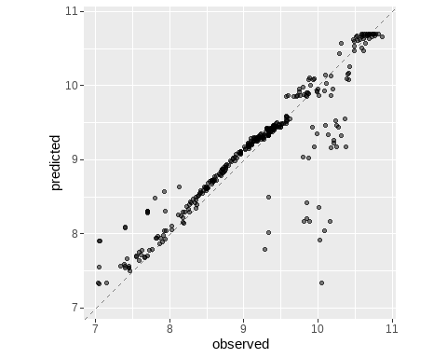
The predicted and observed insurance costs align mainly on the diagonal line.

References
- Medical Cost Personal Datasets [Internet]. [cited 2026 May 14]. Available from: https://www.kaggle.com/datasets/mirichoi0218/insurance
- stedy. GitHub [Internet]. [cited 2026 May 14]. Machine-Learning-with-R-datasets/insurance.csv at master · stedy/Machine-Learning-with-R-datasets. Available from: https://github.com/stedy/Machine-Learning-with-R-datasets/blob/master/insurance.csv
- Health Care Cost Prediction w/ Linear Regression [Internet]. [cited 2026 May 14]. Available from: https://kaggle.com/code/ruslankl/health-care-cost-prediction-w-linear-regression
- Identify and Remove Duplicate Data in R - Datanovia [Internet]. [cited 2026 Apr 25]. Available from: https://www.datanovia.com/en/lessons/identify-and-remove-duplicate-data-in-r/
- How to Remove Duplicate Rows in R DataFrame? - GeeksforGeeks [Internet]. [cited 2026 Apr 25]. Available from: https://www.geeksforgeeks.org/r-language/how-to-remove-duplicate-rows-in-r-dataframe/
- R CHARTS | A collection of charts and graphs made with the R programming language [Internet]. 2021 [cited 2026 Jan 29]. Pie chart with percentages in ggplot2. Available from: https://r-charts.com/part-whole/pie-chart-percentages-ggplot2/
- Gohel D. Chapter 5 officedown for Word | officeverse [Internet]. [cited 2026 Apr 25]. Available from: https://ardata-fr.github.io/officeverse/officedown-for-word.html
- Science B. Make Microsoft Word Reports with R + officedown | R-bloggers [Internet]. 2023 Mar 3 [cited 2026 Apr 25]. Available from: https://www.r-bloggers.com/2023/03/make-microsoft-word-reports-with-r-officedown/
- Riederer YX Christophe Dervieux, Emily. R Markdown Cookbook [Internet]. [cited 2026 Apr 25]. Available from: https://yihui.org/rmarkdown-cookbook/
- 11 Colour scales and legends – ggplot2: Elegant Graphics for Data Analysis (3e) [Internet]. [cited 2026 Apr 25]. Available from: https://ggplot2-book.org/scales-colour#brewer-scales
- R CHARTS | A collection of charts and graphs made with the R programming language [Internet]. 2021 [cited 2026 Apr 25]. Pie chart in ggplot2. Available from: https://r-charts.com/part-whole/pie-chart-ggplot2/
- Sequential, diverging and qualitative colour scales from ColorBrewer — scale_colour_brewer [Internet]. [cited 2026 Apr 25]. Available from: https://ggplot2.tidyverse.org/reference/scale_brewer.html
- RPubs - Reordering a ggplot bar chart axis [Internet]. [cited 2026 Apr 25]. Available from: https://www.rpubs.com/dvdunne/reorder_ggplot_barchart_axis
- Heiss A. Andrew Heiss [Internet]. [cited 2026 Apr 25]. Quick and easy ways to deal with long labels in ggplot2. Available from: https://www.andrewheiss.com/blog/2022/06/23/long-labels-ggplot/
- DataCamp [Internet]. [cited 2026 Apr 25]. Sorting Data in R. Available from: https://www.datacamp.com/doc/r/sorting
- ggplot2: Elegant Graphics for Data Analysis (3e) [Internet]. [cited 2026 Apr 25]. Available from: https://ggplot2-book.org/
- GeeksforGeeks [Internet]. 15:59:51+00:00 [cited 2026 Apr 25]. Remove Rows with Missing Values using R. Available from: https://www.geeksforgeeks.org/r-language/remove-rows-with-missing-values-using-r/
- Presentation-Ready Data Summary and Analytic Result Tables [Internet]. [cited 2026 Apr 25]. Available from: https://www.danieldsjoberg.com/gtsummary/
- Summary table — tbl_summary [Internet]. [cited 2026 Apr 25]. Available from: https://www.danieldsjoberg.com/gtsummary/reference/tbl_summary.html#ref-usage
- Working with model coefficients – tidymodels [Internet]. [cited 2026 Apr 26]. Available from: https://www.tidymodels.org/learn/models/coefficients/
- Fitting and predicting with parsnip [Internet]. [cited 2026 Apr 26]. Available from: https://parsnip.tidymodels.org/articles/Examples.html#boost_tree-models
- RPubs - Train and Evaluate Regression Models using Tidymodels [Internet]. [cited 2026 Apr 26]. Available from: https://rpubs.com/eR_ic/regression
- Silge MK and J. 15 Screening Many Models | Tidy Modeling with R [Internet]. [cited 2026 Apr 26]. Available from: https://www.tmwr.org/workflow-sets
- Sinks LE. Louise E. Sinks - A Tidymodels Tutorial: A Structural Approach [Internet]. 2023 [cited 2026 May 9]. Available from: https://lsinks.github.io/posts/2023-04-10-tidymodels/tidymodels_tutorial.html
- A Gentle Introduction to tidymodels · R Views [Internet]. [cited 2026 May 9]. Available from: https://rviews.rstudio.com/2019/06/19/a-gentle-intro-to-tidymodels/
- Obtain and format results produced by tuning functions — collect_predictions [Internet]. [cited 2026 May 17]. Available from: https://tune.tidymodels.org/reference/collect_predictions.html
- beckmw. Variable importance in neural networks | R-bloggers [Internet]. 2013 Aug 12 [cited 2026 May 17]. Available from: https://www.r-bloggers.com/2013/08/variable-importance-in-neural-networks/

