交互式气象数据查询系统软件V1.0

使用说明书

前言
本系统将目前用于工程、科研为目的的气象数据查询，系统具备全球位置的各类气象数据查询功能外，主要功能点即是提供全面、专业、可靠的气象数据。现对系统各模块功能做一全面说明：
一．系统登录界面
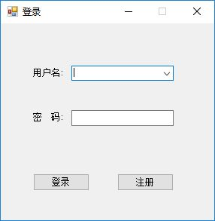
二．系统注册界面
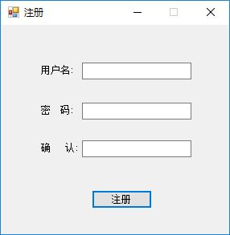
三．系统主界面
登录成功，即进入系统主界面。
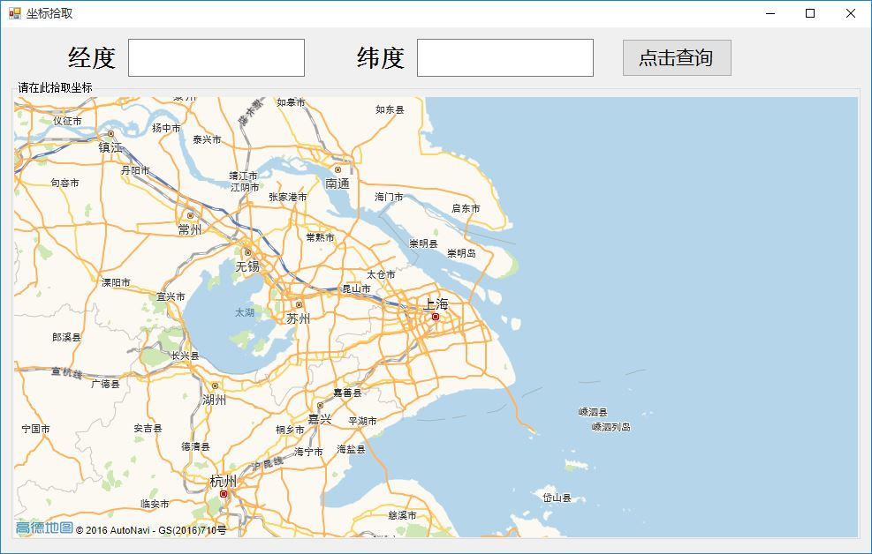
坐标拾取：
使用鼠标拖动来平移，使用鼠标滚轮来放缩，使用鼠标单击来选取位置，其坐标将立即显示：
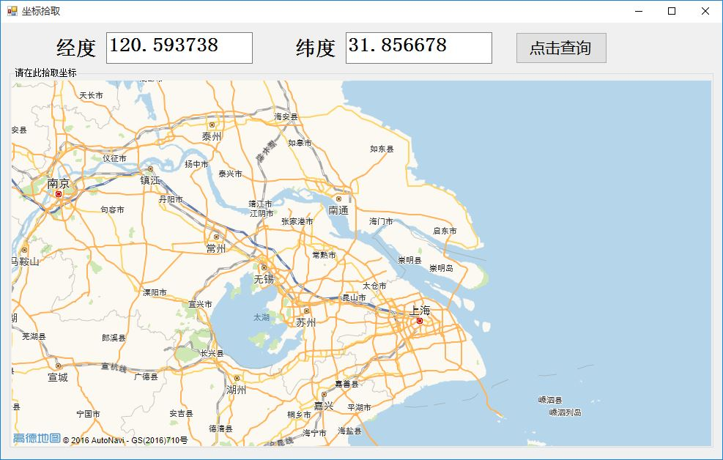
四．数据项选取界面
位置确定后，点击查询，即进入数据项选取界面。
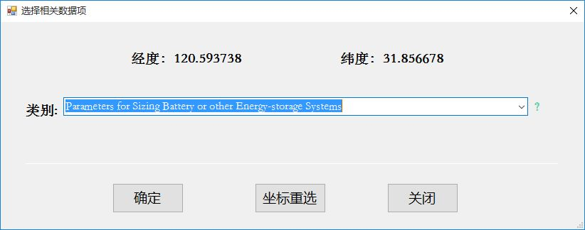
选择需要查询的数据的类别：
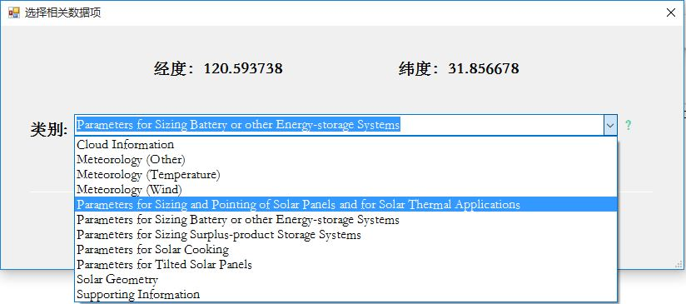
选择该类别下具体的数据项：
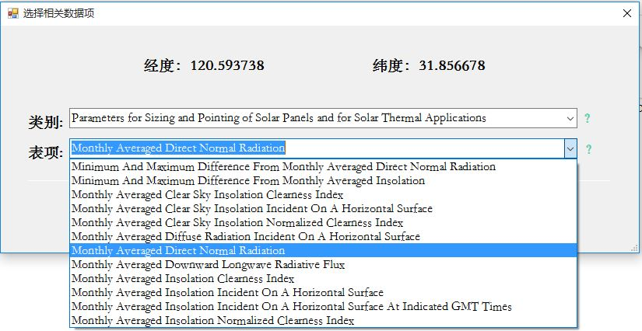
点击确定，查询到目标数据：
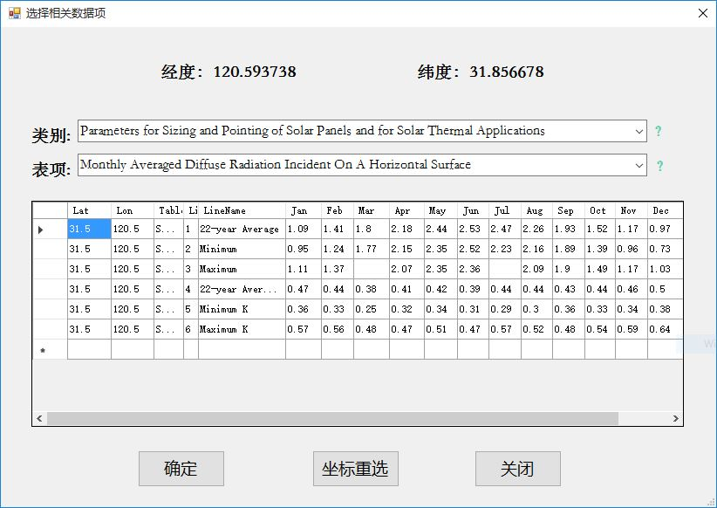
目前可供查询的数据项目见下表：
类别 | 表项
Parameters for Solar Cooking | Monthly Averaged Insolation Incident On A Horizontal Surface (kWh/m2/day)
Parameters for Solar Cooking | Monthly Averaged Midday Insolation Incident On A Horizontal Surface (kW/m2)
Parameters for Solar Cooking | Monthly Averaged Clear Sky Insolation Incident On A Horizontal Surface (kWh/m2/day)
Parameters for Solar Cooking | Monthly Averaged Clear Sky Days (days)
Parameters for Sizing and Pointing of Solar Panels and for Solar Thermal Applications | Monthly Averaged Insolation Incident On A Horizontal Surface (kWh/m2/day)
 | Minimum And Maximum Difference From Monthly Averaged Insolation (%)
 | Monthly Averaged Diffuse Radiation On A Horizontal Surface (kWh/m2/day)
 | Monthly Averaged Direct Normal Radiation (kWh/m2/day)
 | Minimum And Maximum Difference From Monthly Averaged Direct Normal Radiation (%)
 | Monthly Averaged Insolation Incident On A Horizontal Surface At Indicated GMT Times (kW/m2)
 | Monthly Averaged Insolation Clearness Index (0 to 1.0)
 | Monthly Averaged Insolation Normalized Clearness Index (0 to 1.0)
 | Monthly Averaged Clear Sky Insolation Incident On A Horizontal Surface (kWh/m2/day)
 | Monthly Averaged Clear Sky Insolation Clearness Index (0 to 1.0)
 | Monthly Averaged Clear Sky Insolation Normalized Clearness Index (0 to 1.0)
 | Monthly Averaged Downward Longwave Radiative Flux (kWh/m2/day)
Solar Geometry | Monthly Averaged Solar Noon (GMT time)
Solar Geometry | Monthly Averaged Daylight Hours (hours)
Solar Geometry | Monthly Averaged Daylight Average Of Hourly Cosine Solar Zenith Angles (dimensionless)
Solar Geometry | Monthly Averaged Cosine Solar Zenith Angle At Mid-Time Between Sunrise And Solar Noon (dimensionless)
Solar Geometry | Monthly Averaged Declination (degrees)
Solar Geometry | Monthly Averaged Sunset Hour Angle (degrees)
Solar Geometry | Monthly Averaged Maximum Solar Angle Relative To The Horizon (degrees)
Solar Geometry | Monthly Averaged Hourly Solar Angles Relative To The Horizon (degrees)
Solar Geometry | Monthly Averaged Hourly Solar Azimuth Angles (degrees)
Parameters for Tilted Solar Panels | Monthly Averaged Radiation Incident On An Equator-Pointed Tilted Surface (kWh/m2/day)
Parameters for Tilted Solar Panels | Minimum Radiation Incident On An Equator-pointed Tilted Surface (kWh/m2/day)
Parameters for Tilted Solar Panels | Maximum Radiation Incident On An Equator-pointed Tilted Surface (kWh/m2/day)
Parameters for Sizing Battery or other Energy-storage Systems | Minimum Available Insolation Over A Consecutive-day Period (%)
 | Solar Radiation Deficits Below Expected Values Incident On A Horizontal Surface Over A Consecutive-day Period (kWh/m2)
 | Equivalent Number Of NO-SUN Or BLACK Days (days)
Parameters for Sizing Surplus-product Storage Systems | Available Surplus Insolation Over A Consecutive-day Period (%)
Cloud Information | Monthly Averaged Daylight Cloud Amount (%)
Cloud Information | Monthly Averaged Cloud Amount At Indicated GMT Times (%)
Cloud Information | Monthly Averaged Frequency Of Clear Skies At Indicated GMT Times (%)
Cloud Information | Monthly Averaged Frequency Of Broken-cloud Skies At Indicated GMT Times (%)
Cloud Information | Monthly Averaged Frequency Of Near-overcast Skies At Indicated GMT Times (%)
Meteorology (Temperature) | Monthly Averaged Air Temperature At 10 m Above The Surface Of The Earth (°C)
Meteorology (Temperature) | Average Daily Temperature Range (°C)
Meteorology (Temperature) | Monthly Averaged Cooling Degree Days Above 18 °C
Meteorology (Temperature) | Monthly Averaged Heating Degree Days Below 18 °C
Meteorology (Temperature) | Monthly Averaged Arctic Heating Degree Days Below 10 °C
Meteorology (Temperature) | Monthly Averaged Arctic Heating Degree Days Below 0 °C
Meteorology (Temperature) | Monthly Averaged Earth Skin Temperature (°C)
Meteorology (Temperature) | Average Minimum, Maximum and Amplitude Of The Daily Mean Earth Temperature (°C)
Meteorology (Temperature) | Monthly Averaged Frost Days (days)
Meteorology (Temperature) | Dew/Frost Point Temperature At 10 m (°C)
Meteorology (Wind) | Monthly Averaged Wind Speed At 50 m Above The Surface Of The Earth (m/s)
Meteorology (Wind) | Minimum And Maximum Difference From Monthly Averaged Wind Speed At 50 m (%)
Meteorology (Wind) | Monthly Averaged Percent Of Time The Wind Speed At 50 m Above The Surface Of The Earth Is Within The Indicated Range (%)
Meteorology (Wind) | Monthly Averaged Wind Speed At 50 m Above The Surface Of The Earth For Indicated GMT Times (m/s)
Meteorology (Wind) | Monthly Averaged Wind Direction At 50 m Above The Surface Of The Earth (degrees)
Meteorology (Wind) | Monthly Averaged Wind Direction At 50 m Above The Surface Of The Earth For Indicated GMT Times (degrees)
Meteorology (Wind) | Monthly Averaged Wind Speed At 10 m Above The Surface Of The Earth For Terrain Similar To Airports (m/s)
Meteorology (Wind) | Difference Between The Average Wind Speed At 10 m Above The Surface Of The Earth And The Average Wind speed At 50 m Above The Surface Of The Earth (%)
Meteorology (Wind) | Monthly Averaged Wind Speed Adjusted For Height And Vegetation Type (m/s)
Meteorology (Wind) | Monthly Averaged Wind Speed At 50, 100, 150 and 300 m Above The Surface Of The Earth (m/s)
Meteorology (Wind) | Monthly Averaged Wind Speed For Several Vegetation And Surface Types (m/s)
Meteorology (Other) | Monthly Averaged Relative Humidity (%)
Meteorology (Other) | Monthly Averaged Specific Humidity At 10 m Above The Surface Of The Earth (kg/kg)
Meteorology (Other) | Monthly Averaged Atmospheric Pressure (kPa)
Meteorology (Other) | Monthly Averaged Total Column Precipitable Water (cm)
Meteorology (Other) | Monthly Averaged Precipitation (mm/day)
Supporting Information | Monthly Averaged Top-of-atmosphere Insolation (kWh/m2/day)
Supporting Information | Monthly Averaged Surface Albedo (0 to 1.0)

本系统有一个重要的创新，即用户交互方式进行创新，使用地图选点的方式来获取气象数据，这样从根本上改变了传统的输入文本，获得数据的模式，使用技术把整个过程变成为更加友好的过程。具有将可靠的数据以友好的方式贡献给有需要的人重要意义。

