1. write a SQL query to find Employees who have the biggest salary in their Department

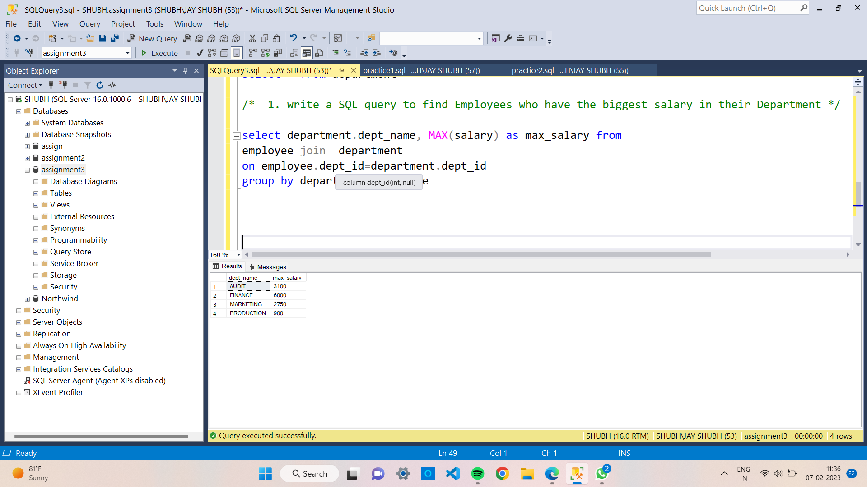

2. write a SQL query to find Departments that have less than 3 people in it

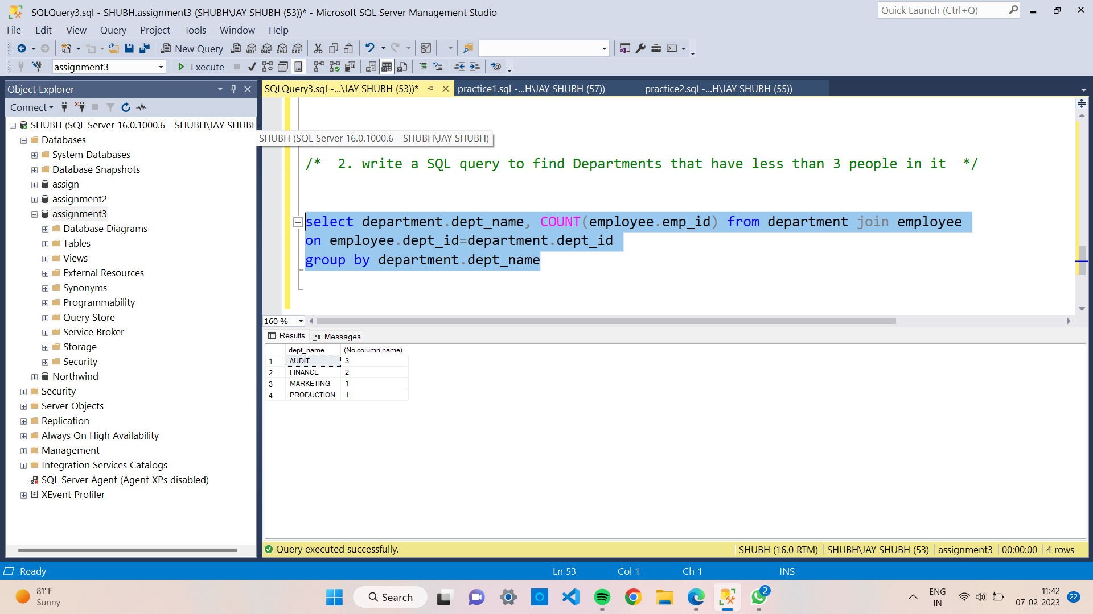

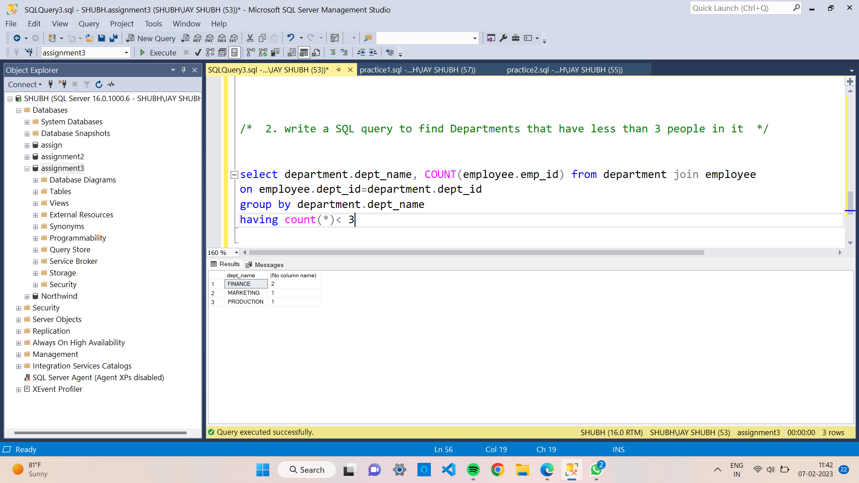

3. write a SQL query to find All Department along with the number of people there

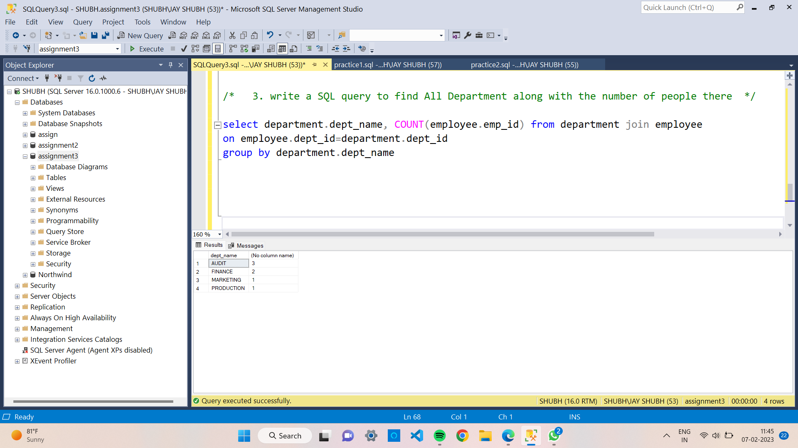

4. write a SQL query to find All Department along with the total salary there

