Business Statistics of two types
- Descriptive Statistics
- Inferential Statistics

Descriptive Statistics is of 3 types
- Measure of Central Tendency: - We get an idea about the centre of the data.
# Mean : - Mean is the number which represents the whole set of data. Mean will fail if outliers are present in dataset
# Median : - middle most value in a sorted data, 50th percentile of the sorted data. Median will also help in outliers case as well
# Mode : - the number which is repeating majority no. of time.
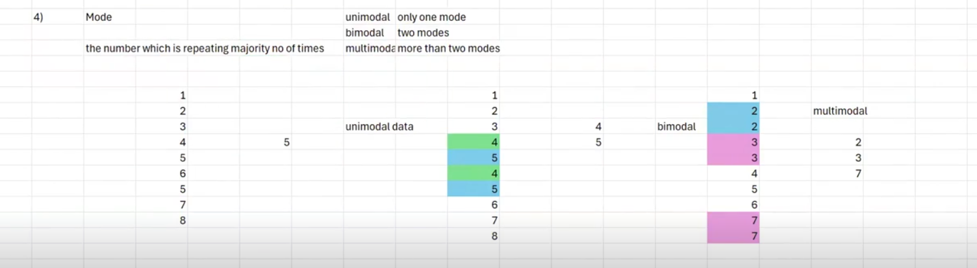
For e.g 1,2,3,4,5,6,5,7,8 [mode = 5(uni modal data) ] && 1,2,3,4,5,4,5 [Mode = 4,5(bi modal data) && 1,2,2,3,3,4,5,6,7,7 (Multi Modal data )

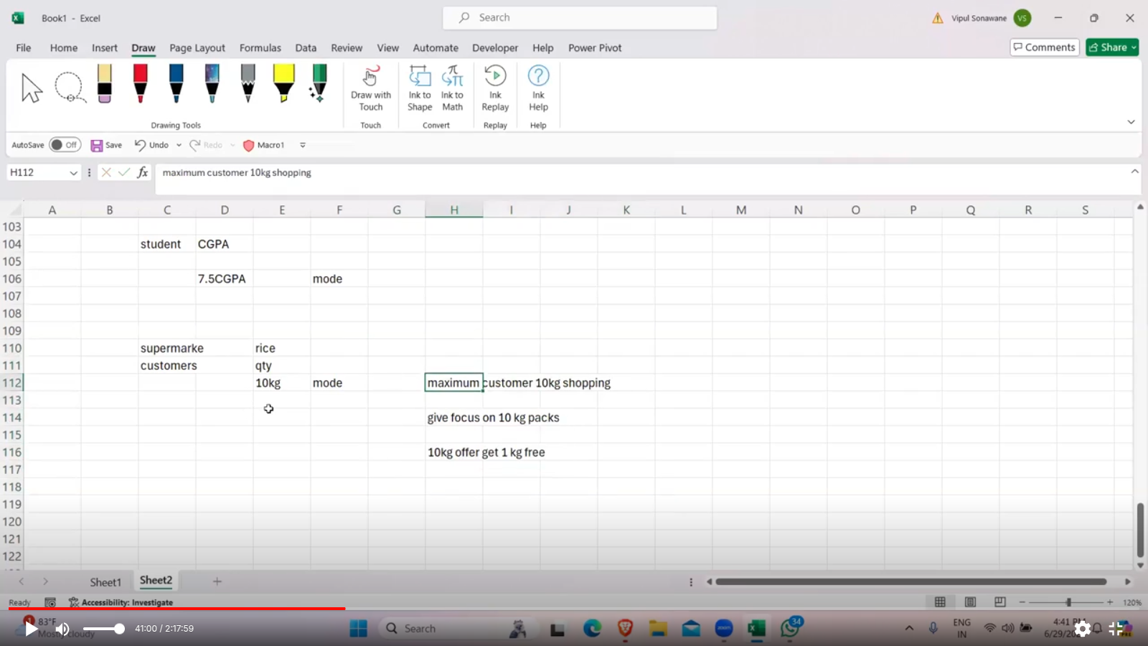
Video Link

- Measure of Dispersion
# Range
# Quartiles
# Variance
# Standard deviation
- Measure of Shape
# Kurtosis
# Skewness

outliers :- distribution ke bahar lie karte hain. [ Mean will fail if outliers are present in dataset ]
In median there is no problem if outliers are present. It will work with outliers

Statistics: Is the branch of mathematics that deals with the study and manipulation of data, including ways to gather, review, analyze, and draw conclusions from data.
- Use data & probability to estimate how likely an event is to happen
- A foundation in statistics helps you understand underlying relationships and build ML models that are optimized
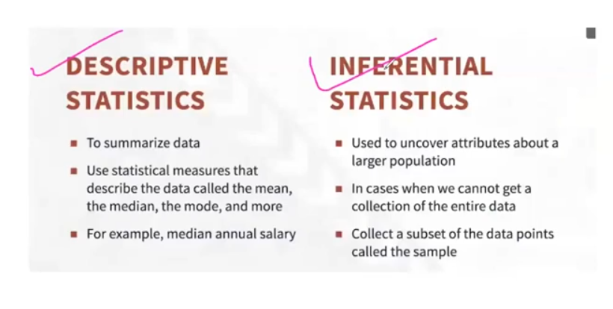
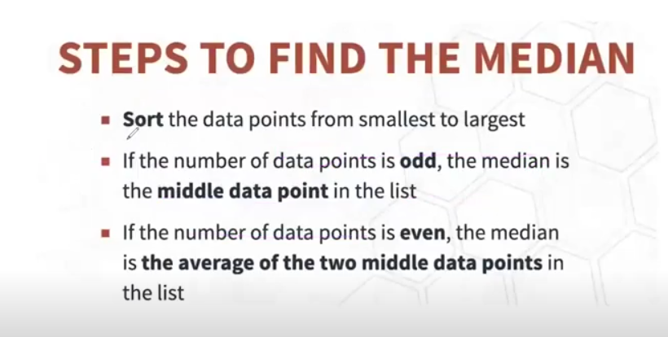

MEASURE OF DISPERSION
# Range: - difference b/t numbers (max-min) for e,g:- 1,2,3,4,5,6,7,8,9,10 [max-min (10-1) ] Range = 9
# Quartiles: - divide your data into four equal parts
# Variance: - average squared distance of each data point wrt mean (distance can’t be negative )
Squaring makes each term positive so that values above the mean do not cancel below the mean.
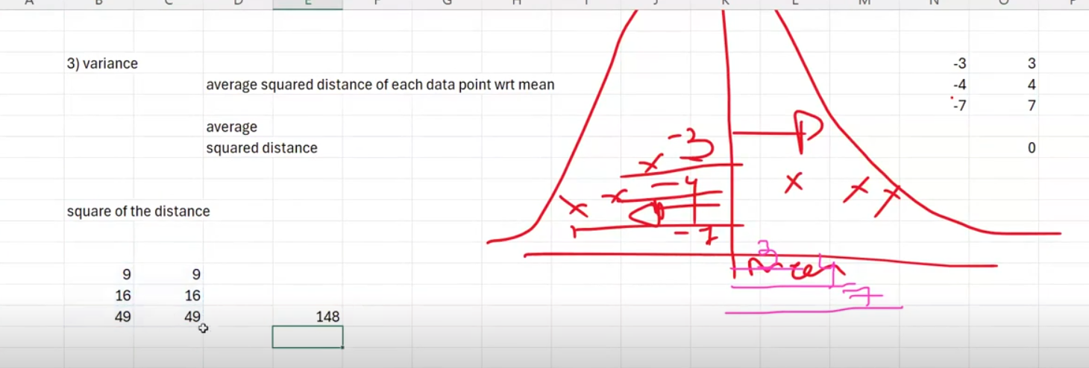
# Standard deviation: square root of variance
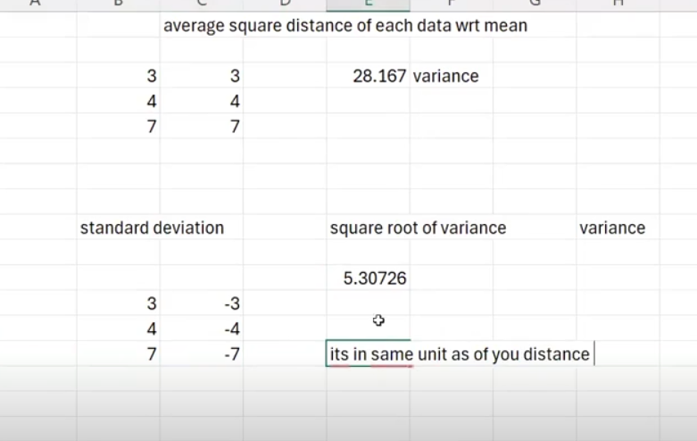
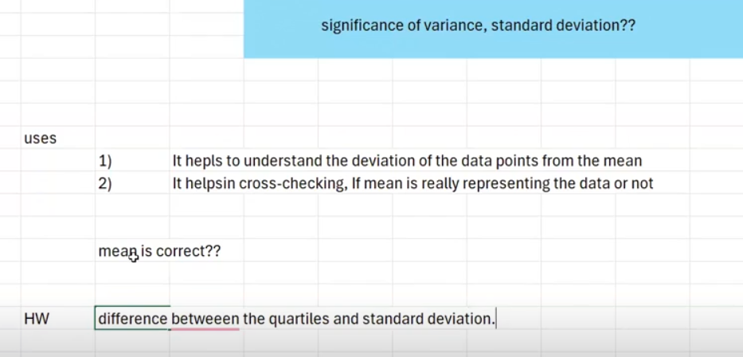

Why do we take square root of the variance ?

Measure of shape : -
Kurtosis: - describes the shape of distribution in terms of heights or flatness
Its Types
leptokurtic: - high peak [ >=1 ], [ SD less ], [ mean good ]
platykurtic: - small peak [ <=-1 ], [SD more ], [ mean not good ]
mesokurtic: - middle of this two [ Closer to zero ], [ SD moderate ], [ mean moderate ]

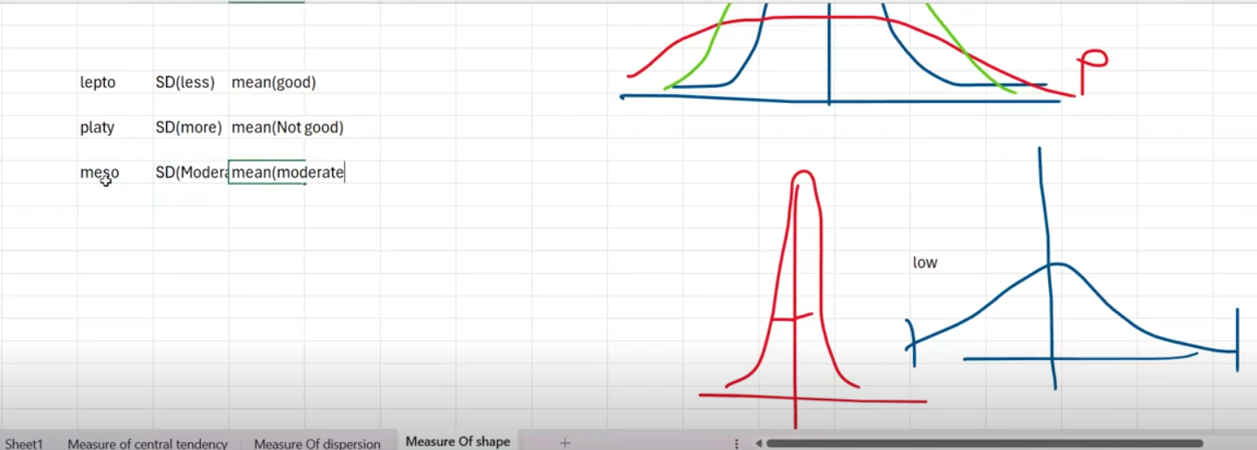
keypoint: - less the distance between between data point and mean less the standard deviation and good is the mean

Why do we use kurtosis ?
It is a measure to study whether standard deviation is good or not ??

Skewness: - distribution is off-centered or not ??

