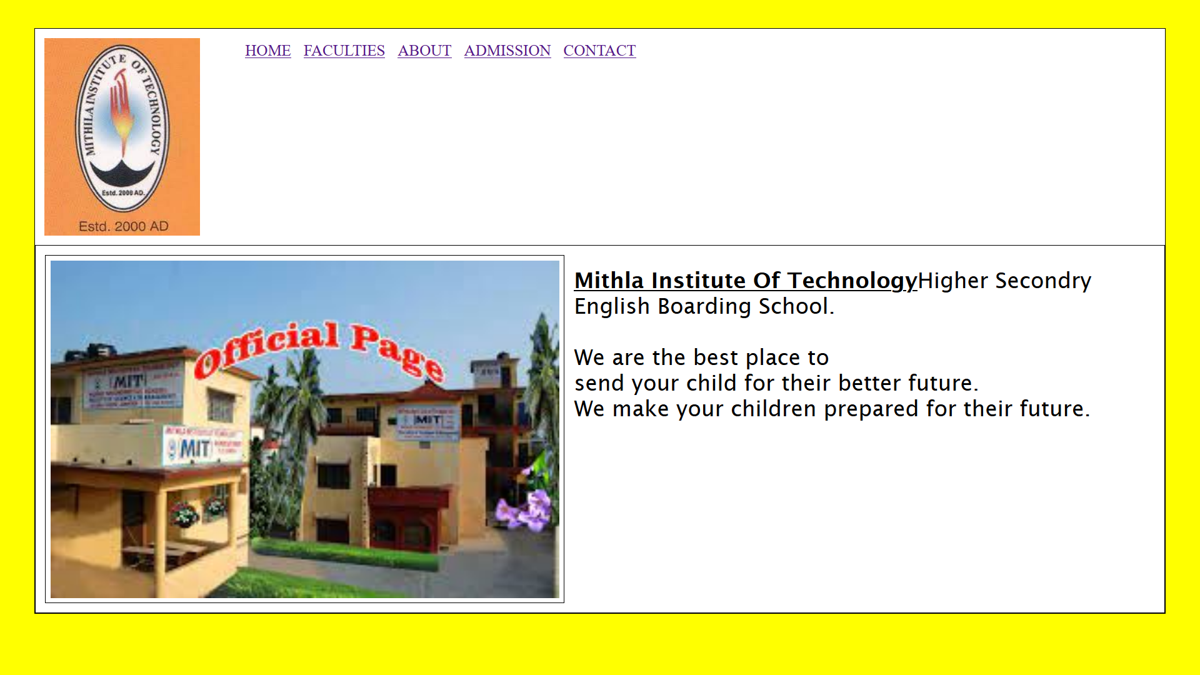**Homepage:**

## Image:

I have designed this page using HTML and little CSS. I have used <div> tags for convenience in CSS. I fetched those images from internet and I wrote those texts myself. The logo that I used was uploaded on school’s official social media page. I used yellow color as body background. The navigation contains link to other four pages.

**About Page:**

### Image:

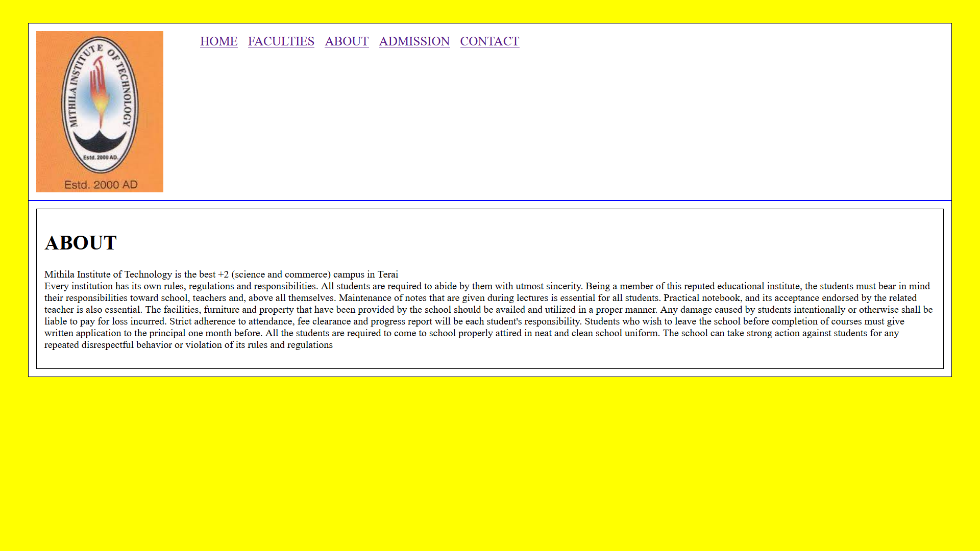

I have Used mostly HTML and this was easier To make as it doesn’t contain any image. The text about MIT school/campus is from internet (Facebook). I have used yellow color as body background. The border in every part in webpage makes it look better.

**Faculty page:**

### Image:

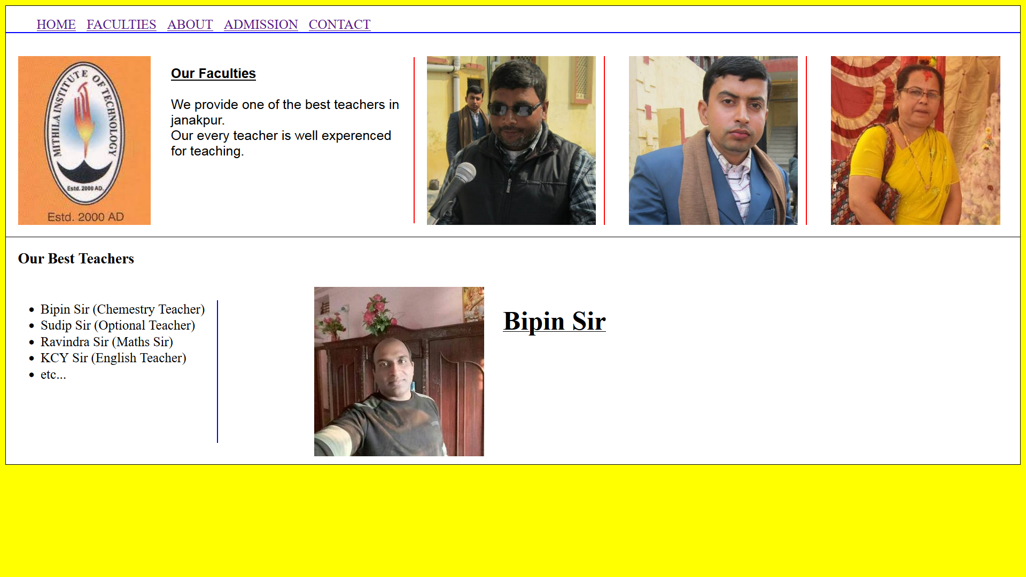

I have Used a lot of CSS in it because it is full of images. The images are from internet (Facebook). This was the second hardest page to design. I have used more than 100 lines of code including CSS and HTML. This time I used different style in navigation by adjusting the logo below the links to other page. I used border-right tags in CSS to make it more attractive.

**Admission page:**

### Image:

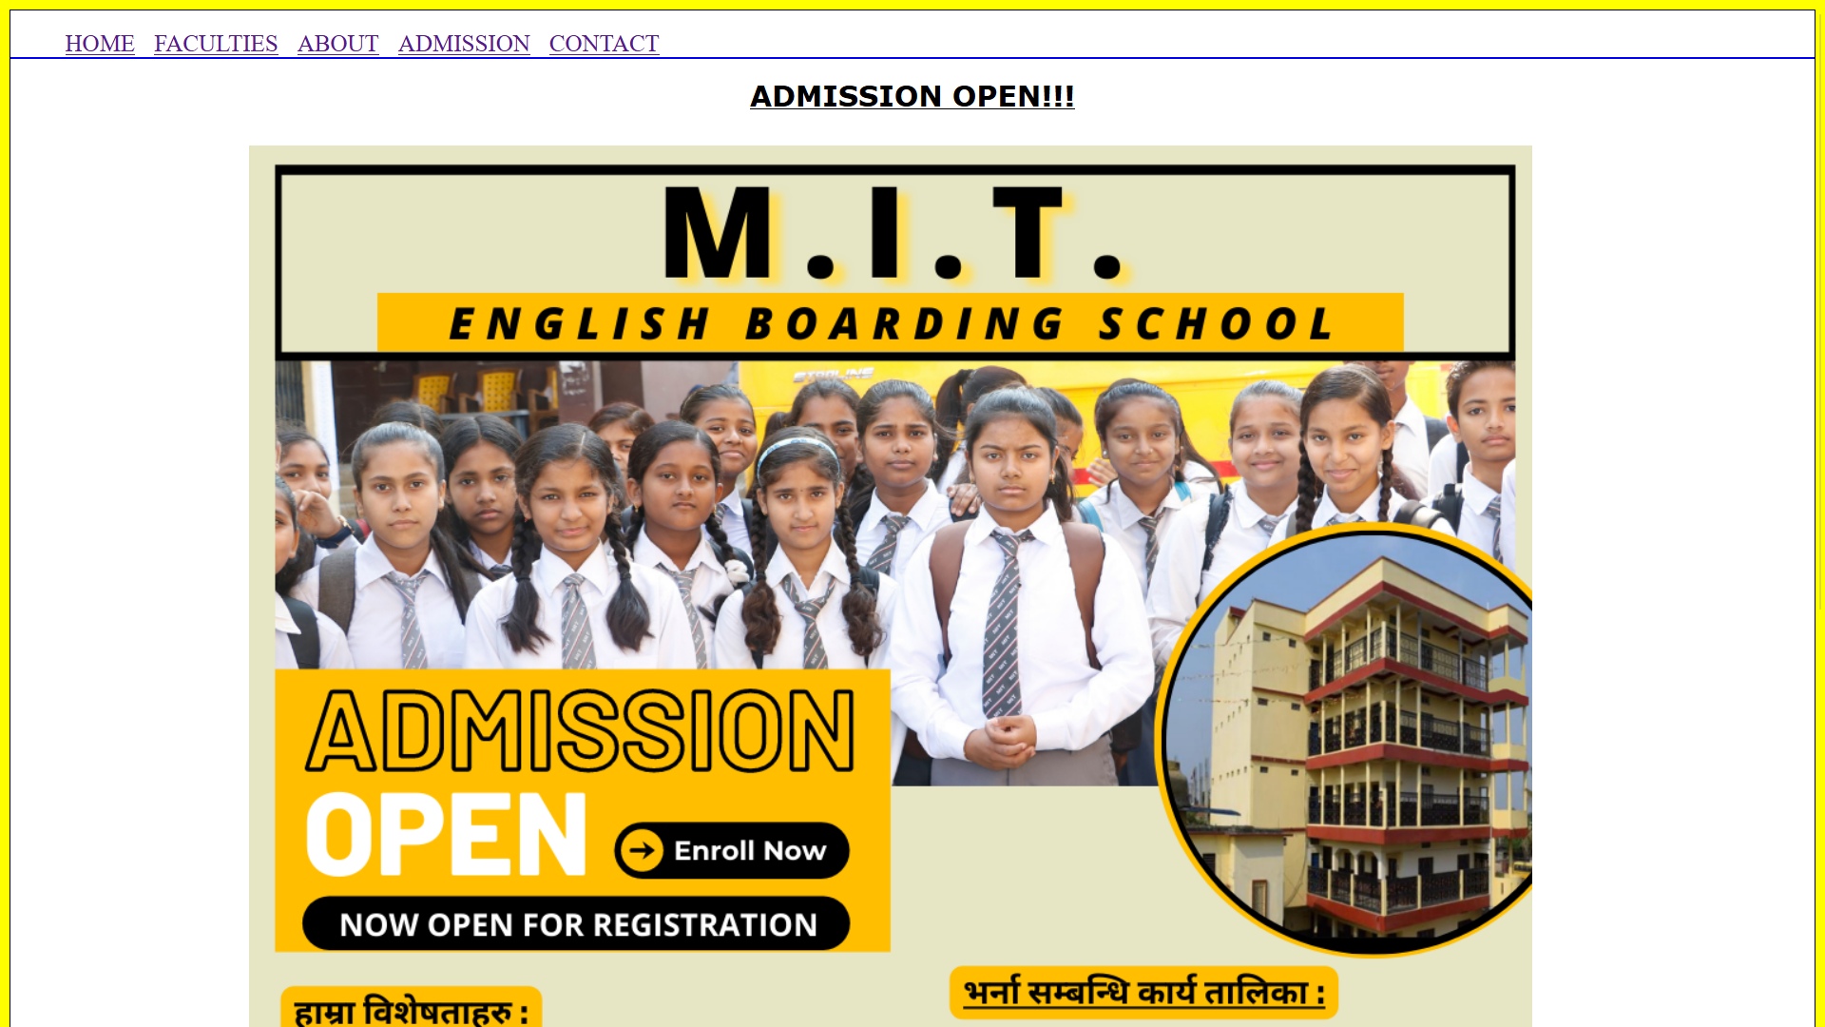

This was the easiest page to make because it contains no texts and only one image. I didn’t made it more because I had no idea what to do with it. I added a text as heading same as title.

**Contact page:**

### Image:

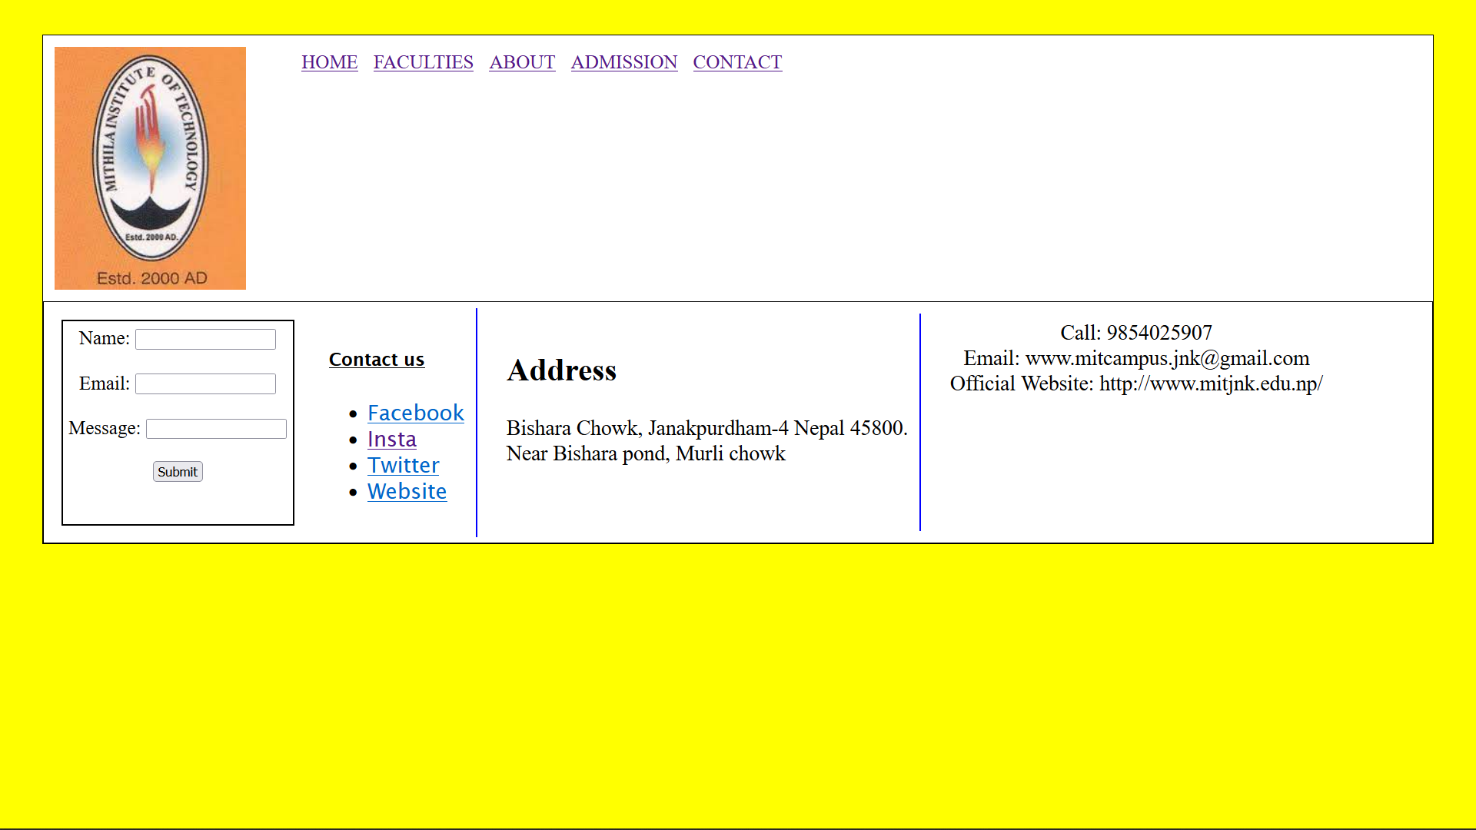

This was most difficult page to design which took me a lot of critical thinking. I took its inspiration from my personal website. All the information and contacts provided in this page are from internet (facebook). I used a form tag where I put name, email, message inputs and a submit button. I also added links to school’s official social media platform in right of form.