Sometimes you may already have a promising starting design, but several lenses do not meet basic manufacturing constraints.
In this example, the starting structure is taken from a patent. Its EFL and TTL are already close to my design targets, but five of the seven lenses are too thin. I require each lens to have a center thickness (CT) greater than 1.0 mm, whereas L3-L7 are all below this threshold.
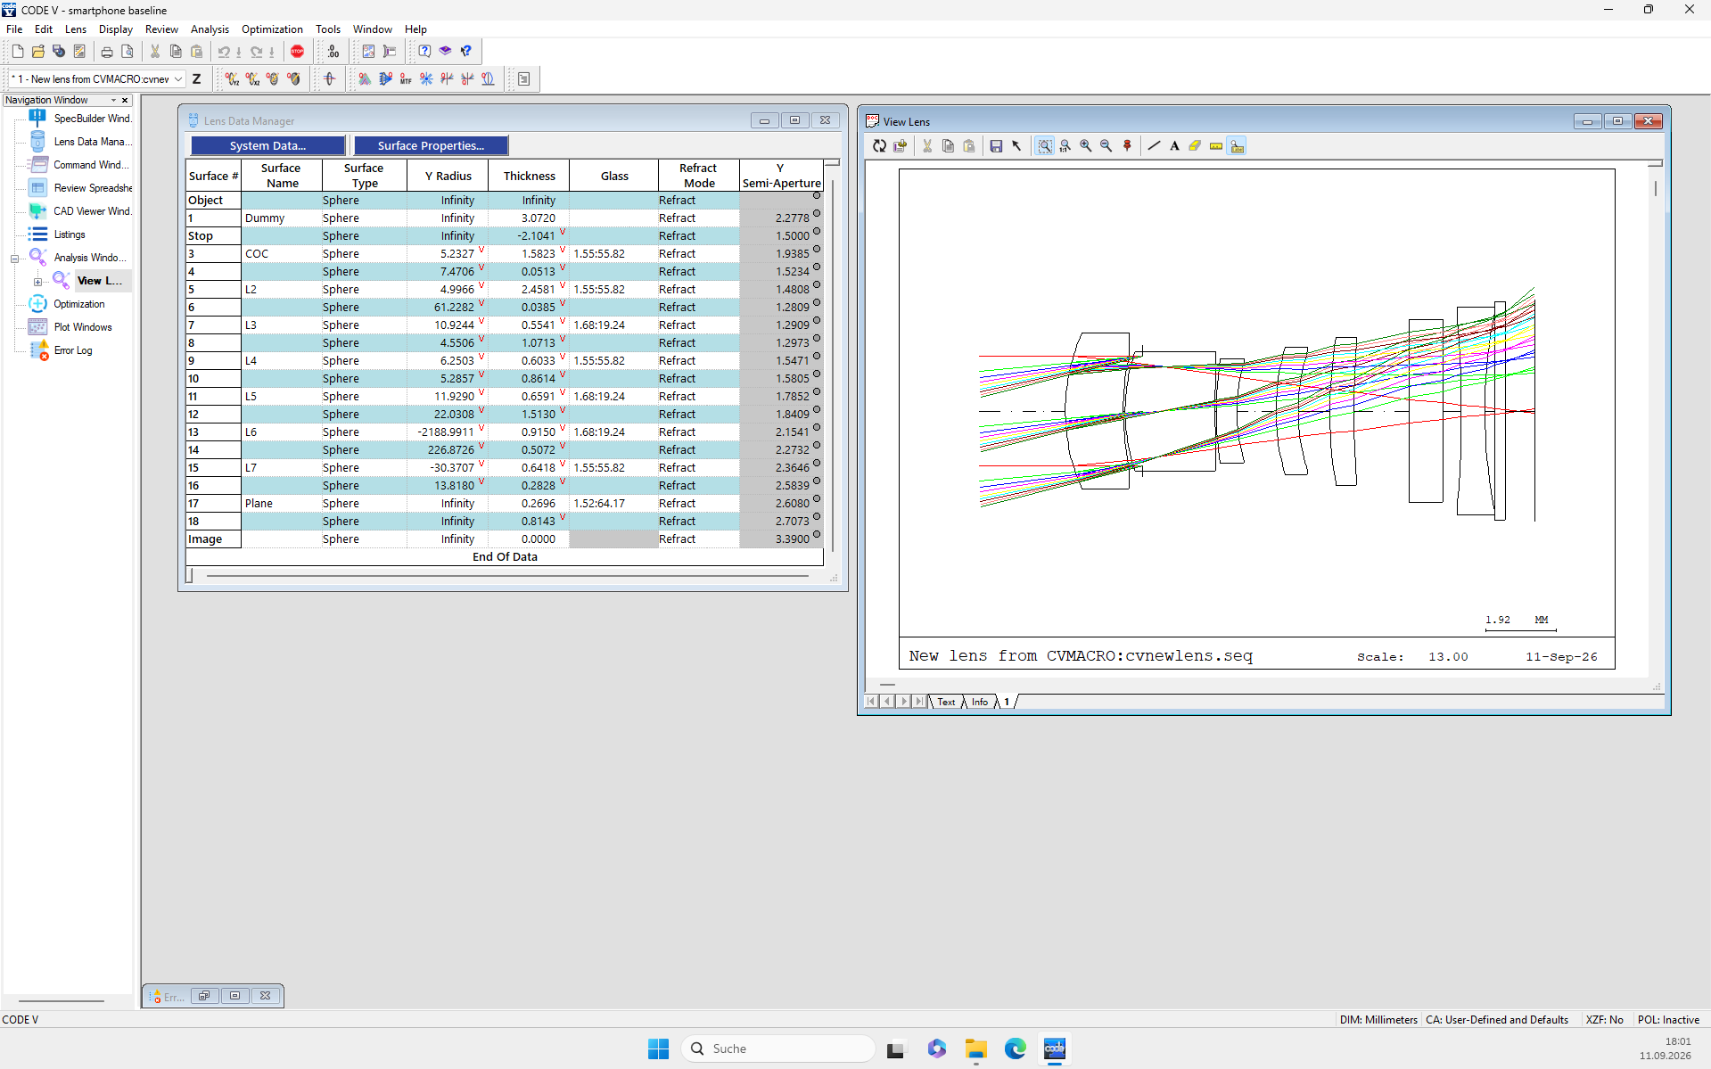

Of course, one straightforward approach is to increase the lens thicknesses by adding constraints in CODE V. Let us first see what happens with that workflow.

Before repairing all thickness and air-gap constraints, I first want to merge L1 and L2. In later optimization, these two lenses tended to form a strongly coupled front group with large, opposing aberration contributions, which made field-curvature control difficult. To make the merge easier, I initially keep only CTmax, CTmin, and ETmin active and leave the air-gap constraints inactive.
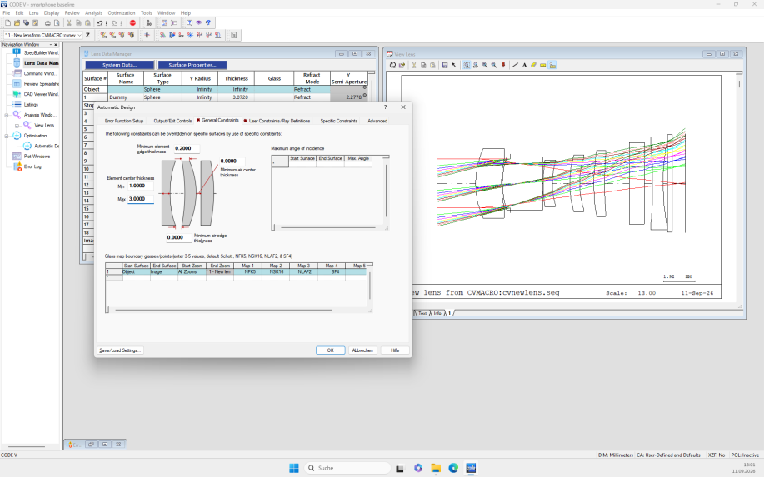
I also constrain EFL and OAL.
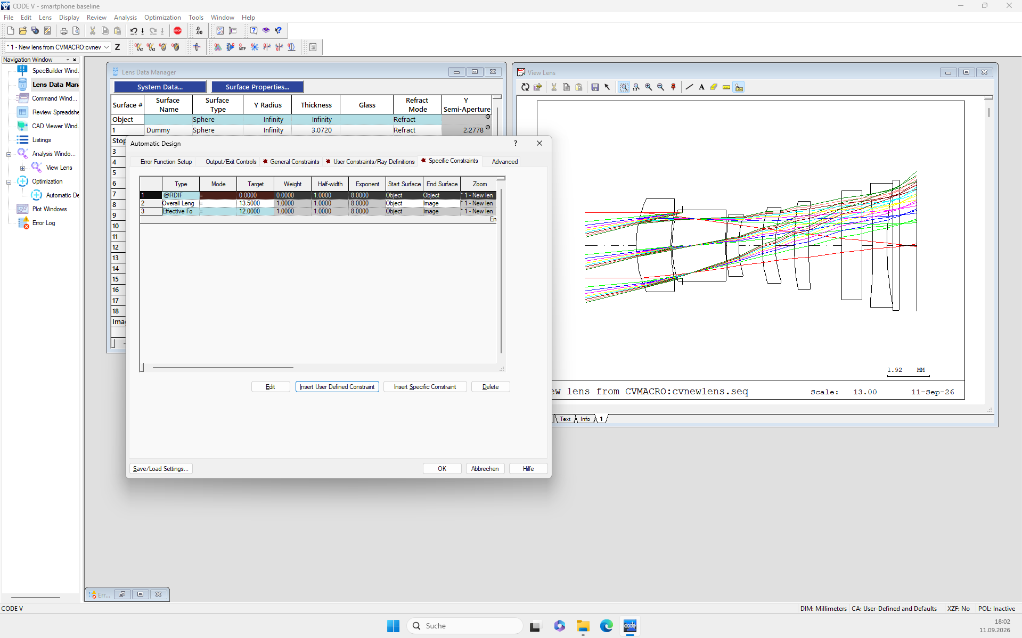

The L1/L2 merge can then be completed.
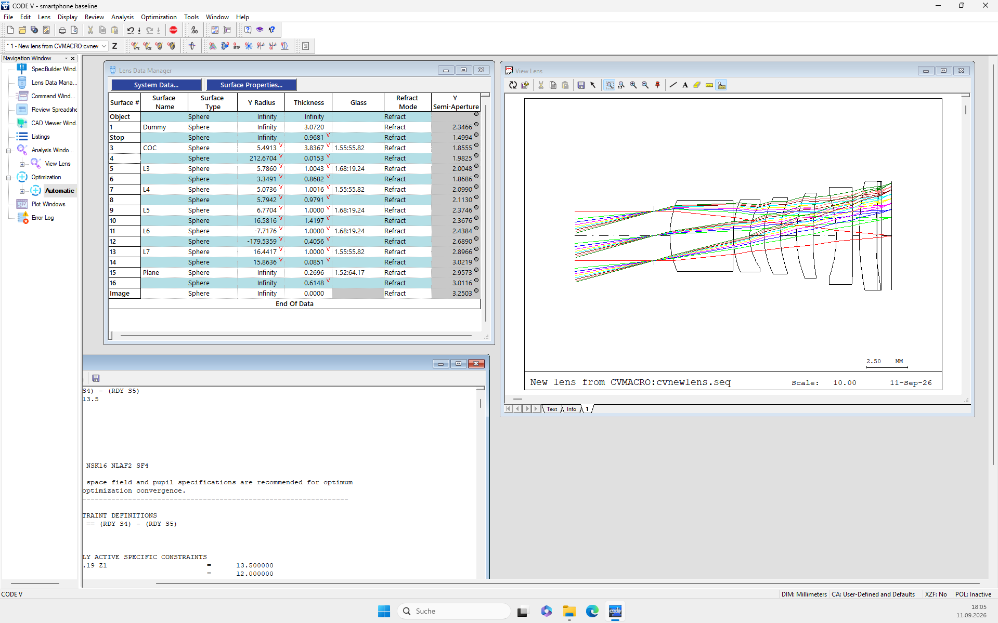
Next, I activate the center and edge air-gap constraints and run CODE V automatic optimization.
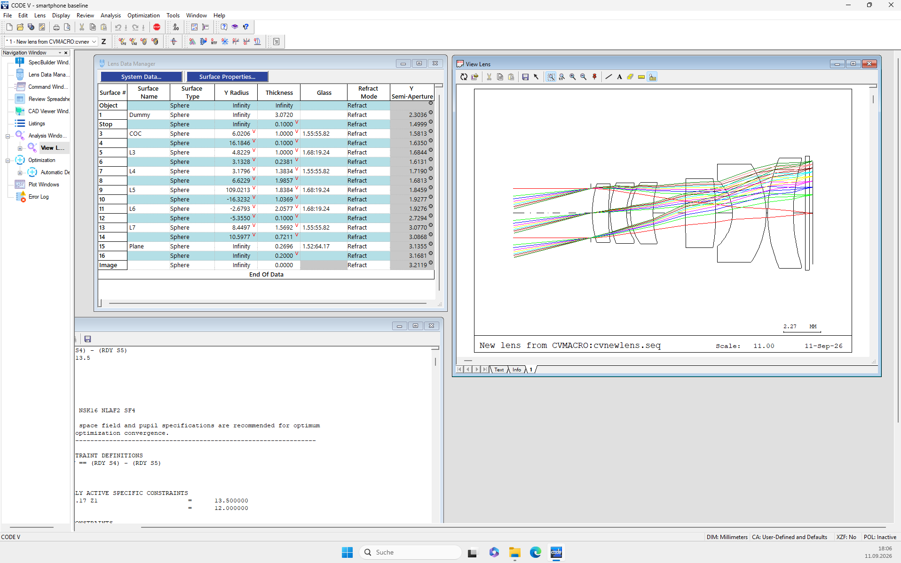
The resulting design is feasible, but I do not consider it a good starting point. In my tests, this branch could not be optimized reliably below about F/2.2. In addition, the edge clearance between the last lens and the plane plate restricts the later bending freedom of the last lens.
Opening the Qcon aspheric coefficients and running automatic optimization again does not fully solve the problem. The rear group, especially the last lens, still looks structurally unfavorable.
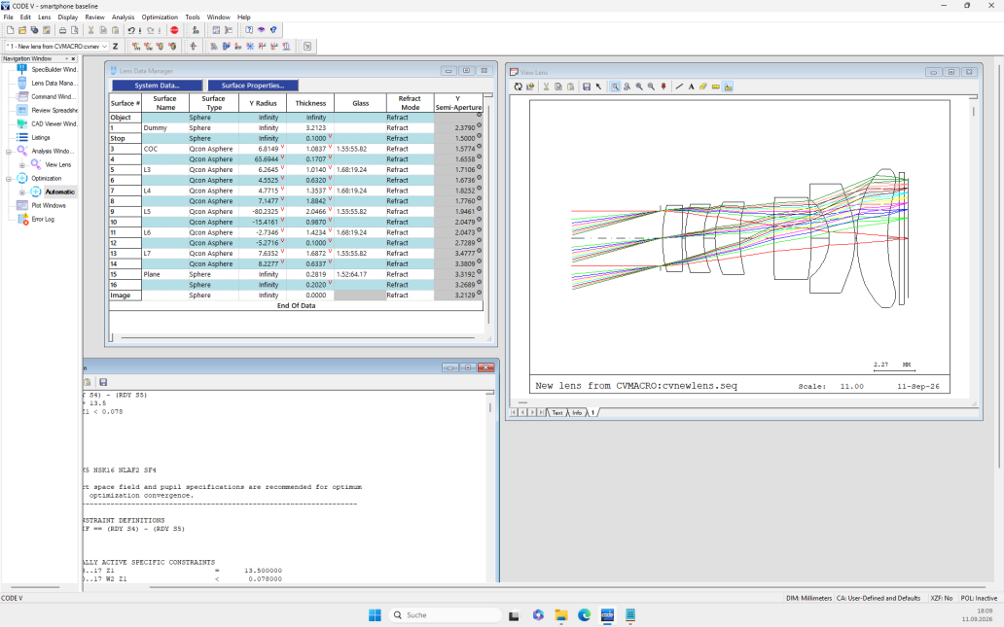

Now let us look at a different way to repair the thickness problem.
I input the original .SEQ file into thickness_repair.py and set CTmin and the minimum center air gap. This run returns 17 valid structures. All satisfy the constraints while keeping the system EFL essentially unchanged. Each repaired lens keeps its original paraxial optical power. Its individual principal planes are allowed to move, but adjacent air gaps are adjusted to compensate those shifts and preserve the spacing between neighboring principal planes. The result is a set of nearly first-order-equivalent structures that retain the original optical-power distribution.
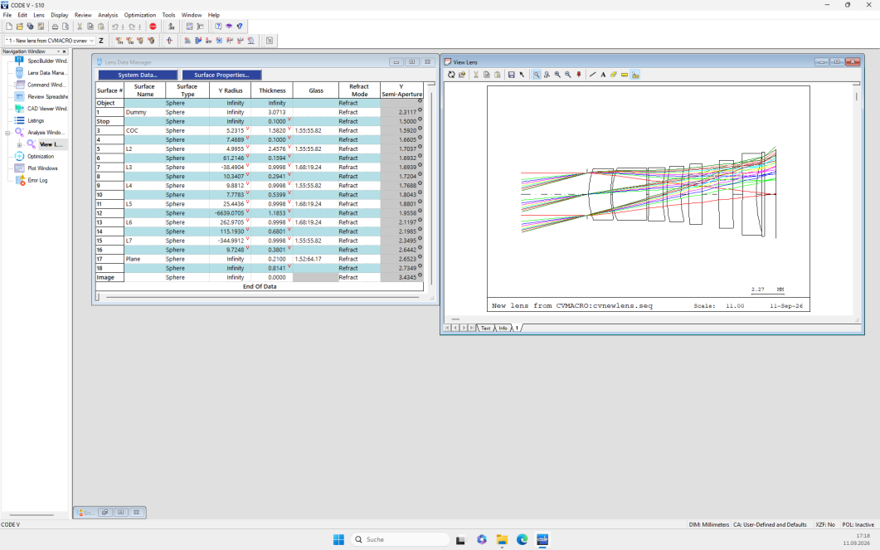

I then use one of these generated structures as the starting point for the L1/L2 merge.
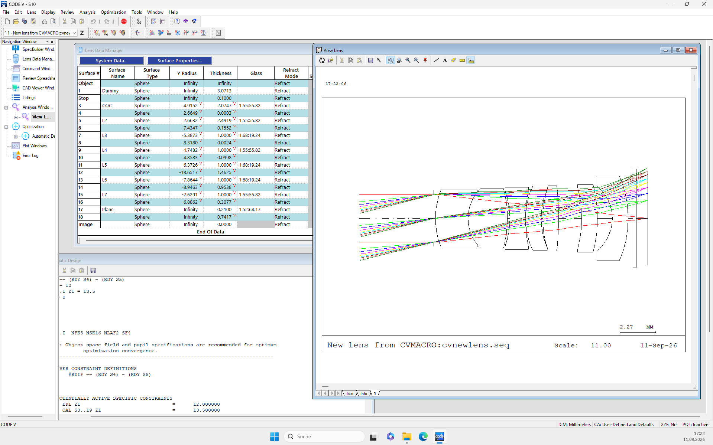
After applying the same minimum center- and edge-air-gap constraints and running automatic optimization, the layout is noticeably better. A clearer front, middle, and rear-group structure emerges naturally.
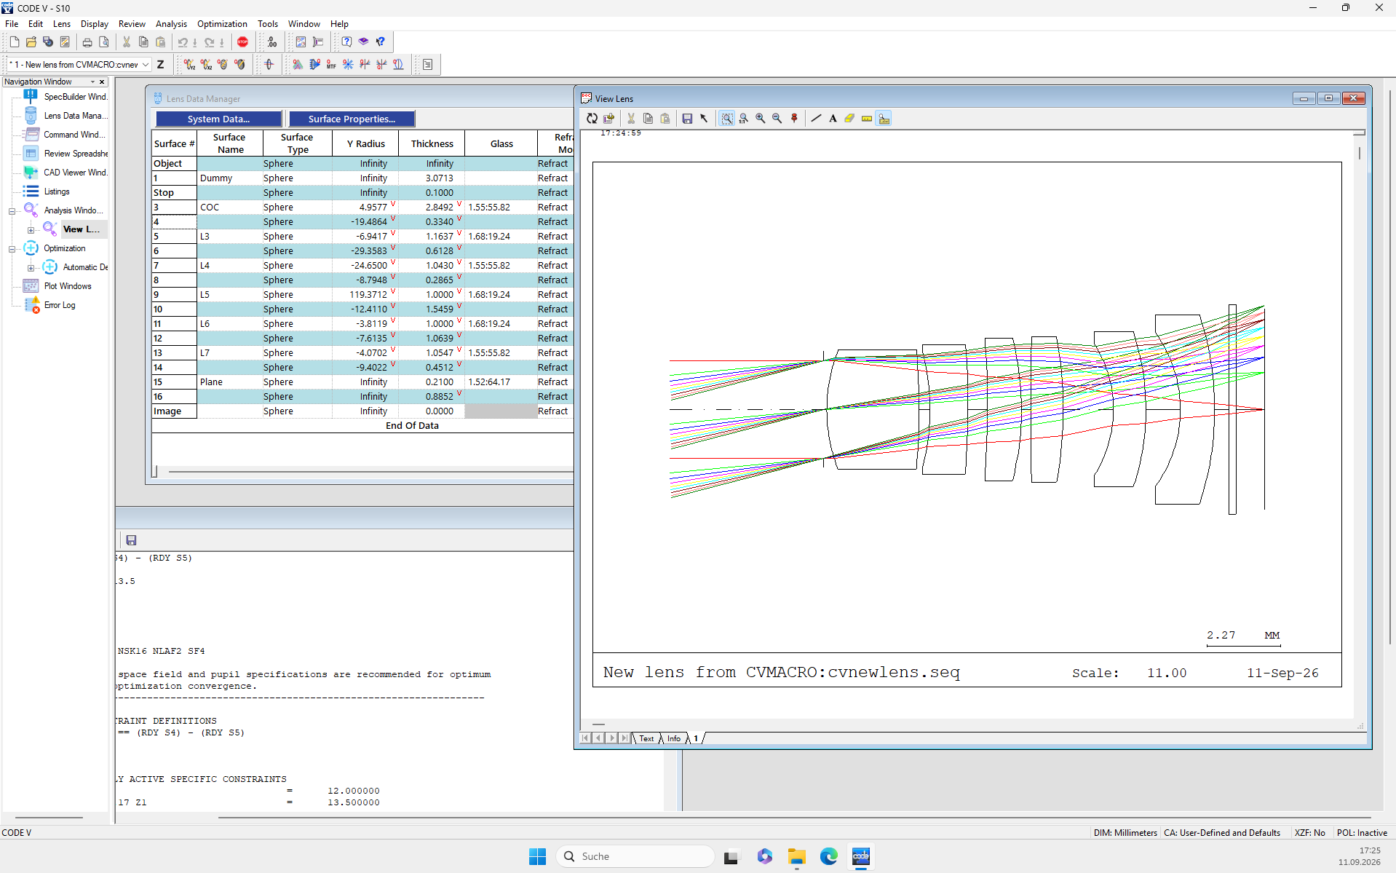

Next, I open the Qcon aspheric coefficients and run automatic optimization again. The last lens becomes more relaxed. More importantly, ray height increases only gradually through the lens train, leaving more room for optimization toward lower F/#. (Current state: F/4.0.)
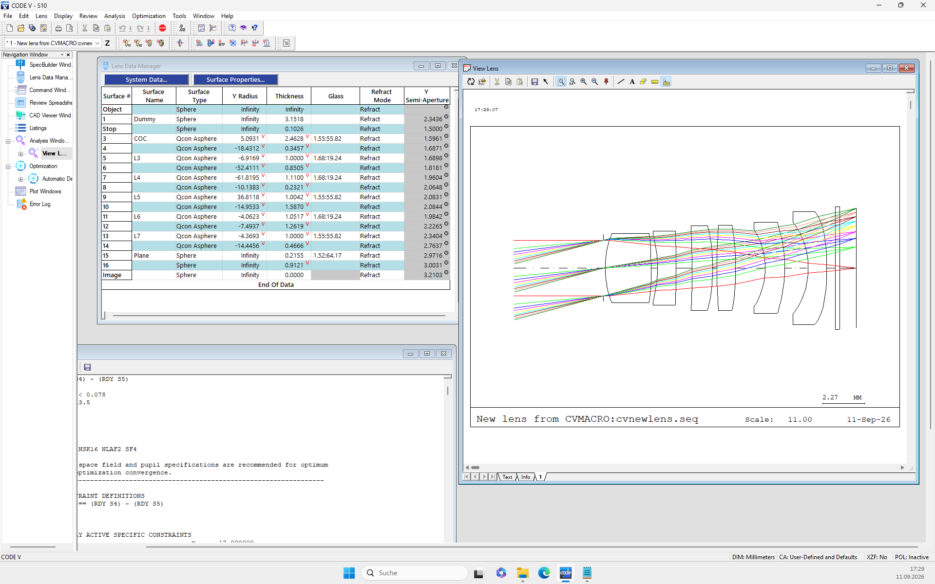
This is the final result obtained along this optimization path.
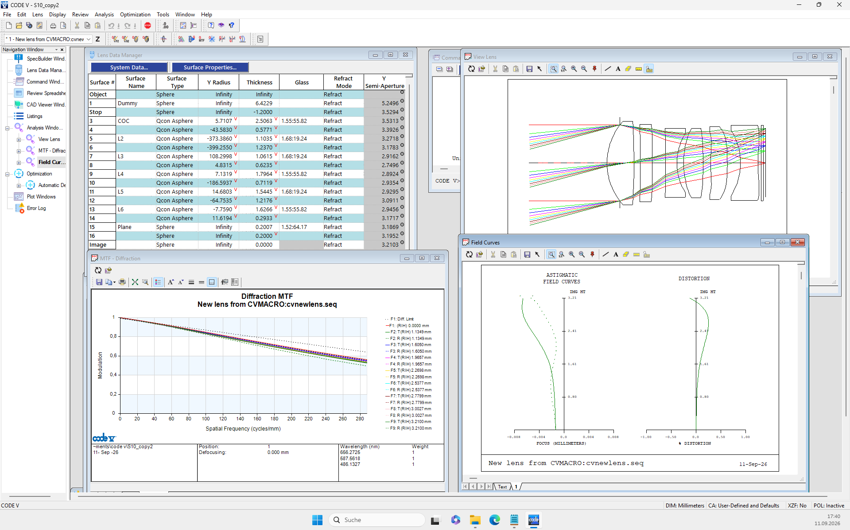
thickness_repair.py does not guarantee a good starting structure. Optimization strategy still matters; in this case, the L1/L2 merge was essential. The script's role is to provide alternative, structurally feasible starting points when the original design is constrained by insufficient lens thickness.
An experienced designer may achieve a similar result by gradually tightening thickness constraints in CODE V. The advantage here is that the major thickness restrictions are removed before later optimization, leaving more usable structural freedom.
If none of the first approximately 20 candidates is attractive, simply run the script again and choose from a new random batch generated in a few minutes.

