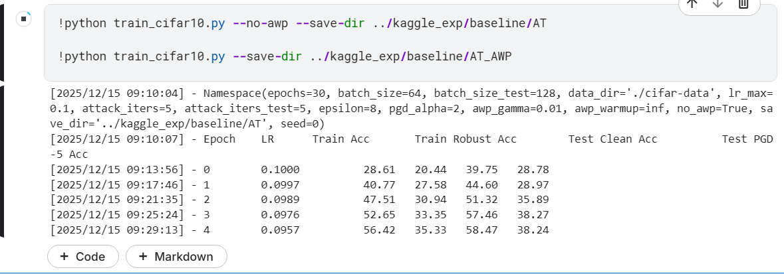
[2025/12/15 09:36:11] - Namespace(epochs=30, batch_size=64, batch_size_test=128, data_dir='./cifar-data', lr_max=0.1, attack_iters=5, attack_iters_test=5, epsilon=8, pgd_alpha=2, awp_gamma=0.01, awp_warmup=inf, no_awp=True, save_dir='../kaggle_exp/baseline/AT', seed=0)
[2025/12/15 09:36:14] - Epoch LR Train Acc Train Robust Acc Test Clean Acc Test PGD-5 Acc
[2025/12/15 09:40:05] - 0 0.1000 29.17 20.73 39.99 29.18
[2025/12/15 09:43:54] - 1 0.0997 41.02 27.81 44.95 28.98
[2025/12/15 09:47:44] - 2 0.0989 47.78 31.08 51.20 35.73
[2025/12/15 09:51:34] - 3 0.0976 52.68 33.44 57.08 38.07
[2025/12/15 09:55:23] - 4 0.0957 56.51 35.24 58.84 39.34
[2025/12/15 09:59:12] - 5 0.0933 59.27 36.77 56.70 38.06
[2025/12/15 10:03:02] - 6 0.0905 61.18 37.82 61.81 40.28
[2025/12/15 10:06:50] - 7 0.0872 63.35 39.17 61.58 40.23
[2025/12/15 10:10:39] - 8 0.0835 64.64 39.71 63.76 41.45
[2025/12/15 10:14:27] - 9 0.0794 66.28 40.91 63.93 43.41
[2025/12/15 10:18:15] - 10 0.0750 67.23 41.50 65.37 42.28
[2025/12/15 10:22:03] - 11 0.0703 68.38 42.37 67.82 43.95
[2025/12/15 10:25:52] - 12 0.0655 69.28 43.07 68.67 44.02
[2025/12/15 10:29:40] - 13 0.0604 70.39 43.76 69.50 46.69
[2025/12/15 10:33:29] - 14 0.0552 71.87 44.82 67.77 44.12
[2025/12/15 10:37:17] - 15 0.0500 72.90 45.73 68.54 46.04
[2025/12/15 10:41:06] - 16 0.0448 73.72 46.34 71.45 48.25
[2025/12/15 10:44:55] - 17 0.0396 74.73 47.38 72.43 47.92
[2025/12/15 10:48:43] - 18 0.0345 75.64 48.08 73.60 47.44
[2025/12/15 10:52:32] - 19 0.0297 76.65 49.17 72.70 48.46
[2025/12/15 10:56:21] - 20 0.0250 77.98 50.57 74.55 50.56
[2025/12/15 11:00:10] - 21 0.0206 78.88 51.32 76.90 50.27
[2025/12/15 11:03:58] - 22 0.0165 80.15 52.73 76.96 52.10
[2025/12/15 11:07:47] - 23 0.0128 81.24 54.14 78.50 53.37
[2025/12/15 11:11:36] - 24 0.0095 82.29 55.49 80.32 53.06
[2025/12/15 11:15:24] - 25 0.0067 83.58 57.17 81.27 53.76
[2025/12/15 11:19:13] - 26 0.0043 84.58 58.44 82.41 54.59
[2025/12/15 11:23:02] - 27 0.0024 85.68 59.97 81.96 54.90
[2025/12/15 11:26:50] - 28 0.0011 86.35 61.11 83.30 54.51
[2025/12/15 11:30:39] - 29 0.0003 86.63 61.86 83.43 56.56
AT 训练完成！最终 Test Clean: 83.43%, PGD-5: 56.56%
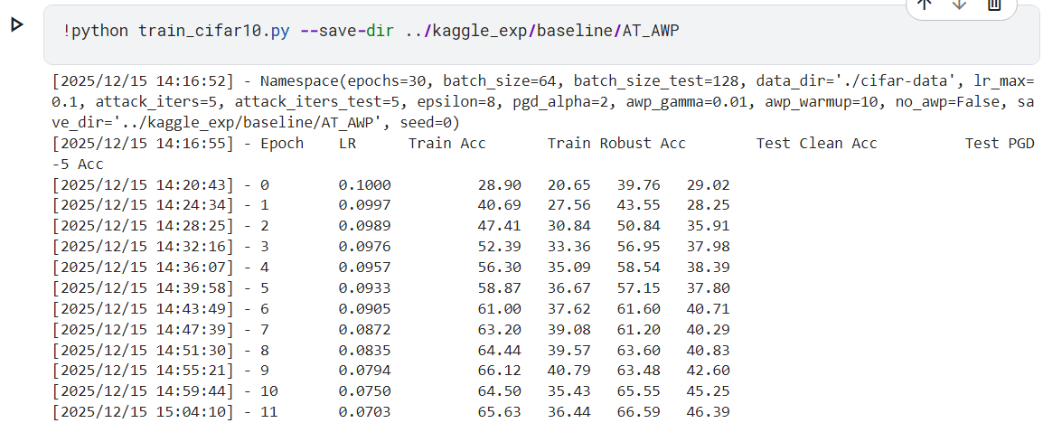
(awp-gpu) PS C:\Users\Administrator\Desktop\wxk\AWP-main\AT_AWP> python train_cifar10.py --save-dir ../experiments/AT/AT_AWP --awp-gamma 0.005 --awp-wa
rmup 15
>>
[2025/12/16 11:51:14] - Namespace(epochs=30, batch_size=64, batch_size_test=128, data_dir='./cifar-data', lr_max=0.1, attack_iters=5, attack_iters_test
=5, epsilon=8, pgd_alpha=2, awp_gamma=0.005, awp_warmup=15, no_awp=False, save_dir='../experiments/AT/AT_AWP', seed=0)
Files already downloaded and verified
Files already downloaded and verified
[2025/12/16 11:51:19] - Epoch LR Train Acc Train Robust Acc Test Clean Acc Test PGD-5 Acc
[2025/12/16 11:52:48] - 0 0.1000 28.09 20.35 37.14 26.65
[2025/12/16 11:54:20] - 1 0.0997 39.69 27.34 43.42 28.38
[2025/12/16 11:55:47] - 2 0.0989 46.41 30.66 50.22 34.89
[2025/12/16 11:57:14] - 3 0.0976 51.78 33.20 54.90 36.52
[2025/12/16 11:58:42] - 4 0.0957 56.35 35.38 56.98 37.58
[2025/12/16 12:00:09] - 5 0.0933 59.29 36.74 58.74 39.01
[2025/12/16 12:01:37] - 6 0.0905 61.24 37.93 60.94 40.26
[2025/12/16 12:03:04] - 7 0.0872 63.68 39.15 61.87 40.08
[2025/12/16 12:04:32] - 8 0.0835 64.88 39.98 63.93 41.45
[2025/12/16 12:05:59] - 9 0.0794 66.71 41.21 65.56 44.27
[2025/12/16 12:07:28] - 10 0.0750 67.64 41.66 65.52 43.26
[2025/12/16 12:08:55] - 11 0.0703 68.97 42.79 68.24 44.39
[2025/12/16 12:10:23] - 12 0.0655 69.85 43.69 67.78 45.24
[2025/12/16 12:11:51] - 13 0.0604 71.08 44.46 70.62 47.25
[2025/12/16 12:13:20] - 14 0.0552 72.45 45.00 69.85 46.68
[2025/12/16 12:15:02] - 15 0.0500 72.27 42.40 70.37 49.77
[2025/12/16 12:16:43] - 16 0.0448 73.07 43.04 71.09 50.73
[2025/12/16 12:18:26] - 17 0.0396 73.77 43.83 73.96 51.12
[2025/12/16 12:20:08] - 18 0.0345 74.51 44.52 73.89 50.84
[2025/12/16 12:21:51] - 19 0.0297 75.36 45.20 74.26 53.04
[2025/12/16 12:23:34] - 20 0.0250 76.39 46.01 75.26 53.32
[2025/12/16 12:25:17] - 21 0.0206 77.04 46.62 76.37 52.69
[2025/12/16 12:26:59] - 22 0.0165 77.99 47.59 77.18 53.90
[2025/12/16 12:28:41] - 23 0.0128 78.64 48.38 77.76 54.43
[2025/12/16 12:30:24] - 24 0.0095 79.52 48.99 78.46 54.75
[2025/12/16 12:32:07] - 25 0.0067 80.11 49.82 79.90 55.12
[2025/12/16 12:33:49] - 26 0.0043 80.74 50.37 79.87 56.63
[2025/12/16 12:35:31] - 27 0.0024 81.22 50.80 79.96 56.62
[2025/12/16 12:37:14] - 28 0.0011 81.49 51.39 80.13 56.37
[2025/12/16 12:38:57] - 29 0.0003 81.50 51.54 80.22 57.24
AT_AWP 训练完成！最终 Test Clean: 80.22%, PGD-5: 57.24%
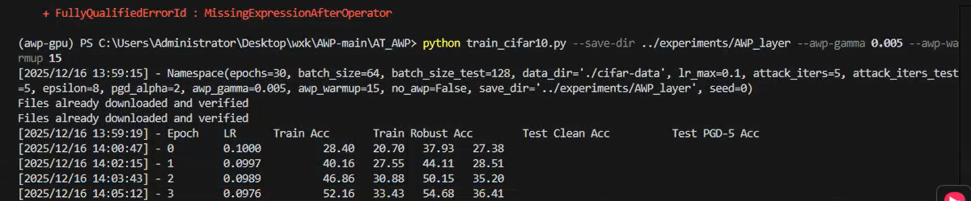
(awp-gpu) PS C:\Users\Administrator\Desktop\wxk\AWP-main\AT_AWP> python train_cifar10.py --save-dir ../experiments/AWP_layer --awp-gamma 0.005 --awp-warmup 15
[2025/12/16 13:59:15] - Namespace(epochs=30, batch_size=64, batch_size_test=128, data_dir='./cifar-data', lr_max=0.1, attack_iters=5, attack_iters_test
=5, epsilon=8, pgd_alpha=2, awp_gamma=0.005, awp_warmup=15, no_awp=False, save_dir='../experiments/AWP_layer', seed=0)
Files already downloaded and verified
Files already downloaded and verified
[2025/12/16 13:59:19] - Epoch LR Train Acc Train Robust Acc Test Clean Acc Test PGD-5 Acc
[2025/12/16 14:00:47] - 0 0.1000 28.40 20.70 37.93 27.38
[2025/12/16 14:02:15] - 1 0.0997 40.16 27.55 44.11 28.51
[2025/12/16 14:03:43] - 2 0.0989 46.86 30.88 50.15 35.20
[2025/12/16 14:05:12] - 3 0.0976 52.16 33.43 54.68 36.41
[2025/12/16 14:06:41] - 4 0.0957 56.35 35.55 56.51 37.63
[2025/12/16 14:08:10] - 5 0.0933 59.39 36.87 58.50 39.46
[2025/12/16 14:09:40] - 6 0.0905 61.39 38.06 60.70 40.00
[2025/12/16 14:11:08] - 7 0.0872 63.80 39.45 62.21 40.65
[2025/12/16 14:12:38] - 8 0.0835 65.08 39.87 64.04 41.32
[2025/12/16 14:14:07] - 9 0.0794 66.91 41.27 65.63 44.60
[2025/12/16 14:15:36] - 10 0.0750 67.80 41.49 65.63 43.07
[2025/12/16 14:17:05] - 11 0.0703 69.04 42.96 68.10 44.81
[2025/12/16 14:18:35] - 12 0.0655 70.01 43.64 67.88 45.61
[2025/12/16 14:20:04] - 13 0.0604 71.11 44.52 70.17 47.66
[2025/12/16 14:21:34] - 14 0.0552 72.60 45.30 70.07 46.64
[2025/12/16 14:23:16] - 15 0.0500 72.38 42.45 70.69 49.91
[2025/12/16 14:24:58] - 16 0.0448 73.22 43.04 70.90 50.29
[2025/12/16 14:26:41] - 17 0.0396 74.12 43.85 74.00 50.99
[2025/12/16 14:28:24] - 18 0.0345 74.81 44.68 73.93 50.61
[2025/12/16 14:30:08] - 19 0.0297 75.46 45.22 74.22 52.58
[2025/12/16 14:31:51] - 20 0.0250 76.53 46.22 75.09 53.15
[2025/12/16 14:33:35] - 21 0.0206 77.07 46.77 76.72 52.69
[2025/12/16 14:35:18] - 22 0.0165 78.11 47.66 77.19 54.25
[2025/12/16 14:37:01] - 23 0.0128 78.77 48.43 77.74 54.49
[2025/12/16 14:38:44] - 24 0.0095 79.56 49.19 78.57 54.98
[2025/12/16 14:40:26] - 25 0.0067 80.28 49.88 80.23 55.25
[2025/12/16 14:42:10] - 26 0.0043 80.77 50.47 80.15 56.55
[2025/12/16 14:43:53] - 27 0.0024 81.32 50.96 80.22 56.38
[2025/12/16 14:45:37] - 28 0.0011 81.58 51.55 80.45 56.25
[2025/12/16 14:47:21] - 29 0.0003 81.55 51.71 80.30 57.13
AT_AWP 训练完成！最终 Test Clean: 80.30%, PGD-5: 57.13%

[2025/12/16 18:51:22] - Namespace(epochs=30, batch_size=64, batch_size_test=128, data_dir='./cifar-data', lr_max=0.1, attack_iters=5, attack_iters_test=5, epsilon=8, pgd_alpha=2, awp_gamma=0.005, awp_warmup=15, no_awp=False, save_dir='../experiments/Progressive_AWP', seed=0)
[2025/12/16 18:51:27] - Epoch LR Train Acc Train Robust Acc Test Clean Acc Test PGD-5 Acc
[2025/12/16 18:52:54] - 0 0.1000 28.00 20.43 37.93 27.30
[2025/12/16 18:54:23] - 1 0.0997 39.94 27.43 43.19 28.14
[2025/12/16 18:55:51] - 2 0.0989 46.79 30.67 49.99 34.81
[2025/12/16 18:57:19] - 3 0.0976 52.35 33.62 55.61 36.82
[2025/12/16 18:58:48] - 4 0.0957 56.52 35.51 57.06 38.41
[2025/12/16 19:00:17] - 5 0.0933 59.52 36.81 58.00 38.84
[2025/12/16 19:01:45] - 6 0.0905 61.44 38.11 59.97 39.50
[2025/12/16 19:03:15] - 7 0.0872 63.66 39.43 62.01 40.33
[2025/12/16 19:04:42] - 8 0.0835 65.09 39.86 64.69 41.28
[2025/12/16 19:06:12] - 9 0.0794 66.70 41.36 65.14 44.06
[2025/12/16 19:07:40] - 10 0.0750 67.70 41.70 65.76 42.94
[2025/12/16 19:09:09] - 11 0.0703 68.96 42.83 68.02 44.18
[2025/12/16 19:10:39] - 12 0.0655 69.82 43.55 67.81 45.42
[2025/12/16 19:12:08] - 13 0.0604 71.14 44.42 70.06 47.06
[2025/12/16 19:13:37] - 14 0.0552 72.40 45.04 69.57 46.33
[2025/12/16 19:15:19] - 15 0.0500 72.16 42.29 70.85 50.17
[2025/12/16 19:17:02] - 16 0.0448 73.00 42.96 70.47 50.48
[2025/12/16 19:18:45] - 17 0.0396 73.77 43.80 74.10 51.23
[2025/12/16 19:20:28] - 18 0.0345 74.68 44.55 73.91 51.04
[2025/12/16 19:22:11] - 19 0.0297 75.31 45.05 73.88 52.30
[2025/12/16 19:23:53] - 20 0.0250 76.41 46.05 75.29 53.24
[2025/12/16 19:25:36] - 21 0.0206 77.05 46.60 76.39 52.76
[2025/12/16 19:27:18] - 22 0.0165 78.01 47.63 77.22 53.91
[2025/12/16 19:29:01] - 23 0.0128 78.72 48.21 77.70 54.25
[2025/12/16 19:30:43] - 24 0.0095 79.51 49.08 78.34 54.83
[2025/12/16 19:32:26] - 25 0.0067 80.05 49.86 79.64 55.03
[2025/12/16 19:34:09] - 26 0.0043 80.55 50.17 79.65 56.39
[2025/12/16 19:35:52] - 27 0.0024 81.22 50.89 80.03 56.53
[2025/12/16 19:37:35] - 28 0.0011 81.55 51.45 80.41 55.77
[2025/12/16 19:39:18] - 29 0.0003 81.55 51.43 80.20 56.84

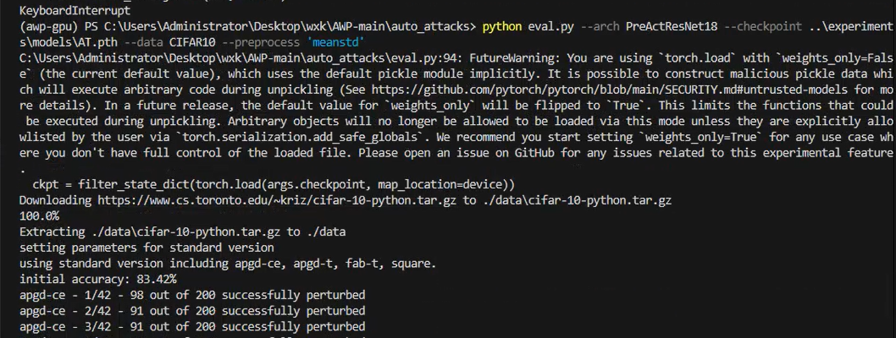
(awp-gpu) PS C:\Users\Administrator\Desktop\wxk\AWP-main\auto_attacks> python eval.py --arch PreActResNet18 --checkpoint ..\experiment
s\models\AT.pth --data CIFAR10 --preprocess 'meanstd'
C:\Users\Administrator\Desktop\wxk\AWP-main\auto_attacks\eval.py:94: FutureWarning: You are using `torch.load` with `weights_only=Fals
e` (the current default value), which uses the default pickle module implicitly. It is possible to construct malicious pickle data whi
ch will execute arbitrary code during unpickling (See https://github.com/pytorch/pytorch/blob/main/SECURITY.md#untrusted-models for mo
re details). In a future release, the default value for `weights_only` will be flipped to `True`. This limits the functions that could
be executed during unpickling. Arbitrary objects will no longer be allowed to be loaded via this mode unless they are explicitly allo
wlisted by the user via `torch.serialization.add_safe_globals`. We recommend you start setting `weights_only=True` for any use case wh
ere you don't have full control of the loaded file. Please open an issue on GitHub for any issues related to this experimental feature
.
ckpt = filter_state_dict(torch.load(args.checkpoint, map_location=device))
Downloading https://www.cs.toronto.edu/~kriz/cifar-10-python.tar.gz to ./data\cifar-10-python.tar.gz
100.0%
Extracting ./data\cifar-10-python.tar.gz to ./data
setting parameters for standard version
using standard version including apgd-ce, apgd-t, fab-t, square.
initial accuracy: 83.42%
apgd-ce - 1/42 - 98 out of 200 successfully perturbed
apgd-ce - 2/42 - 91 out of 200 successfully perturbed
apgd-ce - 3/42 - 91 out of 200 successfully perturbed
apgd-ce - 4/42 - 78 out of 200 successfully perturbed
apgd-ce - 5/42 - 82 out of 200 successfully perturbed
apgd-ce - 6/42 - 83 out of 200 successfully perturbed
apgd-ce - 7/42 - 87 out of 200 successfully perturbed
apgd-ce - 8/42 - 88 out of 200 successfully perturbed
apgd-ce - 9/42 - 90 out of 200 successfully perturbed
apgd-ce - 10/42 - 76 out of 200 successfully perturbed
apgd-ce - 11/42 - 98 out of 200 successfully perturbed
apgd-ce - 12/42 - 92 out of 200 successfully perturbed
apgd-ce - 13/42 - 77 out of 200 successfully perturbed
apgd-ce - 14/42 - 82 out of 200 successfully perturbed
apgd-ce - 15/42 - 78 out of 200 successfully perturbed
apgd-ce - 16/42 - 79 out of 200 successfully perturbed
apgd-ce - 17/42 - 95 out of 200 successfully perturbed
apgd-ce - 18/42 - 82 out of 200 successfully perturbed
apgd-ce - 19/42 - 72 out of 200 successfully perturbed
apgd-ce - 20/42 - 88 out of 200 successfully perturbed
apgd-ce - 21/42 - 99 out of 200 successfully perturbed
apgd-ce - 22/42 - 85 out of 200 successfully perturbed
apgd-ce - 23/42 - 82 out of 200 successfully perturbed
apgd-ce - 24/42 - 90 out of 200 successfully perturbed
apgd-ce - 25/42 - 95 out of 200 successfully perturbed
apgd-ce - 26/42 - 83 out of 200 successfully perturbed
apgd-ce - 27/42 - 95 out of 200 successfully perturbed
apgd-ce - 28/42 - 90 out of 200 successfully perturbed
apgd-ce - 29/42 - 86 out of 200 successfully perturbed
apgd-ce - 30/42 - 92 out of 200 successfully perturbed
apgd-ce - 31/42 - 92 out of 200 successfully perturbed
apgd-ce - 32/42 - 84 out of 200 successfully perturbed
apgd-ce - 33/42 - 81 out of 200 successfully perturbed
apgd-ce - 34/42 - 86 out of 200 successfully perturbed
apgd-ce - 35/42 - 105 out of 200 successfully perturbed
apgd-ce - 36/42 - 90 out of 200 successfully perturbed
apgd-ce - 37/42 - 83 out of 200 successfully perturbed
apgd-ce - 38/42 - 80 out of 200 successfully perturbed
apgd-ce - 39/42 - 80 out of 200 successfully perturbed
apgd-ce - 40/42 - 91 out of 200 successfully perturbed
apgd-ce - 41/42 - 82 out of 200 successfully perturbed
apgd-ce - 42/42 - 57 out of 142 successfully perturbed
robust accuracy after APGD-CE: 47.27% (total time 64.7 s)
apgd-t - 1/24 - 16 out of 200 successfully perturbed
apgd-t - 2/24 - 18 out of 200 successfully perturbed
apgd-t - 3/24 - 13 out of 200 successfully perturbed
apgd-t - 4/24 - 14 out of 200 successfully perturbed
apgd-t - 5/24 - 11 out of 200 successfully perturbed
apgd-t - 6/24 - 13 out of 200 successfully perturbed
apgd-t - 7/24 - 14 out of 200 successfully perturbed
apgd-t - 8/24 - 17 out of 200 successfully perturbed
apgd-t - 9/24 - 12 out of 200 successfully perturbed
apgd-t - 10/24 - 8 out of 200 successfully perturbed
apgd-t - 11/24 - 14 out of 200 successfully perturbed
apgd-t - 12/24 - 6 out of 200 successfully perturbed
apgd-t - 13/24 - 18 out of 200 successfully perturbed
apgd-t - 14/24 - 8 out of 200 successfully perturbed
apgd-t - 15/24 - 11 out of 200 successfully perturbed
apgd-t - 16/24 - 14 out of 200 successfully perturbed
apgd-t - 17/24 - 14 out of 200 successfully perturbed
apgd-t - 18/24 - 12 out of 200 successfully perturbed
apgd-t - 19/24 - 14 out of 200 successfully perturbed
apgd-t - 20/24 - 13 out of 200 successfully perturbed
apgd-t - 21/24 - 15 out of 200 successfully perturbed
apgd-t - 22/24 - 15 out of 200 successfully perturbed
apgd-t - 23/24 - 12 out of 200 successfully perturbed
apgd-t - 24/24 - 11 out of 127 successfully perturbed
robust accuracy after APGD-T: 44.14% (total time 410.8 s)
fab-t - 1/23 - 0 out of 200 successfully perturbed
fab-t - 2/23 - 0 out of 200 successfully perturbed
fab-t - 3/23 - 0 out of 200 successfully perturbed
fab-t - 4/23 - 0 out of 200 successfully perturbed
fab-t - 5/23 - 0 out of 200 successfully perturbed
fab-t - 6/23 - 0 out of 200 successfully perturbed
fab-t - 7/23 - 0 out of 200 successfully perturbed
fab-t - 8/23 - 0 out of 200 successfully perturbed
fab-t - 9/23 - 0 out of 200 successfully perturbed
fab-t - 10/23 - 0 out of 200 successfully perturbed
fab-t - 11/23 - 0 out of 200 successfully perturbed
fab-t - 12/23 - 0 out of 200 successfully perturbed
fab-t - 13/23 - 0 out of 200 successfully perturbed
fab-t - 14/23 - 0 out of 200 successfully perturbed
fab-t - 15/23 - 0 out of 200 successfully perturbed
fab-t - 16/23 - 0 out of 200 successfully perturbed
fab-t - 17/23 - 0 out of 200 successfully perturbed
fab-t - 18/23 - 0 out of 200 successfully perturbed
fab-t - 19/23 - 0 out of 200 successfully perturbed
fab-t - 20/23 - 0 out of 200 successfully perturbed
fab-t - 21/23 - 0 out of 200 successfully perturbed
fab-t - 22/23 - 0 out of 200 successfully perturbed
fab-t - 23/23 - 0 out of 14 successfully perturbed
robust accuracy after FAB-T: 44.14% (total time 1206.8 s)
square - 1/23 - 0 out of 200 successfully perturbed
square - 2/23 - 0 out of 200 successfully perturbed
square - 3/23 - 0 out of 200 successfully perturbed
square - 4/23 - 0 out of 200 successfully perturbed
square - 5/23 - 0 out of 200 successfully perturbed
square - 6/23 - 0 out of 200 successfully perturbed
square - 7/23 - 0 out of 200 successfully perturbed
square - 8/23 - 0 out of 200 successfully perturbed
square - 9/23 - 0 out of 200 successfully perturbed
square - 10/23 - 0 out of 200 successfully perturbed
square - 11/23 - 0 out of 200 successfully perturbed
square - 12/23 - 0 out of 200 successfully perturbed
square - 13/23 - 0 out of 200 successfully perturbed
square - 14/23 - 0 out of 200 successfully perturbed
square - 15/23 - 0 out of 200 successfully perturbed
square - 16/23 - 0 out of 200 successfully perturbed
square - 17/23 - 0 out of 200 successfully perturbed
square - 18/23 - 0 out of 200 successfully perturbed
square - 19/23 - 0 out of 200 successfully perturbed
square - 20/23 - 0 out of 200 successfully perturbed
square - 21/23 - 0 out of 200 successfully perturbed
square - 22/23 - 0 out of 200 successfully perturbed
square - 23/23 - 0 out of 14 successfully perturbed
robust accuracy after SQUARE: 44.14% (total time 2909.3 s)
max Linf perturbation: 0.03137, nan in tensor: 0, max: 1.00000, min: 0.00000
robust accuracy: 44.14%
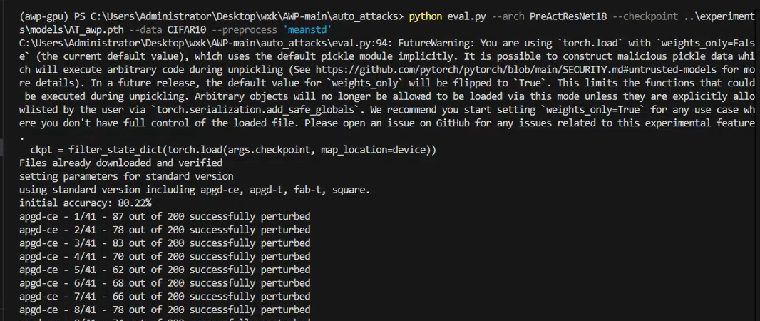
(awp-gpu) PS C:\Users\Administrator\Desktop\wxk\AWP-main\auto_attacks> python eval.py --arch PreActResNet18 --checkpoint ..\experiment
s\models\AT_awp.pth --data CIFAR10 --preprocess 'meanstd'
C:\Users\Administrator\Desktop\wxk\AWP-main\auto_attacks\eval.py:94: FutureWarning: You are using `torch.load` with `weights_only=Fals
e` (the current default value), which uses the default pickle module implicitly. It is possible to construct malicious pickle data whi
ch will execute arbitrary code during unpickling (See https://github.com/pytorch/pytorch/blob/main/SECURITY.md#untrusted-models for mo
re details). In a future release, the default value for `weights_only` will be flipped to `True`. This limits the functions that could
be executed during unpickling. Arbitrary objects will no longer be allowed to be loaded via this mode unless they are explicitly allo
wlisted by the user via `torch.serialization.add_safe_globals`. We recommend you start setting `weights_only=True` for any use case wh
ere you don't have full control of the loaded file. Please open an issue on GitHub for any issues related to this experimental feature
.
ckpt = filter_state_dict(torch.load(args.checkpoint, map_location=device))
Files already downloaded and verified
setting parameters for standard version
using standard version including apgd-ce, apgd-t, fab-t, square.
initial accuracy: 80.22%
apgd-ce - 1/41 - 87 out of 200 successfully perturbed
apgd-ce - 2/41 - 78 out of 200 successfully perturbed
apgd-ce - 3/41 - 83 out of 200 successfully perturbed
apgd-ce - 4/41 - 70 out of 200 successfully perturbed
apgd-ce - 5/41 - 62 out of 200 successfully perturbed
apgd-ce - 6/41 - 68 out of 200 successfully perturbed
apgd-ce - 7/41 - 66 out of 200 successfully perturbed
apgd-ce - 8/41 - 78 out of 200 successfully perturbed
apgd-ce - 9/41 - 74 out of 200 successfully perturbed
apgd-ce - 10/41 - 71 out of 200 successfully perturbed
apgd-ce - 11/41 - 83 out of 200 successfully perturbed
apgd-ce - 12/41 - 77 out of 200 successfully perturbed
apgd-ce - 13/41 - 70 out of 200 successfully perturbed
apgd-ce - 14/41 - 66 out of 200 successfully perturbed
apgd-ce - 15/41 - 72 out of 200 successfully perturbed
apgd-ce - 16/41 - 81 out of 200 successfully perturbed
apgd-ce - 17/41 - 74 out of 200 successfully perturbed
apgd-ce - 18/41 - 68 out of 200 successfully perturbed
apgd-ce - 19/41 - 74 out of 200 successfully perturbed
apgd-ce - 20/41 - 76 out of 200 successfully perturbed
apgd-ce - 21/41 - 78 out of 200 successfully perturbed
apgd-ce - 22/41 - 72 out of 200 successfully perturbed
apgd-ce - 23/41 - 78 out of 200 successfully perturbed
apgd-ce - 24/41 - 74 out of 200 successfully perturbed
apgd-ce - 25/41 - 72 out of 200 successfully perturbed
apgd-ce - 26/41 - 80 out of 200 successfully perturbed
apgd-ce - 27/41 - 82 out of 200 successfully perturbed
apgd-ce - 28/41 - 75 out of 200 successfully perturbed
apgd-ce - 29/41 - 79 out of 200 successfully perturbed
apgd-ce - 30/41 - 77 out of 200 successfully perturbed
apgd-ce - 31/41 - 68 out of 200 successfully perturbed
apgd-ce - 32/41 - 76 out of 200 successfully perturbed
apgd-ce - 33/41 - 76 out of 200 successfully perturbed
apgd-ce - 34/41 - 86 out of 200 successfully perturbed
apgd-ce - 35/41 - 82 out of 200 successfully perturbed
apgd-ce - 36/41 - 65 out of 200 successfully perturbed
apgd-ce - 37/41 - 70 out of 200 successfully perturbed
apgd-ce - 38/41 - 84 out of 200 successfully perturbed
apgd-ce - 39/41 - 71 out of 200 successfully perturbed
apgd-ce - 40/41 - 76 out of 200 successfully perturbed
apgd-ce - 41/41 - 5 out of 22 successfully perturbed
robust accuracy after APGD-CE: 50.18% (total time 136.3 s)
apgd-t - 1/26 - 9 out of 200 successfully perturbed
apgd-t - 2/26 - 20 out of 200 successfully perturbed
apgd-t - 3/26 - 21 out of 200 successfully perturbed
apgd-t - 4/26 - 23 out of 200 successfully perturbed
apgd-t - 5/26 - 14 out of 200 successfully perturbed
apgd-t - 6/26 - 17 out of 200 successfully perturbed
apgd-t - 7/26 - 12 out of 200 successfully perturbed
apgd-t - 8/26 - 13 out of 200 successfully perturbed
apgd-t - 9/26 - 12 out of 200 successfully perturbed
apgd-t - 10/26 - 13 out of 200 successfully perturbed
apgd-t - 11/26 - 8 out of 200 successfully perturbed
apgd-t - 12/26 - 16 out of 200 successfully perturbed
apgd-t - 13/26 - 13 out of 200 successfully perturbed
apgd-t - 14/26 - 20 out of 200 successfully perturbed
apgd-t - 15/26 - 15 out of 200 successfully perturbed
apgd-t - 16/26 - 19 out of 200 successfully perturbed
apgd-t - 17/26 - 20 out of 200 successfully perturbed
apgd-t - 18/26 - 10 out of 200 successfully perturbed
apgd-t - 19/26 - 18 out of 200 successfully perturbed
apgd-t - 20/26 - 10 out of 200 successfully perturbed
apgd-t - 21/26 - 14 out of 200 successfully perturbed
apgd-t - 22/26 - 17 out of 200 successfully perturbed
apgd-t - 23/26 - 20 out of 200 successfully perturbed
apgd-t - 24/26 - 10 out of 200 successfully perturbed
apgd-t - 25/26 - 14 out of 200 successfully perturbed
apgd-t - 26/26 - 1 out of 18 successfully perturbed
robust accuracy after APGD-T: 46.39% (total time 1248.2 s)
fab-t - 1/24 - 0 out of 200 successfully perturbed
fab-t - 2/24 - 0 out of 200 successfully perturbed
fab-t - 3/24 - 0 out of 200 successfully perturbed
fab-t - 4/24 - 0 out of 200 successfully perturbed
fab-t - 5/24 - 0 out of 200 successfully perturbed
fab-t - 6/24 - 0 out of 200 successfully perturbed
fab-t - 7/24 - 0 out of 200 successfully perturbed
fab-t - 8/24 - 0 out of 200 successfully perturbed
fab-t - 9/24 - 0 out of 200 successfully perturbed
fab-t - 10/24 - 0 out of 200 successfully perturbed
fab-t - 11/24 - 0 out of 200 successfully perturbed
fab-t - 12/24 - 0 out of 200 successfully perturbed
fab-t - 13/24 - 0 out of 200 successfully perturbed
fab-t - 14/24 - 0 out of 200 successfully perturbed
fab-t - 15/24 - 0 out of 200 successfully perturbed
fab-t - 16/24 - 0 out of 200 successfully perturbed
fab-t - 17/24 - 0 out of 200 successfully perturbed
fab-t - 18/24 - 0 out of 200 successfully perturbed
fab-t - 19/24 - 0 out of 200 successfully perturbed
fab-t - 20/24 - 0 out of 200 successfully perturbed
fab-t - 21/24 - 0 out of 200 successfully perturbed
fab-t - 22/24 - 0 out of 200 successfully perturbed
fab-t - 23/24 - 0 out of 200 successfully perturbed
fab-t - 24/24 - 0 out of 39 successfully perturbed
robust accuracy after FAB-T: 46.39% (total time 3372.9 s)
square - 1/24 - 0 out of 200 successfully perturbed
square - 2/24 - 0 out of 200 successfully perturbed
square - 3/24 - 0 out of 200 successfully perturbed
square - 4/24 - 0 out of 200 successfully perturbed
square - 5/24 - 0 out of 200 successfully perturbed
square - 6/24 - 0 out of 200 successfully perturbed
square - 7/24 - 0 out of 200 successfully perturbed
square - 8/24 - 0 out of 200 successfully perturbed
square - 9/24 - 0 out of 200 successfully perturbed
square - 10/24 - 0 out of 200 successfully perturbed
square - 11/24 - 0 out of 200 successfully perturbed
square - 12/24 - 0 out of 200 successfully perturbed
square - 13/24 - 0 out of 200 successfully perturbed
square - 14/24 - 0 out of 200 successfully perturbed
square - 15/24 - 0 out of 200 successfully perturbed
square - 16/24 - 0 out of 200 successfully perturbed
square - 17/24 - 0 out of 200 successfully perturbed
square - 18/24 - 0 out of 200 successfully perturbed
square - 19/24 - 0 out of 200 successfully perturbed
square - 20/24 - 0 out of 200 successfully perturbed
square - 21/24 - 0 out of 200 successfully perturbed
square - 22/24 - 0 out of 200 successfully perturbed
square - 23/24 - 0 out of 200 successfully perturbed
square - 24/24 - 0 out of 39 successfully perturbed
robust accuracy after SQUARE: 46.39% (total time 5955.8 s)
max Linf perturbation: 0.03137, nan in tensor: 0, max: 1.00000, min: 0.00000
robust accuracy: 46.39%
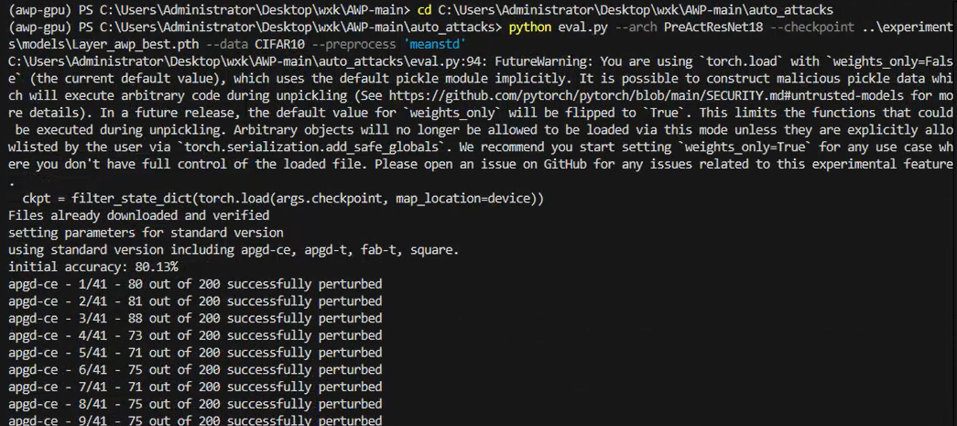
(awp-gpu) PS C:\Users\Administrator\Desktop\wxk\AWP-main\auto_attacks> python eval.py --arch PreActResNet18 --checkpoint ..\experiment
s\models\Layer_awp_best.pth --data CIFAR10 --preprocess 'meanstd'
C:\Users\Administrator\Desktop\wxk\AWP-main\auto_attacks\eval.py:94: FutureWarning: You are using `torch.load` with `weights_only=Fals
e` (the current default value), which uses the default pickle module implicitly. It is possible to construct malicious pickle data whi
ch will execute arbitrary code during unpickling (See https://github.com/pytorch/pytorch/blob/main/SECURITY.md#untrusted-models for mo
re details). In a future release, the default value for `weights_only` will be flipped to `True`. This limits the functions that could
be executed during unpickling. Arbitrary objects will no longer be allowed to be loaded via this mode unless they are explicitly allo
wlisted by the user via `torch.serialization.add_safe_globals`. We recommend you start setting `weights_only=True` for any use case wh
ere you don't have full control of the loaded file. Please open an issue on GitHub for any issues related to this experimental feature
.
ckpt = filter_state_dict(torch.load(args.checkpoint, map_location=device))
Files already downloaded and verified
setting parameters for standard version
using standard version including apgd-ce, apgd-t, fab-t, square.
initial accuracy: 80.13%
apgd-ce - 1/41 - 80 out of 200 successfully perturbed
apgd-ce - 2/41 - 81 out of 200 successfully perturbed
apgd-ce - 3/41 - 88 out of 200 successfully perturbed
apgd-ce - 4/41 - 73 out of 200 successfully perturbed
apgd-ce - 5/41 - 71 out of 200 successfully perturbed
apgd-ce - 6/41 - 75 out of 200 successfully perturbed
apgd-ce - 7/41 - 71 out of 200 successfully perturbed
apgd-ce - 8/41 - 75 out of 200 successfully perturbed
apgd-ce - 9/41 - 75 out of 200 successfully perturbed
apgd-ce - 10/41 - 73 out of 200 successfully perturbed
apgd-ce - 11/41 - 85 out of 200 successfully perturbed
apgd-ce - 12/41 - 74 out of 200 successfully perturbed
apgd-ce - 13/41 - 68 out of 200 successfully perturbed
apgd-ce - 14/41 - 64 out of 200 successfully perturbed
apgd-ce - 15/41 - 70 out of 200 successfully perturbed
apgd-ce - 16/41 - 80 out of 200 successfully perturbed
apgd-ce - 17/41 - 66 out of 200 successfully perturbed
apgd-ce - 18/41 - 79 out of 200 successfully perturbed
apgd-ce - 19/41 - 69 out of 200 successfully perturbed
apgd-ce - 20/41 - 73 out of 200 successfully perturbed
apgd-ce - 21/41 - 80 out of 200 successfully perturbed
apgd-ce - 22/41 - 70 out of 200 successfully perturbed
apgd-ce - 23/41 - 76 out of 200 successfully perturbed
apgd-ce - 24/41 - 74 out of 200 successfully perturbed
apgd-ce - 25/41 - 73 out of 200 successfully perturbed
apgd-ce - 26/41 - 86 out of 200 successfully perturbed
apgd-ce - 27/41 - 82 out of 200 successfully perturbed
apgd-ce - 28/41 - 79 out of 200 successfully perturbed
apgd-ce - 29/41 - 76 out of 200 successfully perturbed
apgd-ce - 30/41 - 71 out of 200 successfully perturbed
apgd-ce - 31/41 - 72 out of 200 successfully perturbed
apgd-ce - 32/41 - 72 out of 200 successfully perturbed
apgd-ce - 33/41 - 73 out of 200 successfully perturbed
apgd-ce - 34/41 - 89 out of 200 successfully perturbed
apgd-ce - 35/41 - 74 out of 200 successfully perturbed
apgd-ce - 36/41 - 64 out of 200 successfully perturbed
apgd-ce - 37/41 - 72 out of 200 successfully perturbed
apgd-ce - 38/41 - 77 out of 200 successfully perturbed
apgd-ce - 39/41 - 74 out of 200 successfully perturbed
apgd-ce - 40/41 - 81 out of 200 successfully perturbed
apgd-ce - 41/41 - 3 out of 13 successfully perturbed
robust accuracy after APGD-CE: 50.05% (total time 197.8 s)
apgd-t - 1/26 - 13 out of 200 successfully perturbed
apgd-t - 2/26 - 12 out of 200 successfully perturbed
apgd-t - 3/26 - 18 out of 200 successfully perturbed
apgd-t - 4/26 - 20 out of 200 successfully perturbed
apgd-t - 5/26 - 16 out of 200 successfully perturbed
apgd-t - 6/26 - 19 out of 200 successfully perturbed
apgd-t - 7/26 - 15 out of 200 successfully perturbed
apgd-t - 8/26 - 16 out of 200 successfully perturbed
apgd-t - 9/26 - 14 out of 200 successfully perturbed
apgd-t - 10/26 - 11 out of 200 successfully perturbed
apgd-t - 11/26 - 13 out of 200 successfully perturbed
apgd-t - 12/26 - 15 out of 200 successfully perturbed
apgd-t - 13/26 - 13 out of 200 successfully perturbed
apgd-t - 14/26 - 16 out of 200 successfully perturbed
apgd-t - 15/26 - 16 out of 200 successfully perturbed
apgd-t - 16/26 - 11 out of 200 successfully perturbed
apgd-t - 17/26 - 19 out of 200 successfully perturbed
apgd-t - 18/26 - 18 out of 200 successfully perturbed
apgd-t - 19/26 - 18 out of 200 successfully perturbed
apgd-t - 20/26 - 13 out of 200 successfully perturbed
apgd-t - 21/26 - 13 out of 200 successfully perturbed
apgd-t - 22/26 - 16 out of 200 successfully perturbed
apgd-t - 23/26 - 19 out of 200 successfully perturbed
apgd-t - 24/26 - 16 out of 200 successfully perturbed
apgd-t - 25/26 - 13 out of 200 successfully perturbed
apgd-t - 26/26 - 2 out of 5 successfully perturbed
robust accuracy after APGD-T: 46.20% (total time 1280.8 s)
fab-t - 1/24 - 0 out of 200 successfully perturbed
fab-t - 2/24 - 0 out of 200 successfully perturbed
fab-t - 3/24 - 0 out of 200 successfully perturbed
fab-t - 4/24 - 0 out of 200 successfully perturbed
fab-t - 5/24 - 0 out of 200 successfully perturbed
fab-t - 6/24 - 0 out of 200 successfully perturbed
fab-t - 7/24 - 0 out of 200 successfully perturbed
fab-t - 8/24 - 0 out of 200 successfully perturbed
fab-t - 9/24 - 0 out of 200 successfully perturbed
fab-t - 10/24 - 0 out of 200 successfully perturbed
fab-t - 11/24 - 0 out of 200 successfully perturbed
fab-t - 12/24 - 0 out of 200 successfully perturbed
fab-t - 13/24 - 0 out of 200 successfully perturbed
fab-t - 14/24 - 0 out of 200 successfully perturbed
fab-t - 15/24 - 0 out of 200 successfully perturbed
fab-t - 16/24 - 0 out of 200 successfully perturbed
fab-t - 17/24 - 0 out of 200 successfully perturbed
fab-t - 18/24 - 0 out of 200 successfully perturbed
fab-t - 19/24 - 0 out of 200 successfully perturbed
fab-t - 20/24 - 0 out of 200 successfully perturbed
fab-t - 21/24 - 0 out of 200 successfully perturbed
fab-t - 22/24 - 0 out of 200 successfully perturbed
fab-t - 23/24 - 0 out of 200 successfully perturbed
fab-t - 24/24 - 0 out of 20 successfully perturbed
robust accuracy after FAB-T: 46.20% (total time 3367.2 s)
square - 1/24 - 0 out of 200 successfully perturbed
square - 2/24 - 0 out of 200 successfully perturbed
square - 3/24 - 0 out of 200 successfully perturbed
square - 4/24 - 0 out of 200 successfully perturbed
square - 5/24 - 0 out of 200 successfully perturbed
square - 6/24 - 0 out of 200 successfully perturbed
square - 7/24 - 0 out of 200 successfully perturbed
square - 8/24 - 0 out of 200 successfully perturbed
square - 9/24 - 0 out of 200 successfully perturbed
square - 10/24 - 0 out of 200 successfully perturbed
square - 11/24 - 0 out of 200 successfully perturbed
square - 12/24 - 0 out of 200 successfully perturbed
square - 13/24 - 0 out of 200 successfully perturbed
square - 14/24 - 0 out of 200 successfully perturbed
square - 15/24 - 0 out of 200 successfully perturbed
square - 16/24 - 0 out of 200 successfully perturbed
square - 17/24 - 0 out of 200 successfully perturbed
square - 18/24 - 0 out of 200 successfully perturbed
square - 19/24 - 0 out of 200 successfully perturbed
square - 20/24 - 0 out of 200 successfully perturbed
square - 21/24 - 0 out of 200 successfully perturbed
square - 22/24 - 0 out of 200 successfully perturbed
square - 23/24 - 0 out of 200 successfully perturbed
square - 24/24 - 0 out of 20 successfully perturbed
robust accuracy after SQUARE: 46.20% (total time 5926.0 s)
max Linf perturbation: 0.03137, nan in tensor: 0, max: 1.00000, min: 0.00000
robust accuracy: 46.20%
(awp-gpu) PS C:\Users\Administrator\Desktop\wxk\AWP-main\auto_attacks>
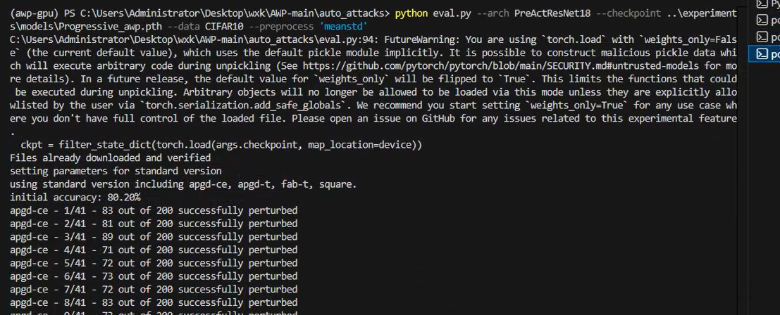
(awp-gpu) PS C:\Users\Administrator\Desktop\wxk\AWP-main\auto_attacks> python eval.py --arch PreActResNet18 --checkpoint ..\experiment
s\models\Progressive_awp.pth --data CIFAR10 --preprocess 'meanstd'
C:\Users\Administrator\Desktop\wxk\AWP-main\auto_attacks\eval.py:94: FutureWarning: You are using `torch.load` with `weights_only=Fals
e` (the current default value), which uses the default pickle module implicitly. It is possible to construct malicious pickle data whi
ch will execute arbitrary code during unpickling (See https://github.com/pytorch/pytorch/blob/main/SECURITY.md#untrusted-models for mo
re details). In a future release, the default value for `weights_only` will be flipped to `True`. This limits the functions that could
be executed during unpickling. Arbitrary objects will no longer be allowed to be loaded via this mode unless they are explicitly allo
wlisted by the user via `torch.serialization.add_safe_globals`. We recommend you start setting `weights_only=True` for any use case wh
ere you don't have full control of the loaded file. Please open an issue on GitHub for any issues related to this experimental feature
.
ckpt = filter_state_dict(torch.load(args.checkpoint, map_location=device))
Files already downloaded and verified
setting parameters for standard version
using standard version including apgd-ce, apgd-t, fab-t, square.
initial accuracy: 80.20%
apgd-ce - 1/41 - 83 out of 200 successfully perturbed
apgd-ce - 2/41 - 81 out of 200 successfully perturbed
apgd-ce - 3/41 - 89 out of 200 successfully perturbed
apgd-ce - 4/41 - 71 out of 200 successfully perturbed
apgd-ce - 5/41 - 72 out of 200 successfully perturbed
apgd-ce - 6/41 - 73 out of 200 successfully perturbed
apgd-ce - 7/41 - 72 out of 200 successfully perturbed
apgd-ce - 8/41 - 83 out of 200 successfully perturbed
apgd-ce - 9/41 - 73 out of 200 successfully perturbed
apgd-ce - 10/41 - 69 out of 200 successfully perturbed
apgd-ce - 11/41 - 85 out of 200 successfully perturbed
apgd-ce - 12/41 - 82 out of 200 successfully perturbed
apgd-ce - 13/41 - 68 out of 200 successfully perturbed
apgd-ce - 14/41 - 67 out of 200 successfully perturbed
apgd-ce - 15/41 - 75 out of 200 successfully perturbed
apgd-ce - 16/41 - 85 out of 200 successfully perturbed
apgd-ce - 17/41 - 72 out of 200 successfully perturbed
apgd-ce - 18/41 - 71 out of 200 successfully perturbed
apgd-ce - 19/41 - 78 out of 200 successfully perturbed
apgd-ce - 20/41 - 71 out of 200 successfully perturbed
apgd-ce - 21/41 - 80 out of 200 successfully perturbed
apgd-ce - 22/41 - 74 out of 200 successfully perturbed
apgd-ce - 23/41 - 73 out of 200 successfully perturbed
apgd-ce - 24/41 - 71 out of 200 successfully perturbed
apgd-ce - 25/41 - 71 out of 200 successfully perturbed
apgd-ce - 26/41 - 79 out of 200 successfully perturbed
apgd-ce - 27/41 - 84 out of 200 successfully perturbed
apgd-ce - 28/41 - 78 out of 200 successfully perturbed
apgd-ce - 29/41 - 78 out of 200 successfully perturbed
apgd-ce - 30/41 - 73 out of 200 successfully perturbed
apgd-ce - 31/41 - 75 out of 200 successfully perturbed
apgd-ce - 32/41 - 70 out of 200 successfully perturbed
apgd-ce - 33/41 - 76 out of 200 successfully perturbed
apgd-ce - 34/41 - 85 out of 200 successfully perturbed
apgd-ce - 35/41 - 80 out of 200 successfully perturbed
apgd-ce - 36/41 - 62 out of 200 successfully perturbed
apgd-ce - 37/41 - 78 out of 200 successfully perturbed
apgd-ce - 38/41 - 83 out of 200 successfully perturbed
apgd-ce - 39/41 - 66 out of 200 successfully perturbed
apgd-ce - 40/41 - 75 out of 200 successfully perturbed
apgd-ce - 41/41 - 4 out of 20 successfully perturbed
robust accuracy after APGD-CE: 49.85% (total time 203.6 s)
apgd-t - 1/25 - 13 out of 200 successfully perturbed
apgd-t - 2/25 - 16 out of 200 successfully perturbed
apgd-t - 3/25 - 16 out of 200 successfully perturbed
apgd-t - 4/25 - 23 out of 200 successfully perturbed
apgd-t - 5/25 - 7 out of 200 successfully perturbed
apgd-t - 6/25 - 17 out of 200 successfully perturbed
apgd-t - 7/25 - 11 out of 200 successfully perturbed
apgd-t - 8/25 - 11 out of 200 successfully perturbed
apgd-t - 9/25 - 15 out of 200 successfully perturbed
apgd-t - 10/25 - 14 out of 200 successfully perturbed
apgd-t - 11/25 - 10 out of 200 successfully perturbed
apgd-t - 12/25 - 14 out of 200 successfully perturbed
apgd-t - 13/25 - 18 out of 200 successfully perturbed
apgd-t - 14/25 - 16 out of 200 successfully perturbed
apgd-t - 15/25 - 17 out of 200 successfully perturbed
apgd-t - 16/25 - 13 out of 200 successfully perturbed
apgd-t - 17/25 - 26 out of 200 successfully perturbed
apgd-t - 18/25 - 14 out of 200 successfully perturbed
apgd-t - 19/25 - 12 out of 200 successfully perturbed
apgd-t - 20/25 - 14 out of 200 successfully perturbed
apgd-t - 21/25 - 11 out of 200 successfully perturbed
apgd-t - 22/25 - 12 out of 200 successfully perturbed
apgd-t - 23/25 - 13 out of 200 successfully perturbed
apgd-t - 24/25 - 13 out of 200 successfully perturbed
apgd-t - 25/25 - 15 out of 185 successfully perturbed
robust accuracy after APGD-T: 46.24% (total time 1248.4 s)
fab-t - 1/24 - 0 out of 200 successfully perturbed
fab-t - 2/24 - 0 out of 200 successfully perturbed
fab-t - 3/24 - 0 out of 200 successfully perturbed
fab-t - 4/24 - 0 out of 200 successfully perturbed
fab-t - 5/24 - 0 out of 200 successfully perturbed
fab-t - 6/24 - 0 out of 200 successfully perturbed
fab-t - 7/24 - 0 out of 200 successfully perturbed
fab-t - 8/24 - 0 out of 200 successfully perturbed
fab-t - 9/24 - 0 out of 200 successfully perturbed
fab-t - 10/24 - 0 out of 200 successfully perturbed
fab-t - 11/24 - 0 out of 200 successfully perturbed
fab-t - 12/24 - 0 out of 200 successfully perturbed
fab-t - 13/24 - 0 out of 200 successfully perturbed
fab-t - 14/24 - 0 out of 200 successfully perturbed
fab-t - 15/24 - 0 out of 200 successfully perturbed
fab-t - 16/24 - 0 out of 200 successfully perturbed
fab-t - 17/24 - 0 out of 200 successfully perturbed
fab-t - 18/24 - 0 out of 200 successfully perturbed
fab-t - 19/24 - 0 out of 200 successfully perturbed
fab-t - 20/24 - 0 out of 200 successfully perturbed
fab-t - 21/24 - 0 out of 200 successfully perturbed
fab-t - 22/24 - 0 out of 200 successfully perturbed
fab-t - 23/24 - 1 out of 200 successfully perturbed
fab-t - 24/24 - 0 out of 24 successfully perturbed
robust accuracy after FAB-T: 46.23% (total time 3332.9 s)
square - 1/24 - 0 out of 200 successfully perturbed
square - 2/24 - 0 out of 200 successfully perturbed
square - 3/24 - 0 out of 200 successfully perturbed
square - 4/24 - 0 out of 200 successfully perturbed
square - 5/24 - 0 out of 200 successfully perturbed
square - 6/24 - 0 out of 200 successfully perturbed
square - 7/24 - 0 out of 200 successfully perturbed
square - 8/24 - 0 out of 200 successfully perturbed
square - 9/24 - 0 out of 200 successfully perturbed
square - 10/24 - 0 out of 200 successfully perturbed
square - 11/24 - 0 out of 200 successfully perturbed
square - 12/24 - 0 out of 200 successfully perturbed
square - 13/24 - 0 out of 200 successfully perturbed
square - 14/24 - 0 out of 200 successfully perturbed
square - 15/24 - 0 out of 200 successfully perturbed
square - 16/24 - 0 out of 200 successfully perturbed
square - 17/24 - 0 out of 200 successfully perturbed
square - 18/24 - 0 out of 200 successfully perturbed
square - 19/24 - 0 out of 200 successfully perturbed
square - 20/24 - 0 out of 200 successfully perturbed
square - 21/24 - 0 out of 200 successfully perturbed
square - 22/24 - 0 out of 200 successfully perturbed
square - 23/24 - 0 out of 200 successfully perturbed
square - 24/24 - 0 out of 23 successfully perturbed
robust accuracy after SQUARE: 46.23% (total time 5893.6 s)
max Linf perturbation: 0.03137, nan in tensor: 0, max: 1.00000, min: 0.00000
robust accuracy: 46.23%

