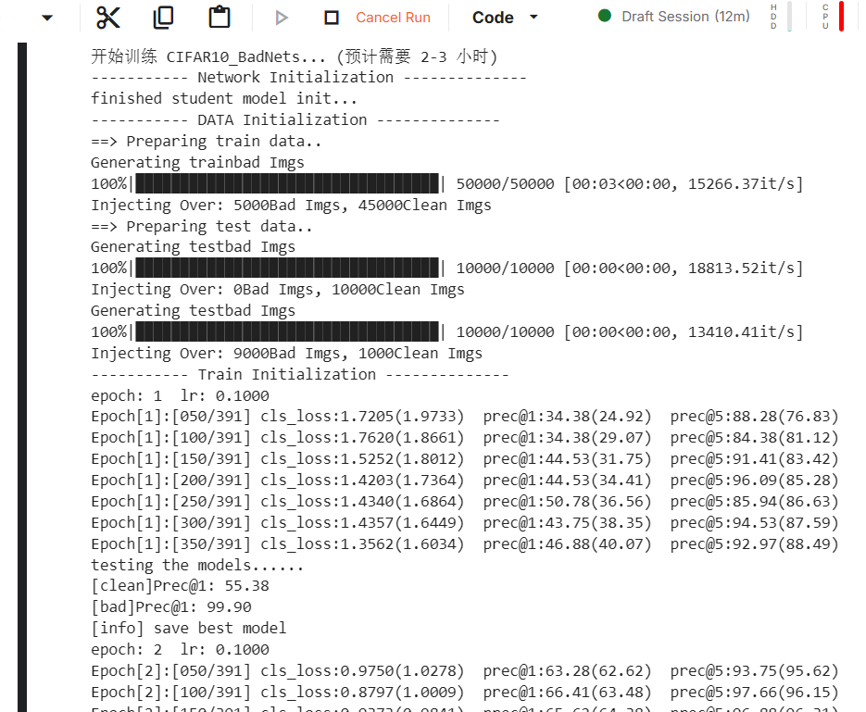
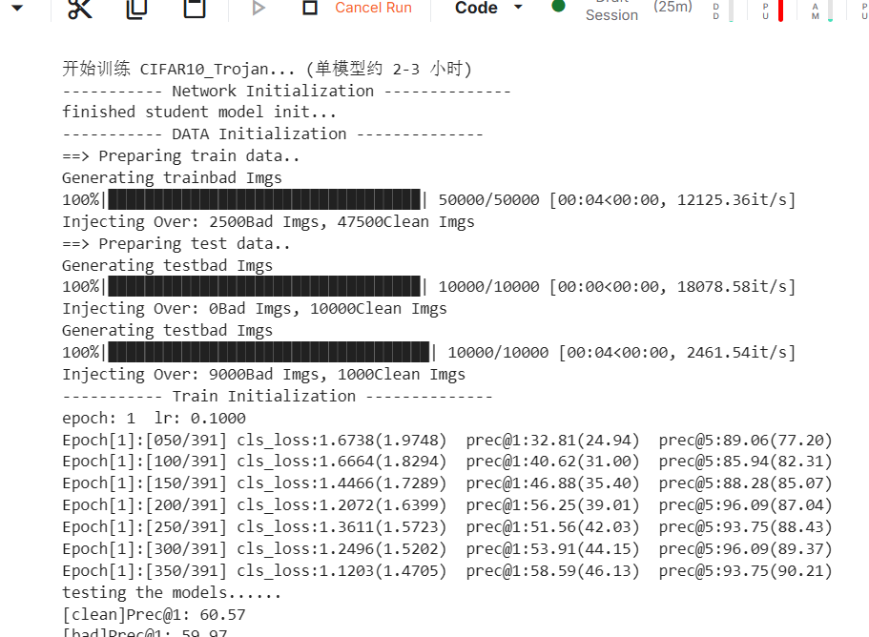
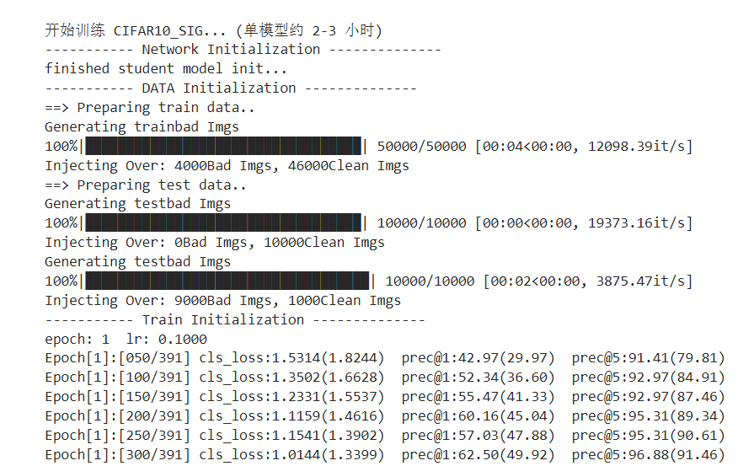
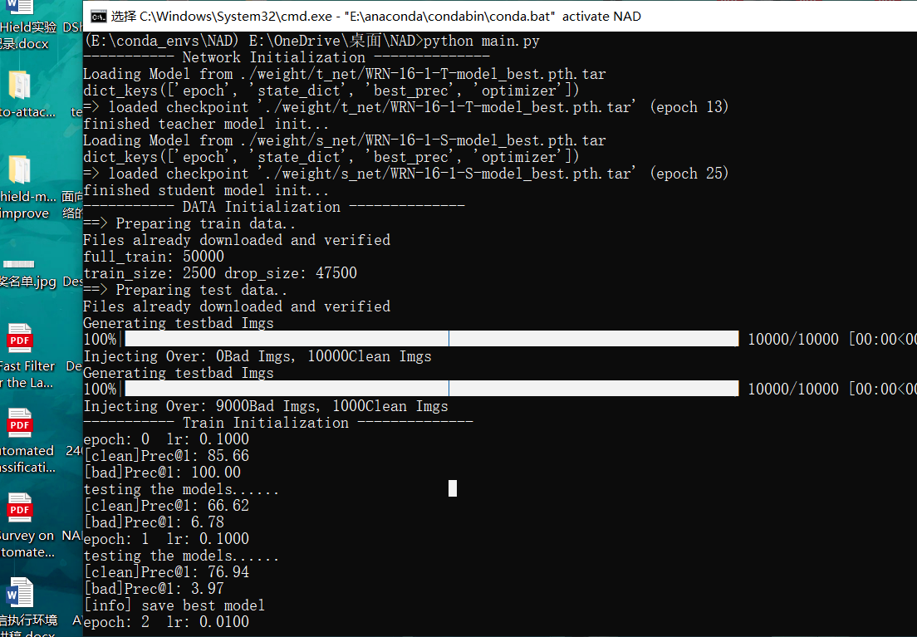
(E:\conda_envs\NAD) E:\OneDrive\桌面\NAD>python main.py
----------- Network Initialization --------------
Loading Model from ./weight/t_net/WRN-16-1-T-model_best.pth.tar
dict_keys(['epoch', 'state_dict', 'best_prec', 'optimizer'])
=> loaded checkpoint './weight/t_net/WRN-16-1-T-model_best.pth.tar' (epoch 13)
finished teacher model init...
Loading Model from ./weight/s_net/WRN-16-1-S-model_best.pth.tar
dict_keys(['epoch', 'state_dict', 'best_prec', 'optimizer'])
=> loaded checkpoint './weight/s_net/WRN-16-1-S-model_best.pth.tar' (epoch 25)
finished student model init...
----------- DATA Initialization --------------
==> Preparing train data..
Files already downloaded and verified
full_train: 50000
train_size: 2500 drop_size: 47500
==> Preparing test data..
Files already downloaded and verified
Generating testbad Imgs
100%|█████████████████████████████████████████████████████████████████████████| 10000/10000 [00:00<00:00, 23545.94it/s]
Injecting Over: 0Bad Imgs, 10000Clean Imgs
Generating testbad Imgs
100%|█████████████████████████████████████████████████████████████████████████| 10000/10000 [00:00<00:00, 19134.93it/s]
Injecting Over: 9000Bad Imgs, 1000Clean Imgs
----------- Train Initialization --------------
epoch: 0 lr: 0.1000
[clean]Prec@1: 85.66
[bad]Prec@1: 100.00
testing the models......
[clean]Prec@1: 66.62
[bad]Prec@1: 6.78
epoch: 1 lr: 0.1000
testing the models......
[clean]Prec@1: 76.94
[bad]Prec@1: 3.97
[info] save best model
epoch: 2 lr: 0.0100
testing the models......
[clean]Prec@1: 81.52
[bad]Prec@1: 3.28
[info] save best model
epoch: 3 lr: 0.0100
testing the models......
[clean]Prec@1: 82.31
[bad]Prec@1: 3.46
[info] save best model
…………
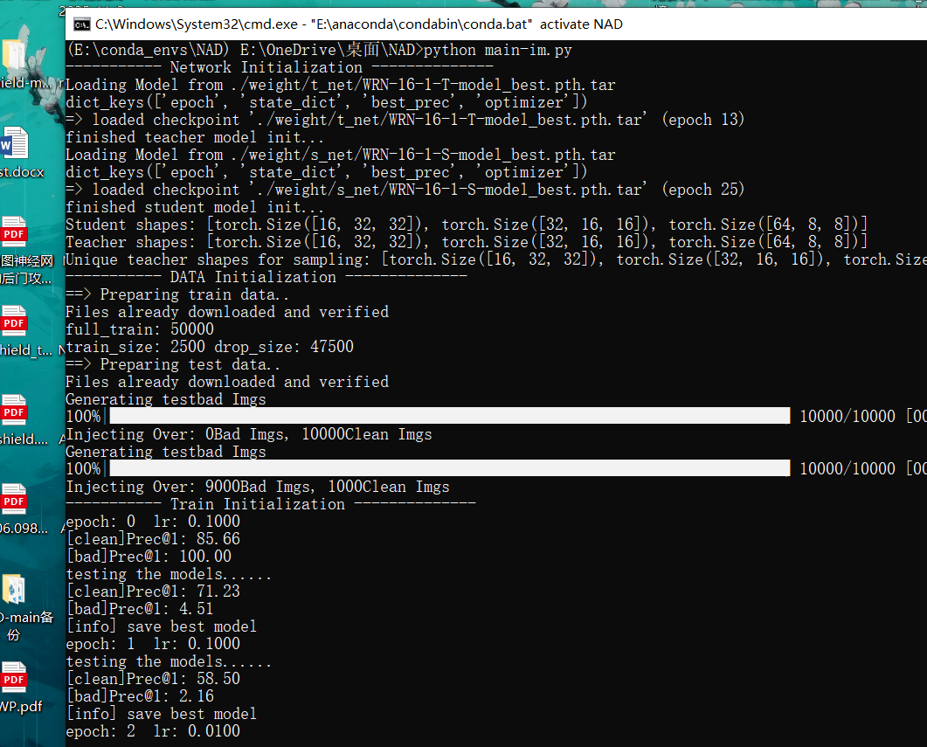
(E:\conda_envs\NAD) E:\OneDrive\桌面\NAD>python main-im.py
----------- Network Initialization --------------
Loading Model from ./weight/t_net/WRN-16-1-T-model_best.pth.tar
dict_keys(['epoch', 'state_dict', 'best_prec', 'optimizer'])
=> loaded checkpoint './weight/t_net/WRN-16-1-T-model_best.pth.tar' (epoch 13)
finished teacher model init...
Loading Model from ./weight/s_net/WRN-16-1-S-model_best.pth.tar
dict_keys(['epoch', 'state_dict', 'best_prec', 'optimizer'])
=> loaded checkpoint './weight/s_net/WRN-16-1-S-model_best.pth.tar' (epoch 25)
finished student model init...
Student shapes: [torch.Size([16, 32, 32]), torch.Size([32, 16, 16]), torch.Size([64, 8, 8])]
Teacher shapes: [torch.Size([16, 32, 32]), torch.Size([32, 16, 16]), torch.Size([64, 8, 8])]
Unique teacher shapes for sampling: [torch.Size([16, 32, 32]), torch.Size([32, 16, 16]), torch.Size([64, 8, 8])]
----------- DATA Initialization --------------
==> Preparing train data..
Files already downloaded and verified
full_train: 50000
train_size: 2500 drop_size: 47500
==> Preparing test data..
Files already downloaded and verified
Generating testbad Imgs
100%|█████████████████████████████████████████████████████████████████████████████| 10000/10000 [00:00<00:00, 23582.04it/s]
Injecting Over: 0Bad Imgs, 10000Clean Imgs
Generating testbad Imgs
100%|█████████████████████████████████████████████████████████████████████████████| 10000/10000 [00:00<00:00, 19320.90it/s]
Injecting Over: 9000Bad Imgs, 1000Clean Imgs
----------- Train Initialization --------------
epoch: 0 lr: 0.1000
[clean]Prec@1: 85.66
[bad]Prec@1: 100.00
testing the models......
[clean]Prec@1: 71.23
[bad]Prec@1: 4.51
[info] save best model
epoch: 1 lr: 0.1000
testing the models......
[clean]Prec@1: 58.50
[bad]Prec@1: 2.16
[info] save best model
epoch: 2 lr: 0.0100
testing the models......
[clean]Prec@1: 81.76
[bad]Prec@1: 2.13
[info] save best model
epoch: 3 lr: 0.0100
testing the models......
[clean]Prec@1: 82.51
[bad]Prec@1: 2.96
[info] save best model
…………
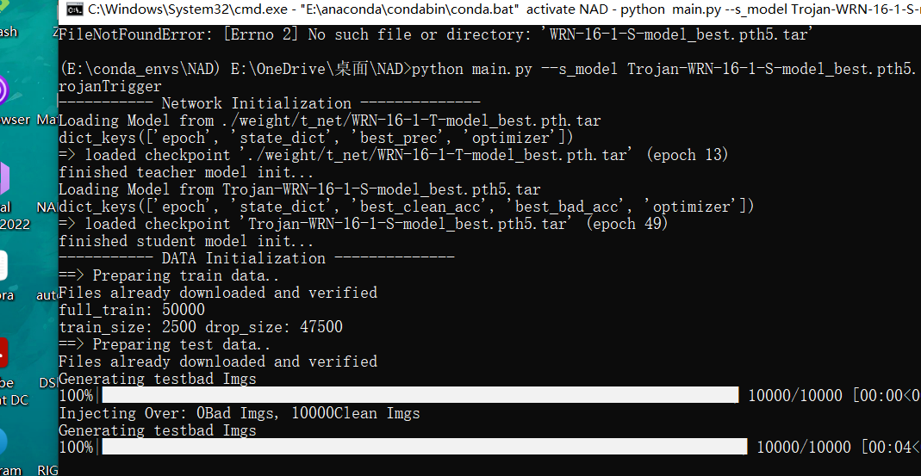
(E:\conda_envs\NAD) E:\OneDrive\桌面\NAD>python main.py --s_model Trojan-WRN-16-1-S-model_best.pth5.tar --trigger_type trojanTrigger
----------- Network Initialization --------------
Loading Model from ./weight/t_net/WRN-16-1-T-model_best.pth.tar
dict_keys(['epoch', 'state_dict', 'best_prec', 'optimizer'])
=> loaded checkpoint './weight/t_net/WRN-16-1-T-model_best.pth.tar' (epoch 13)
finished teacher model init...
Loading Model from Trojan-WRN-16-1-S-model_best.pth5.tar
dict_keys(['epoch', 'state_dict', 'best_clean_acc', 'best_bad_acc', 'optimizer'])
=> loaded checkpoint 'Trojan-WRN-16-1-S-model_best.pth5.tar' (epoch 49)
finished student model init...
----------- DATA Initialization --------------
==> Preparing train data..
Files already downloaded and verified
full_train: 50000
train_size: 2500 drop_size: 47500
==> Preparing test data..
Files already downloaded and verified
Generating testbad Imgs
100%|█████████████████████████████████████████████████████████████████████████| 10000/10000 [00:00<00:00, 23774.26it/s]
Injecting Over: 0Bad Imgs, 10000Clean Imgs
Generating testbad Imgs
100%|██████████████████████████████████████████████████████████████████████████| 10000/10000 [00:04<00:00, 2021.79it/s]
Injecting Over: 9000Bad Imgs, 1000Clean Imgs
----------- Train Initialization --------------
epoch: 0 lr: 0.1000
[clean]Prec@1: 83.72
[bad]Prec@1: 99.43
testing the models......
[clean]Prec@1: 72.88
[bad]Prec@1: 3.43
[info] save best model
epoch: 1 lr: 0.1000
testing the models......
[clean]Prec@1: 72.67
[bad]Prec@1: 3.87
[info] save best model
epoch: 2 lr: 0.0100
testing the models......
[clean]Prec@1: 80.08
[bad]Prec@1: 2.43
[info] save best model
epoch: 3 lr: 0.0100
testing the models......
[clean]Prec@1: 81.23
[bad]Prec@1: 1.98
[info] save best model
…………
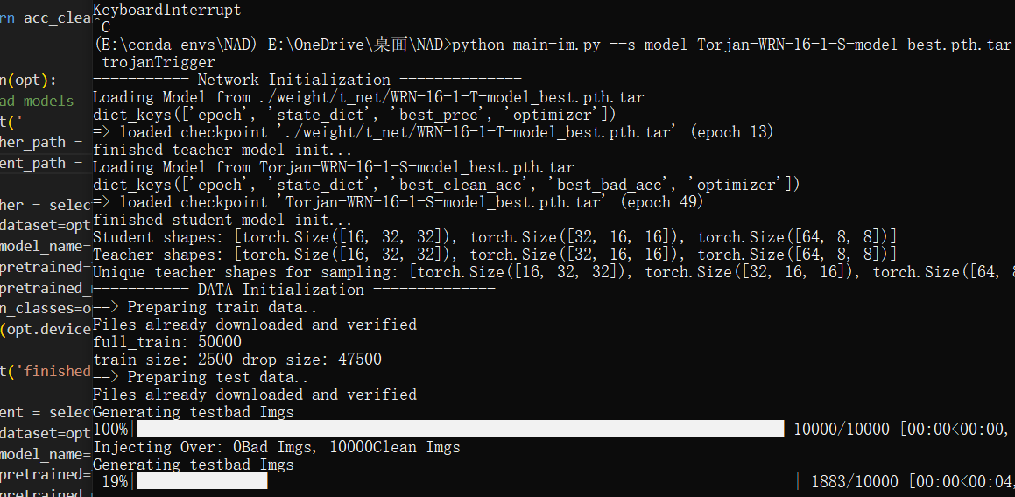
(E:\conda_envs\NAD) E:\OneDrive\桌面\NAD>python main-im.py --s_model Torjan-WRN-16-1-S-model_best.pth.tar --trigger_type trojanTrigger
----------- Network Initialization --------------
Loading Model from ./weight/t_net/WRN-16-1-T-model_best.pth.tar
dict_keys(['epoch', 'state_dict', 'best_prec', 'optimizer'])
=> loaded checkpoint './weight/t_net/WRN-16-1-T-model_best.pth.tar' (epoch 13)
finished teacher model init...
Loading Model from Torjan-WRN-16-1-S-model_best.pth.tar
dict_keys(['epoch', 'state_dict', 'best_clean_acc', 'best_bad_acc', 'optimizer'])
=> loaded checkpoint 'Torjan-WRN-16-1-S-model_best.pth.tar' (epoch 49)
finished student model init...
Student shapes: [torch.Size([16, 32, 32]), torch.Size([32, 16, 16]), torch.Size([64, 8, 8])]
Teacher shapes: [torch.Size([16, 32, 32]), torch.Size([32, 16, 16]), torch.Size([64, 8, 8])]
Unique teacher shapes for sampling: [torch.Size([16, 32, 32]), torch.Size([32, 16, 16]), torch.Size([64, 8, 8])]
----------- DATA Initialization --------------
==> Preparing train data..
Files already downloaded and verified
full_train: 50000
train_size: 2500 drop_size: 47500
==> Preparing test data..
Files already downloaded and verified
Generating testbad Imgs
100%|█████████████████████████████████████████████████████████████████████████| 10000/10000 [00:00<00:00, 23522.57it/s]
Injecting Over: 0Bad Imgs, 10000Clean Imgs
Generating testbad Imgs
100%|██████████████████████████████████████████████████████████████████████████| 10000/10000 [00:04<00:00, 2069.18it/s]
Injecting Over: 9000Bad Imgs, 1000Clean Imgs
----------- Train Initialization --------------
epoch: 0 lr: 0.1000
[clean]Prec@1: 83.72
[bad]Prec@1: 99.43
testing the models......
[clean]Prec@1: 57.78
[bad]Prec@1: 4.08
epoch: 1 lr: 0.1000
testing the models......
[clean]Prec@1: 74.39
[bad]Prec@1: 6.17
[info] save best model
epoch: 2 lr: 0.0100
testing the models......
[clean]Prec@1: 79.13
[bad]Prec@1: 3.32
[info] save best model
…………
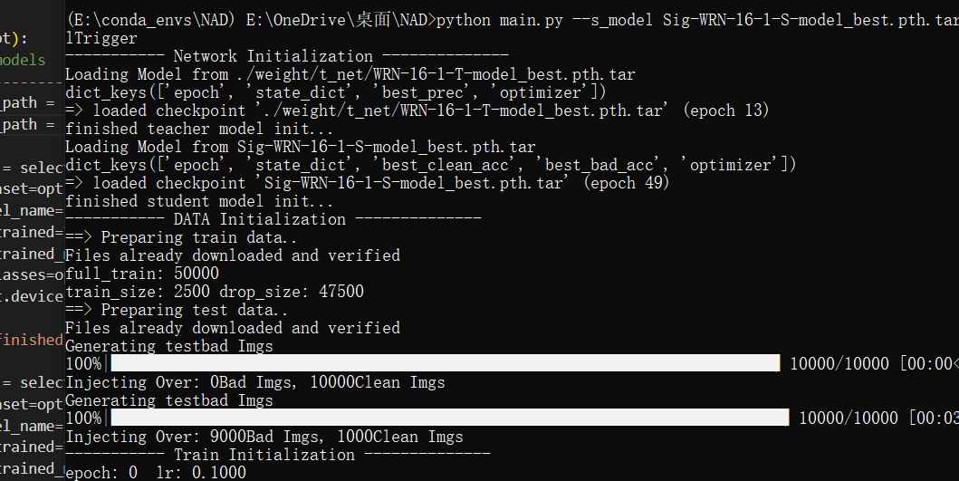
(E:\conda_envs\NAD) E:\OneDrive\桌面\NAD>python main.py --s_model Sig-WRN-16-1-S-model_best.pth.tar --trigger_type signalTrigger
----------- Network Initialization --------------
Loading Model from ./weight/t_net/WRN-16-1-T-model_best.pth.tar
dict_keys(['epoch', 'state_dict', 'best_prec', 'optimizer'])
=> loaded checkpoint './weight/t_net/WRN-16-1-T-model_best.pth.tar' (epoch 13)
finished teacher model init...
Loading Model from Sig-WRN-16-1-S-model_best.pth.tar
dict_keys(['epoch', 'state_dict', 'best_clean_acc', 'best_bad_acc', 'optimizer'])
=> loaded checkpoint 'Sig-WRN-16-1-S-model_best.pth.tar' (epoch 49)
finished student model init...
----------- DATA Initialization --------------
==> Preparing train data..
Files already downloaded and verified
full_train: 50000
train_size: 2500 drop_size: 47500
==> Preparing test data..
Files already downloaded and verified
Generating testbad Imgs
100%|█████████████████████████████████████████████████████████████████████████| 10000/10000 [00:00<00:00, 24358.00it/s]
Injecting Over: 0Bad Imgs, 10000Clean Imgs
Generating testbad Imgs
100%|██████████████████████████████████████████████████████████████████████████| 10000/10000 [00:03<00:00, 3109.07it/s]
Injecting Over: 9000Bad Imgs, 1000Clean Imgs
----------- Train Initialization --------------
epoch: 0 lr: 0.1000
[clean]Prec@1: 83.10
[bad]Prec@1: 99.94
testing the models......
[clean]Prec@1: 65.59
[bad]Prec@1: 38.03
epoch: 1 lr: 0.1000
testing the models......
[clean]Prec@1: 70.47
[bad]Prec@1: 1.89
[info] save best model
epoch: 2 lr: 0.0100
testing the models......
[clean]Prec@1: 81.16
[bad]Prec@1: 0.82
[info] save best model
epoch: 3 lr: 0.0100
testing the models......
[clean]Prec@1: 80.72
[bad]Prec@1: 2.72
[info] save best model
epoch: 4 lr: 0.0100
testing the models......
[clean]Prec@1: 81.52
[bad]Prec@1: 2.66
[info] save best model
…………
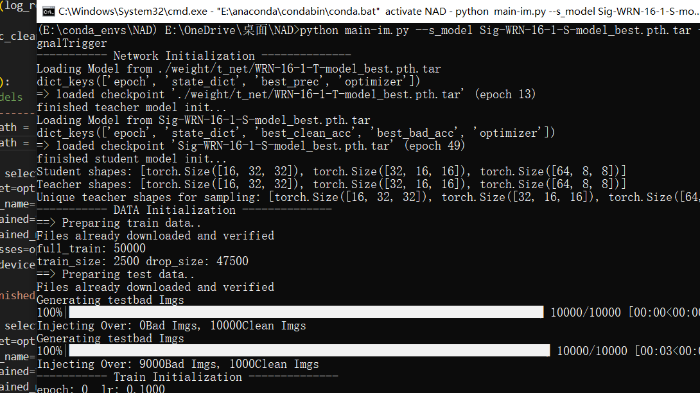
(E:\conda_envs\NAD) E:\OneDrive\桌面\NAD>python main-im.py --s_model Sig-WRN-16-1-S-model_best.pth.tar --trigger_type signalTrigger
----------- Network Initialization --------------
Loading Model from ./weight/t_net/WRN-16-1-T-model_best.pth.tar
dict_keys(['epoch', 'state_dict', 'best_prec', 'optimizer'])
=> loaded checkpoint './weight/t_net/WRN-16-1-T-model_best.pth.tar' (epoch 13)
finished teacher model init...
Loading Model from Sig-WRN-16-1-S-model_best.pth.tar
dict_keys(['epoch', 'state_dict', 'best_clean_acc', 'best_bad_acc', 'optimizer'])
=> loaded checkpoint 'Sig-WRN-16-1-S-model_best.pth.tar' (epoch 49)
finished student model init...
Student shapes: [torch.Size([16, 32, 32]), torch.Size([32, 16, 16]), torch.Size([64, 8, 8])]
Teacher shapes: [torch.Size([16, 32, 32]), torch.Size([32, 16, 16]), torch.Size([64, 8, 8])]
Unique teacher shapes for sampling: [torch.Size([16, 32, 32]), torch.Size([32, 16, 16]), torch.Size([64, 8, 8])]
----------- DATA Initialization --------------
==> Preparing train data..
Files already downloaded and verified
full_train: 50000
train_size: 2500 drop_size: 47500
==> Preparing test data..
Files already downloaded and verified
Generating testbad Imgs
100%|█████████████████████████████████████████████████████████████████████████| 10000/10000 [00:00<00:00, 23610.41it/s]
Injecting Over: 0Bad Imgs, 10000Clean Imgs
Generating testbad Imgs
100%|██████████████████████████████████████████████████████████████████████████| 10000/10000 [00:03<00:00, 3133.05it/s]
Injecting Over: 9000Bad Imgs, 1000Clean Imgs
----------- Train Initialization --------------
epoch: 0 lr: 0.1000
[clean]Prec@1: 83.10
[bad]Prec@1: 99.94
testing the models......
[clean]Prec@1: 61.58
[bad]Prec@1: 2.76
epoch: 1 lr: 0.1000
testing the models......
[clean]Prec@1: 67.84
[bad]Prec@1: 0.26
[info] save best model
epoch: 2 lr: 0.0100
testing the models......
[clean]Prec@1: 79.66
[bad]Prec@1: 1.40
[info] save best model
…………
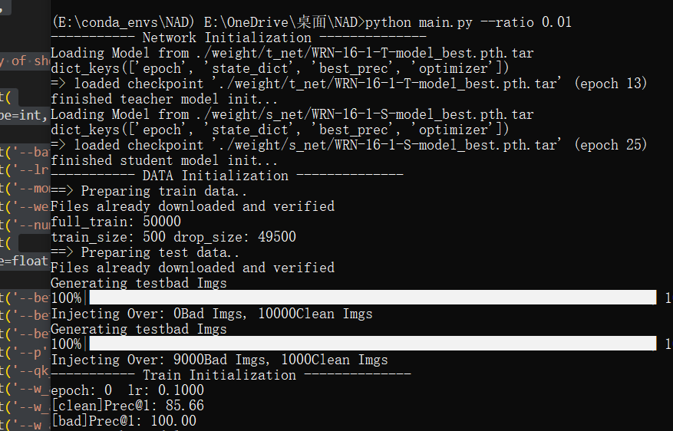
(E:\conda_envs\NAD) E:\OneDrive\桌面\NAD>python main.py --ratio 0.01
----------- Network Initialization --------------
Loading Model from ./weight/t_net/WRN-16-1-T-model_best.pth.tar
dict_keys(['epoch', 'state_dict', 'best_prec', 'optimizer'])
=> loaded checkpoint './weight/t_net/WRN-16-1-T-model_best.pth.tar' (epoch 13)
finished teacher model init...
Loading Model from ./weight/s_net/WRN-16-1-S-model_best.pth.tar
dict_keys(['epoch', 'state_dict', 'best_prec', 'optimizer'])
=> loaded checkpoint './weight/s_net/WRN-16-1-S-model_best.pth.tar' (epoch 25)
finished student model init...
----------- DATA Initialization --------------
==> Preparing train data..
Files already downloaded and verified
full_train: 50000
train_size: 500 drop_size: 49500
==> Preparing test data..
Files already downloaded and verified
Generating testbad Imgs
100%|█████████████████████████████████████████████████████████████████████████| 10000/10000 [00:00<00:00, 23702.83it/s]
Injecting Over: 0Bad Imgs, 10000Clean Imgs
Generating testbad Imgs
100%|█████████████████████████████████████████████████████████████████████████| 10000/10000 [00:00<00:00, 19389.53it/s]
Injecting Over: 9000Bad Imgs, 1000Clean Imgs
----------- Train Initialization --------------
epoch: 0 lr: 0.1000
[clean]Prec@1: 85.66
[bad]Prec@1: 100.00
testing the models......
[clean]Prec@1: 66.46
[bad]Prec@1: 18.53
epoch: 1 lr: 0.1000
testing the models......
[clean]Prec@1: 69.61
[bad]Prec@1: 15.10
[info] save best model
epoch: 2 lr: 0.0100
testing the models......
[clean]Prec@1: 76.38
[bad]Prec@1: 13.78
[info] save best model
epoch: 3 lr: 0.0100
testing the models......
[clean]Prec@1: 78.37
[bad]Prec@1: 13.46
[info] save best model
…………
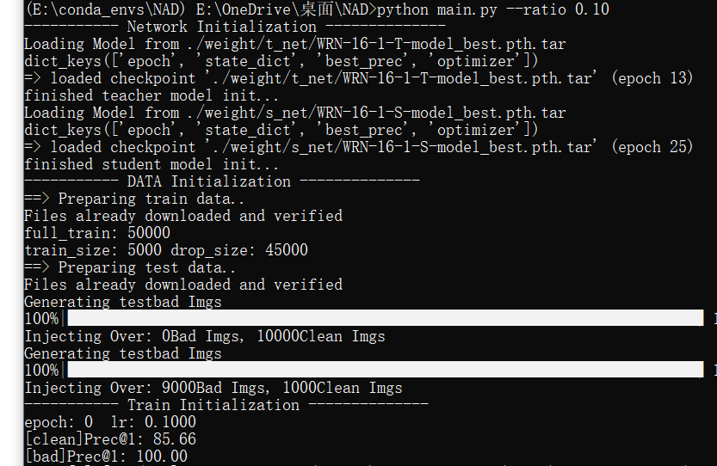
(E:\conda_envs\NAD) E:\OneDrive\桌面\NAD>python main.py --ratio 0.10
----------- Network Initialization --------------
Loading Model from ./weight/t_net/WRN-16-1-T-model_best.pth.tar
dict_keys(['epoch', 'state_dict', 'best_prec', 'optimizer'])
=> loaded checkpoint './weight/t_net/WRN-16-1-T-model_best.pth.tar' (epoch 13)
finished teacher model init...
Loading Model from ./weight/s_net/WRN-16-1-S-model_best.pth.tar
dict_keys(['epoch', 'state_dict', 'best_prec', 'optimizer'])
=> loaded checkpoint './weight/s_net/WRN-16-1-S-model_best.pth.tar' (epoch 25)
finished student model init...
----------- DATA Initialization --------------
==> Preparing train data..
Files already downloaded and verified
full_train: 50000
train_size: 5000 drop_size: 45000
==> Preparing test data..
Files already downloaded and verified
Generating testbad Imgs
100%|█████████████████████████████████████████████████████████████████████████| 10000/10000 [00:00<00:00, 23834.74it/s]
Injecting Over: 0Bad Imgs, 10000Clean Imgs
Generating testbad Imgs
100%|█████████████████████████████████████████████████████████████████████████| 10000/10000 [00:00<00:00, 19188.64it/s]
Injecting Over: 9000Bad Imgs, 1000Clean Imgs
----------- Train Initialization --------------
epoch: 0 lr: 0.1000
[clean]Prec@1: 85.66
[bad]Prec@1: 100.00
Epoch[1]:[050/079] AT_loss:1.7752(2.2318) prec@1:78.12(73.88) prec@5:98.44(98.00)
testing the models......
[clean]Prec@1: 75.92
[bad]Prec@1: 11.86
[info] save best model
epoch: 1 lr: 0.1000
Epoch[2]:[050/079] AT_loss:1.7913(1.5700) prec@1:68.75(79.34) prec@5:100.00(98.72)
testing the models......
[clean]Prec@1: 80.42
[bad]Prec@1: 5.31
[info] save best model
epoch: 2 lr: 0.0100
Epoch[3]:[050/079] AT_loss:1.3032(1.3725) prec@1:84.38(83.38) prec@5:100.00(99.44)
testing the models......
[clean]Prec@1: 84.56
[bad]Prec@1: 2.08
[info] save best model
epoch: 3 lr: 0.0100
Epoch[4]:[050/079] AT_loss:1.2495(1.2906) prec@1:84.38(84.84) prec@5:100.00(99.53)
testing the models......
[clean]Prec@1: 84.53
[bad]Prec@1: 3.17
[info] save best model
…………
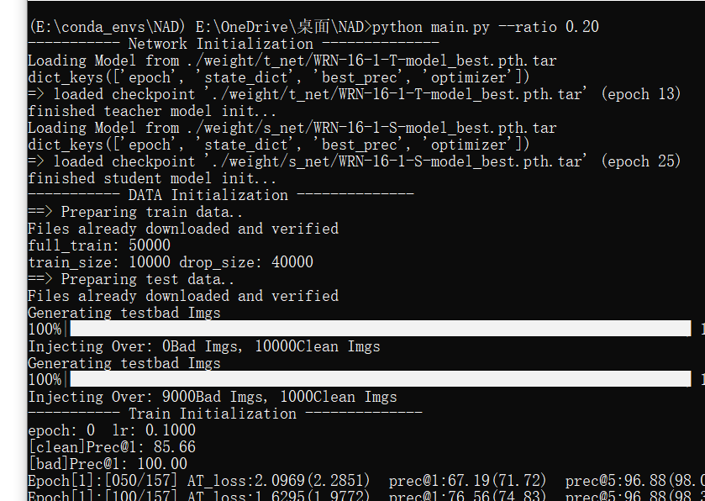
(E:\conda_envs\NAD) E:\OneDrive\桌面\NAD>python main.py --ratio 0.20
----------- Network Initialization --------------
Loading Model from ./weight/t_net/WRN-16-1-T-model_best.pth.tar
dict_keys(['epoch', 'state_dict', 'best_prec', 'optimizer'])
=> loaded checkpoint './weight/t_net/WRN-16-1-T-model_best.pth.tar' (epoch 13)
finished teacher model init...
Loading Model from ./weight/s_net/WRN-16-1-S-model_best.pth.tar
dict_keys(['epoch', 'state_dict', 'best_prec', 'optimizer'])
=> loaded checkpoint './weight/s_net/WRN-16-1-S-model_best.pth.tar' (epoch 25)
finished student model init...
----------- DATA Initialization --------------
==> Preparing train data..
Files already downloaded and verified
full_train: 50000
train_size: 10000 drop_size: 40000
==> Preparing test data..
Files already downloaded and verified
Generating testbad Imgs
100%|█████████████████████████████████████████████████████████████████████████| 10000/10000 [00:00<00:00, 24253.80it/s]
Injecting Over: 0Bad Imgs, 10000Clean Imgs
Generating testbad Imgs
100%|█████████████████████████████████████████████████████████████████████████| 10000/10000 [00:00<00:00, 19808.78it/s]
Injecting Over: 9000Bad Imgs, 1000Clean Imgs
----------- Train Initialization --------------
epoch: 0 lr: 0.1000
[clean]Prec@1: 85.66
[bad]Prec@1: 100.00
Epoch[1]:[050/157] AT_loss:2.0969(2.2851) prec@1:67.19(71.72) prec@5:96.88(98.09)
Epoch[1]:[100/157] AT_loss:1.6295(1.9772) prec@1:76.56(74.83) prec@5:96.88(98.30)
Epoch[1]:[150/157] AT_loss:1.2894(1.8258) prec@1:85.94(76.48) prec@5:100.00(98.52)
testing the models......
[clean]Prec@1: 82.09
[bad]Prec@1: 5.08
[info] save best model
epoch: 1 lr: 0.1000
Epoch[2]:[050/157] AT_loss:1.3768(1.4329) prec@1:84.38(80.88) prec@5:100.00(99.09)
Epoch[2]:[100/157] AT_loss:1.5060(1.4374) prec@1:79.69(80.42) prec@5:98.44(99.09)
Epoch[2]:[150/157] AT_loss:1.3686(1.4283) prec@1:79.69(80.28) prec@5:98.44(98.98)
testing the models......
[clean]Prec@1: 82.19
[bad]Prec@1: 0.84
[info] save best model
epoch: 2 lr: 0.0100
Epoch[3]:[050/157] AT_loss:1.4099(1.2963) prec@1:76.56(82.91) prec@5:100.00(99.06)
Epoch[3]:[100/157] AT_loss:1.3646(1.2732) prec@1:78.12(83.38) prec@5:100.00(99.27)
Epoch[3]:[150/157] AT_loss:1.3247(1.2551) prec@1:78.12(83.60) prec@5:100.00(99.34)
testing the models......
[clean]Prec@1: 85.01
[bad]Prec@1: 2.31
[info] save best model
epoch: 3 lr: 0.0100
…………
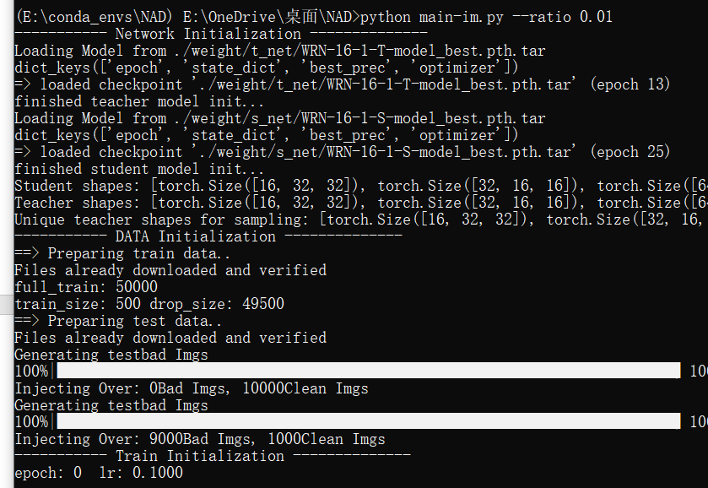
(E:\conda_envs\NAD) E:\OneDrive\桌面\NAD>python main-im.py --ratio 0.01
----------- Network Initialization --------------
Loading Model from ./weight/t_net/WRN-16-1-T-model_best.pth.tar
dict_keys(['epoch', 'state_dict', 'best_prec', 'optimizer'])
=> loaded checkpoint './weight/t_net/WRN-16-1-T-model_best.pth.tar' (epoch 13)
finished teacher model init...
Loading Model from ./weight/s_net/WRN-16-1-S-model_best.pth.tar
dict_keys(['epoch', 'state_dict', 'best_prec', 'optimizer'])
=> loaded checkpoint './weight/s_net/WRN-16-1-S-model_best.pth.tar' (epoch 25)
finished student model init...
Student shapes: [torch.Size([16, 32, 32]), torch.Size([32, 16, 16]), torch.Size([64, 8, 8])]
Teacher shapes: [torch.Size([16, 32, 32]), torch.Size([32, 16, 16]), torch.Size([64, 8, 8])]
Unique teacher shapes for sampling: [torch.Size([16, 32, 32]), torch.Size([32, 16, 16]), torch.Size([64, 8, 8])]
----------- DATA Initialization --------------
==> Preparing train data..
Files already downloaded and verified
full_train: 50000
train_size: 500 drop_size: 49500
==> Preparing test data..
Files already downloaded and verified
Generating testbad Imgs
100%|█████████████████████████████████████████████████████████████████████████| 10000/10000 [00:00<00:00, 24067.59it/s]
Injecting Over: 0Bad Imgs, 10000Clean Imgs
Generating testbad Imgs
100%|█████████████████████████████████████████████████████████████████████████| 10000/10000 [00:00<00:00, 19800.91it/s]
Injecting Over: 9000Bad Imgs, 1000Clean Imgs
----------- Train Initialization --------------
epoch: 0 lr: 0.1000
[clean]Prec@1: 85.66
[bad]Prec@1: 100.00
testing the models......
[clean]Prec@1: 45.27
[bad]Prec@1: 0.47
epoch: 1 lr: 0.1000
testing the models......
[clean]Prec@1: 53.52
[bad]Prec@1: 0.82
[info] save best model
epoch: 2 lr: 0.0100
testing the models......
[clean]Prec@1: 69.12
[bad]Prec@1: 4.76
[info] save best model
epoch: 3 lr: 0.0100
testing the models......
[clean]Prec@1: 75.70
[bad]Prec@1: 7.08
[info] save best model
…………
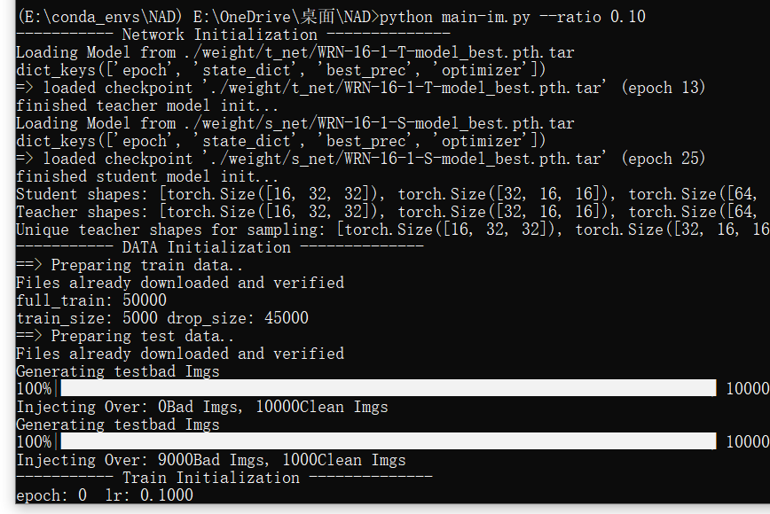
(E:\conda_envs\NAD) E:\OneDrive\桌面\NAD>python main-im.py --ratio 0.10
----------- Network Initialization --------------
Loading Model from ./weight/t_net/WRN-16-1-T-model_best.pth.tar
dict_keys(['epoch', 'state_dict', 'best_prec', 'optimizer'])
=> loaded checkpoint './weight/t_net/WRN-16-1-T-model_best.pth.tar' (epoch 13)
finished teacher model init...
Loading Model from ./weight/s_net/WRN-16-1-S-model_best.pth.tar
dict_keys(['epoch', 'state_dict', 'best_prec', 'optimizer'])
=> loaded checkpoint './weight/s_net/WRN-16-1-S-model_best.pth.tar' (epoch 25)
finished student model init...
Student shapes: [torch.Size([16, 32, 32]), torch.Size([32, 16, 16]), torch.Size([64, 8, 8])]
Teacher shapes: [torch.Size([16, 32, 32]), torch.Size([32, 16, 16]), torch.Size([64, 8, 8])]
Unique teacher shapes for sampling: [torch.Size([16, 32, 32]), torch.Size([32, 16, 16]), torch.Size([64, 8, 8])]
----------- DATA Initialization --------------
==> Preparing train data..
Files already downloaded and verified
full_train: 50000
train_size: 5000 drop_size: 45000
==> Preparing test data..
Files already downloaded and verified
Generating testbad Imgs
100%|█████████████████████████████████████████████████████████████████████████| 10000/10000 [00:00<00:00, 24133.24it/s]
Injecting Over: 0Bad Imgs, 10000Clean Imgs
Generating testbad Imgs
100%|█████████████████████████████████████████████████████████████████████████| 10000/10000 [00:00<00:00, 19867.47it/s]
Injecting Over: 9000Bad Imgs, 1000Clean Imgs
----------- Train Initialization --------------
epoch: 0 lr: 0.1000
[clean]Prec@1: 85.66
[bad]Prec@1: 100.00
Epoch[1]:[050/079] AT_loss:3.0475(3.7466) prec@1:71.88(73.16) prec@5:100.00(98.28)
testing the models......
[clean]Prec@1: 65.46
[bad]Prec@1: 14.34
epoch: 1 lr: 0.1000
Epoch[2]:[050/079] AT_loss:2.5609(2.6522) prec@1:76.56(77.91) prec@5:96.88(99.00)
testing the models......
[clean]Prec@1: 68.78
[bad]Prec@1: 18.53
[info] save best model
epoch: 2 lr: 0.0100
Epoch[3]:[050/079] AT_loss:2.1941(2.3111) prec@1:82.81(81.44) prec@5:100.00(99.22)
testing the models......
[clean]Prec@1: 83.26
[bad]Prec@1: 2.79
[info] save best model
epoch: 3 lr: 0.0100
Epoch[4]:[050/079] AT_loss:2.3941(2.1950) prec@1:75.00(82.34) prec@5:98.44(99.28)
testing the models......
[clean]Prec@1: 83.27
[bad]Prec@1: 2.44
[info] save best model
epoch: 4 lr: 0.0100
Epoch[5]:[050/079] AT_loss:1.9043(2.1639) prec@1:87.50(83.19) prec@5:100.00(99.34)
testing the models......
[clean]Prec@1: 83.84
[bad]Prec@1: 1.91
[info] save best model
epoch: 5 lr: 0.0100
…………
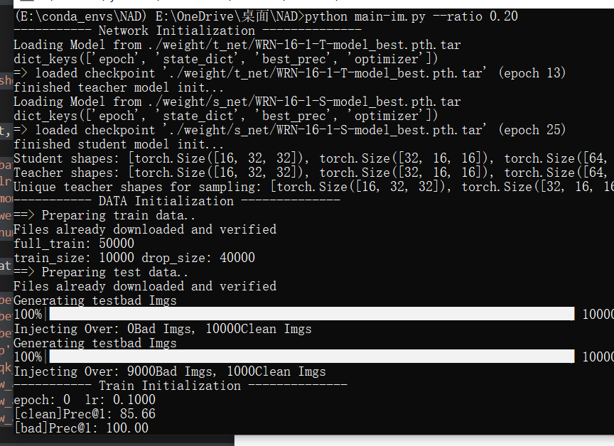
(E:\conda_envs\NAD) E:\OneDrive\桌面\NAD>python main-im.py --ratio 0.20
----------- Network Initialization --------------
Loading Model from ./weight/t_net/WRN-16-1-T-model_best.pth.tar
dict_keys(['epoch', 'state_dict', 'best_prec', 'optimizer'])
=> loaded checkpoint './weight/t_net/WRN-16-1-T-model_best.pth.tar' (epoch 13)
finished teacher model init...
Loading Model from ./weight/s_net/WRN-16-1-S-model_best.pth.tar
dict_keys(['epoch', 'state_dict', 'best_prec', 'optimizer'])
=> loaded checkpoint './weight/s_net/WRN-16-1-S-model_best.pth.tar' (epoch 25)
finished student model init...
Student shapes: [torch.Size([16, 32, 32]), torch.Size([32, 16, 16]), torch.Size([64, 8, 8])]
Teacher shapes: [torch.Size([16, 32, 32]), torch.Size([32, 16, 16]), torch.Size([64, 8, 8])]
Unique teacher shapes for sampling: [torch.Size([16, 32, 32]), torch.Size([32, 16, 16]), torch.Size([64, 8, 8])]
----------- DATA Initialization --------------
==> Preparing train data..
Files already downloaded and verified
full_train: 50000
train_size: 10000 drop_size: 40000
==> Preparing test data..
Files already downloaded and verified
Generating testbad Imgs
100%|█████████████████████████████████████████████████████████████████████████| 10000/10000 [00:00<00:00, 24074.94it/s]
Injecting Over: 0Bad Imgs, 10000Clean Imgs
Generating testbad Imgs
100%|█████████████████████████████████████████████████████████████████████████| 10000/10000 [00:00<00:00, 19779.58it/s]
Injecting Over: 9000Bad Imgs, 1000Clean Imgs
----------- Train Initialization --------------
epoch: 0 lr: 0.1000
[clean]Prec@1: 85.66
[bad]Prec@1: 100.00
Epoch[1]:[050/157] AT_loss:3.1814(3.7897) prec@1:68.75(72.53) prec@5:98.44(97.75)
Epoch[1]:[100/157] AT_loss:2.6797(3.2584) prec@1:79.69(75.41) prec@5:98.44(98.25)
Epoch[1]:[150/157] AT_loss:2.2263(3.0287) prec@1:85.94(76.17) prec@5:100.00(98.40)
testing the models......
[clean]Prec@1: 81.23
[bad]Prec@1: 2.41
[info] save best model
epoch: 1 lr: 0.1000
Epoch[2]:[050/157] AT_loss:2.3355(2.4037) prec@1:78.12(80.25) prec@5:100.00(98.94)
Epoch[2]:[100/157] AT_loss:2.3179(2.3709) prec@1:82.81(79.92) prec@5:96.88(98.92)
Epoch[2]:[150/157] AT_loss:2.1083(2.3371) prec@1:84.38(79.61) prec@5:100.00(98.82)
testing the models......
[clean]Prec@1: 74.42
[bad]Prec@1: 6.62
[info] save best model
epoch: 2 lr: 0.0100
Epoch[3]:[050/157] AT_loss:1.9258(2.1211) prec@1:93.75(80.72) prec@5:98.44(99.22)
Epoch[3]:[100/157] AT_loss:1.9293(2.0629) prec@1:92.19(82.00) prec@5:100.00(99.33)
Epoch[3]:[150/157] AT_loss:2.1140(2.0588) prec@1:84.38(81.97) prec@5:100.00(99.19)
testing the models......
[clean]Prec@1: 84.41
[bad]Prec@1: 2.28
[info] save best model
epoch: 3 lr: 0.0100
…………

