

CSE471 : System Analysis and Design
Lab Assignment on API Postman Collection

Project Title : Job Portal
Group Number : 10
Backend Framework : Mern Stack

Submitted by : Mahmuda Akter Alif
Student ID : 21201149
Section: 01

Date : 11.12.2025

APIs of Feature - 01

Login,Get profile, applications, reset password

APIs of Feature - 02

Edit profile, upload resume,image

Instruction:
- You have to develop all the REST APIs/Endpoints of two features (which interfaces you have submitted in the Figma assignment) of your project using your preferred backend framework. Database must be connected.
- Each API description will include:
- Endpoint URL (e.g., https://api.example.com/users)
- HTTP Method (GET, POST, PUT, DELETE, etc.)
- Headers (like Content-Type or Authorization)
- Body/Parameters (data to send with request)
- This is an individual submission. The developed APIs can not be duplicated among group members.
- Add a code snippet for each API.
- Run a backend server on a specific port. The port number should be the last four digits of your student id.
- Test your developed API in Postman. Add a screenshot for each API.
- For example:
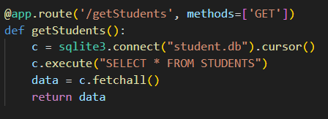
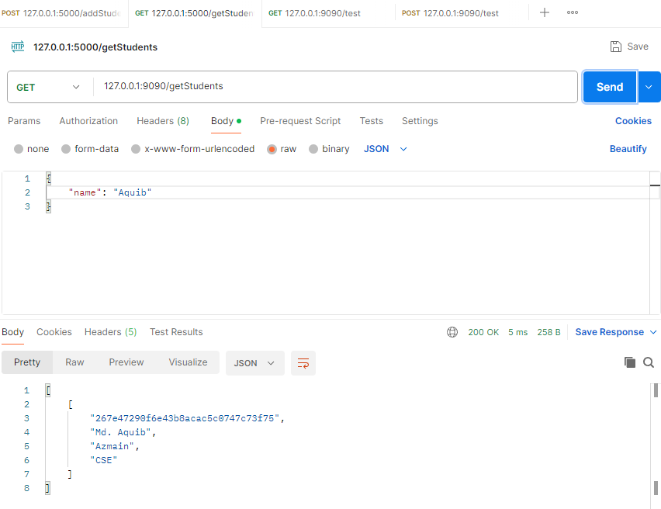

- Endpoint URL: 127.0.0.1:9090/getStudetns
- HTTP Method: Get
- Headers: None
- Body: {“name” : “Aquib”}

API1:Login( http://localhost:1149/api/auth/login)

Code snippet:
@app.route('/api/auth/login', methods=['POST'])
def login():
email = request.json.get('email')
password = request.json.get('password')

user = User.find_one({'email': email})
if not user or not user.compare_password(password):
return {'message': 'Invalid credentials'}, 401

token = jwt.encode({'id': str(user._id), 'role': user.role}, JWT_SECRET, algorithm='HS256')

response = make_response({'user': {'id': user._id, 'name': user.name, 'email': user.email, 'role': user.role}})
response.set_cookie('token', token, httponly=True, samesite='Strict', max_age=3600)
return response, 200

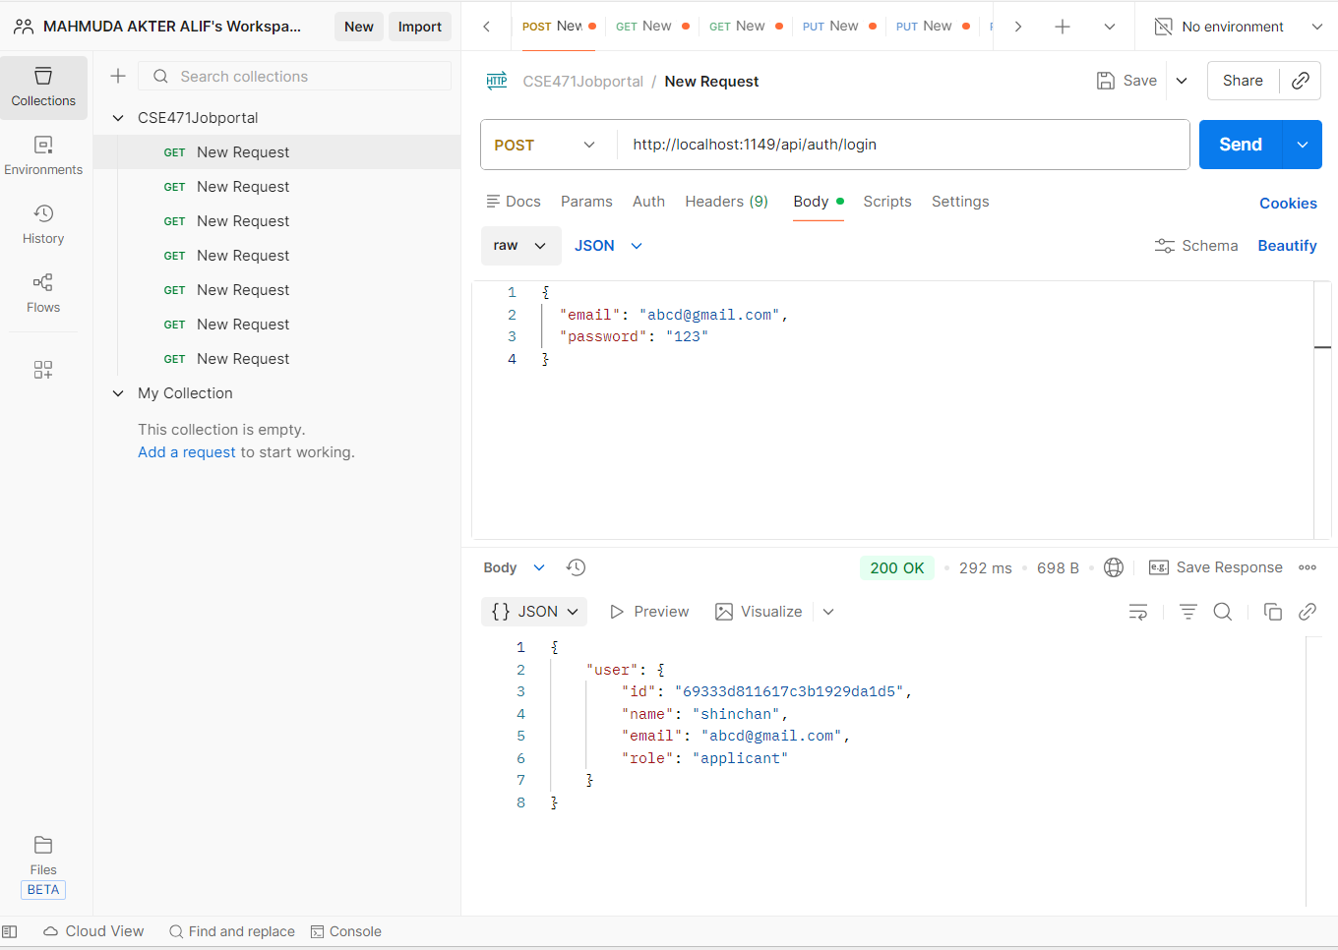

API2:Get profile( http://localhost:1149/api/profile)

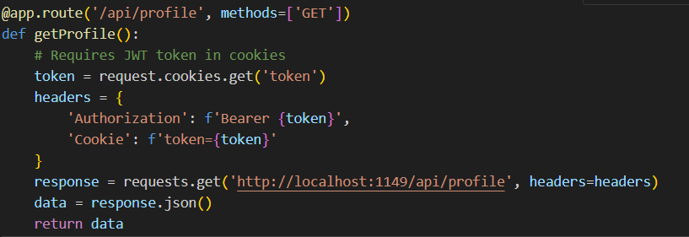

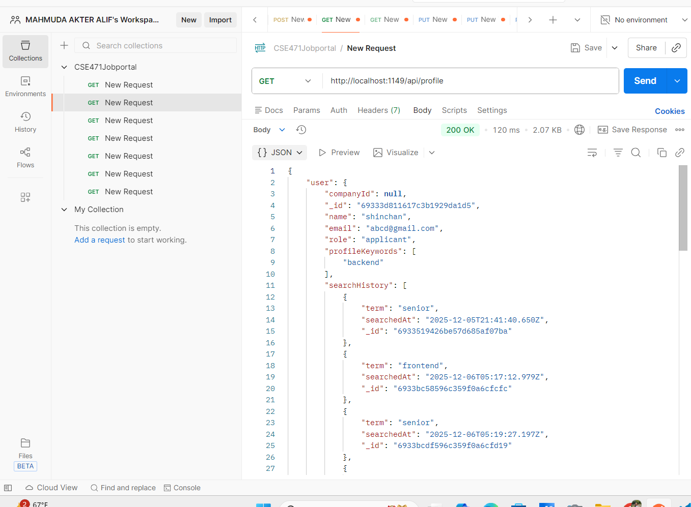

API3:Get Applications (http://localhost:1149/api/jobs/applicant/applications)

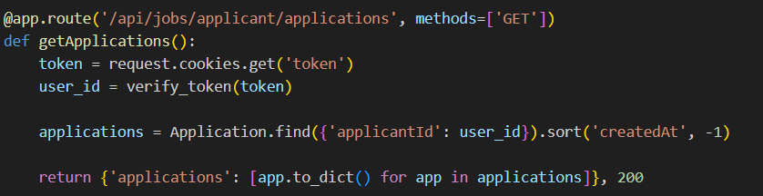

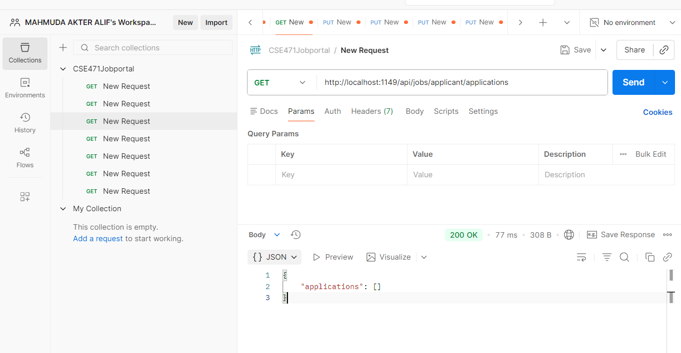

API4: Update skills(http://localhost:1149/api/profile)

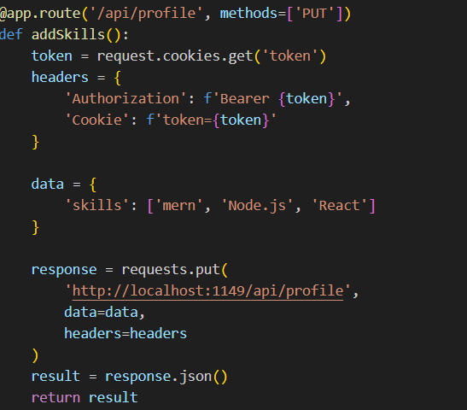

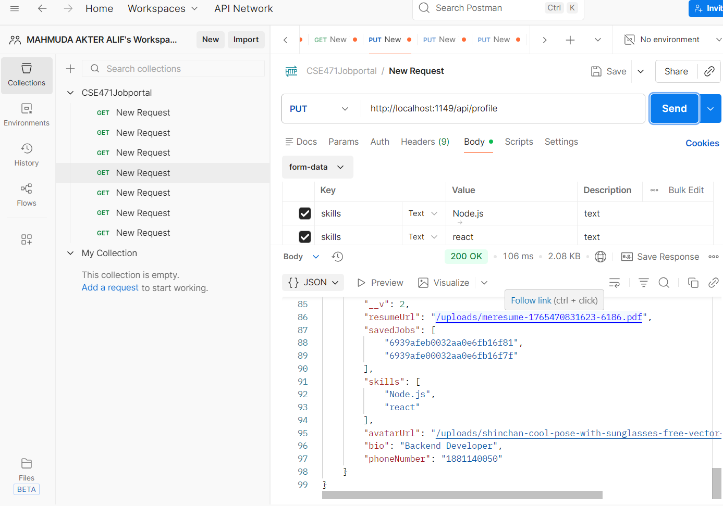

API5: Upload resume(http://localhost:1149/api/profile?resume)

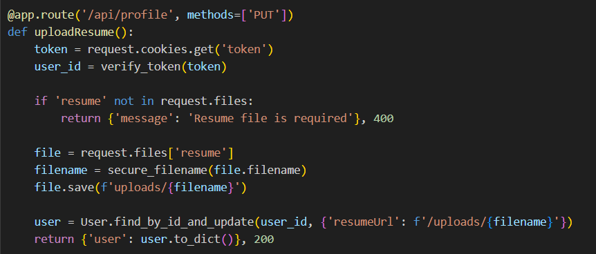
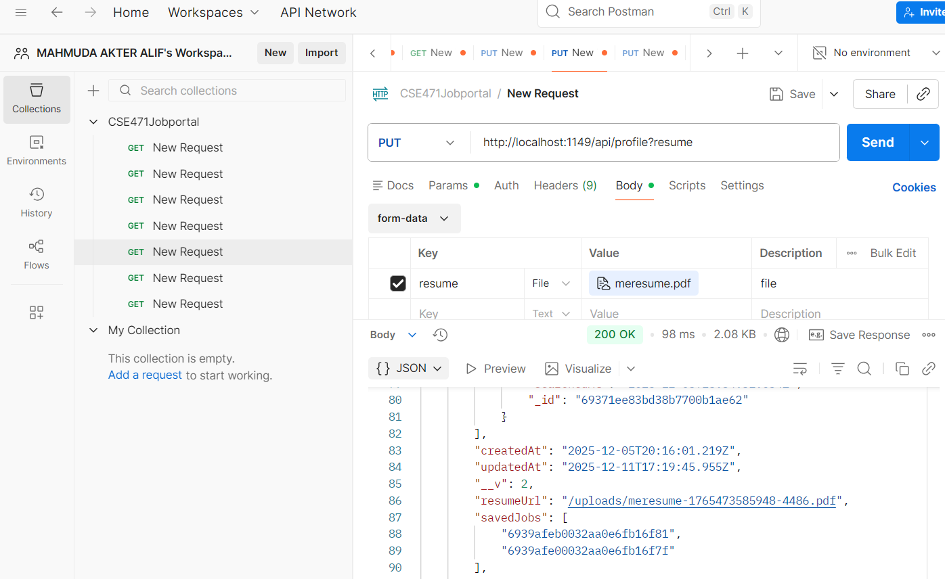

API6: Update profile(http://localhost:1149/api/profile)

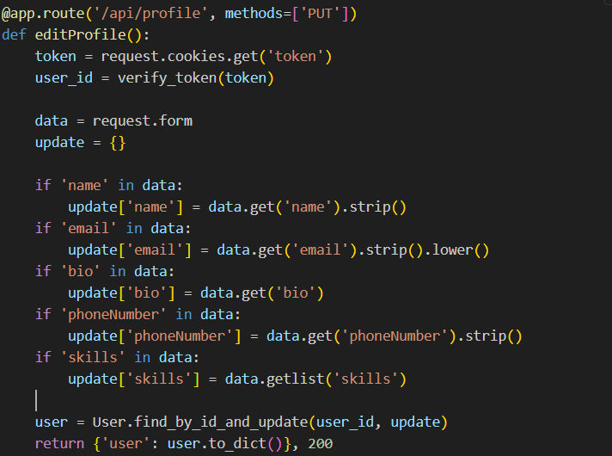
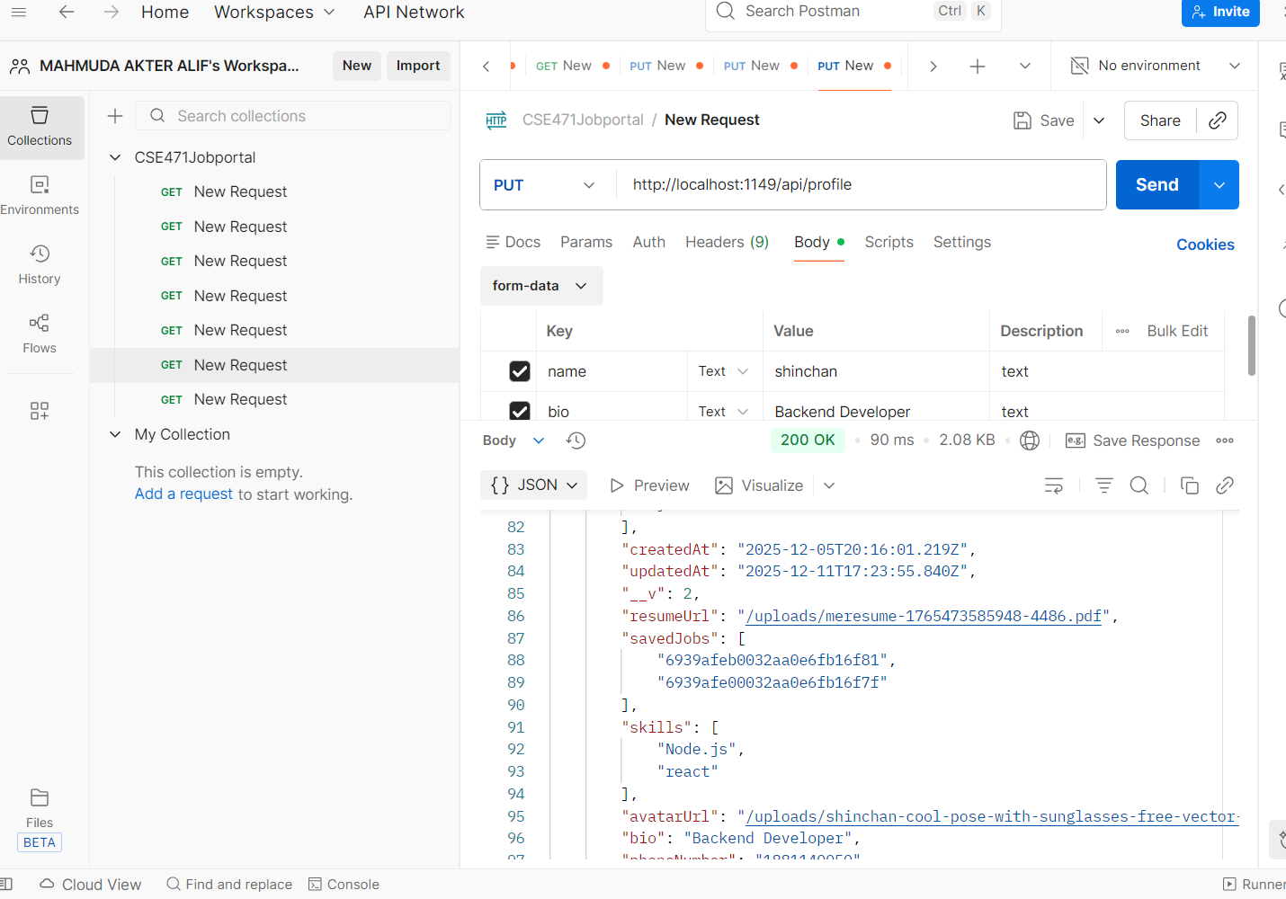

API7: Upload image(http://localhost:1149/api/profile)

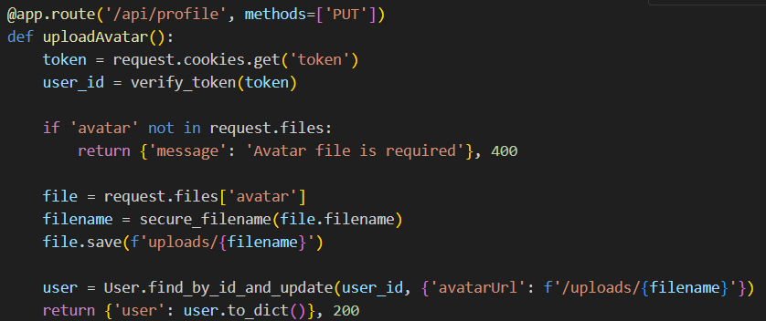
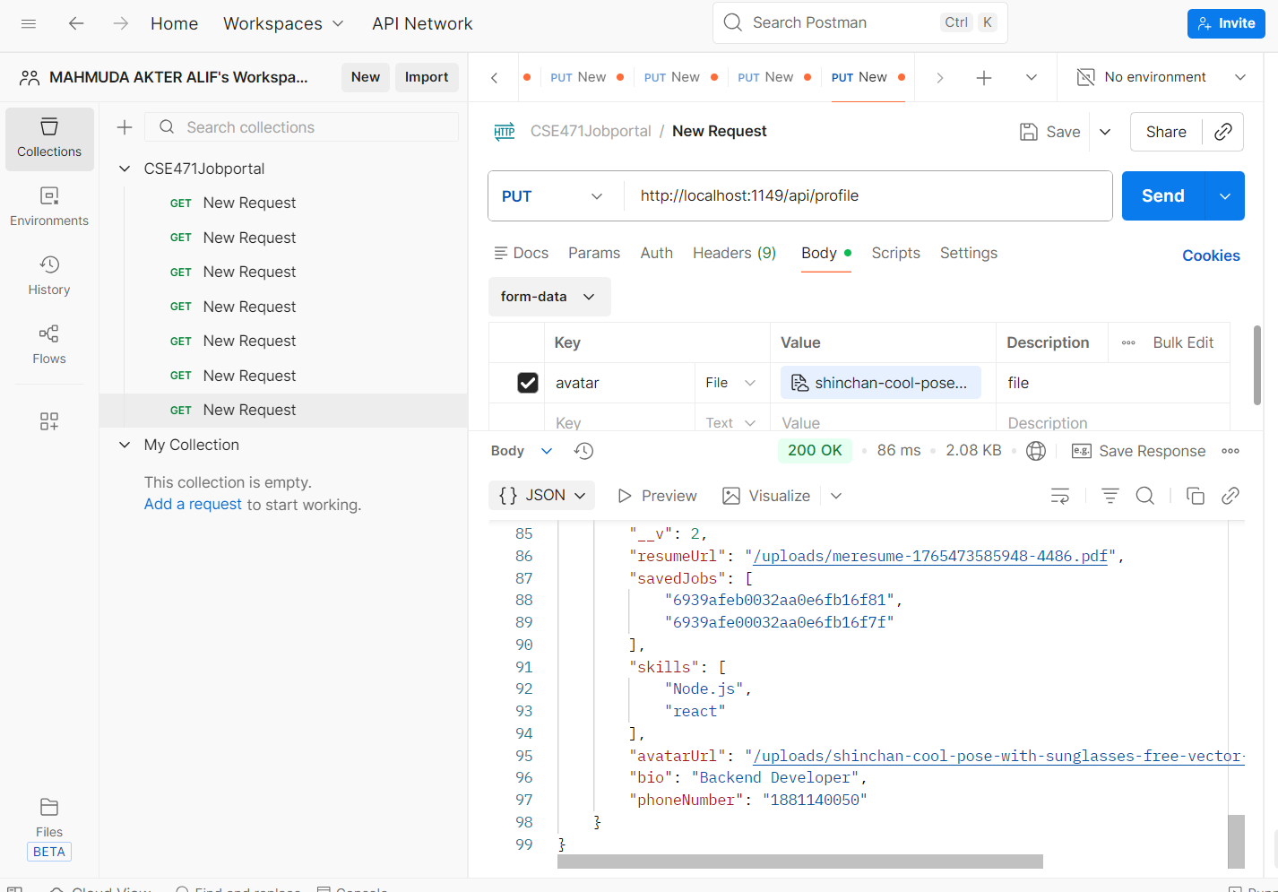

API8: Password reset (http://localhost:1149/api/profile/password)
