

**Basic Linux Commands Assignments**

**Assignment-1**

Connect and disconnect with login Access

* What happens when you login a non-existent users or username?
  + Provide Screenshot and What you understand, explain in short brief?

RESPONSE TO **Assignment-1  
 SCREENSHOT:**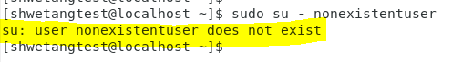

**EXPLAINATION:** Command throws an output that the user/username we are trying to login as doesn’t exist in the system ,which implies, we need to create the user first and then attempt to login

**Assignment-2**

Password changing  
Kindly find the responses inline.

* Login into your account and then change password?
  + Change your password into **IneuR0n#42** and hit the **Enter** key
    - Explain what happen and give screenshot?
* **RESPONSE:   
    
  SCREENSHOT:**Graphical user interface, text, application

  Description automatically generated

**EXPLAINATION:**  
There was a prompt for entering the new password and upon entering the new password as required, there was another prompt to Retype the password once again as part of password change confirmation and post that the password got changed successfully.

* + Try again to change password but use like password ***1234*** or ***abcd***
    - Explain what happen and give screenshot?

**🡪 RESPONSE:  
  
**EXPLAINATION:** Upon trying to change the password to 1234, received a prompt as BAD PASSWORD: The password is shorter than 8 characters, possibly implying that the password may not be strong enough although upon still going ahead and retyping the new password, the password got changed successfully.

* + Try again to change password but now don’t use any password just hit **Enter** key
    - Explain what happen and give screenshot?  
      **🡪 RESPONSE:**  
        
      **SCREENSHOT:**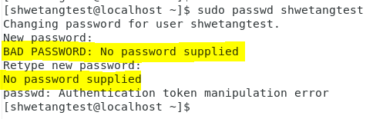

**EXPLAINATION:** Received a prompt as BAD PASSWORD: No password supplied and upon continuing the same under Retype new password, the prompt exited without changes.

**Assignment-3**

Working with Directories  
Kindly find the responses inline.

* Enter the command **cd /** and then **ls** and then hit **Enter** key
  + Take screenshot and explain what output we got?
* **RESPONSE:**  
  **SCREENSHOT:**  
    
  Text

  Description automatically generated with medium confidence

**EXPLAINATION:**  
Upon execution, it has taken us to the topmost level or the root path of the “system” under which all the other primary directories of the system are available.

* Enter the command now **cd /home** and then hit **Enter** key
  + Do **ls,** provide screenshot and explain what is **/home** directory used for?
* **RESPONSE**:  
    
  **SCREENSHOT:**  
  Text

  Description automatically generated  
  **EXPLAINATION:**/home is the directory consisting of all the user/username directories created on the system and it consists of the particular user’s data in the respective folders
* Enter **cd ..** and hit **Enter** key [ *Note: here we have space after cd then use double dot*]
  + Check what happen and give screenshot?
* **RESPONSE:**  
  **SCREENSHOT:** **EXPLAINATION:** Upon execution it takes us back to the “/” path.
* Now enter **cd /var/www/html** and then type **cd** and hit **Enter** key
  + Explain what happen and give screenshot?
* **RESPONSE:**  
  **SCREENSHOT:**Diagram

  Description automatically generated  
  **EXPLAINATION:** Output of No such file or directory as there is no directory with the name www inside /var
* Now type **cd /root** and then hit **Enter** key
  + Do **ls,** check any output we have on screen if yes then take screenshot?
* **RESPONSE:  
  SCREENSHOT:**Text

  Description automatically generated with medium confidence🡪 While trying to access the /root path with a regular user, there is Permission denied error.

Assignment-4

Working with File Listing

* Go to **cd /etc** and type **ls**
  + Take screenshot and explain what files you have seeing?
* **RESPONSE:  
  SCREENSHOT:**Graphical user interface

  Description automatically generated with medium confidence **EXPLAINATION:** /etc looks to be consisting of the system configuration files, command and executable related files etc.  
  + Take screenshot and explain what different output you found compare to previous command you used? QUESTION UNCLEAR(screenshot of what and comparison with which previous command ?)
* Then type **ls -al** and hit **Enter** key
  + Take screenshot and explain what new file or directory you found?
* **RESPONSE:  
  SCREENSHOT:**  
    
  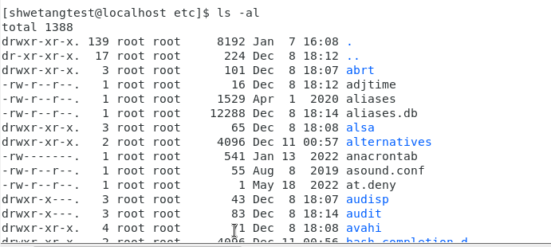  
    
  **EXPLAINATION:** The command listed certain folders such as “.” , “..” and several folders which were earlier hidden
* Then use **ls -i** and hit **Enter** key
  + Now see what different output its shows and take screenshot?
* **RESPONSE:  
    
    
    
    
  SCREENSHOT:** Graphical user interface, text, application

  Description automatically generated  
    
  **EXPLAINATION:** The command resulted in the files/folder being listed with the respective index numbers.
* Then use **ls –help** and see other options about **ls** command
  + Explore it and try with other attribute we can use with **ls** command
* **RESPONSE**:  
    
  **SCREENSHOTs:**  
    
  A screenshot of a computer

  Description automatically generated with medium confidence  
    
  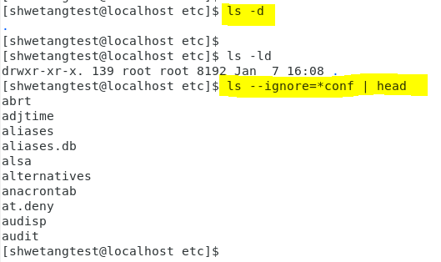

**Assignment-5**

Know where you are and where you working

*Here we use* ***pwd, cd and ls*** *as combine task to understand where you working on terminal and how you can switch from one directory to another one.*

* Open terminal after restart the linux
  + Check which location you working, type **pwd** and take screenshot
* **RESPONSE:  
  SCREENSHOT:**Text

  Description automatically generated
* Now use **cd /var** and hit **Enter** key
  + Do **ls,** and see what output comes, give screenshot?
* **RESPONSE:  
    
  SCREENSHOT:**A picture containing timeline

  Description automatically generated
* Do explore other help options of each command to learn more other things we can do with these commands  
    
  