

# Linux Basic Commands Assignment

***Assignment Part-3***

Playing with files

1. Create a file like **nano file1.txt**

* Edit some data and then save the file
* **RESPONSE:  
    
  SCREENSHOTs:  
    
  EDITING**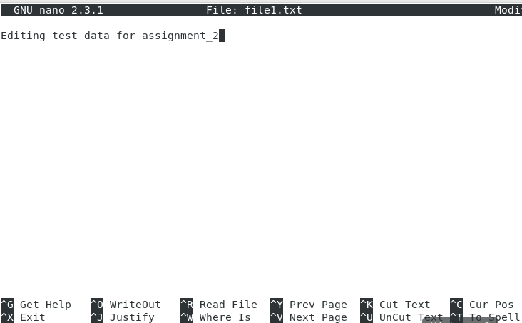

**

1. Now we will copy date from file1 to new file2

# o cp file1.txt file2.txt

* Then see the output of file2.txt, **cat file2.txt**
* Give screenshot
* **RESPONSE:  
    
  SCREENSHOT:**Text

  Description automatically generated

1. Now we will move the file2.txt to new folder **/home**

# mv file2.txt /home

* + Then go to **home** directory and check **ls,** file exits or not?
  + Given screenshot
* **RESPONSE:  
    
  SCREENSHOTs:**Text

  Description automatically generated with low confidenceDiagram, schematic

  Description automatically generated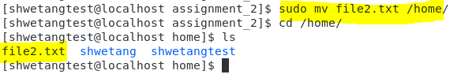 **EXPLAINATION:** file2.txt didn’t move to /home directory with Permission denied error as /home directory has root permissions while we are trying to move the file with non root: shwetangtest user. Using the sudo command I was able to move the file and it was then available under /home

1. Then we create a new **file3.txt and file4.txt** in **home directory** and add content in it.

* **RESPONSE:  
  SCREENSHOTs:**Text

  Description automatically generated with medium confidenceA picture containing table

  Description automatically generatedA picture containing table

  Description automatically generated
  + Now do **echo “Hello I am newline” > file3.txt** and provide the output of file3.txt
* **RESPONSE:  
  OUTPUT SCREENSHOT:**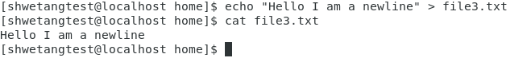
  + Now do **echo “Hello I am newline” >> file4.txt** and provide the output of file4.txt
* **RESPONSE:  
  OUTPUT SCREENSHOT:**Chart, text

  Description automatically generated
  + Tell the different between both step you follow and the reason behind it
* **RESPONSE:** Here while using echo with only “>” for file3.txt, the new line or data has replaced the older line or data in the file.

On the other hand, while using echo with “>>” for file4.txt, the new line/data got appended additionally to the older line/data in the file.

**NOTE**: Since I was getting error in using echo for file3.txt & file4.txt even with sudo as they had root user/group permissions, I changed the user and group for these two files using chown & chgrp as below:  
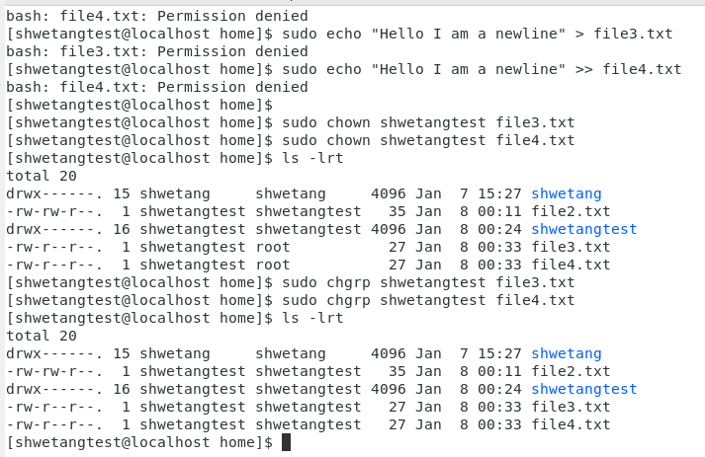

1. For remove a file or directory you can use the below two commands

* To delete a file – **rm <any_filename>**

* To delete a directory - **rmdir <any_directoryname>**

