

**What is MongoDB?**

MongoDB is a popular NoSQL database system that stores data in a flexible document format instead of rigid tables with rows and columns, like traditional relational databases.

**Key Features of MongoDB:**

**Flexible Document storage:**

* Unlike rigid tables, MongoDB stores data in JSON_like doucuments.
* This allows for more natural modelling of complex data structures and easier adaptation as data evolves.

**Scalability for Growing Data:**

* As your application grows and the amount of data you store increases, MongoDB can easily scale horizontally by adding more servers.

**High Performance:**

* Optimized for fast reads and writes, MongoDB excels in real-time applications where data needs to be accessed and updated quickly.

**NoSQL database:**

* Offers advantages over relational databases for certain use cases, like ease of development and flexibility.

**Developer-Friendly:**

* The use of JSON-like documents and a familiar query language (similar to SQL) makes MongoDB easy to learn and use for developers.

**MongoDB is a popular choice for various applications :**

* **Web applications:** Storing user data, content, and preferences.
* **Mobile apps:** Managing user data and application state on the backend.
* **Real-time analytics:** Storing and analyzing data streams from sensors or applications.
* **Content management systems:** Storing and managing content in a flexible way.

**How to Install MongoDB on Windows?**

**Requirements to Install MongoDB on Windows:**

* MongoDB versions 4.4 and later only support 64-bit versions of Windows.
* If you're using an older version (e.g., MongoDB 7.0), supported Windows versions include:
* Windows Server 2022 (64-bit)
* Windows Server 2019 (64-bit)
* Windows 11 (64-bit)

**Steps to Install MongoDB on windows using MSI:**

To install MongoDB on Windows, first, download the MongoDB server and then install the MongoDB shell.

**STEP1:** Go to the MongoDB Download Center to download the MongoDB Community Server.

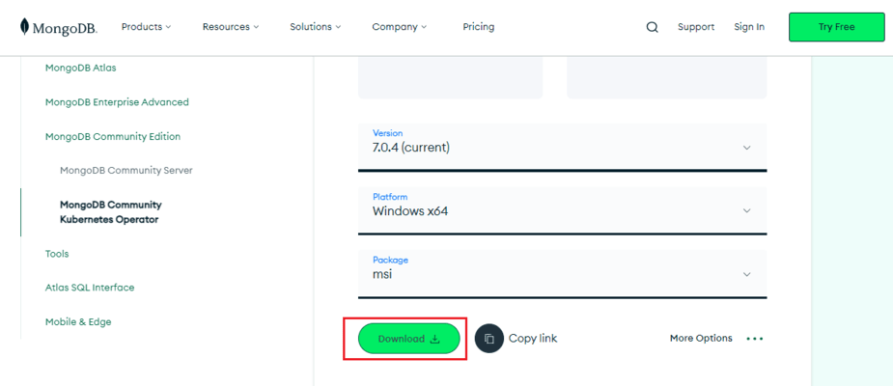

select any version, Windows, and package according to your requirement. For Windows, we need to choose:

* Version: 7.0.4
* OS: Windows x64
* Package: msi

**Step2:** When the download is complete open the msi file and click the next button in the startup screen:

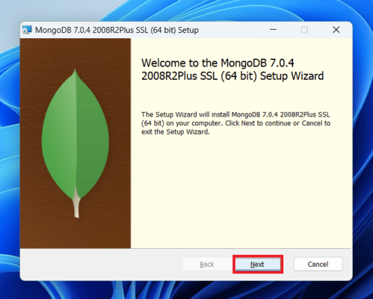

**Step3:**Now accept the End-User License Agreement and click the next button:

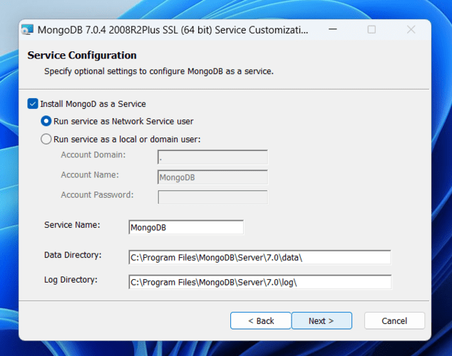

**Step4:** Now select the complete option to install all the program features. Here, if you can want to install only selected program features and want to select the location of the installation, then use the Custom option:

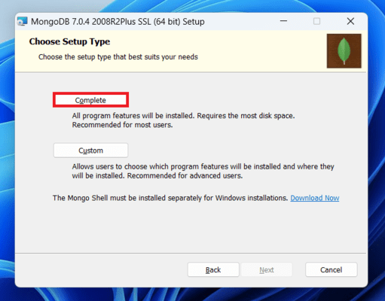

**Step5:** Select “Run service as Network Service user” and copy the path of the data directory. Click Next:

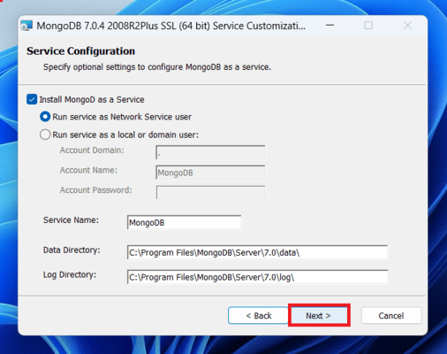

**Step6:** Click the Install button to start the MongoDB installation process:

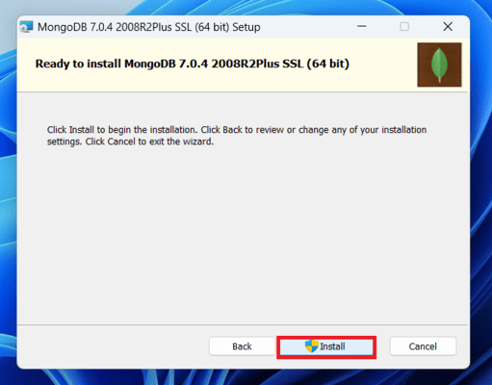

**Step 7:**After clicking on the install button installation of MongoDB begins:

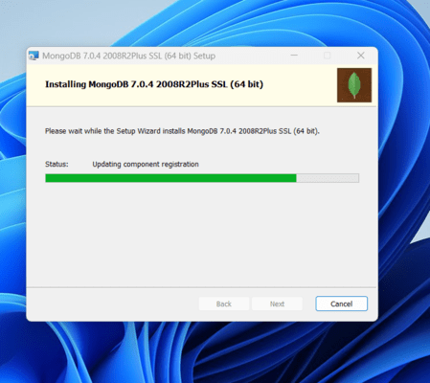

**Step 8:** Now click the Finish button to complete the MongoDB installation process:

# **MongoDB Shell Download**

MongoDB Shell is the quickest way to connect to (and work with) MongoDB. Easily query data, configure settings, and execute other actions with this modern, extensible command-line interface — replete with syntax highlighting, intelligent autocomplete, contextual help, and error messages.

Note: MongoDB Shell is an open source (Apache 2.0), standalone product developed separately from the MongoDB Server.

Steps to Download MongoDB Shell

Step1: Open the MongoDB Shell download page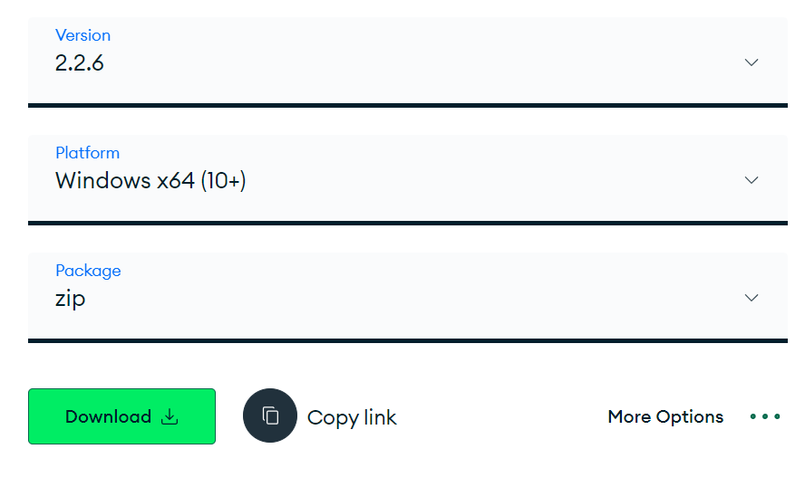 and Open the MongoDB Download Center.

Select any version, Windows, and package according to your requirement. For Windows, we need to choose:

* Version: 2.2.6
* OS: Windows x64
* Package: zip

Step2: Locate the downloaded .zip file in your Downloads folder (or wherever you saved it).

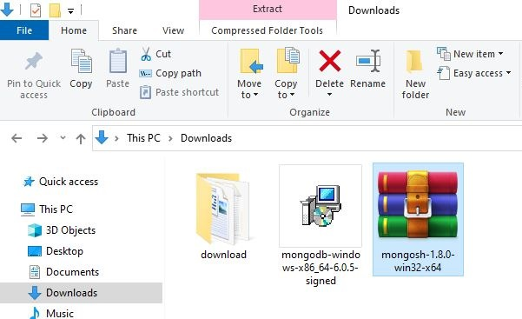

Step3: Right-click on the mongosh-2.2.6-win32-x64 file and select "Extract Here"