Experiment 3

Student Name: {{STUDENT_NAME}} UID:24BCS12733
Branch:BE-CSE Section/Group:719-‘A’
Semester:{{SEMESTER}} Date:01/09/2026
Subject Name: {{SUBJECT_NAME}} Subject Code: 24CSH-301
Aim: Design Java programs showcasing exception handling through square root calculations, an ATM withdrawal system, and a university enrollment system with custom exceptions.

EASY LEVEL
- Problem Statement: To implement a Java program to calculate the square root of a number entered by the user and demonstrate exception handling using try-catch-finally for invalid and negative inputs.
- Objective:
• To understand the basic concept of exception handling in Java.
• To use try-catch blocks to handle runtime errors.
• To handle negative numbers using a custom-thrown exception.
• To use the finally block for resource management.

Code:

import java.util.Scanner;

public class SquareRootCalculator {

public static void main(String[] args) {

Scanner scanner = new Scanner(System.in);

try {
System.out.print("Enter a number: ");
double number = scanner.nextDouble();

if (number < 0) {
throw new IllegalArgumentException(
"Error: Cannot calculate the square root of a negative number."
);
}

double result = Math.sqrt(number);

System.out.println("Square root: " + result);

} catch (IllegalArgumentException e) {
System.out.println(e.getMessage());

} catch (Exception e) {
System.out.println(
"Error: Invalid input. Please enter a valid number."
);

} finally {
scanner.close();
}
}
}

Output:
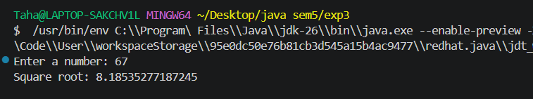

Problem -2
- Problem Statement: - To implement a Java ATM withdrawal system using exception handling for invalid PIN and insufficient account balance, while ensuring that the remaining balance is displayed using the finally block.

- Objective:
• To understand the use of custom exceptions in Java.
• To validate the PIN entered by the user.
• To handle insufficient account balance using an exception.
• To use multiple catch blocks for different exceptions.
• To demonstrate the use of finally for displaying the current balance.

Code:

import java.util.Scanner;

class InvalidPinException extends Exception {

public InvalidPinException(String message) {
super(message);
}
}

class InsufficientBalanceException extends Exception {

public InsufficientBalanceException(String message) {
super(message);
}
}

public class ATMWithdrawalSystem {

private static final int CORRECT_PIN = 1234;
private static double balance = 3000.0;

public static void main(String[] args) {

Scanner scanner = new Scanner(System.in);

try {
System.out.print("Enter PIN: ");
int enteredPin = scanner.nextInt();

if (enteredPin != CORRECT_PIN) {
throw new InvalidPinException(
"Error: Invalid PIN. Please try again."
);
}

System.out.print("Withdraw Amount: ");
double withdrawAmount = scanner.nextDouble();

if (withdrawAmount <= 0) {
throw new IllegalArgumentException(
"Error: Withdrawal amount must be greater than zero."
);
}

if (withdrawAmount > balance) {
throw new InsufficientBalanceException(
"Error: Insufficient balance."
);
}

balance -= withdrawAmount;

System.out.println(
"Withdrawal Successful!"
);

} catch (InvalidPinException | InsufficientBalanceException e) {
System.out.println(e.getMessage());

} catch (IllegalArgumentException e) {
System.out.println(e.getMessage());

} catch (Exception e) {
System.out.println(
"Error: Invalid input. Please enter numeric values."
);

} finally {
System.out.println("Current Balance: " + balance);
scanner.close();
}
}
}

Output:
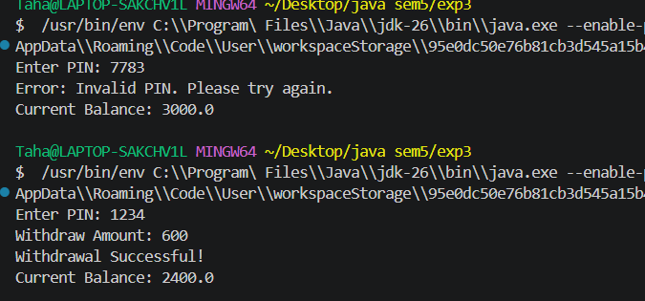

Hard Level
  - Problem Statement: To design and implement a Java university enrollment system using custom exceptions to handle full courses and unmet prerequisites during student enrollment.

  - Objective:
- To understand the use of custom exception classes in Java.
- To implement exception handling for course enrollment.
- To handle courses that have reached their maximum capacity.
- To verify prerequisite requirements before enrollment.
- To use throw, throws, try, catch, and finally in a practical application.

Code:

import java.util.*;

class CourseFullException extends Exception {

public CourseFullException(String message) {
super(message);
}
}

class PrerequisiteNotMetException extends Exception {

public PrerequisiteNotMetException(String message) {
super(message);
}
}

class Course {

private String name;
private int maxCapacity;
private int enrolledStudents;
private String prerequisite;

public Course(String name, int maxCapacity, String prerequisite) {
this.name = name;
this.maxCapacity = maxCapacity;
this.enrolledStudents = 0;
this.prerequisite = prerequisite;
}

public void enrollStudent(Set<String> completedCourses)
throws CourseFullException, PrerequisiteNotMetException {

if (enrolledStudents >= maxCapacity) {
throw new CourseFullException(
"Error: CourseFullException - " +
name + " has reached maximum capacity."
);
}

if (prerequisite != null &&
!prerequisite.isEmpty() &&
!completedCourses.contains(prerequisite)) {

throw new PrerequisiteNotMetException(
"Error: PrerequisiteNotMetException - Complete " +
prerequisite + " before enrolling in " + name + "."
);
}

enrolledStudents++;

System.out.println(
"Successfully enrolled in " + name +
". Remaining slots: " +
(maxCapacity - enrolledStudents)
);
}
}

public class UniversityEnrollmentSystem {

public static void main(String[] args) {

Scanner scanner = new Scanner(System.in);

Course coreJava = new Course("Core Java", 2, "");
Course advancedJava = new Course("Advanced Java", 2, "Core Java");

Set<String> completedCourses = new HashSet<>();

try {
System.out.print(
"Have you completed Core Java? (yes/no): "
);

String input = scanner.nextLine().trim().toLowerCase();

if (input.equals("yes")) {
completedCourses.add("Core Java");
}

System.out.println("\nEnrolling in Advanced Java...");

advancedJava.enrollStudent(completedCourses);

System.out.println(
"Enrollment process completed successfully."
);

} catch (CourseFullException |
PrerequisiteNotMetException e) {

System.out.println(e.getMessage());

} catch (Exception e) {

System.out.println("Error: Invalid input.");

} finally {
scanner.close();
}
}
}

Output:

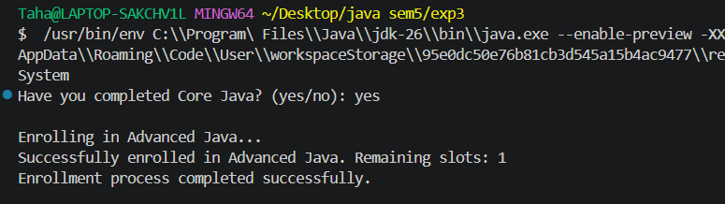

5. Learning Outcome:

• Understand the fundamental concept of exception handling in Java.
• Use try, catch, and finally blocks to handle runtime errors.
• Identify and handle invalid user input.
• Use the throw keyword to generate exceptions explicitly.
• Create and use custom exception classes.
• Handle multiple exceptions using appropriate catch blocks.
• Use the throws keyword for exception propagation.
• Apply exception handling to practical systems such as calculators, ATMs, and university enrollment.
• Validate conditions and prevent invalid operations through exception handling.
• Develop more reliable and fault-tolerant Java applications.

