# Overview:

My project will be a database for high school sports teams. The database will be used to display & organize a schools database of all of their teams, coaches, and student athletes (known as players).

The database will show what players play which sports, which players play on a team together, which coach coaches each team, and which players & coaches belong to each school

# Database Outline:

Entities:

1. Schools
   1. **Attributes**: id, Name, City, State
2. Coaches
   1. **Attributes**: id, First_Name, Last_Name, School_id
3. Players
   1. **Attributes**: id, First_Name, Last_Name, School_id
4. Teams
   1. **Attributes**: id, Sport, Level

# Relationships:

1. Schools:
   1. A school can have many coaches
   2. A school can have no coaches as some schools do not have sports
   3. A school has many Players
   4. A school can have no players as some schools do not have sports.
2. Coaches
   1. A coach works for at most 1 school
   2. Some coaches are not associated to a school (ie. They are fired & cannot find a new coaching job).
   3. A coach can coach several sports team.
   4. A coach does not have to coach a sports team (See point b.)
3. Players
   1. A Player has exactly 1 school (Players cannot be student Athletes if they are not a student).
   2. A Player can play on several sports teams
   3. Not all Student athletes are on a team (Some student athletes could be on academic probation and can be considered not on a team).
4. Sports Teams
   1. A Sports team can have many Players.
   2. Not all sports teams have players (No one wants to play/No one tries out for the team).
   3. A Sports team can be coached by several coaches
   4. A Sports team must have a coach.

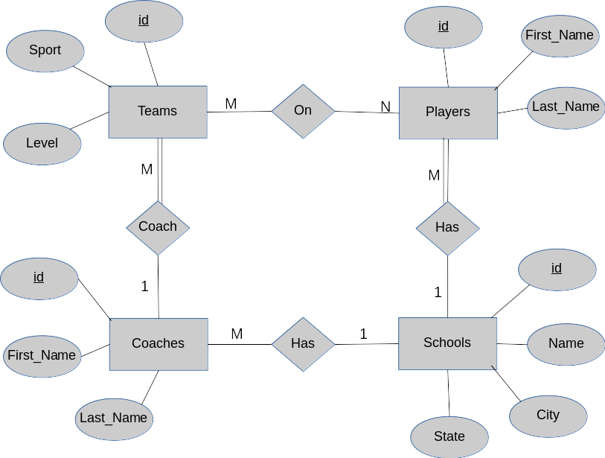

ER Diagram

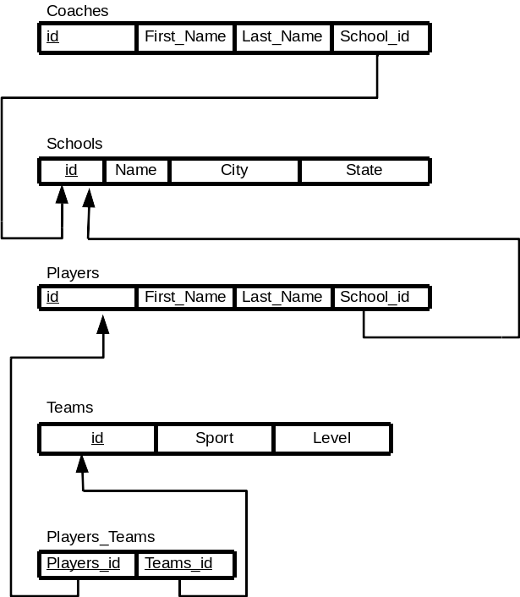Schema

# Create Table Queries

-- Table: School

CREATE TABLE School (

id int NOT NULL AUTO_INCREMENT,

Name char(255) NOT NULL,

City char(255) NOT NULL,

State char(2) NOT NULL,

PRIMARY KEY (id)

) ENGINE InnoDB;

-- Table: Coaches

CREATE TABLE Coaches (

id int NOT NULL AUTO_INCREMENT,

First_Name char(255) NOT NULL,

Last_Name char(255) NOT NULL,

School_id int,

PRIMARY Key (id),

FOREIGN KEY (School_id) REFERENCES School(id)

) ENGINE InnoDB;

-- Table: Players

CREATE TABLE Players (

id int NOT NULL AUTO_INCREMENT,

First_Name char(255) NOT NULL,

Last_Name char(255) NOT NULL,

School_id int NOT NULL,

PRIMARY KEY (id),

FOREIGN KEY (School_id) REFERENCES School(id)

) ENGINE InnoDB;

-- Table: Sports_Teams

CREATE TABLE Teams (

id int NOT NULL AUTO_INCREMENT,

Sport char(255) NOT NULL,

Level int NOT NULL,

PRIMARY KEY (id)

) ENGINE InnoDB;

-- Table Coaches_Teams

CREATE TABLE Coaches_Teams(

Coaches_id int NOT NULL,

Teams_id int NOT NULL,

PRIMARY KEY (Coaches_id, Teams_id),

FOREIGN KEY (Coaches_id) REFERENCES Coaches(id),

FOREIGN KEY (Teams_id) REFERENCES Teams(id)

)ENGINE InnoDB;

-- Table: Players_Teams

CREATE TABLE Players_Teams(

Players_id int NOT NULL,

Teams_id int NOT NULL,

PRIMARY KEY (Players_id, Teams_id),

FOREIGN KEY (Players_id) REFERENCES Players(id),

FOREIGN KEY (Teams_id) REFERENCES Teams(id)

)ENGINE InnoDB;

# Insert Queries:

INSERT INTO `harbers-db`.`Players` (

`id` ,  
`First_Name` ,  
`Last_Name` ,  
`School_id` )  
VALUES (

NULL , ‘[First_Name]`, '[Last_Name]', '[Pick School];

INSERT INTO `harbers-db`.`Coaches` (

`id` ,

`First_Name` ,

`Last_Name` ,

`School_id`)

VALUES (

NULL , '[First_Name]', '[Last_Name]', '[Pick School]'

);

INSERT INTO `harbers-db`.`Teams` (

`id` ,

`Sport` ,

`Level`

)

VALUES (

NULL , '[Sport]', '[Level]'

);

INSERT INTO `harbers-db`.`School` (

`id` ,

`Name` ,

`City` ,

`State`

)

VALUES (

NULL , '[Name]', '[City]', '[State]'

);

Data Manipulation Queries:

Display All Coaches From A School:

SELECT Coaches.First_name, Coaches.Last_Name  
FROM Coaches  
INNER JOIN School AS s ON s.id = Coaches.School_id  
WHERE s.name = "[School Name];

Display All Players who Play A Certain Sport

SELECT Players.First_Name, Players.Last_Name FROM Players

Inner Join Players_Teams ON Players.id = Players_Teams.Players_id

Inner Join Teams On Teams.id = Players_Teams.Teams_id

Where Teams.Sport = "[Sport]"

I was unable to finish due to the deadly Blue Screen of Death. No website was create & Queries were erased.