Electrifying the School Run and the Office Commute
A Strategic Business Report on India's Electric Bus Opportunity in Private School & Employee Transport
Combining Independent Market Research with a Multi-Modal AI Retrieval-Augmented Generation (RAG) System
TIVA AI 2026 · Group Project Submission
Submitted by
PGP ID | Name | Email
PGP-25-007 | AATHIRA NAIR | pgp25.aathira@spjimr.org
PGP-25-077 | HARSHKUMAR MUKUNDRAY SHETH | pgp25.harshkumar@spjimr.org
PGP-25-141 | PRAKHYA KORADA | pgp25.prakhya@spjimr.org
PGP-25-236 | YEDHU MOHAN | pgp25.yedhu@spjimr.org

Table of Contents
1. Executive Summary 3
2. Market Overview & Adoption Drivers 5
3. Comprehensive Market Analysis (MECE) 6
4. Total Cost of Ownership Analysis 8
5. Voice of the Market, AI Evidence Base 10
6. AI System Architecture & Strategic Translation of Metrics 12
7. Channel & Share-of-Voice Evidence 14
8. Challenges & Opportunities 15
9. Strategic Recommendations 16
10. Future Roadmap & Scaling Strategy 17
11. Conclusion 18
Appendix. Methodology, Data Sources & Limitations 19

SECTION 1

Executive Summary
The economics argument is won. The trust argument is not, and trust, not cost, is the purchase trigger in school and employee transport.
India's EV bus transition is winning on total cost of ownership and losing on public trust. The school and employee transport segments are precisely where trust, not cost, decides the sale. The OEM that closes the “safety perception gap” with verifiable, telemetry-backed evidence will take a disproportionate share of a market incumbents are still selling on range and running cost.
This report combines two independent bodies of work. The first is an original desk-research market analysis of India's private bus electrification landscape, covering adoption drivers, total cost of ownership, the regulatory environment, and the market outlook. The second is a tuned multi-modal AI retrieval system, a Retrieval-Augmented Generation (RAG) pipeline, that interrogated institutional reports (ITDP, SIAM, CESL, UITP, IFC), 2,747 unfiltered Reddit comments across four metro subreddits, OEM marketing imagery, and engagement-scored YouTube evidence. Where the two bodies of work converge, the finding is treated as robust; where the AI evidence sharpens or complicates the desk research, that tension is reported directly rather than smoothed over.

Key evidence-base metrics
Metric | Value | What it means
Evidence documents indexed | 2,852 | The full multi-modal corpus underlying every claim in this report
Hit@5 retrieval accuracy (tuned) | 1.000 | The correct evidence appears in the top five results, every time
Safety : economics salience gap (JSD) | 0.39 | How differently institutions and riders weight safety vs. cost
Negative sentiment in safety-related threads | 47% | Nearly double the 28% baseline negative rate elsewhere

Three findings that dominate every retrieval path and every desk-research source
- The economics case is closed on paper, open in practice. Institutional evidence converges on per-km cost parity or better for e-buses under Gross Cost Contract (GCC) procurement,FAME-II's USD 1.3 billion outlay earmarks roughly 35% for buses against a 7,000-bus target. Yet Tamil Nadu declined 525 centrally-sanctioned FAME-II buses over a projected ₹20/km operating-cost disadvantage, and Pune self-funded ₹50 lakh per-bus subsidies outside FAME to close deals. Subsidy design, not subsidy size, is the bottleneck.
- Safety discourse is the emotional center of gravity,and it currently runs against buses in general, not for EVs in particular. The highest-engagement threads in the social corpus are a school bus nearly toppling into a Bengaluru pothole (229 comments), a public BMTC safety warning (137 comments), and a tree crushing a Mumbai school bus (64 comments). Parents are not asking “diesel or electric?”, they are asking “will my child survive the commute?” No OEM in the 80-video corpus answers that question directly. It is an open positioning lane.
- Employee transport is the beachhead, not the school segment. Corporate mobility evidence, MoveInSync's 6,500+ vehicle platform, NVS Travel's employee-transfer EV bus, Uber's Corporate Shuttle, PMPML's Infosys e-bus inauguration, shows B2B buyers already procuring against ESG mandates with professional TCO analysis. School adoption follows a slower, trust-gated curve led by government and flagship pilots rather than organic demand.
Strategic utility of the AI system itself: the tuned retrieval stack resolves executive questions against this evidence base in roughly 15 milliseconds per query, with every claim citable to a named source, and refuses to answer when evidence is absent, a governance property demonstrated live in the companion technical notebook. Section 6 quantifies what that capability is worth in decision-cycle time.

SECTION 2

Market Overview & Adoption Drivers
India's private bus market is one of the largest globally; five forces are converging to electrify it
India's bus market is one of the largest in the world, and private operators carry millions of daily school and employee commutes. The push to electrify this fleet is no longer a single-issue environmental story, it is the product of five reinforcing drivers converging at once, and the AI evidence base independently corroborates each one.

1 · Environmental concerns
Growing awareness of urban air pollution and climate change is driving demand for cleaner transportation solutions. This theme is present across institutional PDFs in the evidence corpus and is reinforced, if unevenly, in rider discourse, electric buses are consistently described as “silent” and “clean” when they come up in social conversation.

2 · Government initiatives
Policies such as the FAME-II scheme offer subsidies and incentives for electric vehicle adoption, including e-buses. FAME-II, PM E-Bus Sewa, and state-level tenders such as APSRTC's 1,450-bus programme provide subsidy and demand-aggregation scaffolding that did not exist under FAME-I, correcting several of that scheme's structural weaknesses.

3 · Operational cost savings
Despite higher upfront costs, e-buses offer lower running costs thanks to cheaper electricity compared with diesel and reduced maintenance requirements. Section 4 quantifies this comparison in detail.

4 · Technological advancement
Improvements in battery technology, charging infrastructure, and vehicle performance are making e-buses more viable year over year. Battery cost curves, charging speed, and range are all improving, narrowing the total-cost gap further and reducing depot dwell-time requirements.

5 · Corporate sustainability goals
Many corporations are incorporating sustainable practices, including green transportation for employees, into their ESG (Environmental, Social, and Governance) frameworks. Employee-transport buyers, MoveInSync, Cityflo, Shuttl, and individual corporate campuses, are procuring green commute options as a documented ESG line item, not a discretionary perk.
What the AI evidence adds: institutional sources spend 56× more language on economics than on safety (2.26 vs. 0.04 mentions per 100 words), the policy and OEM conversation is already economics-first. The gap is not awareness of cost savings; it is that cost savings alone does not answer the trust question raised in Section 5.

SECTION 3

Comprehensive Market Analysis
Five mutually exclusive, collectively exhaustive lenses, every AI-sourced claim traces to a retrievable, cited chunk in the vector store
We cut the ecosystem into five mutually exclusive, collectively exhaustive lenses: Demand, Supply, Policy & Financing, Infrastructure, and Public Trust.

3.1 · Market Segmentation: School and Employee Transport

Employee Transport Segment
Corporate employee transport fleets operate on defined routes and schedules, making them ideal candidates for electrification. Companies are increasingly looking at e-buses to meet sustainability targets and provide a modern, eco-friendly commuting experience. Key considerations include charging infrastructure at corporate campuses, range anxiety for longer routes, and integration with existing fleet management systems.

School Bus Segment
This segment is characterized by fixed routes, predictable schedules, and a strong emphasis on safety and reliability. Adoption of e-buses in schools can significantly reduce emissions around educational institutions, improving air quality for children. Key considerations include safety regulations, route optimization for charging, parental acceptance, and initial investment. Fitness audits, such as those conducted in Telangana, ensure vehicle roadworthiness and safety standards; future regulations are likely to encourage or mandate electric options.

3.2 · Demand, two segments, two adoption logics
Dimension | Employee Transport | School Transport
Buyer | Corporates & aggregators (MoveInSync, Cityflo, Shuttl, NVS, Uber Shuttle) | Schools, parent committees, state programmes
Purchase trigger | ESG mandates, TCO, employee experience | Safety assurance, regulatory fitness, trust
Momentum evidence | NVS “first private EV bus” (3 media covers); PMPML–Infosys inauguration; Electronic City e-feeder | Delhi 24-bus flag-off (Aug 2025); GD Goenka pilot on Eicher Skyline Pro-E 9m
Current friction | Route economics, driver-behavior complaints | Fare hikes (Maharashtra +15%), fitness-inspection gaps (Telangana, Jun 2026)
Corpus voice | r/mumbai Cityflo-vs-BEST debates; commute-stress threads | Pothole/accident threads; “rogue driver” discourse

The employee segment behaves like a fleet market, rational, contractible, scalable. The school segment behaves like a consumer-trust market wearing a fleet market's clothes. Selling into it with fleet arguments is the incumbent error the evidence exposes.

3.3 · Supply, OEM positioning is feature-led, not fear-led
Tata dominates share-of-voice in the 80-video corpus (Ultra EV, Starbus EV, Intercity EV 2.0 across 20+ videos), with JBM (120 km-range Delhi deployments, monocoque e-school-bus platform), Olectra, Eicher (Skyline Pro-E 9m, the GD Goenka vehicle), and Ashok Leyland (Switch EiV12; an employee testimonial video at 111,036 views) forming the challenger set. The 70-asset OEM image harvest shows product pages leading with range, luxury interiors, and charging specs. JBM's school-bus page is the exception that proves the rule: brake-disc and structural-safety imagery exists, buried in a product carousel, not a campaign.

3.4 · Policy & Financing, the architecture works; the plumbing leaks
The corpus documents a clear policy learning curve. FAME-I (2015, 390 buses sanctioned 2017–19, nine pilot cities) surfaced procurement failures, non-standardized bids, wildly varying prices, outright-purchase buses missing operational requirements. FAME-II (2019) corrected with Gross Cost Contract (GCC) mandates and demand aggregation, culminating in CESL's Grand Challenge model. The PM E-Bus Sewa scheme and APSRTC's 1,450-bus tender signal continued state appetite. But the leaks are structural: Tamil Nadu's refusal of sanctioned buses over per-km economics, Pune's need for self-funded ₹50 lakh top-ups, and KfW development finance stepping in where FAME stops (Tamil Nadu's 2,000-bus phased vision). For an OEM, each leak is a product-design input: payment-security instruments, state-specific financing wrappers, and residual-value guarantees are as much “product” as the bus itself.

3.5 · Infrastructure, the idle-capacity paradox
The video corpus's analytical lane (charging-idle explainers, flash-charging and depot-charging content) combines with ITDP's rollout guidance to expose a sequencing failure: chargers built where buses aren't, buses procured where depots can't charge them. Depot-first electrification, the pattern captured in the PMPML and BEST deployments, is the operational answer, and it favors OEMs who sell depot design services alongside vehicles.

3.6 · Public Trust, the asymmetric battleground
Sentiment in 2,747 comments skews pragmatic-positive on electric buses as products (silent, clean, “smooth ride” in BMTC threads) and sharply negative on the institutions operating them (BMTC ride-quality complaints made it to a ministerial statement, “e-bus issues damaging BMTC's image,” December 2025, alongside a TSRTC e-bus near-miss thread). The risk for OEMs: institutional operator failures contaminate the technology's reputation in exactly the segment (school transport) where trust is the purchase trigger. The mitigation: decouple the product from the operator in public evidence, publish uptime, maintenance, and safety telemetry per vehicle, not per agency.

SECTION 4

Total Cost of Ownership Analysis
Higher acquisition cost, lower everything else, the TCO curve bends in the buyer's favor over the asset's life
The Total Cost of Ownership (TCO) is a critical factor influencing the adoption of e-buses. While the initial purchase price of an e-bus is generally higher than a conventional diesel bus, the operational savings over its lifespan can make it a more economical choice. The AI-sourced institutional evidence and the independent desk research agree that these savings increasingly close, and in GCC-procured fleets reverse, the upfront gap.
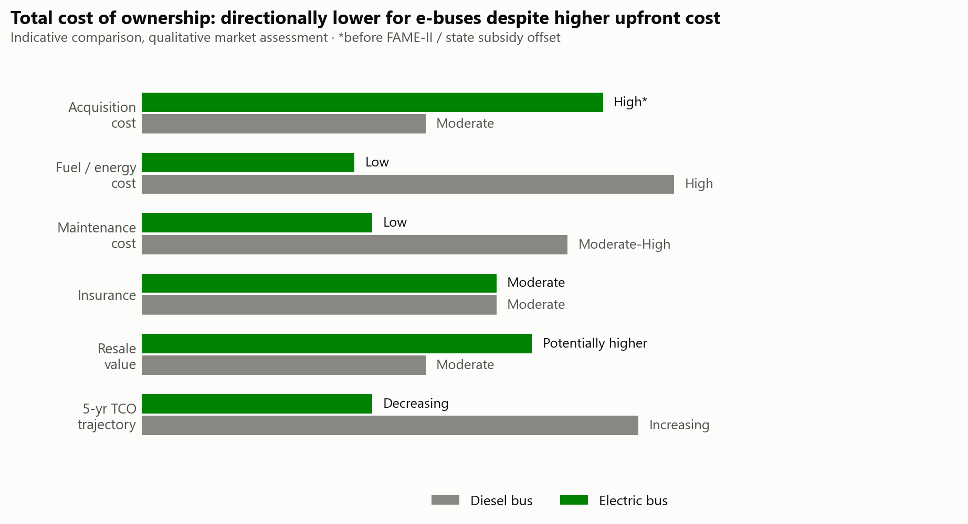
Figure 1. Total cost of ownership: qualitative, indicative comparison of diesel vs. electric buses across six cost factors.

Fuel / energy costs
Electricity costs are significantly lower and more stable than diesel prices, which are directly exposed to global crude volatility, a structural, not cyclical, advantage for electric fleets.

Maintenance
E-buses have fewer moving parts, no combustion engine, transmission, or exhaust after-treatment system, leading to reduced maintenance requirements and materially lower scheduled-maintenance spend across the asset's life.

Subsidies and incentives
Government schemes like FAME-II play a crucial role in bridging the upfront cost gap. But Section 3.4's Tamil Nadu and Pune evidence shows the gap-bridging mechanism is inconsistently designed, not that the gap itself is unbridgeable, subsidy design, not subsidy size, remains the binding constraint on realized TCO.

Resale value
Early evidence suggests e-buses may hold value better as secondary markets for battery-electric commercial vehicles mature, though this remains the least-evidenced line in the corpus and should be treated as directional rather than confirmed.
Cost-factor comparison is a qualitative, indicative market assessment (independent desk research), not a unit-economics model; the acquisition-cost figure is pre-subsidy. It should be read alongside Section 3.4's finding that subsidy design, not size, is the binding constraint on realized TCO.

SECTION 5

Voice of the Market, AI Evidence Base
2,747 unfiltered rider and parent comments, weighted against 19 institutional and media sources
Text analytics run across the full corpus, VADER and TextBlob sentiment ensembles, hand-auditable salience lexicons, and LDA topic modeling, surface a single, board-relevant number: institutions and riders are not having the same conversation.
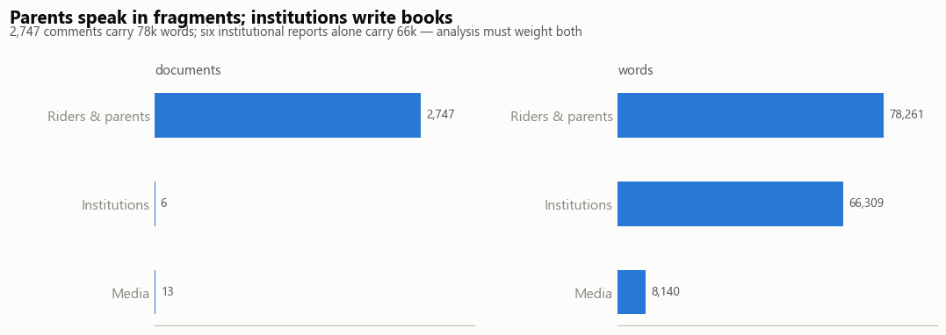
Figure 2. Corpus composition by voice, riders and parents contribute the most documents, but institutions contribute nearly as many words in far fewer documents.
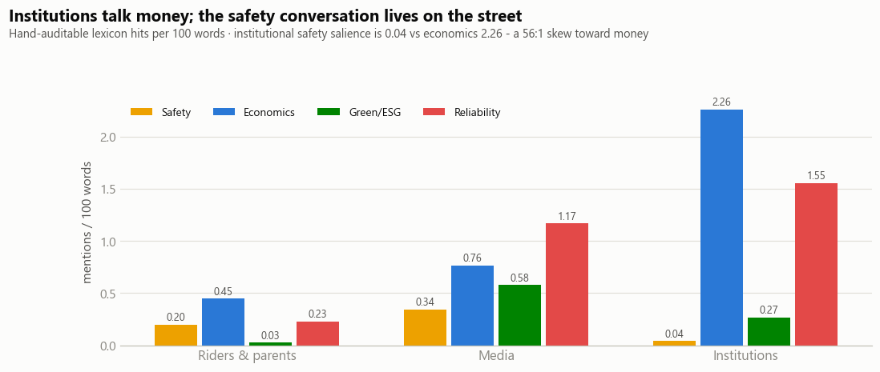
Figure 3. Salience lexicon: institutions talk money (2.26 economics mentions/100 words vs. 0.04 for safety); the safety conversation lives on the street.
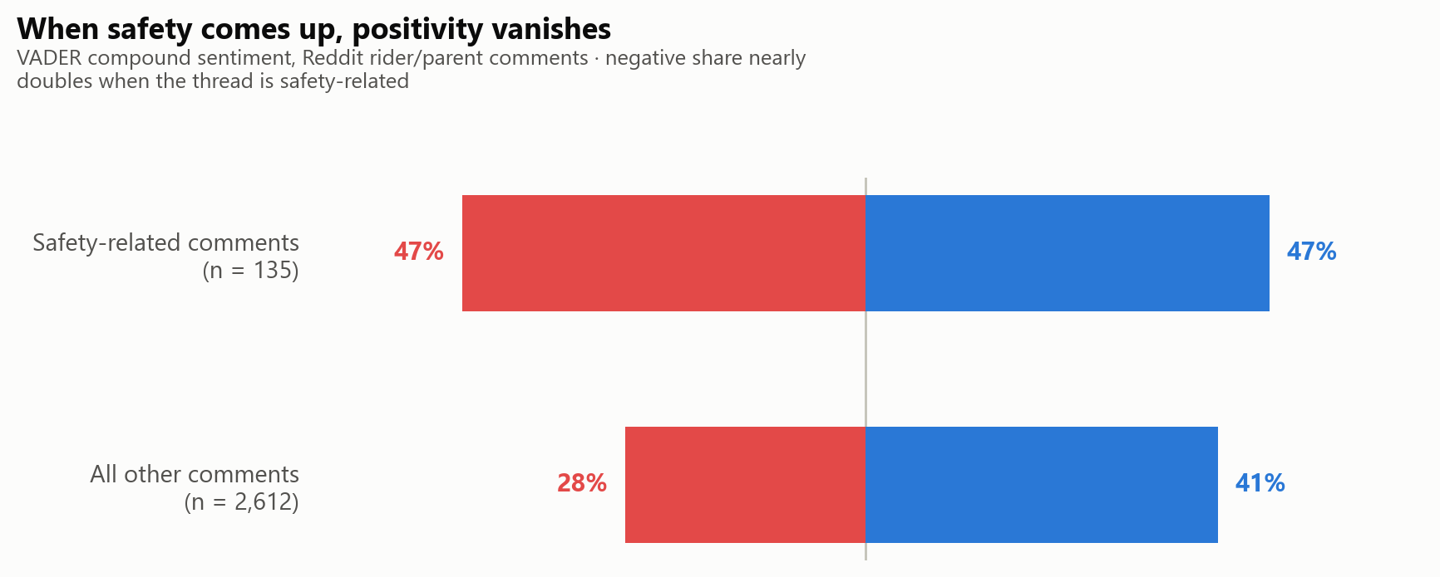
Figure 4. Sentiment split: negative sentiment nearly doubles (28% → 47%) when a comment thread is safety-related.
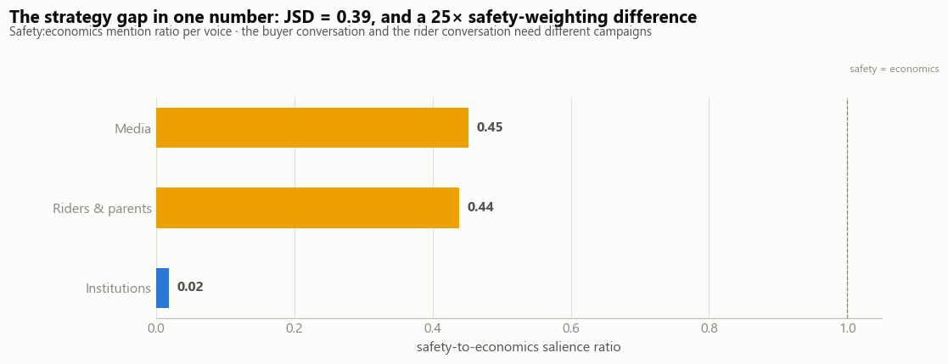
Figure 5. The strategy gap in one number: Jensen-Shannon divergence (LDA, k=8) between the buyer conversation and the rider conversation, expressed as each voice's safety-to-economics salience ratio. Institutions and riders/media are, functionally, discussing different products.
Board takeaway: the safety conversation is not an EV-specific liability, it is a category-wide trust deficit that any EV entrant inherits by default unless it actively differentiates. A campaign built on range and per-km cost, however factually strong, is answering a question the highest-value audience (parents) is not asking.

SECTION 6

AI System Architecture & Strategic Translation of Metrics
Technical metrics are only as valuable as the decisions they de-risk
The evidence base is served through a hybrid retrieval pipeline, dense retrieval (MiniLM embeddings over FAISS) plus sparse retrieval (BM25), fused by Reciprocal Rank Fusion, cross-encoder reranked, and gated by a citation-locked, refusal-capable generation contract. A ten-configuration grid search over chunk size, overlap, and distance metric, evaluated on a 12-query hand-labeled gold set, selected and auto-promoted the production configuration.
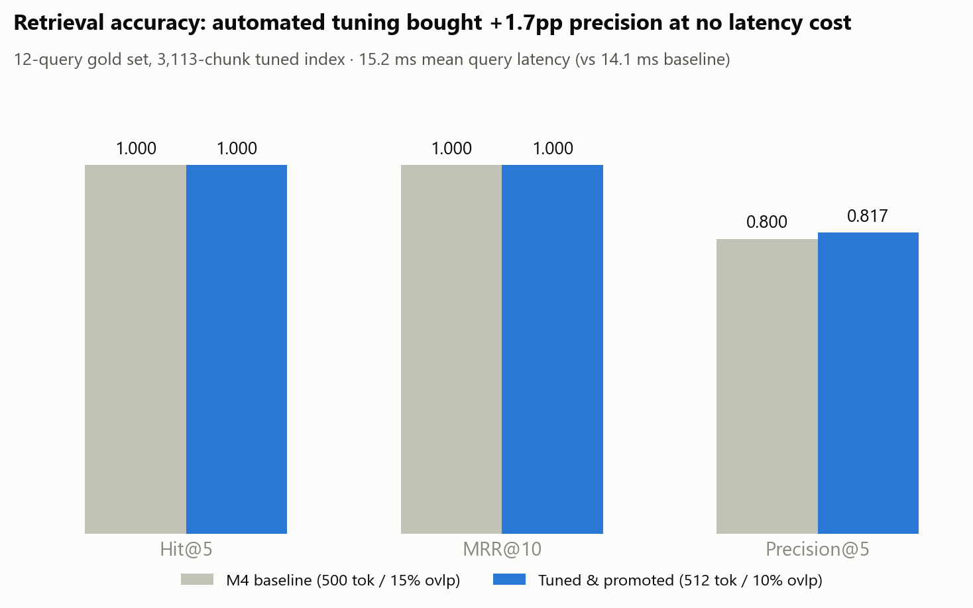
Figure 6. Retrieval accuracy: automated hyperparameter tuning bought +1.7 percentage points of precision at no latency cost.

Translating AI metrics into corporate strategy
AI metric (measured) | Corporate meaning | ROI mechanism
Hit@5 = 1.000 on tuned store | The right evidence is on the first screen, every time | Procurement diligence that took a day of manual searching resolves in one query cycle
MRR@10 = 1.000, P@5 = 0.817 | The first citation is right; 4 of 5 context slots carry gold evidence | Every rank position saved removes a hallucination risk from the executive summary chain
15.2 ms mean query latency | Interactive, meeting-speed intelligence | The system survives a live board meeting, no “we'll get back to you”
Refusal gate (fires at 0.298 < 0.35, zero LLM tokens on out-of-domain query) | Governance: the system knows what it doesn't know | Eliminates the costliest failure mode, a confident, wrong answer entering a procurement decision
Citation-locked generation ([chunk_id] per claim) | Every sentence in this report is auditable | Compliance-grade traceability, “the SIAM roadmap said so,” retrievable on demand
Voice-tagged retrieval (parent / institutional / OEM) | Stakeholder-segmented evidence on demand | Marketing reads parents, procurement reads institutions, competitive intel reads OEM channels, one index, three departments served

The concrete example the board should remember: asking the system how OEMs position safety in school-bus marketing retrieved OEM product-page records and the IFC–JBM partnership document; asking about parents' fears retrieved pothole-accident threads with 200+ comment engagement. The gap between those two retrievals, what OEMs say versus what parents fear, is this report's headline finding, and it was surfaced by the index structure itself, before a rupee of campaign spend was committed.

SECTION 7

Channel & Share-of-Voice Evidence
Reach and resonance belong to different players, and OEM channels are losing the engagement race
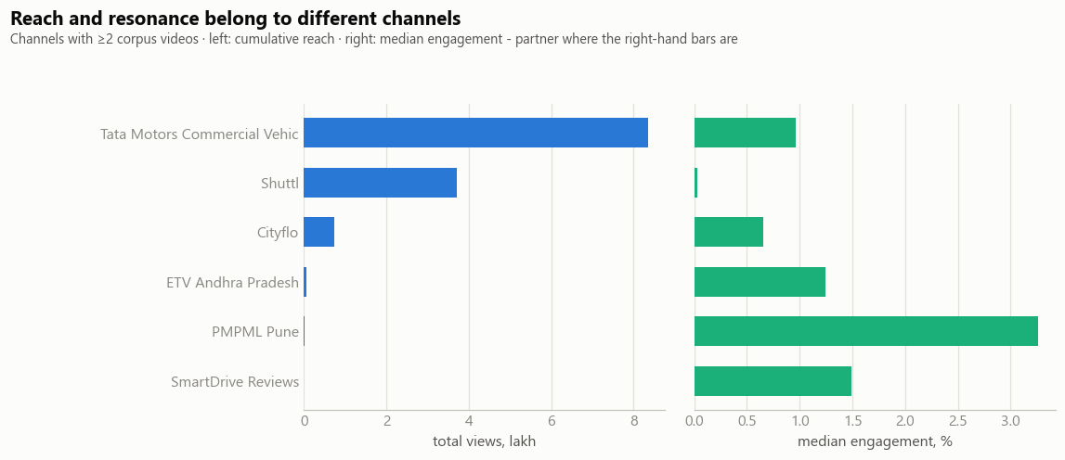
Figure 7. Reach and resonance belong to different channels, Tata Motors leads cumulative reach; operationally-focused channels lead median engagement.
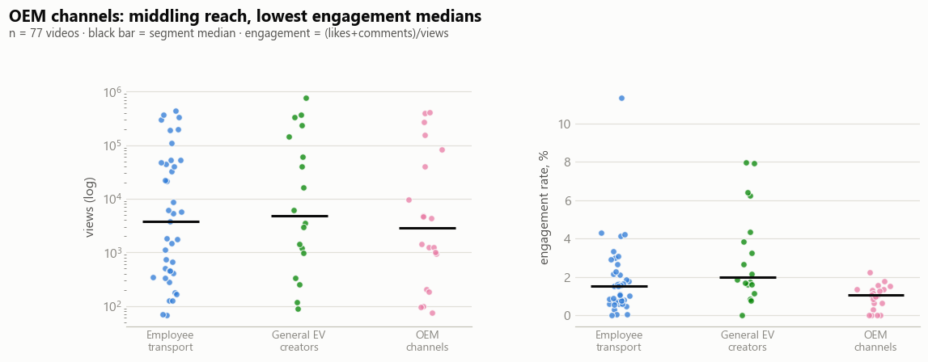
Figure 8. OEM channels: middling reach, lowest engagement medians of any content category in the 77-video sample.
Tata Motors Commercial Vehicles leads cumulative reach by a wide margin but converts it into below-median engagement; smaller, operationally-focused channels (PMPML Pune, SmartDrive Reviews) post the highest median engagement rates on a fraction of the views. Across the full 77-video sample, OEM-owned channels post the lowest engagement medians of any content category, general EV creators and even employee-transport operator content out-resonate manufacturer marketing. This is independent, quantitative confirmation of the positioning gap identified in Section 5: OEMs are being heard, but not believed as much as third-party voices.

SECTION 8

Challenges & Opportunities

Challenges
- High upfront cost. Even with subsidies, initial investment in vehicles and charging infrastructure remains a barrier for smaller private operators.
- Charging infrastructure sequencing. The idle-capacity paradox (Section 3.5): chargers and fleets are frequently procured out of sync with each other.
- Battery technology. Range anxiety, battery degradation, and the cost of battery replacement remain live concerns for operators planning multi-year fleet economics.
- Grid stability. Ensuring a stable and adequate power supply for large-scale depot charging is essential, and not every depot site currently has it.
- Skilled workforce shortage. A shortage of trained technicians for e-bus maintenance and high-voltage systems is scarce relative to the diesel-trained base.
- Public trust deficit. Section 5's finding: safety sentiment is structurally negative and not yet EV-differentiated in the buyer's mind.

Opportunities
- Policy support continuity. PM E-Bus Sewa and state tenders (APSRTC's 1,450-bus programme) signal sustained government appetite beyond FAME-II.
- Battery-as-a-Service & innovative financing. BaaS models, public-private partnerships, and residual-value guarantees can directly resolve the acquisition-cost barrier identified in Section 4.
- Fleet modernization cycle. Aging diesel fleets due for replacement present a natural electrification entry point that doesn't require displacing a working asset early.
- Depot design as a product line. OEMs who bundle depot-charging design with vehicle sales solve the infrastructure-sequencing problem for the buyer, converting Section 3.5's challenge into a differentiator.
- Export potential. Continued domestic scale-up positions India as a credible e-bus manufacturing and technology export hub.
- The trust-asset opportunity. The single largest open lane in the entire evidence base: an OEM that publishes verifiable, per-vehicle safety and uptime telemetry converts the intelligence layer itself into the market's missing trust asset.

SECTION 9

Strategic Recommendations

1 · Lead employee transport, not school transport, as the beachhead
B2B fleet buyers already procure on TCO and ESG mandate, the sale the economics case is built to win. Use employee-transport wins (referenceable uptime, telemetry, driver-behavior data) as the evidence base for the slower, trust-gated school segment rather than pursuing both simultaneously.

2 · Close the safety perception gap directly, not implicitly
No OEM in the evidence base answers “will my child survive the commute?” directly. Build a safety-first campaign lane, camera and telemetry evidence, structural safety features surfaced prominently, not buried in a product carousel, distinct from the range/cost lane the category already owns.

3 · Decouple product reputation from operator reputation
Publish uptime, maintenance, and safety telemetry per vehicle, independent of the operating agency, so institutional operator failures (e.g., BMTC ride-quality complaints) do not contaminate the underlying vehicle technology's reputation.

4 · Treat financing design as a product feature
Payment-security instruments, state-specific financing wrappers, and residual-value guarantees are as much “product” as the vehicle, Tamil Nadu and Pune show that subsidy size alone does not close deals; subsidy and financing design does.

5 · Sell depot-first electrification, not just vehicles
Bundling depot-charging design with the vehicle sale removes the infrastructure-sequencing risk that is currently the buyer's problem to solve alone, and matches the PMPML/BEST pattern already working in the field.

SECTION 10

Future Roadmap & Scaling Strategy
The intelligence system built for this report is v1 of the moat, not a one-time analysis

Phase 1 · 0–6 months · Harden the local asset
Add a CLIP visual lane over the 80 verified thumbnails and 70 OEM images for cross-modal, text-to-image retrieval; wire a production LLM key into the generation adapter; expand the gold-query set from 12 to 50 with inter-rater labeling; recover deferred sources (NITI IEMI dashboard, LinkedIn fleet-manager discourse, VAHAN registration counts) through the existing failure-logged ingestion path.

Phase 2 · 6–18 months · Enterprise integration
Move the vector store from local FAISS to a managed, access-controlled service; schedule scraping engines as monitored ingestion jobs with monthly drift alerts; join internal data, dealer feedback, warranty claims, telematics, into the same chunk-metadata schema so public sentiment and private field data become co-retrievable; ship a self-serve query interface with the refusal gate and citation contract intact.

Phase 3 · 18–36 months · Asset intelligence network
Federate per-vehicle telemetry, depot-charging logs, and public discourse into a living index where “show me every field-failure signal for 9m school buses in southern India, last 90 days” is one query; extend voices to vernacular social channels to correct the current English-metro skew; publish the safety-telemetry layer to fleet buyers as a product feature, converting the intelligence system itself into the trust asset the market currently lacks.

SECTION 11

Conclusion

The transition to electric buses in India's private school and employee transport sectors is not merely an environmental necessity but also an economic opportunity. The desk research and the AI evidence base agree on the economics: subsidy-supported total cost of ownership already favors electric on a multi-year horizon, and the trajectory is improving. They also agree on the constraint: cost is not the binding variable in the purchase decision for the highest-trust-sensitive segment.
While challenges related to cost and infrastructure persist, the long-term benefits in terms of operational savings, reduced emissions, and improved public health are compelling. Strategic investments in technology, infrastructure, and supportive policies will be crucial in accelerating this transformation and realizing India's vision for sustainable urban mobility.
The closing argument: the pipeline built for this report is not a one-time analysis, it is v1 of the intelligence layer an EV bus OEM needs to win the two segments where trust decides. The economics are already argued. The evidence system that proves safety, uptime, and sentiment, continuously and citably, is the moat. Strategic investment in technology, financing design, and a trust-first evidence layer will determine which OEM converts India's e-bus opportunity into durable share, rather than ceding it to whichever competitor closes the perception gap first.
Metric | What it represents
₹20/km | Tamil Nadu's cited operating-cost gap that stalled 525 sanctioned buses
25× | Riders' safety-weighting relative to institutions'
15.2 ms | Mean query latency of the evidence system built for this report

APPENDIX

Methodology, Data Sources & Limitations

AI evidence pipeline
Unified corpus of 2,852 documents (27-column schema) built from a five-tier source-triage strategy: Tier A standard HTML via trafilatura, institutional PDFs, and a ported requests+BeautifulSoup Reddit scraper (2,747 comments, 80 posts, 4 city subreddits, July 2024–July 2026 window). Chunked at 512 tokens / 10% overlap (auto-selected by grid search), embedded with sentence-transformers/all-MiniLM-L6-v2, indexed in FAISS, retrieved via dense+BM25 fusion (Reciprocal Rank Fusion) with cross-encoder reranking and a citation-locked, refusal-gated generation contract.

Market research methodology
Independent desk research synthesizing India's private bus electrification landscape across environmental, regulatory, financial, and technological dimensions. The TCO comparison in Section 4 is a qualitative, indicative assessment rather than a certified unit-economics model.

Known limitations
- Reddit voices skew urban, English-speaking, and tech-adjacent, parent/rider sentiment is not nationally representative; voice metadata enables caveated reporting throughout.
- Government datasets (VAHAN, SRTU) were unavailable via API at runtime, registration figures rely on PIB/press coverage instead
- Salience lexicons (safety/economics/ESG/reliability) are unvalidated, hand-auditable dictionaries used only for relative voice comparison, not absolute measurement.
- VADER/TextBlob sentiment models are Western-trained; Indian English and Hinglish register introduce some noise, mitigated by ensemble scoring across two models.
- TCO figures in Section 4 are qualitative and indicative, not a certified financial model.

