11/15/2013
Report for Week 2
Introduction to the basics
Stefan Hesselman, Ruta Merkyte, UvA - HCM

Report for Week 2
Introduction to the basics

SIFT FEATURES. Step C.1.
Question. The second argument DEFINE AXIS of these functions defines the axis of the normalization. If you set DEFINE AXIS=0 we normalize per column, whereas if you set DEFINE AXIS=1 we normalize per row. Make sure that you normalize per histogram, and not per dimension of the histogram. Please, report the difference in your report.

Answer.

SIFT FEATURES. Step C.2.
Question. Pick two similar pictures of your choice and match their SIFT features for different values of thresholds. Save the visualizations and paste them into the report. The stricter the threshold, the fewer matches there should be. Finally, report the threshold you are going to use for the rest of the assignment.

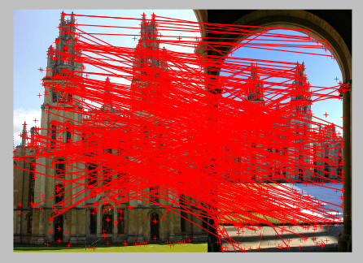
Threshold = 1.1

SIFT FEATURES are invariant to… Step D. Rotation.
Question. Count and plot the matches between the original image and each of the rotated ones (that is, in the end we will have 6 visualizations). Make a plot, where in the x-axis you have the degrees of rotation and in the y-axis you have the respective number of matches. Based on this plot answer and explain in your report whether SIFT is rotation invariant, that is whether the number of matches fluctuates significantly for different rotations?

Answer.
Rotating 15 degrees: number of matches is 427
Rotating 30 degrees: number of matches is 470
Rotating 45 degrees: number of matches is 431
Rotating 60 degrees: number of matches is 461
Rotating 75 degrees: number of matches is 472
Rotating 90 degrees: number of matches is 674
SIFT variation is invariant, because there is only one outlier where the rest of the matches the difference is not significant.

SIFT FEATURES are invariant to… Step E. Scale.

Question. Count and plot the matches between the original image and each of the scaled ones. Make a plot, where in the x-axis you have the different scales and in the y-axis you have the respective number of matches. Based on this plot answer and explain in your report to what degree SIFT is scale invariant, by checking how does the number of matches fluctuate for different scales?

Answer.
Scaling x 0.2: number of matches is 157
Scaling x 0.4: number of matches is 231
Scaling x 0.5: number of matches is 271
Scaling x 0.6: number of matches is 303
Scaling x 0.8: number of matches is 404
Scaling x 1.0: number of matches is 784
Scaling x 1.2: number of matches is 465
Scaling x 1.4: number of matches is 476
Scaling x 1.5: number of matches is 494
Scaling x 1.6: number of matches is 495
Scaling x 1.8: number of matches is 482
Scaling x 2.0: number of matches is 530
SIFT variation is variant, because based on the different image scales; the number of matches fluctuate. When you increase the size of the image, it means there is less loss than in comparison to decreasing the size.

SIFT FEATURES are invariant to… Step F. Perspective.
Question. Count and plot the matches between the original image and each of the ones with change in perspective. Make a plot, where in the x-axis you have the different perspectives and in the y-axis you have the respective number of matches. Based on this plot answer and explain in your report whether SIFT is perspective invariant , that is whether the number of matches fluctuates significantly for different perspectives?
Answer
Perspective 1: number of matches is 452
Perspective 2: number of matches is 375
Perspective 3: number of matches is 288
Perspective 4: number is matches is 151
SIFT variation is variant, because the changes in the number of matches varies with each different perspective.

SIFT FEATURES are invariant to… Step G. Brightness.
Question. Count and plot the matches between the original image and each of the ones with different brightness. Make a plot, where in the x-axis you have the different levels of brightness and in the y-axis you have the respective number of matches. Based on this plot answer and explain in your report whether SIFT is brightness invariant , that is whether the number of matches fluctuates significantly for different brightness levels?
Answer.
Brightness x 0.8: number of matches is 450
Brightness x 0.5: number of matches is 209
Brightness x 1.8: number of matches is 492
Brightness x 1.5: number of matches is 564
Brightness x 1.2: number of matches is 657
SIFT variation is variant, because the number of matches are significantly different when the brightness is increased by 0.5 and 0.8, and 1.2 and 1.5

Using SIFT for geometry. Step H. Find the points.
Question. Please, define yourselves 5 points and project them on the second image with different colors. Plot all the projected points to the same image. Make sure that you implemented the function correctly, so that to verify that the points were automatically, and not manually, plotted. Save the two images with the original points and with the projected points. Paste them to the report.

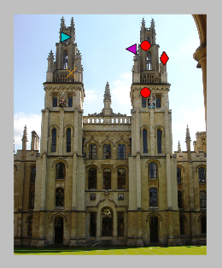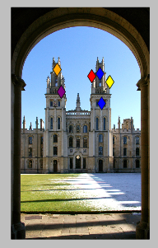

Computing homography using RANSAC. Step I.
Question. Paste the result in your report. What do you observe regarding the success of computing the homography?
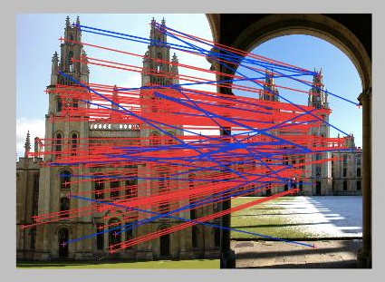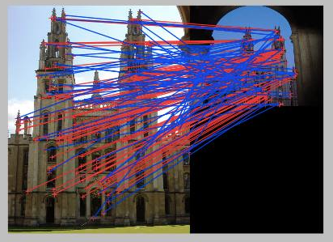

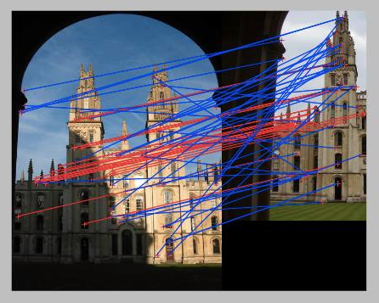

Observations
We observe that from different perspectives, many of the same matches are found back in all three images. This could mean that the matching function can recognize two of the same objects, even when the point of view of one of the images is altered.

Image recognition with geometric verification. Step J.
Question. Given the queries all_souls_000035.jpg and all_souls_000040.jpg, which of the rest images are geometrically recognized. Paste those images, together with the query in your report.

