**COSC-4117EL: Assignment 1 Report**

**Group Number: 2**

**Group Member:**

|  |  |  |  |
| --- | --- | --- | --- |
| **NAME** | **STUDENT#** | **EMAIL** | **CONTRIBUTION** |
| **Haoliang Sheng** | 0441916 | hsheng@laurentian.ca | 60% |
| **Zihao Zhou** | 0429993 | zzhou3@laurentian.ca | 20% |
| **Jiazhou Ye** | 0426609 | Jye1@laurentian.ca | 20% |

1. **Abstract**

In this study, we developed a Python program to solve binary puzzles using constraint satisfaction algorithms, specifically focusing on three heuristics: Random Variable (H1), Most Constrained Variable (H2), and Most Constraining Variable (H3). We further explored the impact of employing the AC3 constraint propagation method within these algorithms. By utilizing puzzles sourced from the [Binary Puzzle](https://www.binarypuzzle.com/) website, our evaluations spanned various sizes and difficulty levels. Performance metrics included average solving time, search attempts, and completion rates. Our primary findings revealed the robustness of the H2 heuristic across all scenarios and the consistent performance enhancements offered by AC3 in terms of search attempts.

1. **Introduction**

Binary puzzles are a captivating subset of constraint satisfaction problems. Presented as square grids of size n×n, the cells within these puzzles can either be filled with a 0, a 1, or left blank. The solver's objective is to populate the blank cells in a manner that adheres to a set of predefined rules:

1. Each cell must contain a number: either 0 or 1.
2. Three consecutive ones or zeros cannot appear in any row or column.
3. Every row and column must have an equal number of ones and zeros.
4. No two rows or columns can be identical.

In our endeavor to assess the efficiency of different heuristics and constraint propagation methods, puzzles were sourced from the Binary Puzzle website. For each puzzle size (ranging from 6x6 to 14x14) and difficulty level (easy, medium, hard, very hard), five distinct puzzles were transformed into a .txt format.

1. **Methodology**

Initially, the approach involved averaging the performance metrics across the five different puzzles for a specific combination of size, difficulty, heuristic, and AC3 usage. However, this method posed challenges due to inconsistencies in completion times, leading to potential unfairness in averaged results.

Subsequently, a revised approach was adopted: a single puzzle, under a specified set of conditions, was run ten times. The average time and attempts across these ten runs were then computed. If a particular set of conditions resulted in solving times exceeding 5 minutes, the case was labeled as "time out" and deemed incomplete.

1. **Experimental Results**

**Impact of Heuristics on Different Puzzle Sizes with Completion Overlay**

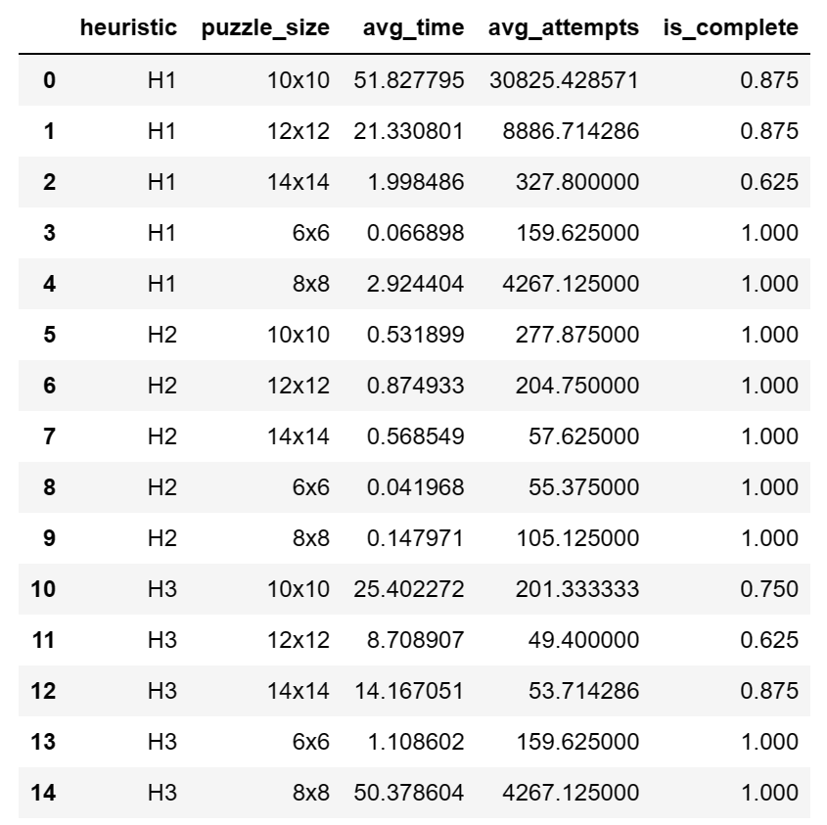

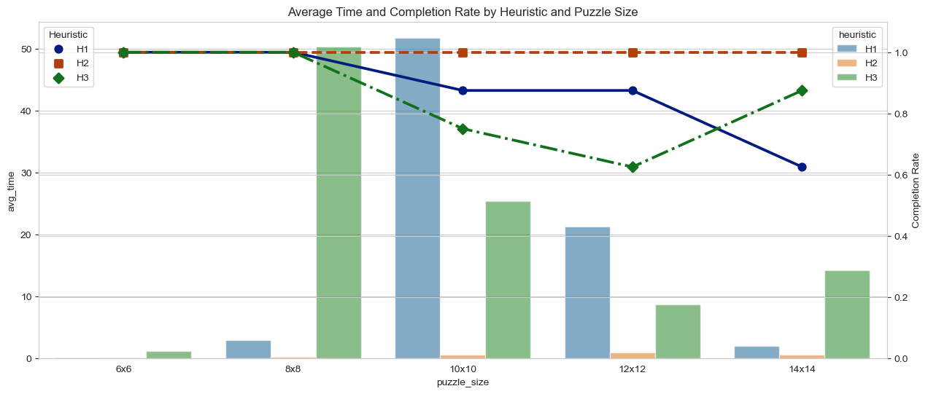

The plot above displays the average time taken by different heuristics across various puzzle sizes, with the completion rate overlaid:

* Bars represent the average time taken.
* Lines represent the completion rate.

Time Observations:

**H1:**

Average time peaks at 51.83 seconds for 10x10 puzzles, then decreases significantly to 21.33 seconds for 12x12 puzzles, and further drops to 1.998 seconds for 14x14 puzzles.

The completion rate for H1 remains at 0.875 for both 10x10 and 12x12 puzzles but decreases to 0.625 for 14x14 puzzles, indicating that some puzzles might not have been completed within the time limit.

**H2:**

Maintains a consistently low average time across all puzzle sizes, with the highest being 0.8749 seconds for 12x12 puzzles.

Achieves a 100% completion rate across all puzzle sizes, indicating its robustness.

**H3:**

Shows a spike in average time for 8x8 puzzles at 50.38 seconds, then decreases to 25.40 seconds for 10x10 puzzles. There's another increase to 14.17 seconds for 14x14 puzzles.

The completion rate remains high for most puzzle sizes but dips to 0.625 for 12x12 puzzles.

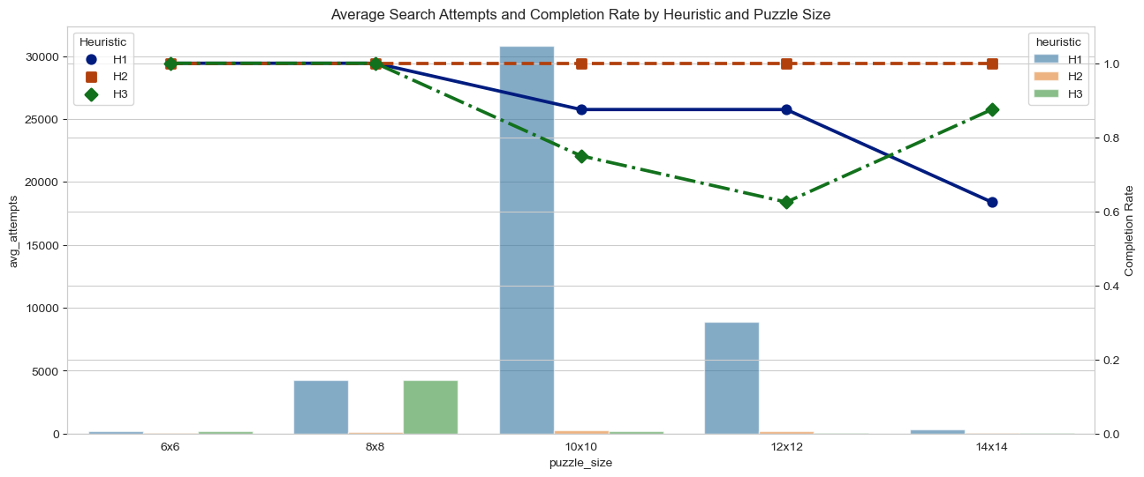

The plot above displays the average number of search attempts made by different heuristics across various puzzle sizes, with the completion rate overlaid:

* Bars represent the average number of search attempts.
* Lines represent the completion rate.

Attempts Observations:

**H1:**

The average number of search attempts peaks at 30,825 for 10x10 puzzles, decreases to 8,886 for 12x12 puzzles, and further drops to 327.8 for 14x14 puzzles.

The completion rate for H1 remains at 0.875 for both 10x10 and 12x12 puzzles but decreases to 0.625 for 14x14 puzzles, suggesting that some puzzles might not have been completed within the time limit.

**H2:**

Maintains a consistently low number of search attempts across all puzzle sizes, with the highest being 277.875 for 10x10 puzzles.

Achieves a 100% completion rate across all puzzle sizes, reinforcing its efficiency.

**H3:**

Like H1, H3 also shows a spike in search attempts for 8x8 puzzles with 4,267.125 attempts. This decreases to 201.333 attempts for 10x10 puzzles and slightly increases to 53.714 for 14x14 puzzles.

The completion rate remains high for most puzzle sizes but dips to 0.625 for 12x12 puzzles.

**Impact of Heuristics on Different Puzzle Difficulties with Completion Overlay**

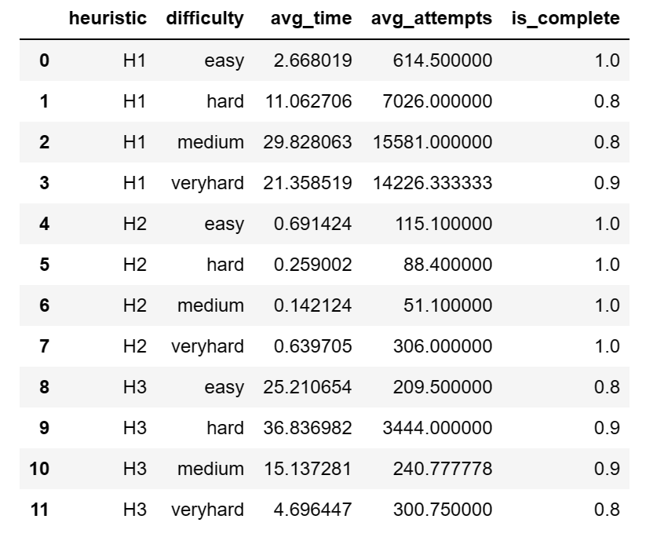

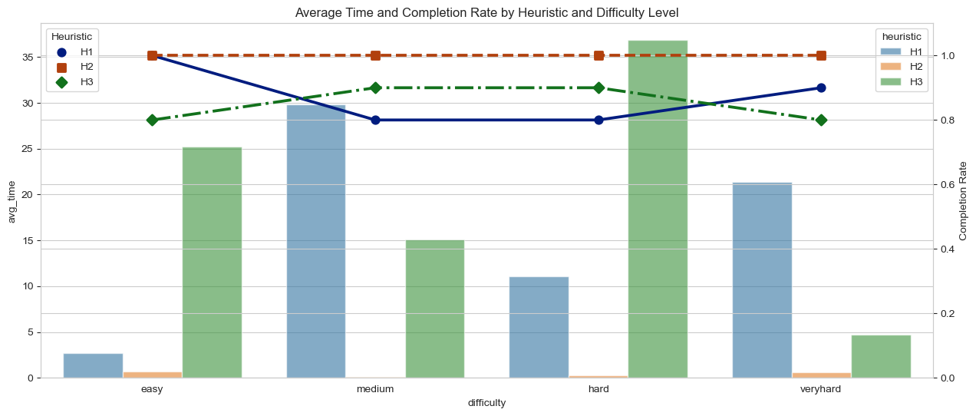

The plot above displays the average time taken by different heuristics across various difficulty levels, with the completion rate overlaid:

* Bars represent the average time taken.
* Lines represent the completion rate.

Time Observations:

**H1:**

Performs most efficiently on 'easy' puzzles with an average time of 2.668 seconds.

For 'medium' puzzles, the average time taken by H1 spikes to 29.83 seconds, which is even higher than the 21.36 seconds taken for 'very hard' puzzles.

The completion rate for H1 is perfect for 'easy' puzzles but drops to 0.8 for both 'hard' and 'medium' puzzles. Interestingly, the completion rate rises slightly to 0.9 for 'very hard' puzzles.

**H2:**

Maintains a consistently low average time across all difficulty levels. While the time is lowest for 'medium' puzzles at 0.1421 seconds, there's a slight increase to 0.6397 seconds for 'very hard' puzzles.

Achieves a 100% completion rate across all difficulty levels.

**H3:**

The average time taken by H3 is highest for 'hard' puzzles at 36.84 seconds, whereas for 'very hard' puzzles, the time surprisingly drops to 4.696 seconds.

The completion rate remains at 0.9 for 'medium' and 'hard' puzzles but drops to 0.8 for both 'easy' and 'very hard' puzzles.

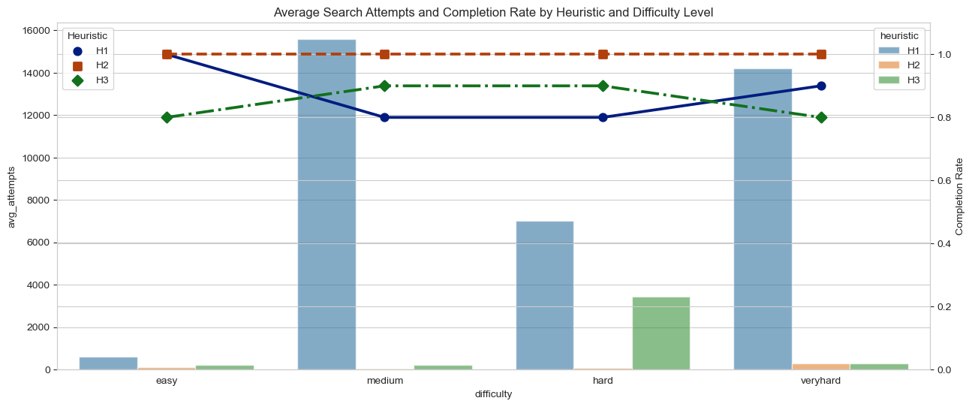

The plot above displays the average number of search attempts made by different heuristics across various difficulty levels, with the completion rate overlaid:

* Bars represent the average number of search attempts.
* Lines represent the completion rate.

Attempts Observations:

**H1:**

The number of search attempts is moderate for 'easy' puzzles at 614.5 but jumps significantly to 15,581 for 'medium' puzzles. For 'very hard' puzzles, it slightly decreases to 14,226.33.

The completion rate is perfect for 'easy' puzzles but drops to 0.8 for both 'hard' and 'medium' puzzles. However, it rises slightly to 0.9 for 'very hard' puzzles.

**H2:**

Maintains a consistently low number of search attempts across all difficulty levels, with the highest being 306 for 'very hard' puzzles.

Achieves a 100% completion rate across all difficulty levels, reinforcing its efficiency and robustness.

**H3:**

The number of search attempts is highest for 'hard' puzzles at 3,444. For 'very hard' puzzles, the attempts drop to 300.75.

The completion rate remains at 0.9 for 'medium' and 'hard' puzzles but drops to 0.8 for both 'easy' and 'very hard' puzzles.

**Impact of AC3 Usage on Different Puzzle Sizes with Completion Overlay**

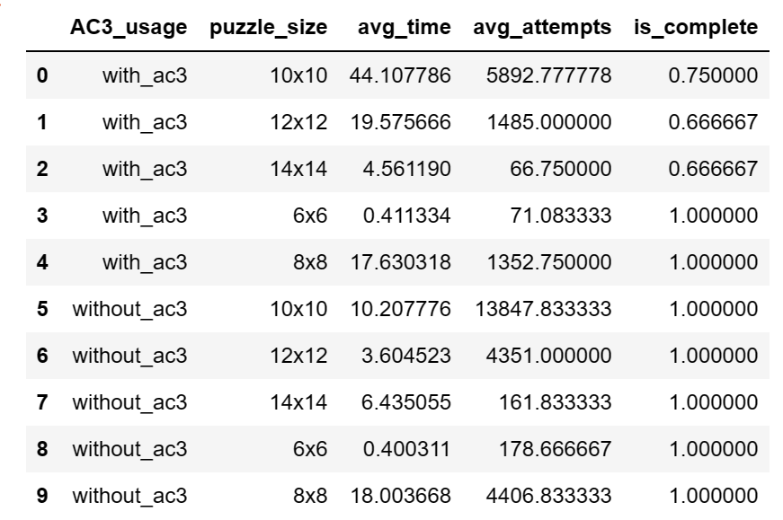

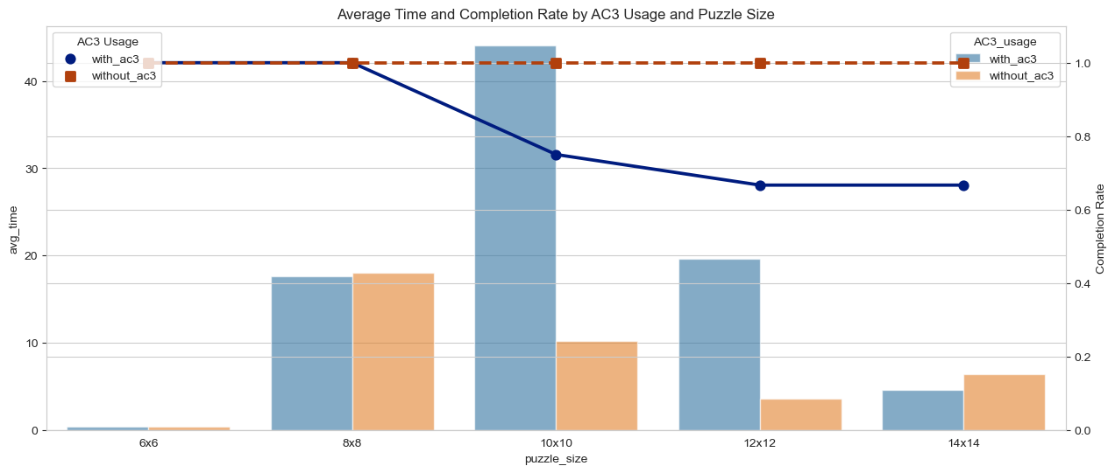

The plot above displays the impact of AC3 usage on the average time taken across various puzzle sizes, with the completion rate overlaid:

* Bars represent the average time taken.
* Lines represent the completion rate, differentiated by AC3 usage (Yes or No).

Time Observations:

**Without AC3:**

The average time peaks at 10.21 seconds for 10x10 puzzles, which is surprisingly lower than the time taken for 8x8 puzzles at 18.00 seconds.

The completion rate without AC3 remains at 100% across all puzzle sizes.

**With AC3:**

The average time is highest for 10x10 puzzles at 44.11 seconds, which then decreases for larger puzzles such as 12x12 and 14x14, with times of 19.58 seconds and 4.56 seconds respectively.

The completion rate remains at 100% for smaller puzzles like 6x6 and 8x8. However, it drops to 0.75 for 10x10 puzzles and further decreases to 0.67 for both 12x12 and 14x14 puzzles.

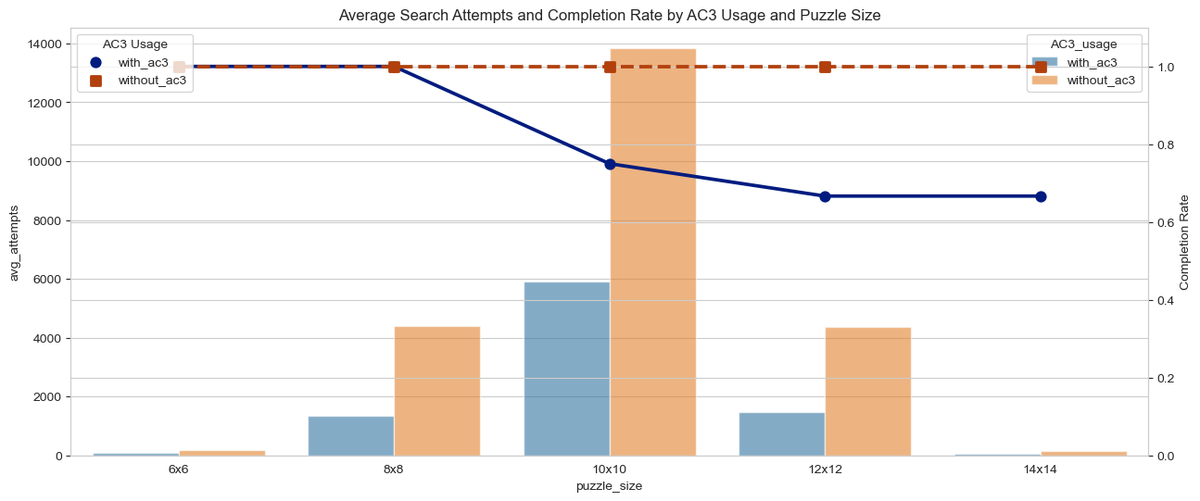

The plot above displays the impact of AC3 usage on the average number of search attempts across various puzzle sizes, with the completion rate overlaid:

* Bars represent the average number of search attempts.
* Lines represent the completion rate, differentiated by AC3 usage (Yes or No).

Attempts Observations:

**Without AC3:**

The average number of search attempts is notably high for 10x10 puzzles with 13,847.83 attempts. For 8x8 puzzles, it jumps to 4,406.83 attempts.

The completion rate without AC3 remains at 100% across all puzzle sizes.

**With AC3:**

Puzzles solved using AC3 generally require fewer search attempts, with 5,892.78 attempts for 10x10 puzzles and 1,485 attempts for 12x12 puzzles.

The completion rate remains at 100% for smaller puzzles like 6x6 and 8x8. However, it drops to 0.75 for 10x10 puzzles and further decreases to 0.67 for both 12x12 and 14x14 puzzles.

**Impact of AC3 Usage on Different Puzzle Difficulties with Completion Overlay**

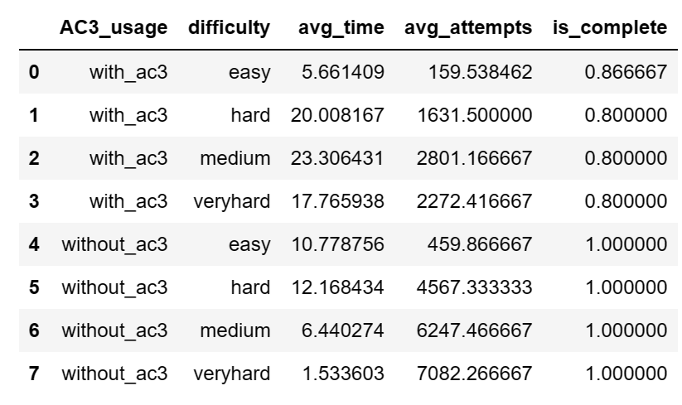

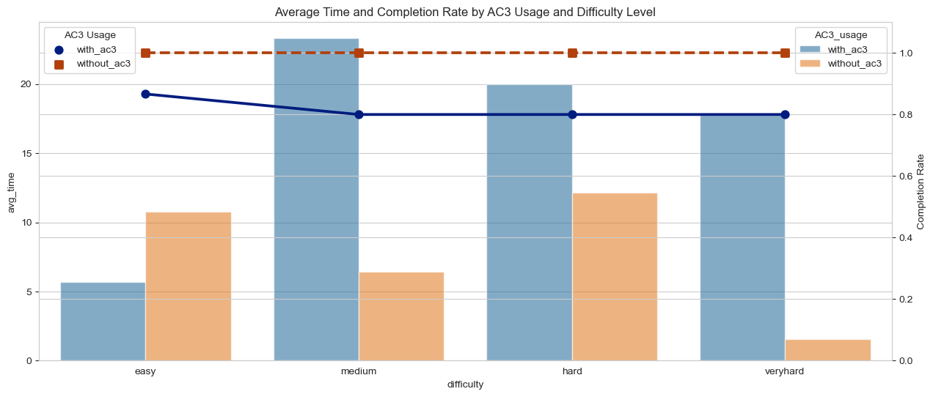

The plot above displays the impact of AC3 usage on the average time taken across various difficulty levels, with the completion rate overlaid:

* Bars represent the average time taken.
* Lines represent the completion rate, differentiated by AC3 usage (Yes or No).

Time Observations:

**Without AC3:**

The average time taken for 'easy' puzzles is 10.78 seconds. Surprisingly, this decreases for 'hard' and 'medium' puzzles to 12.17 seconds and 6.44 seconds, respectively, and further drops to a mere 1.53 seconds for 'very hard' puzzles.

The completion rate without AC3 remains at 100% across all puzzle difficulties.

**With AC3:**

The average time peaks at 23.31 seconds for 'medium' puzzles. While 'hard' puzzles take 20.01 seconds, the time decreases to 17.77 seconds for 'very hard' puzzles.

In general, puzzles solved using AC3 tend to complete slower across most difficulty levels compared to those solved without AC3.

The completion rate for puzzles solved using AC3 is 0.8 for 'hard', 'medium', and 'very hard' puzzles, and 0.8667 for 'easy' puzzles, which is indeed lower than without using AC3.

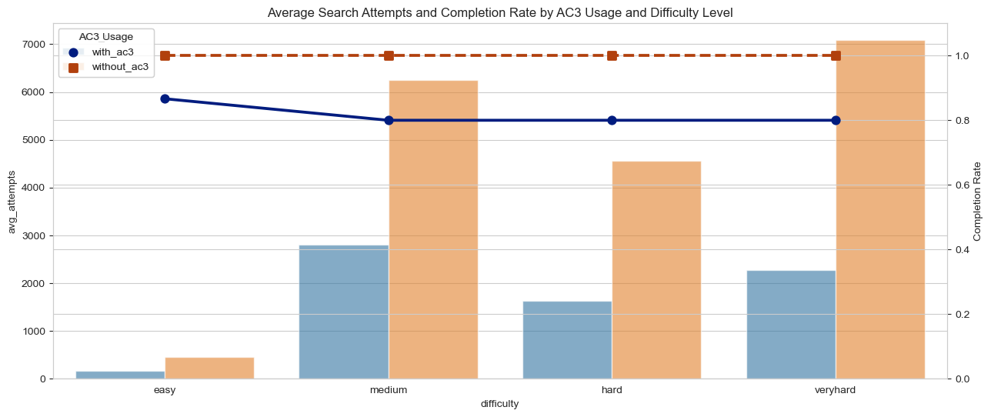

The plot above displays the impact of AC3 usage on the average number of search attempts across various difficulty levels, with the completion rate overlaid:

* Bars represent the average number of search attempts.
* Lines represent the completion rate, differentiated by AC3 usage (Yes or No).

Attempts Observations:

**Without AC3:**

The average number of search attempts is 459.87 for 'easy' puzzles. This number jumps significantly to 4,567.33 for 'hard' puzzles and further increases to 6,247.47 for 'medium' puzzles and 7,082.27 for 'very hard' puzzles.

The completion rate without AC3 remains at 100% across all puzzle difficulties.

**With AC3:**

The average number of search attempts is 159.54 for 'easy' puzzles. This increases to 1,631.5 for 'hard' puzzles, 2,801.17 for 'medium' puzzles, and 2,272.42 for 'very hard' puzzles.

In general, puzzles solved using AC3 require more search attempts for 'hard', 'medium', and 'very hard' puzzles compared to 'easy' puzzles, but fewer attempts than those solved without AC3 for the same difficulties.

The completion rate for puzzles solved using AC3 is 0.8 for 'hard', 'medium', and 'very hard' puzzles, and 0.8667 for 'easy' puzzles. This rate is lower than without using AC3.

1. **Discussion**

**Heuristic Efficiency:**

H2 consistently emerged as the most efficient heuristic. It achieved a 100% completion rate across all scenarios, maintaining low average times and search attempts. This positions it as a highly reliable choice for solving puzzles. Conversely, H1 and H3 were generally effective but showed diminished performance, especially for larger puzzles. Both heuristics displayed increased times and search attempts as the puzzle size expanded.

**Impact of AC3:**

Incorporating AC3 into the puzzle-solving process yielded mixed results. Although the use of AC3 consistently led to fewer search attempts, it didn't always translate to quicker solving times. The efficiency regarding time was influenced by the specific puzzle size and difficulty.

**General Observations:**

With an increase in puzzle size, the challenges inherently magnified, as seen from the declining completion rates for 12x12 and 14x14 puzzles. 'Very Hard' puzzles posed the most significant challenge both in terms of time and search attempts. Interestingly, 'Very Hard' puzzles solved without AC3 demonstrated surprisingly quick completion times, with the average time for such puzzles being a mere 1.53 seconds.

In conclusion, while the heuristic choice plays a pivotal role in solving efficiency, the incorporation of AC3 displayed varied outcomes. Although AC3 consistently minimized the number of search attempts, its effect on solving times wasn't consistent. This analysis underscores the importance of choosing an optimal heuristic, such as H2, and delving into the intricate impacts of utilizing AC3, especially when dealing with larger and intricate puzzles.

1. **Appendix: Experimental Results Table**

The table below presents the compiled results from the experiments:

