



**Credit Hours System**

**CMPN415**

**Embedded Systems**

**Cairo University**

**Embedded Systems**

**Name: Ahmed Osman Ramadan**

**Sahar Hossam ELDen Monier ID: 1142335**

**Nooran Helmy ID:1142235**

**Program Title: CCE-C Track**

**Submitted to: Dr. Bassem El Gendy**

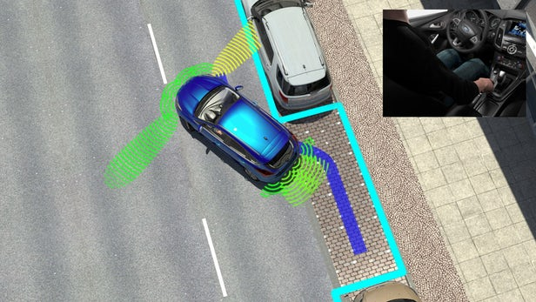

**Table of content**

1. **Introduction……………………………………..…………..1**

**Todo:**

**Table of contents and figures**

**Add refrences**

# **Introduction:**

A parking helper system that detects whether there is an available parking slot for the car or not while it is moving. The helper checks whether the available distance is enough to fit the car or not by comparing it with the car’s width/ length. The helper must be enabled or allowed to start the detection at a low speed.

When the system is enabled the available ultrasonic sensors read whether the barrier is in front of it or not and keeps reading until it exceeds the car’s length/width. If there are no barriers means this slot can be used to park. According to our reference paper Valeo has reached that it can detect the parking slot while the car is not moving. While Siemens has reached that it can detect a parking slot while the car is moving at a speed up to 40m/s.

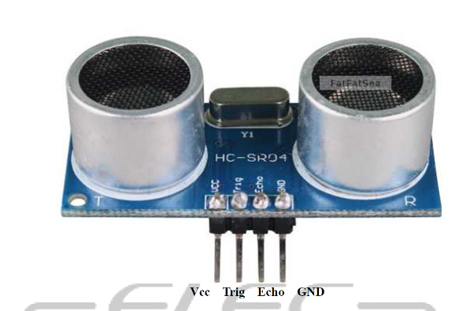

# **List of Components and description**

Ultrasonic

Why used?

Used to detect presence of a free slot using a transmitter and receiver signals.

Method of operation:

It emits an ultrasound at 40 000 Hz which travels through the air and if there is an object or obstacle on its path It will bounce back to the module. Considering the travel time and the speed of the sound you can calculate the distance.

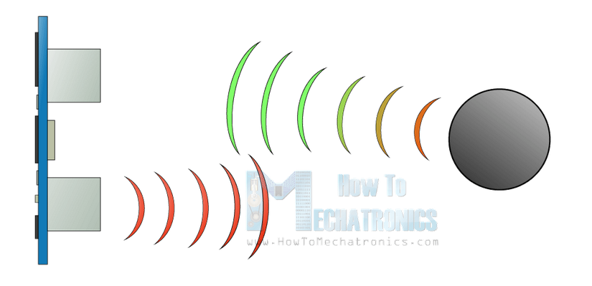

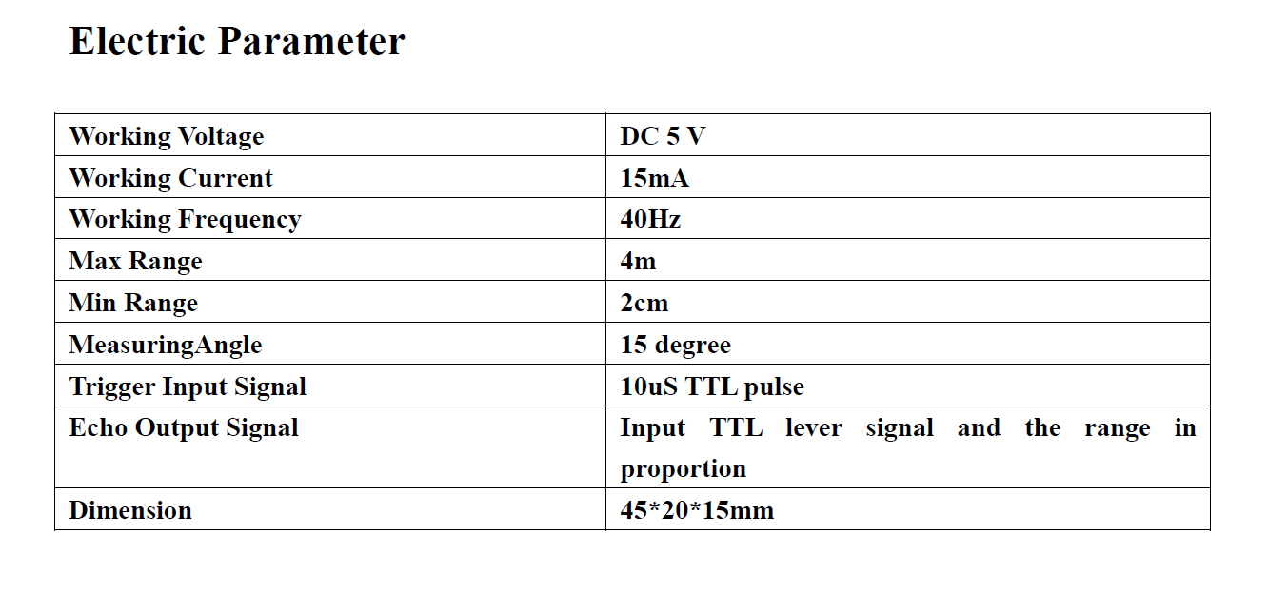

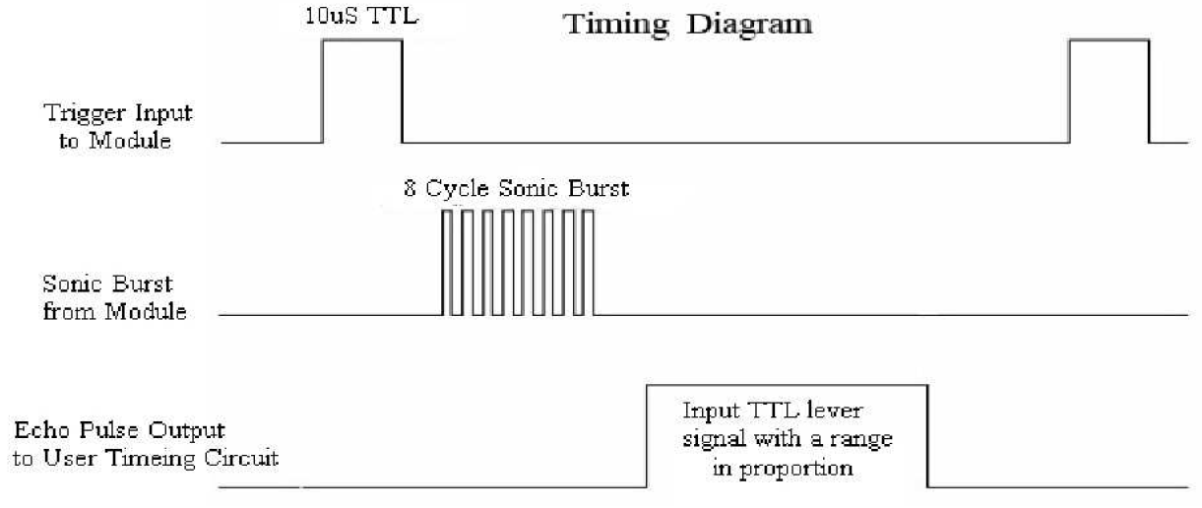

In order to generate the ultrasound you need to set the Trig on a High State for 10 µs. That will send out an 8 cycle sonic burst which will travel at the speed sound and it will be received in the Echo pin. The Echo pin will output the time in microseconds the sound wave traveled.

Accelorometer:

an instrument for measuring the acceleration of a moving or vibrating body.

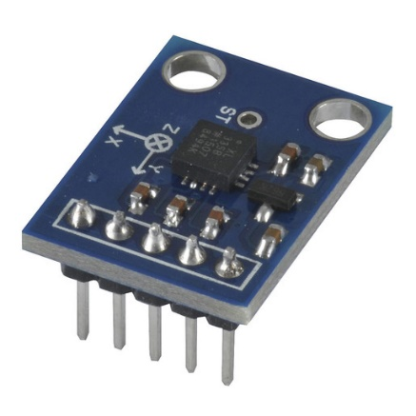Why used?

To measure the safe speed needed to detect a parking slot and if the user is not moving in safe speed we display “Slow down message”.

Arduino

Why used? 3shan angz☺

LCD

Why used? To interact with system user

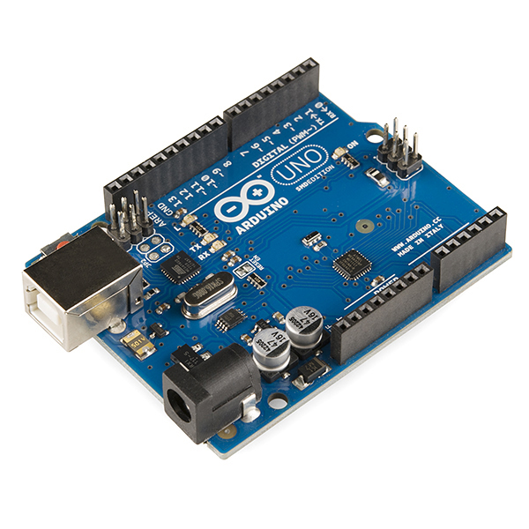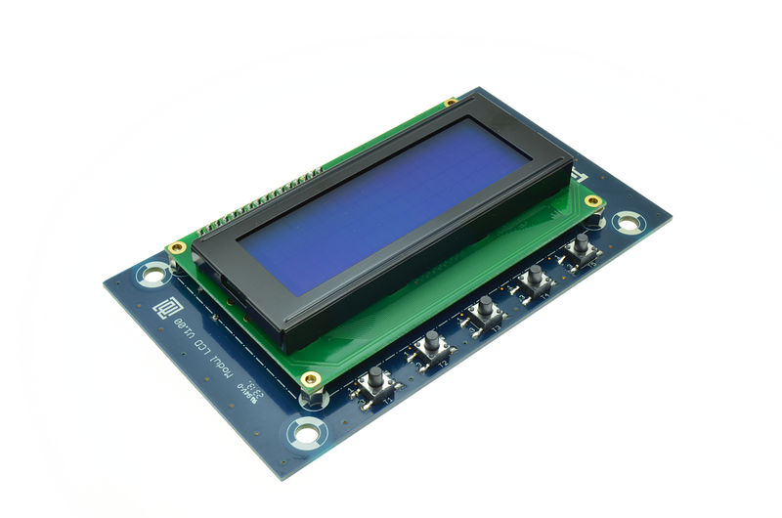

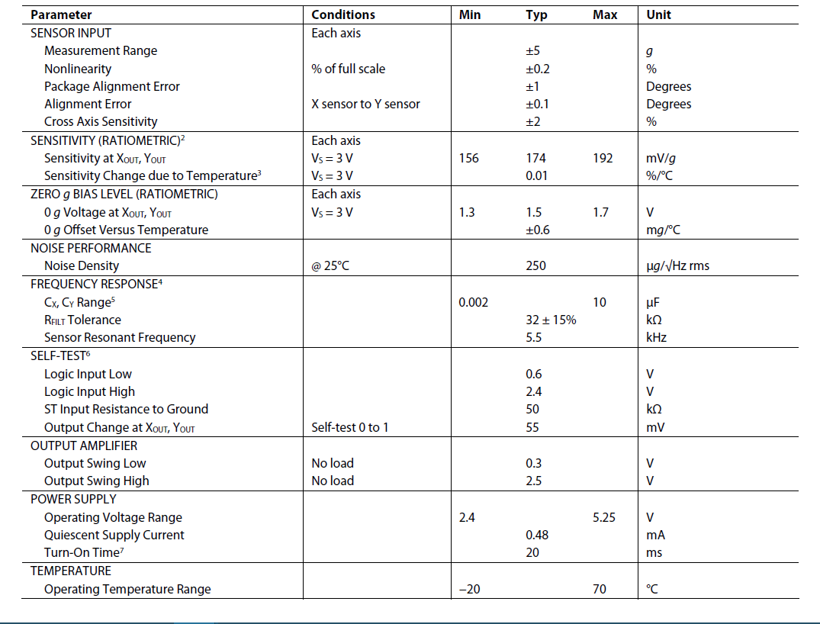

1-Block Diagram

Swra☺

Little description

2-Timing Diagram

Swra☺

Little description

3-Finite State Machine

Swra☺

Little description

4-Sequence Chart

Swra☺

Little description

5-Use Cases

Swra☺

Little description

4

**References**

5