Tired of adding path every time using scripts?
Add your custome path in terminal so that you don’t have to add absolute path runninng scripts

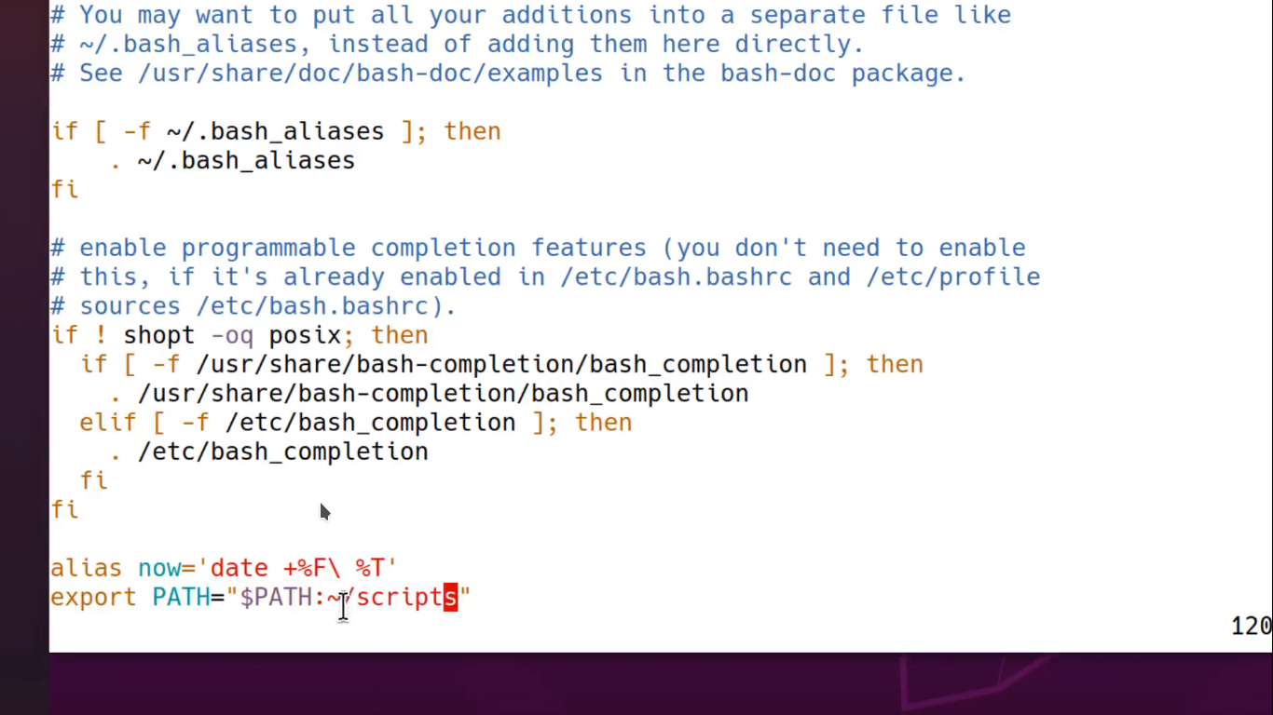

export PATH=”$PATH:path to /directory

wanna make your custom commnad?
alias command :
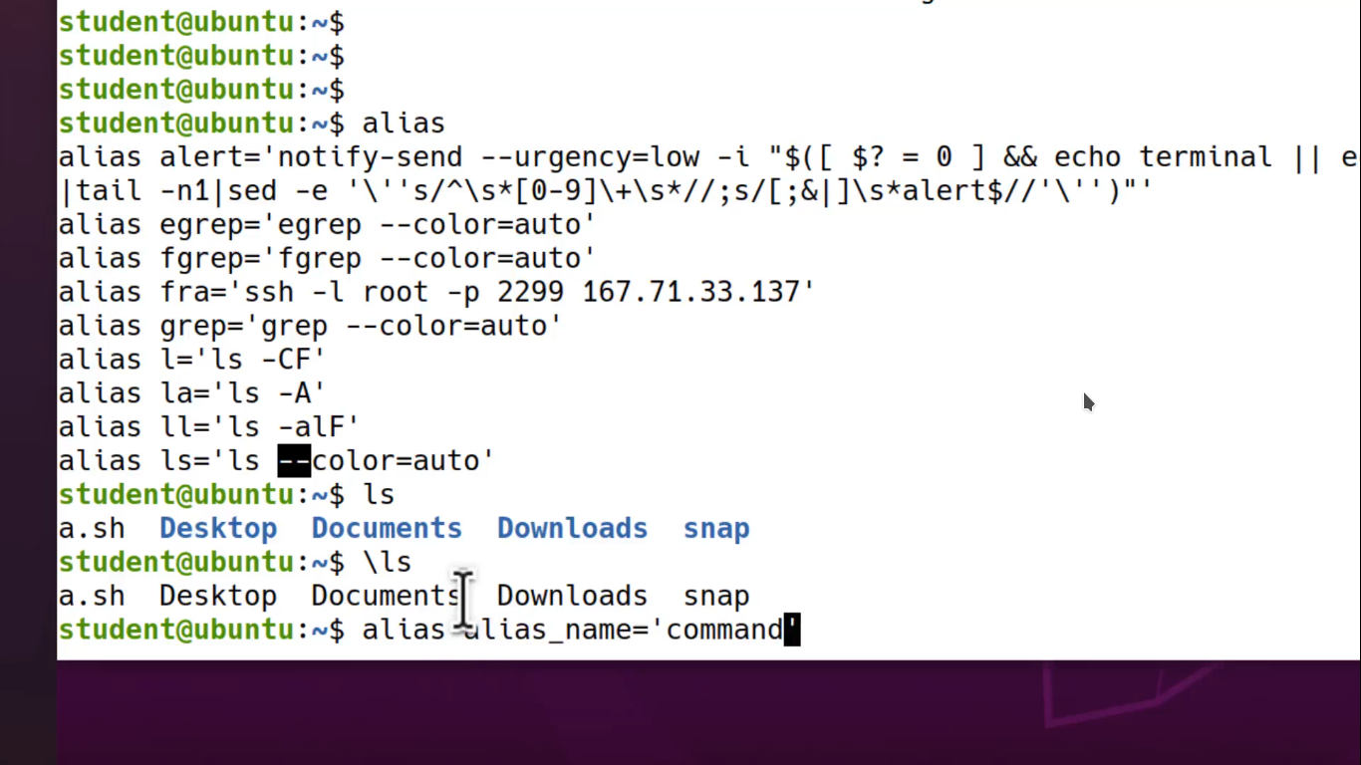
alias alias_name=’your custom commnad’

we can add shebang to tell the interpretor which language interpreter It should use by add in our
scripts like that
if bash file :- #!/path to bash/
to find path of bash write in terminal:- whereis bash
you will get this out put----- bash: /usr/bin/bash /usr/share/man/man1/bash.1.gz
add this in your bash file..

how to add comment in bash scripts?
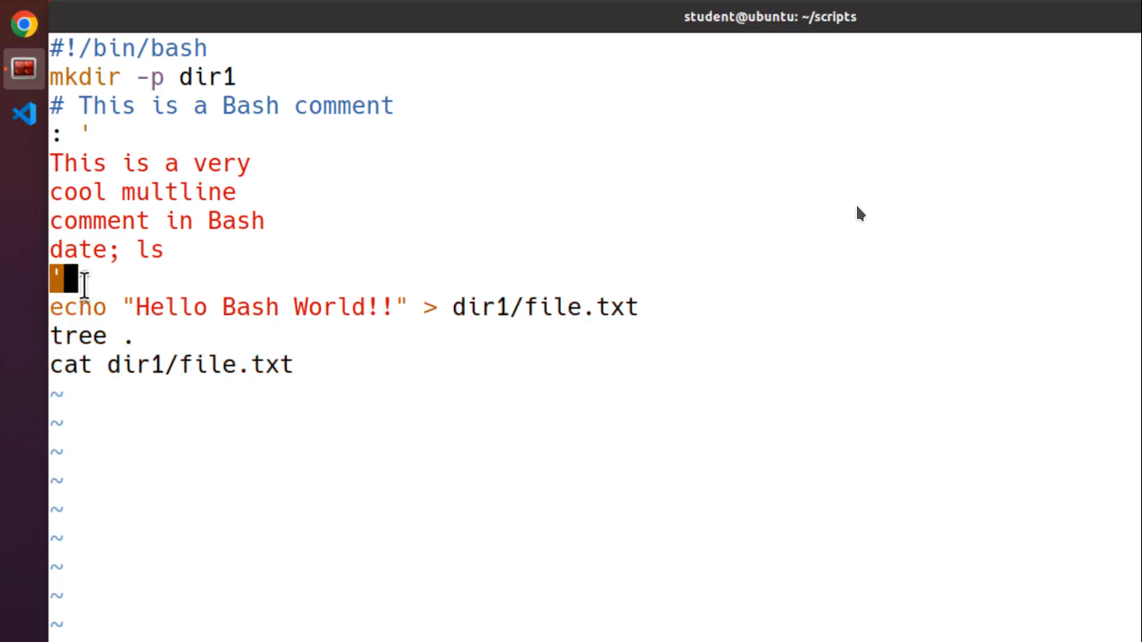
# this is single line comment in bash

#important to note multiline comment syntax:
:[space] ’ here is your multiline comment things ‘

how many ways can you run scripts?
List--
./scripts
bash scripts
source scripts.sh

how to set variable ?
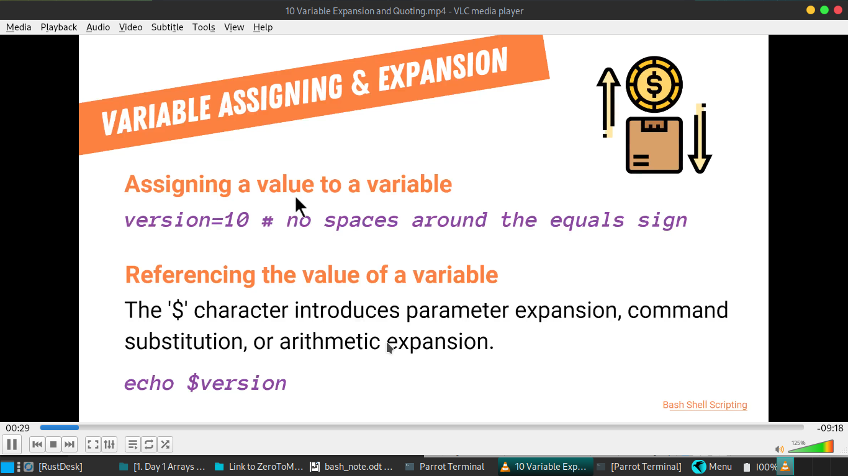

Like that:
myname =”shafikul”
to print It user: echo $myname
if I want want append some thing after variable print then user {} curly braces for that

example pic:
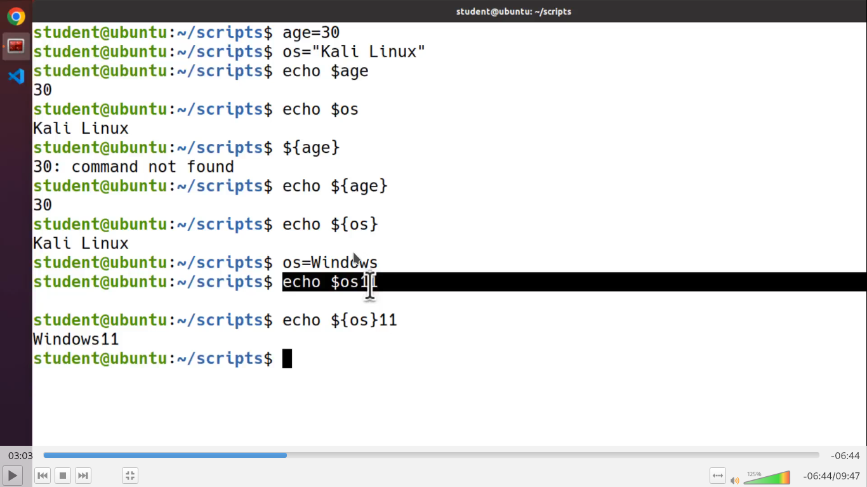

rule of variables:
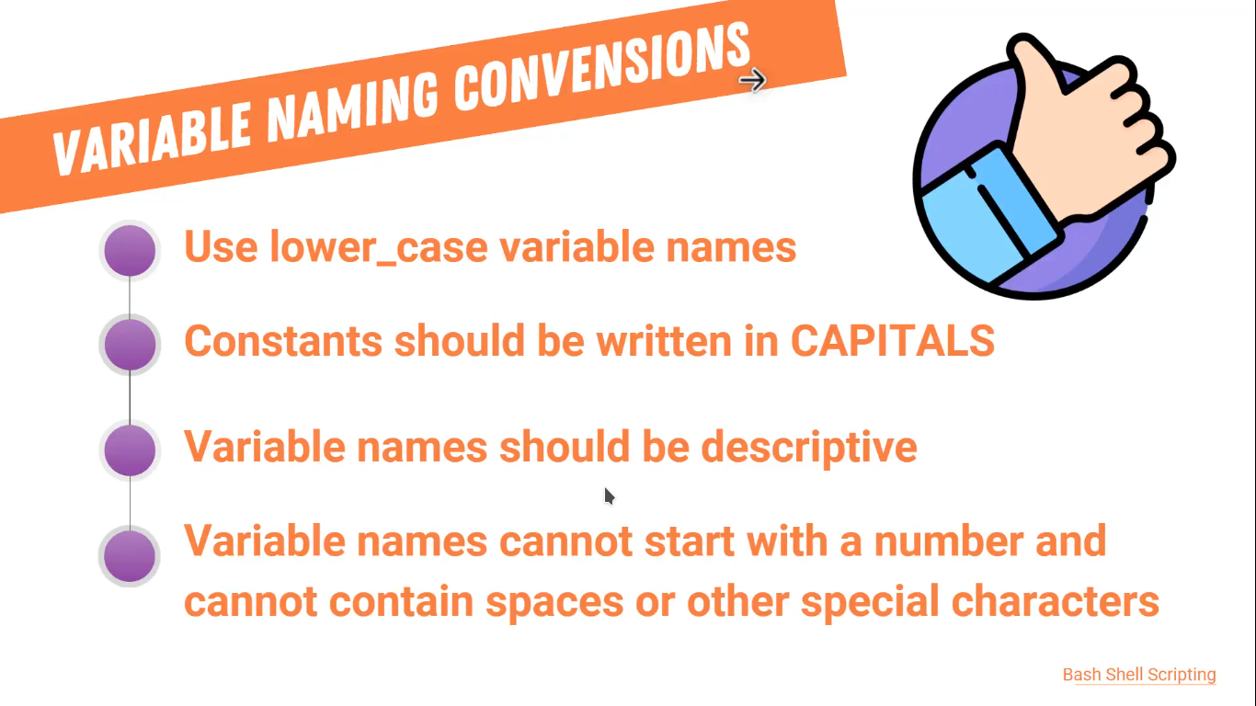

Environment and shell local variables
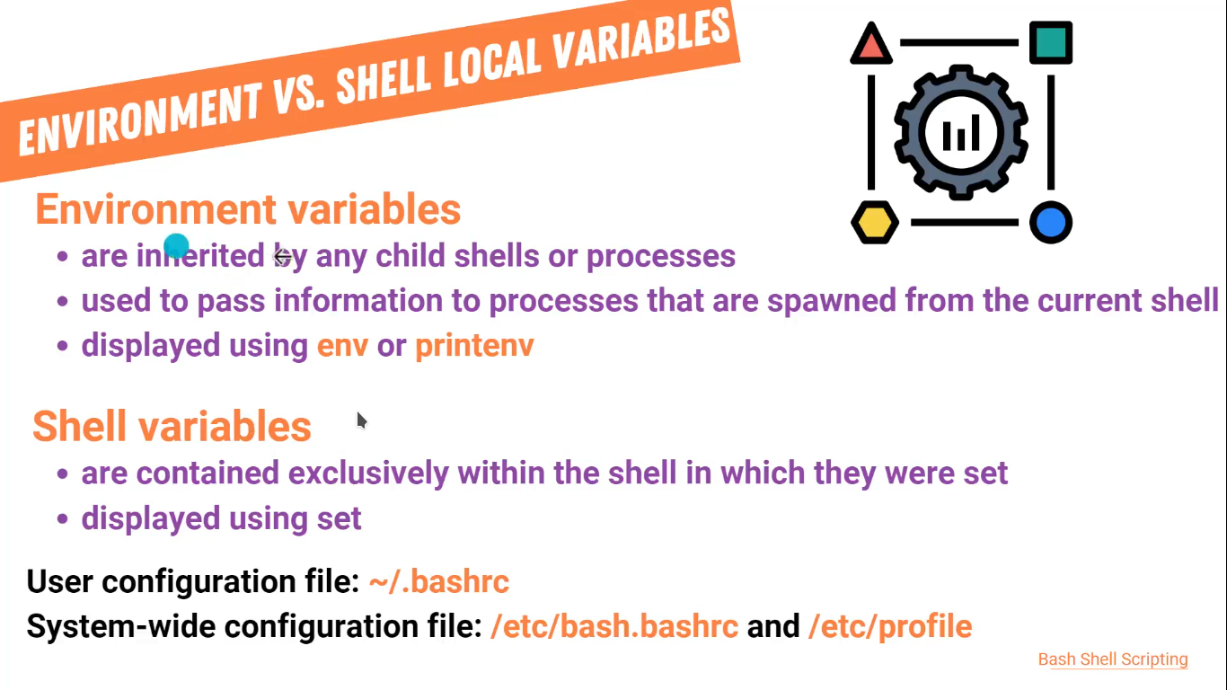
we will learn about it later detailed…

how to get arbetery input?
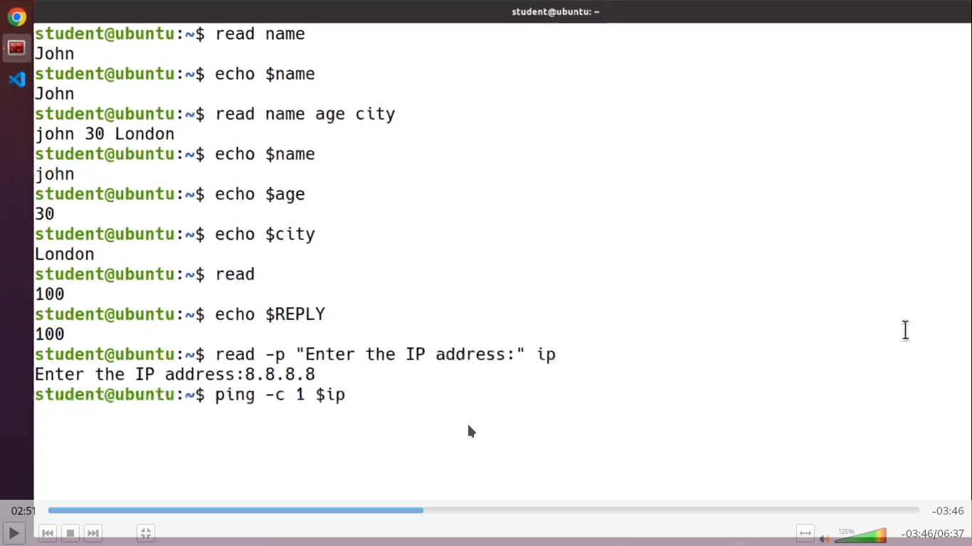
we use read commnad for taking input:
$read name #here read command is taking user input and name is the variable

$read -p “Enter the IP address :” ip #here -p command will show the dobule quated line to guide the user in input
$read -s -p “Enter screct password:” password # this -s will not show password in the password taking section make your self protective

positional parameter:

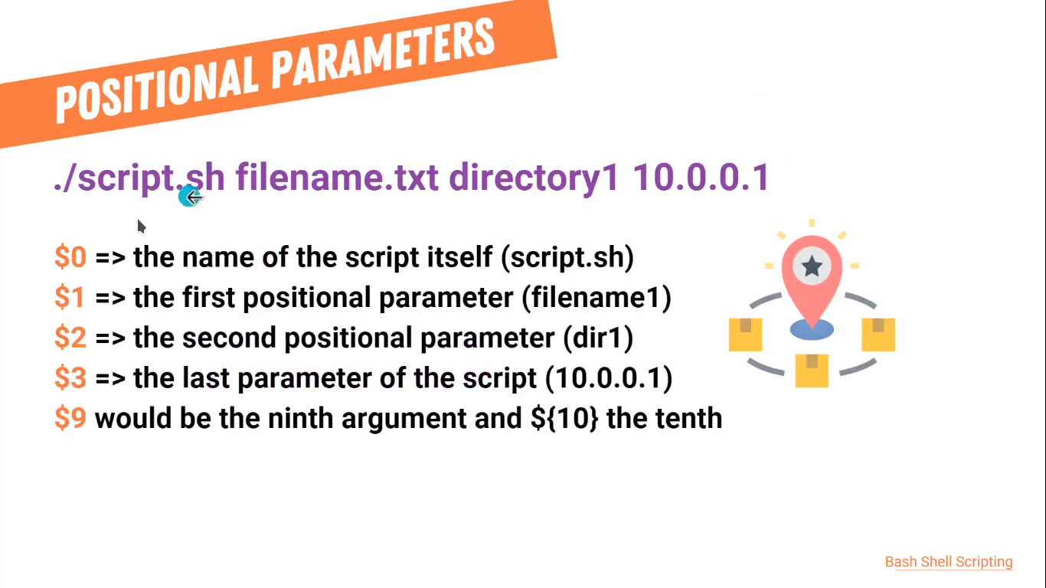
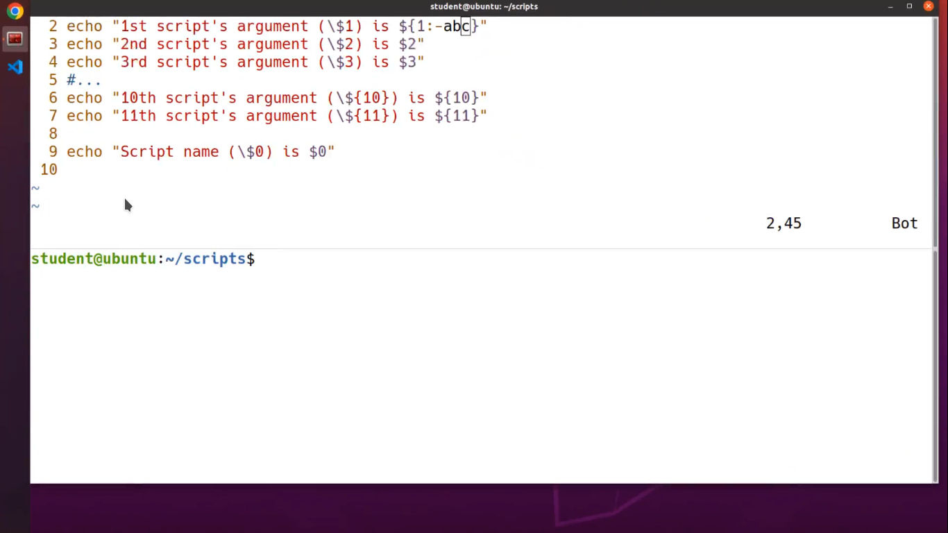

special parameter:
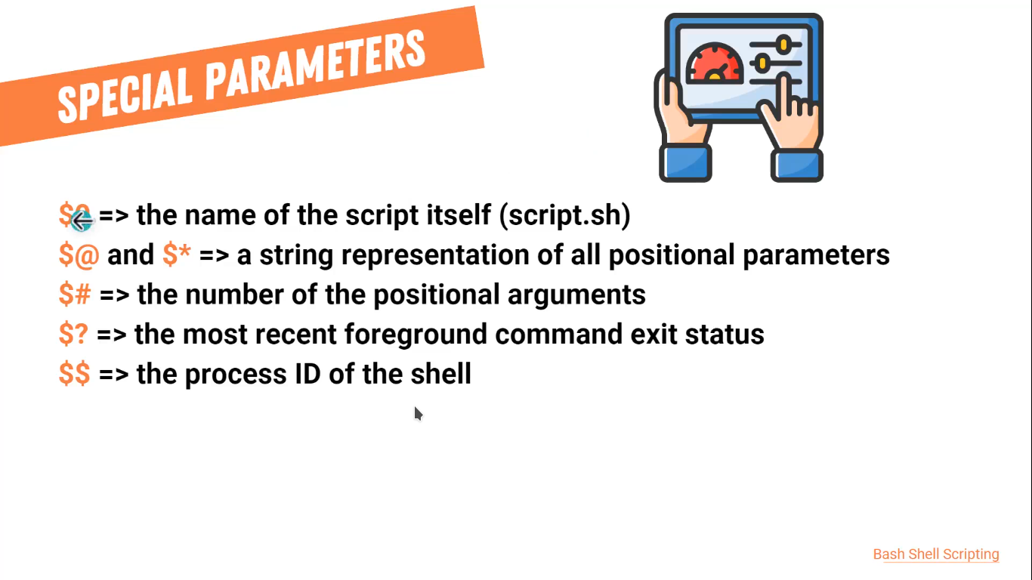

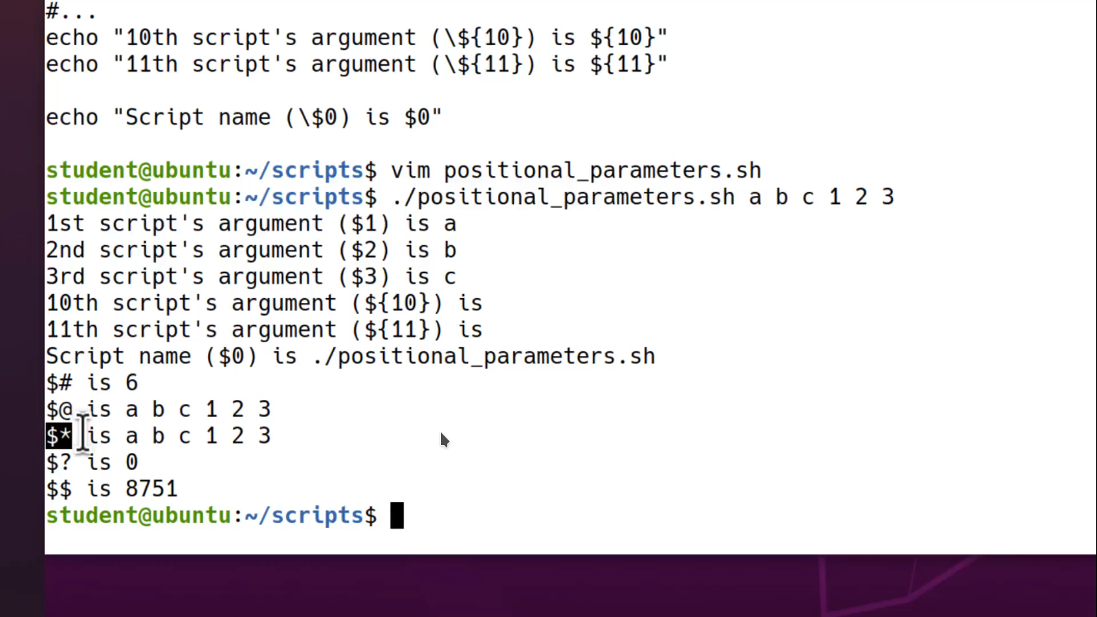

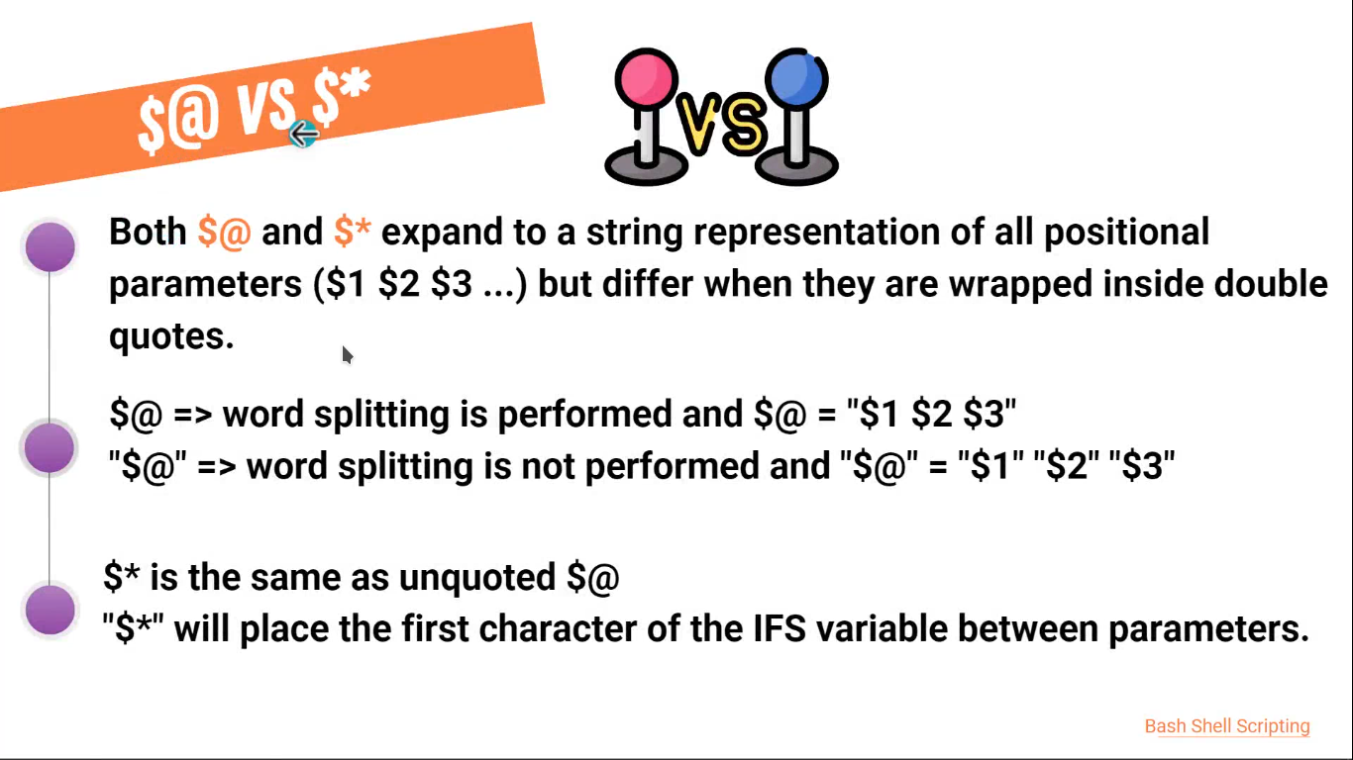

shell Expansion is process to get a value from referance entity like variable to gets it value to following order.
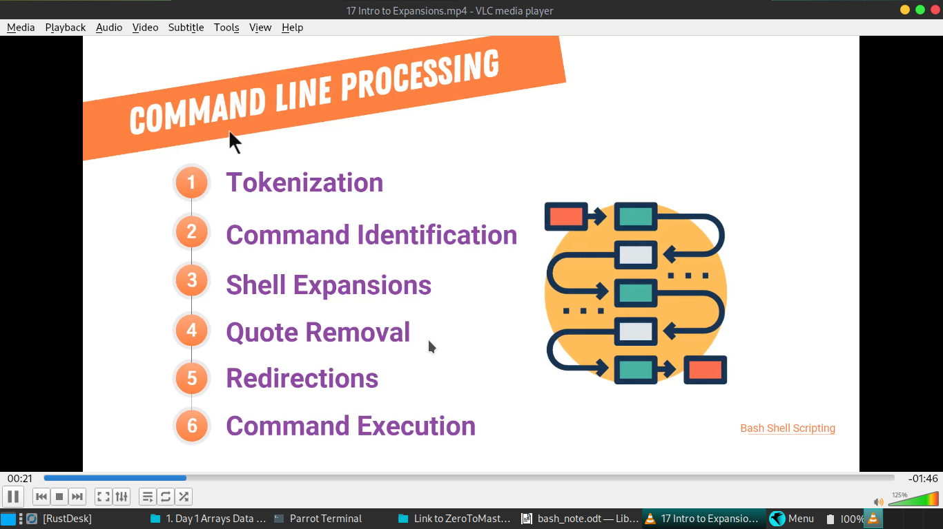
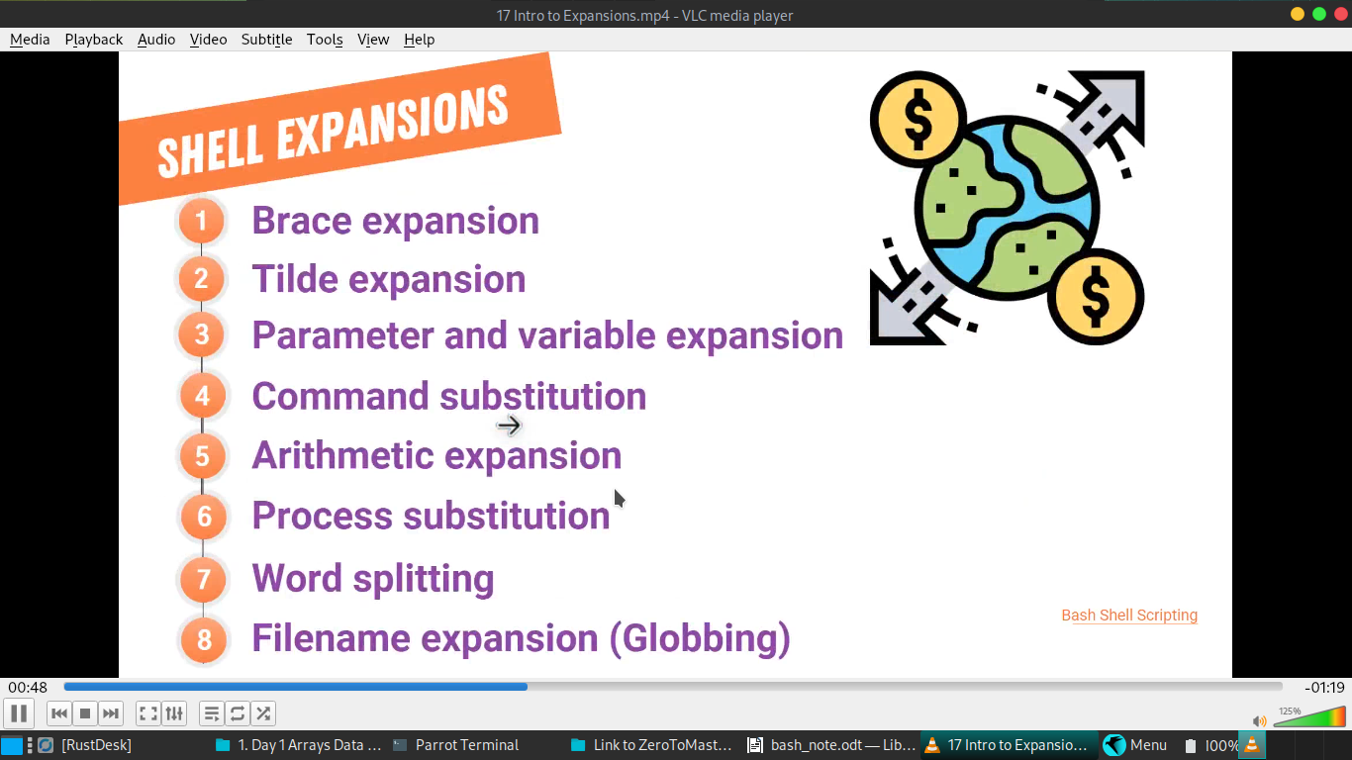
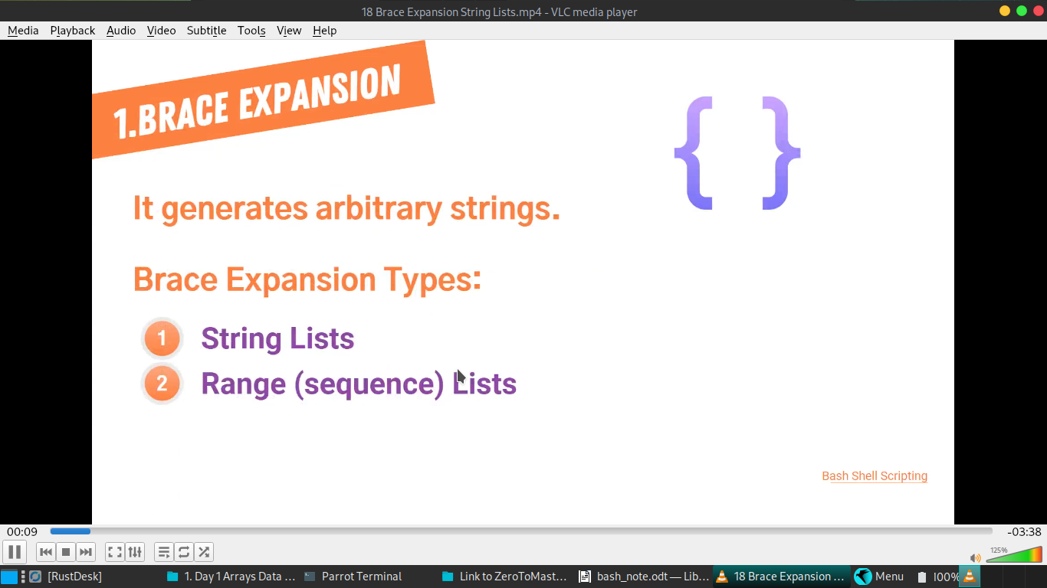

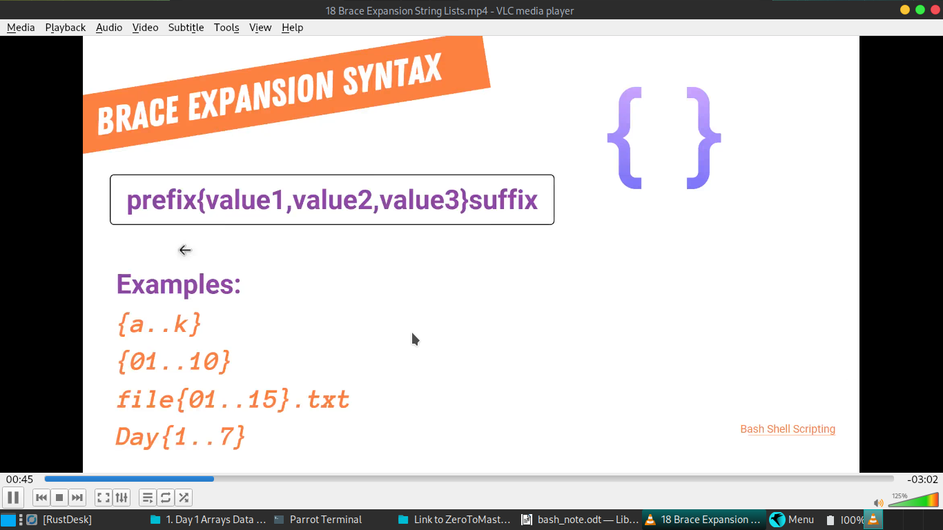

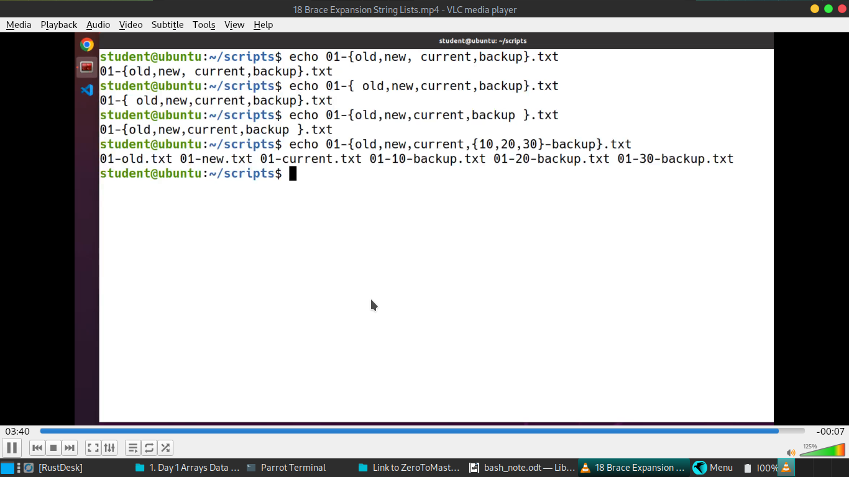

Tilde expension:
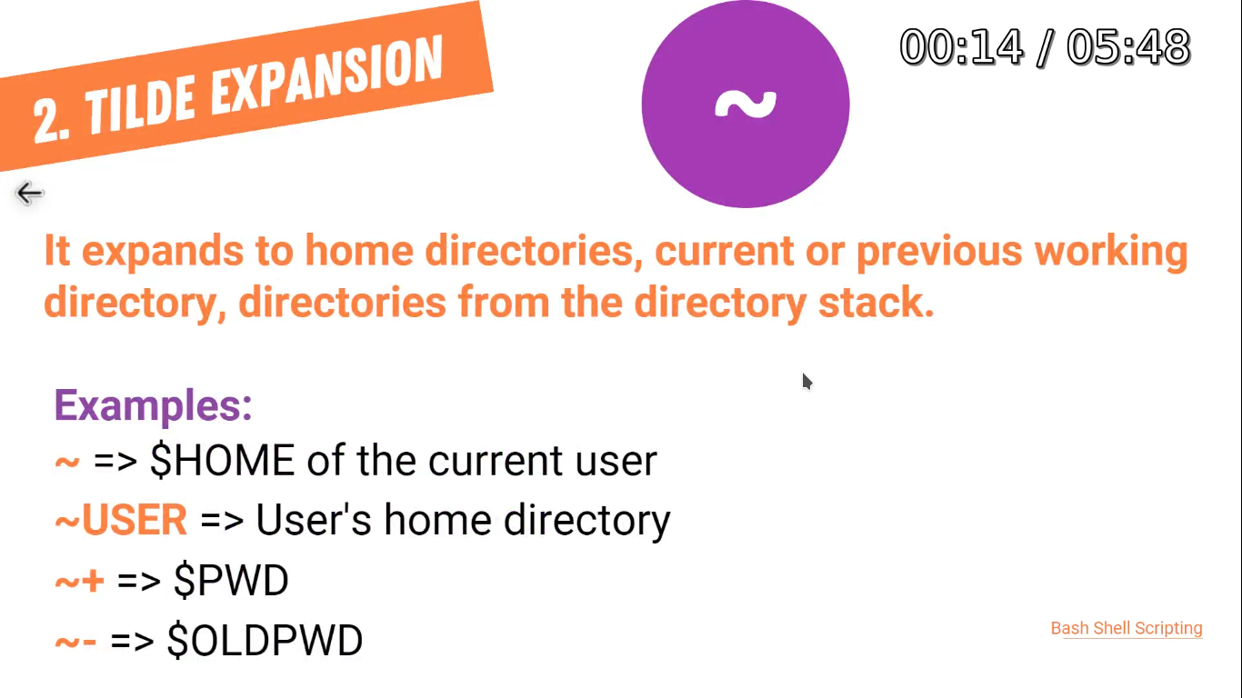

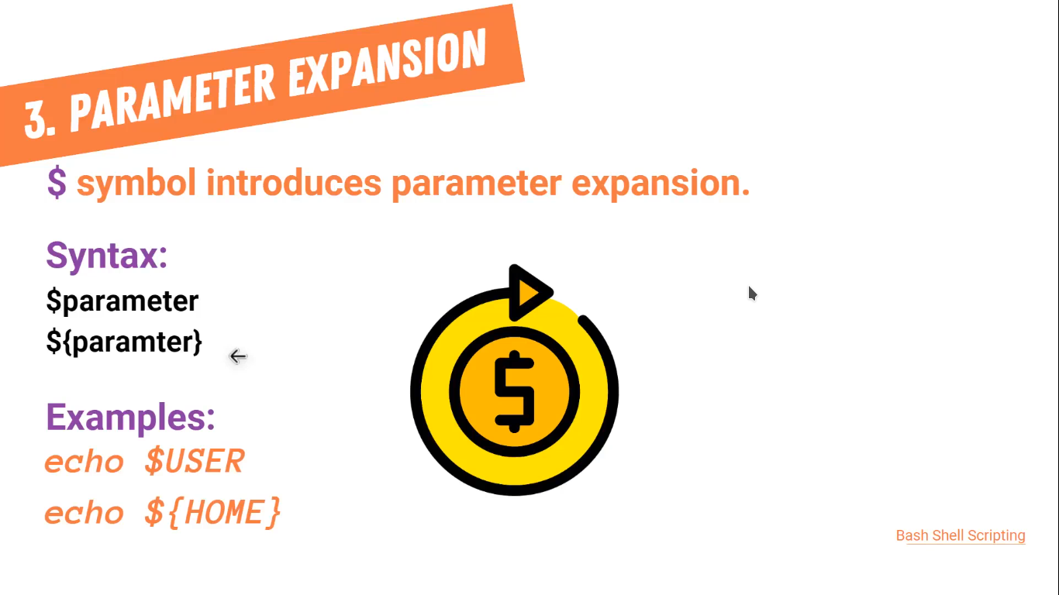

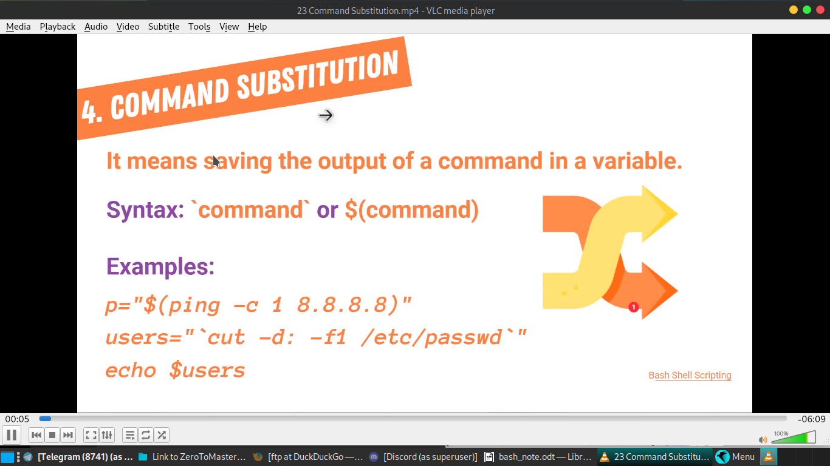
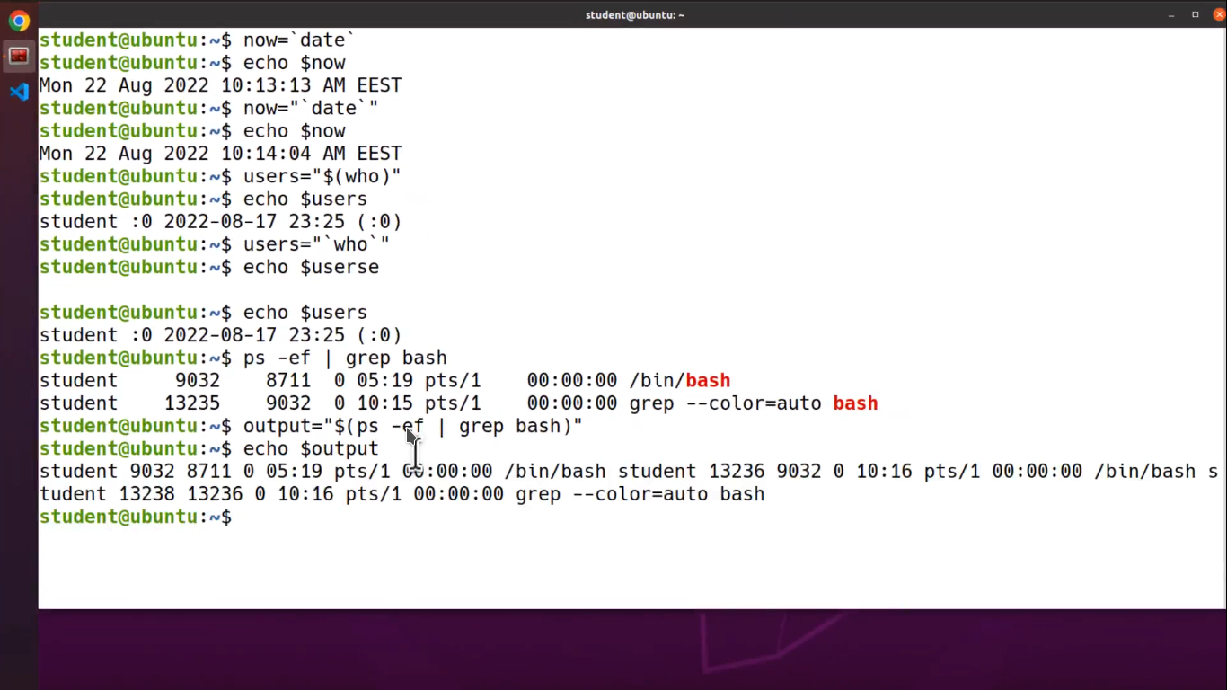
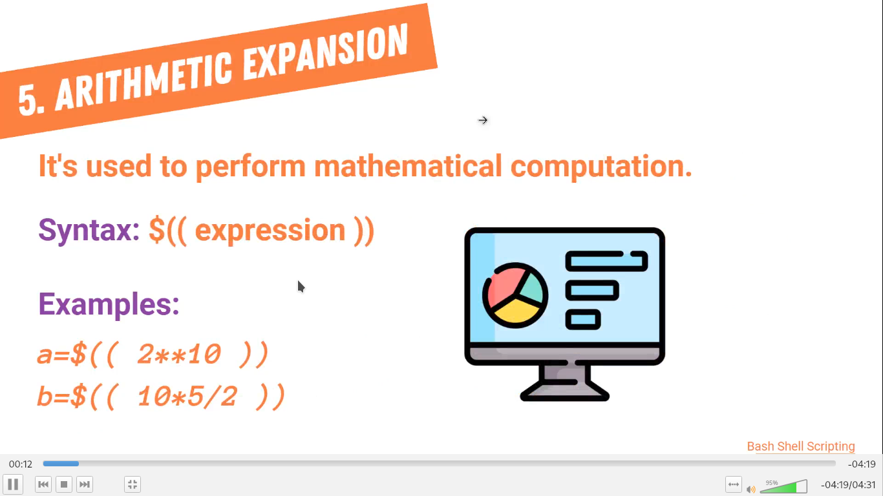

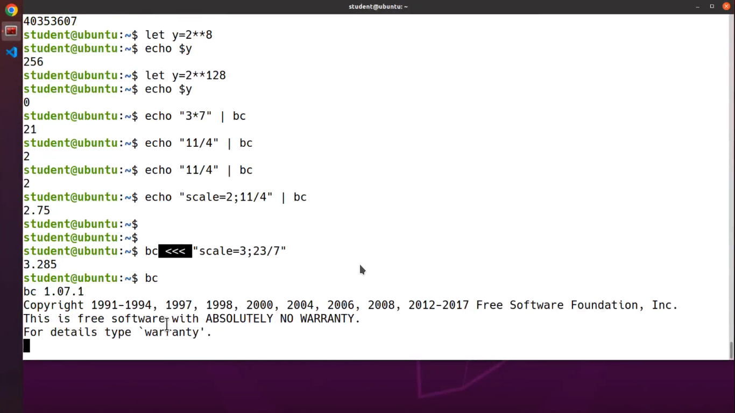

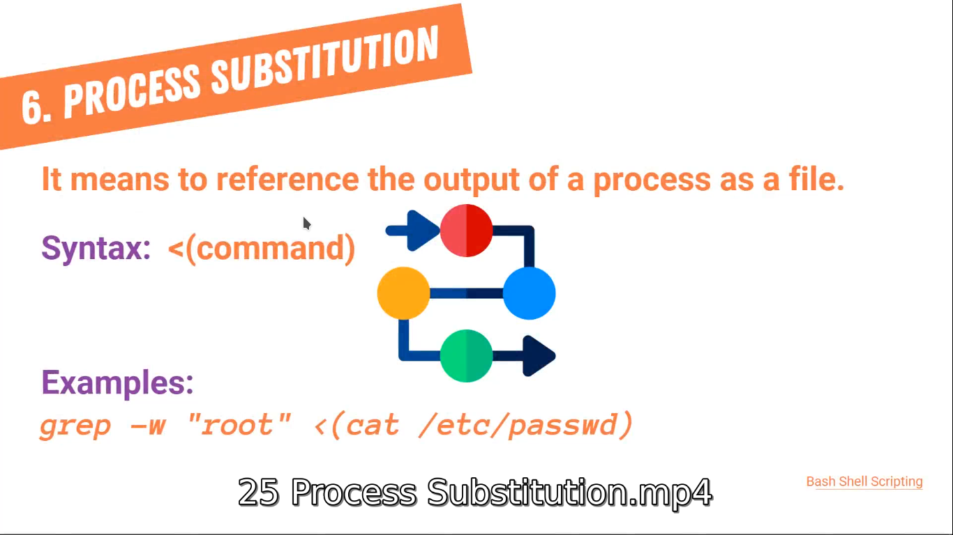

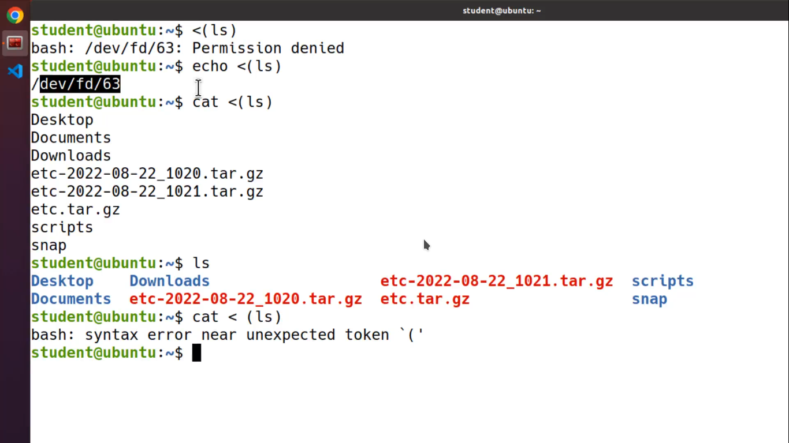
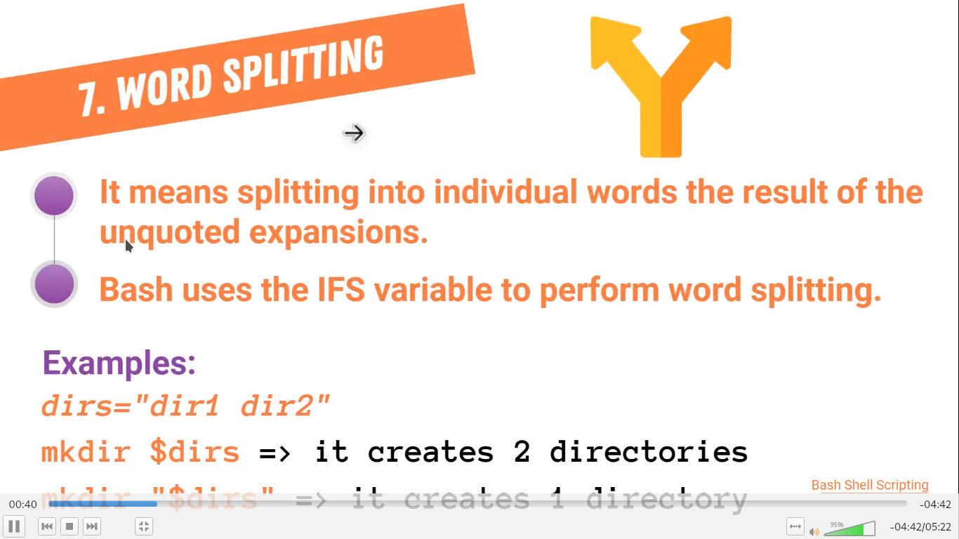
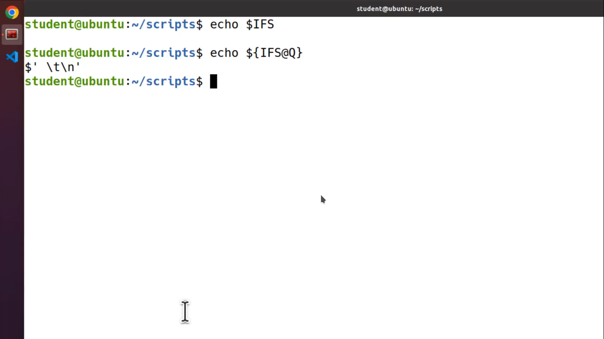
IFS means= internal filed separetor .. it contains space tab and new lines

file expansion:

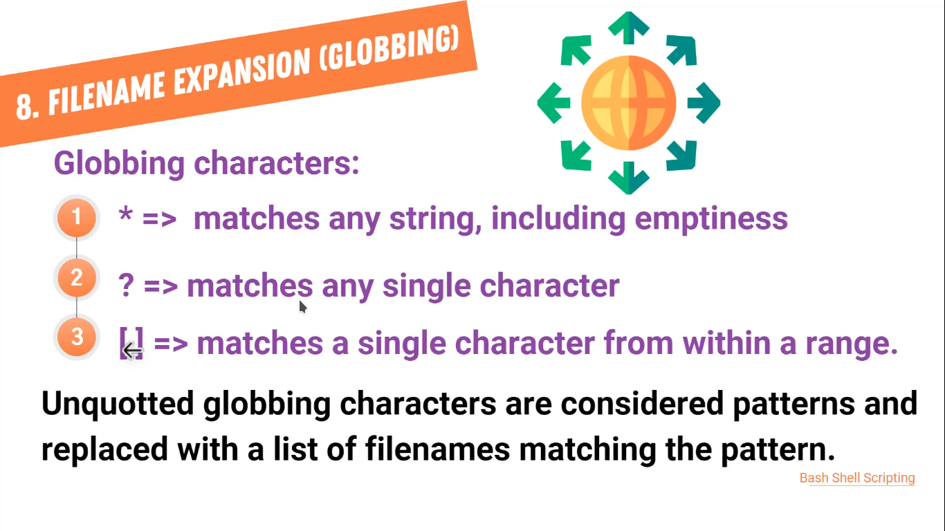
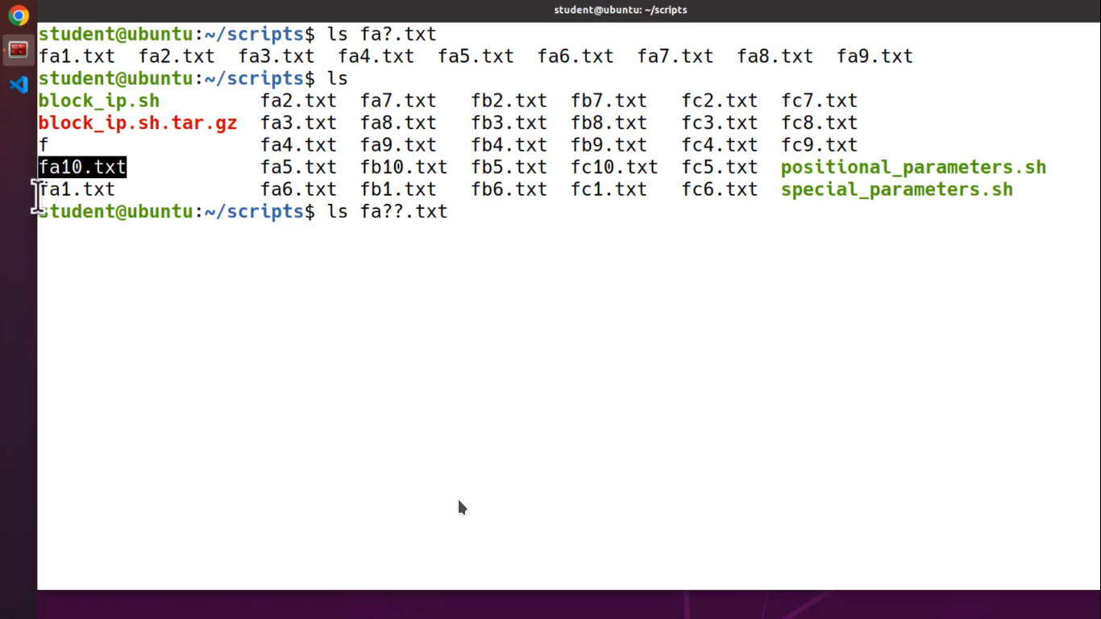

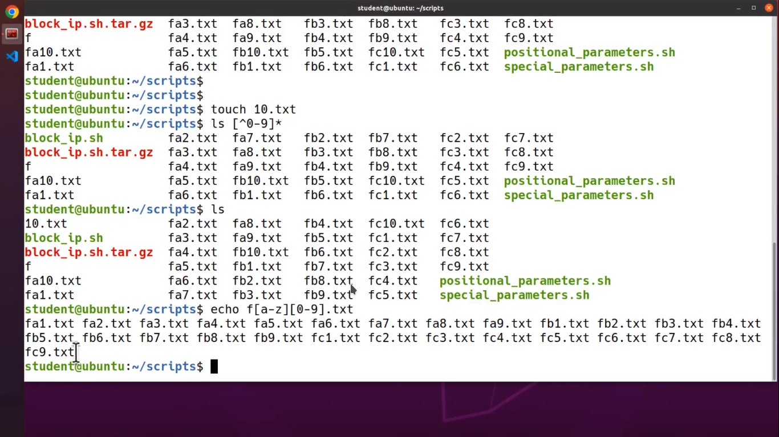
I nee to give extra time to lean pattern make .. best you to practice pattern making using echo .. without distroying anything on pc file …
try this command :

try this on terminal : practice in using internet

------------------------------------------

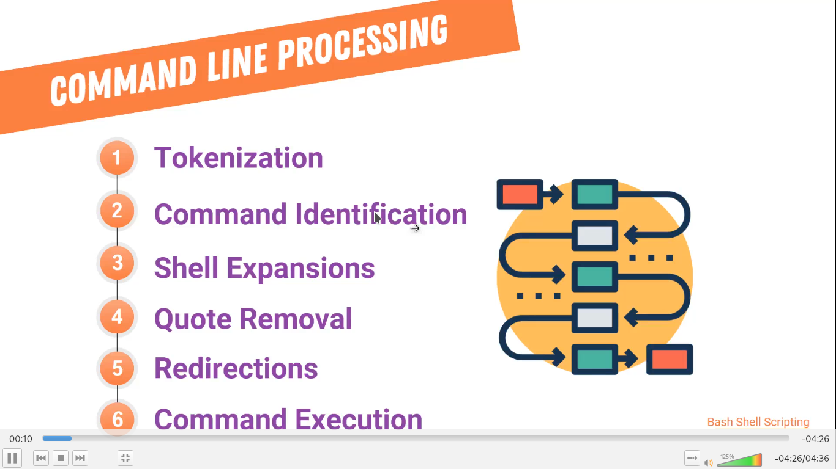

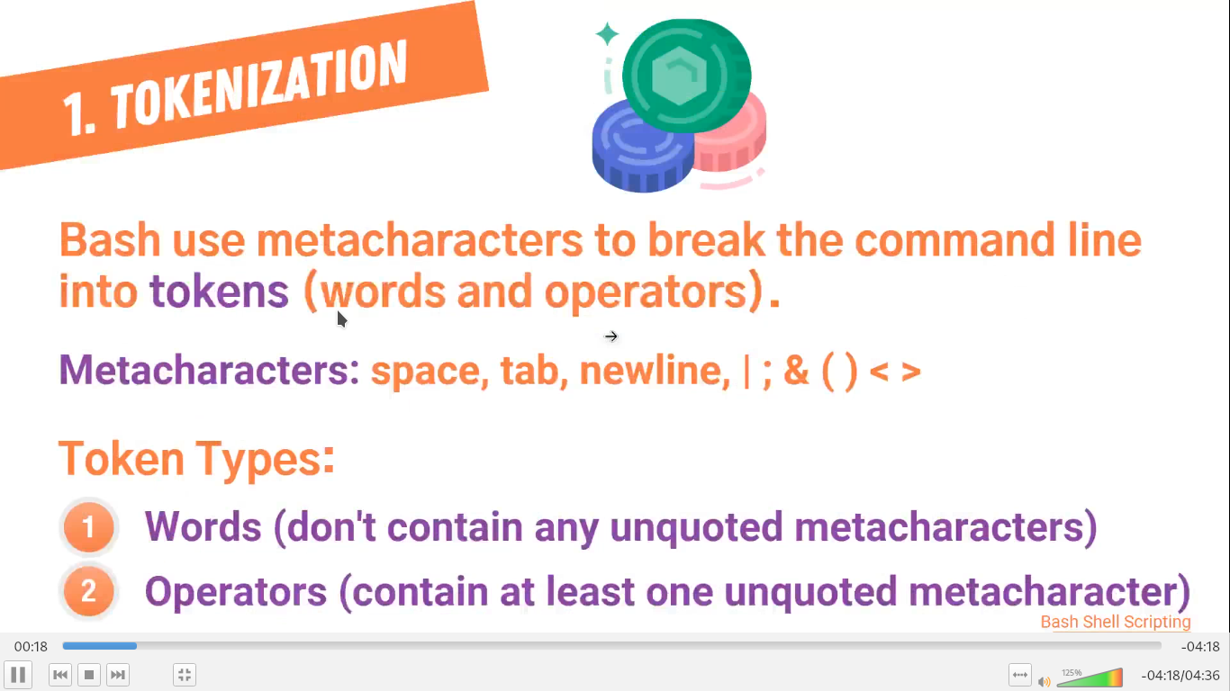

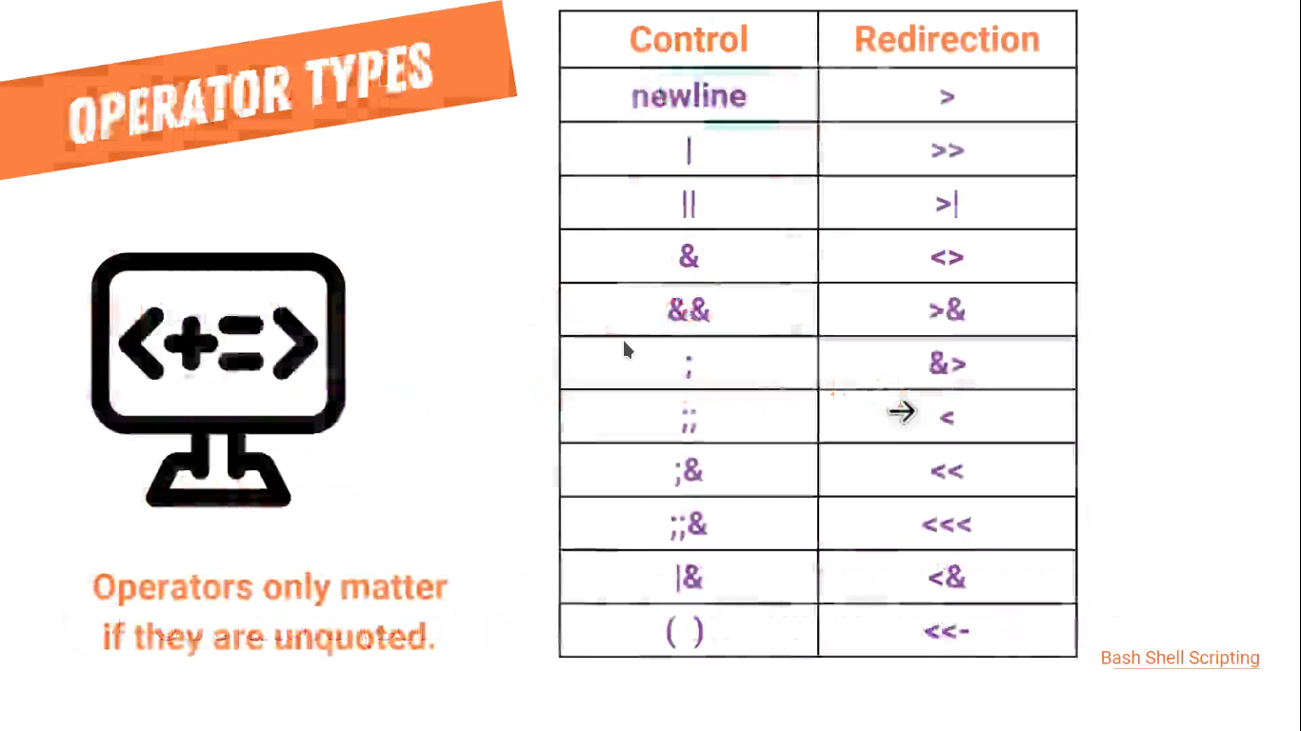
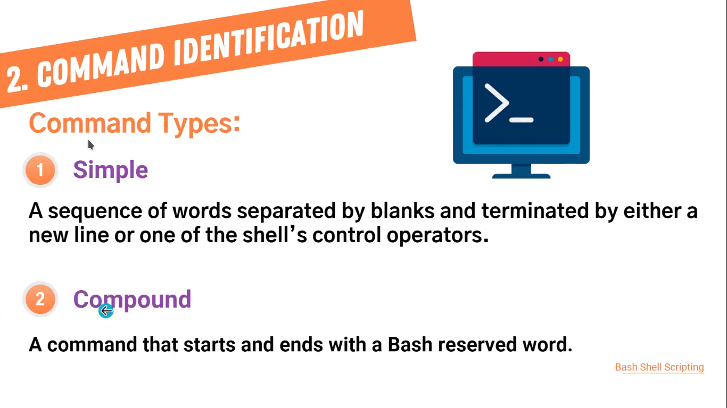

simple commnad are like: ls -a
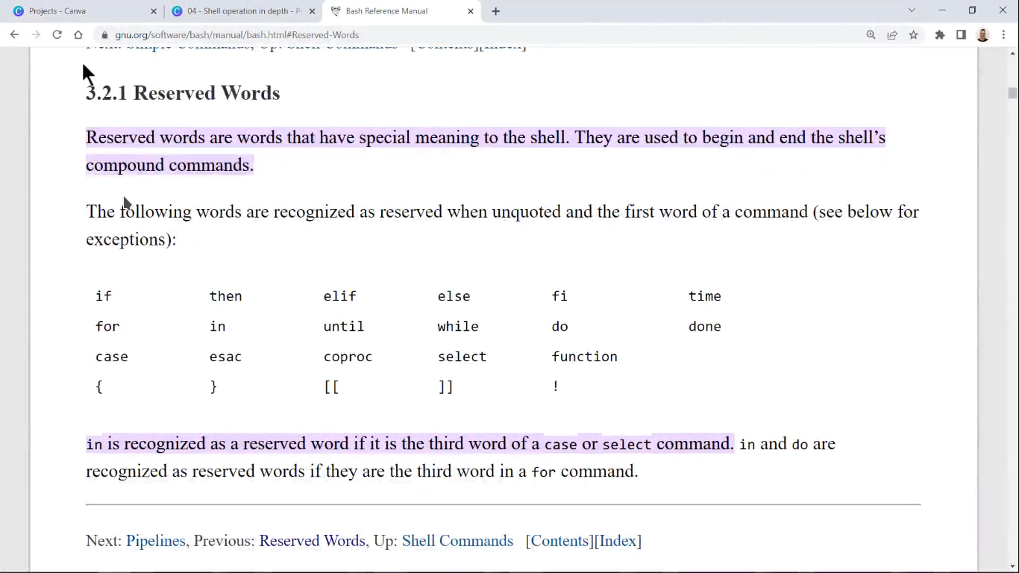

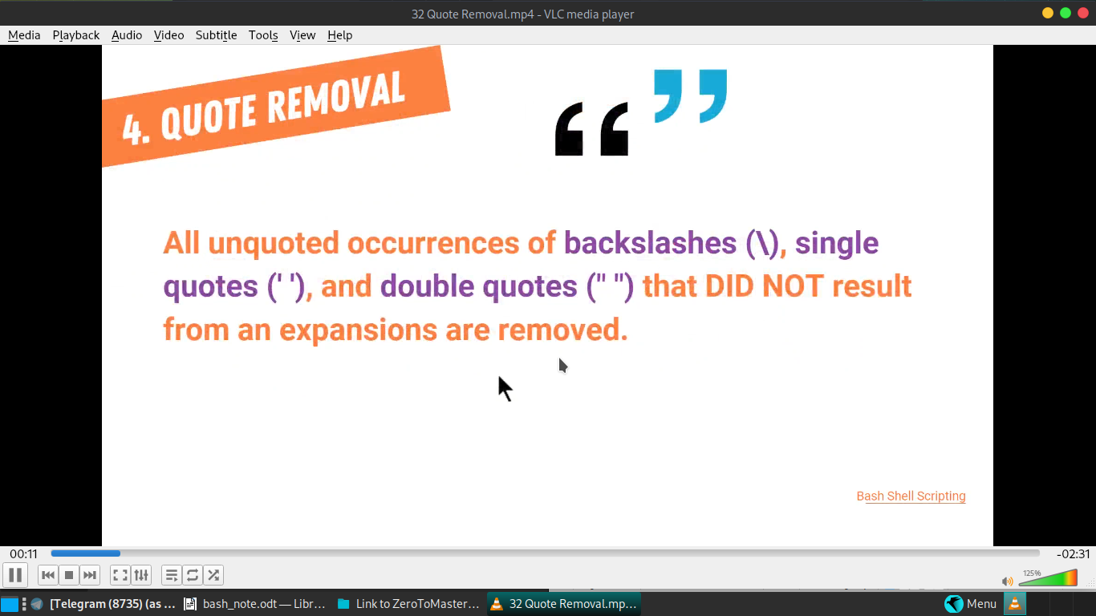

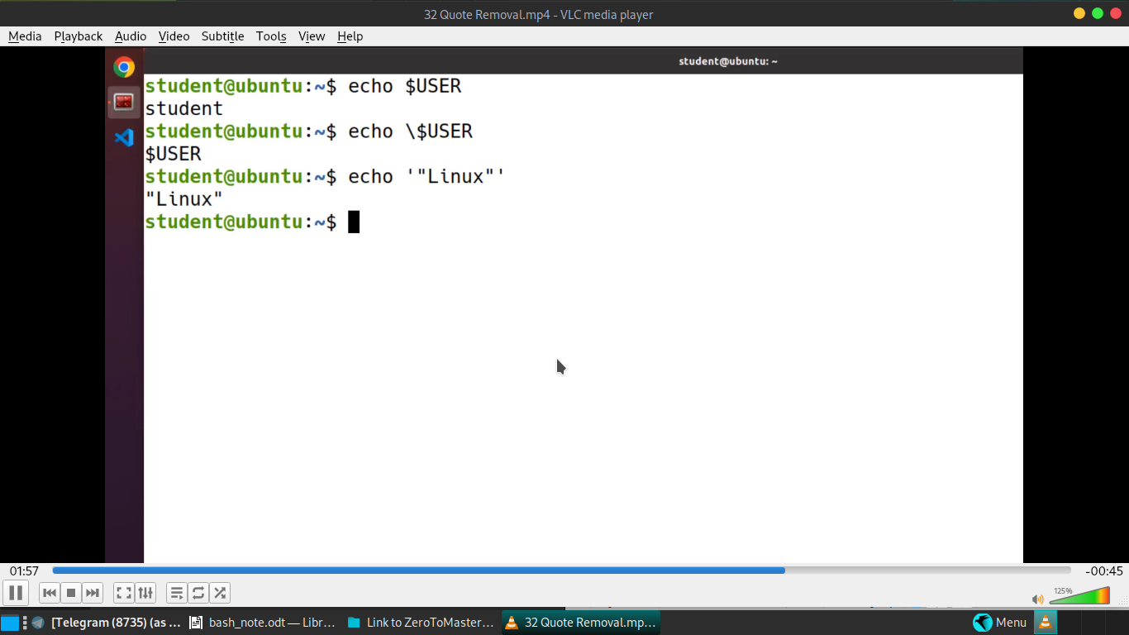

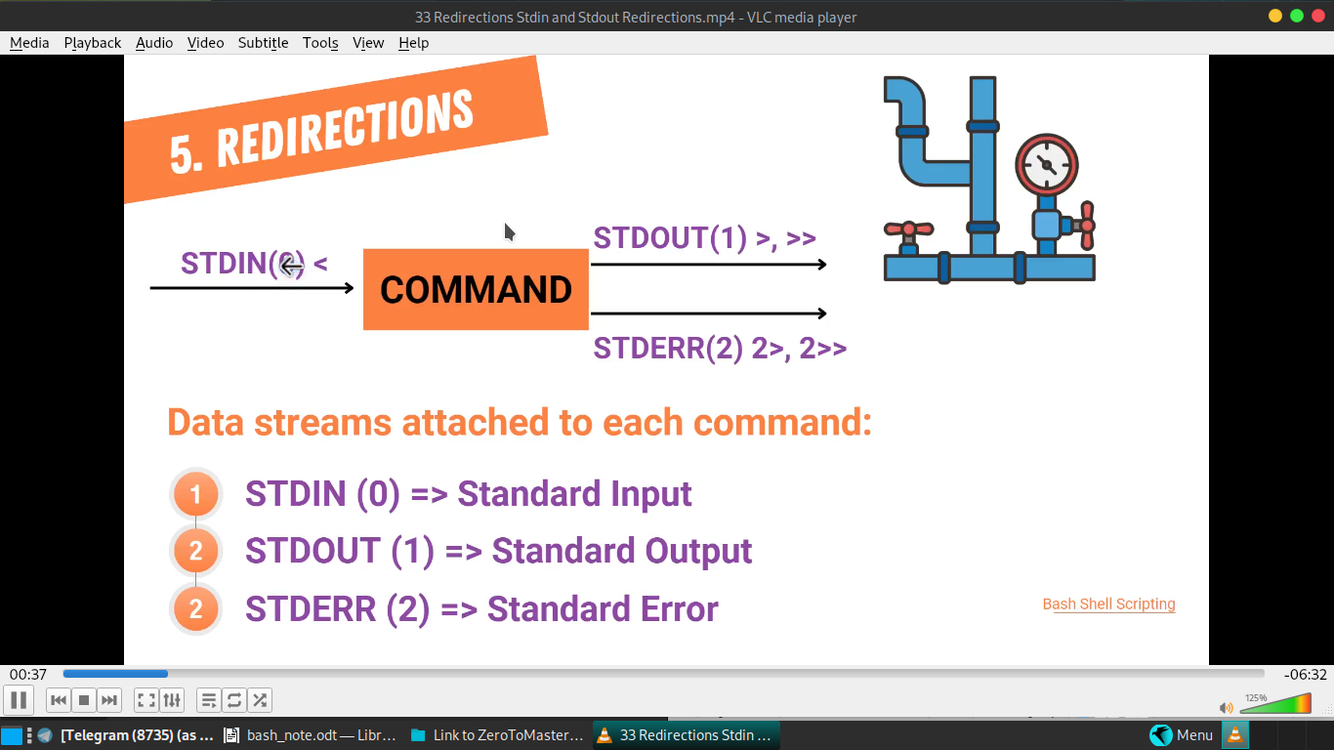

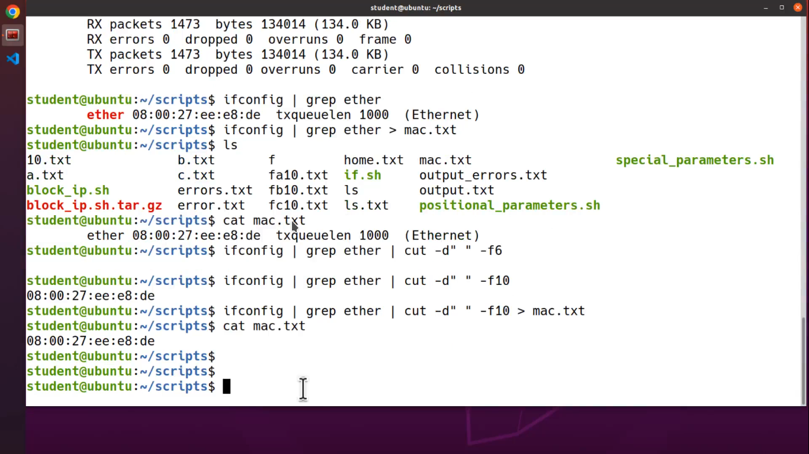
if elif else statement:-
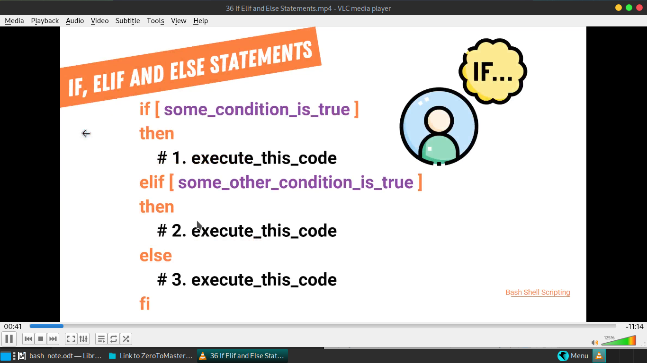
:my code own written code of content checker..
here the code:--
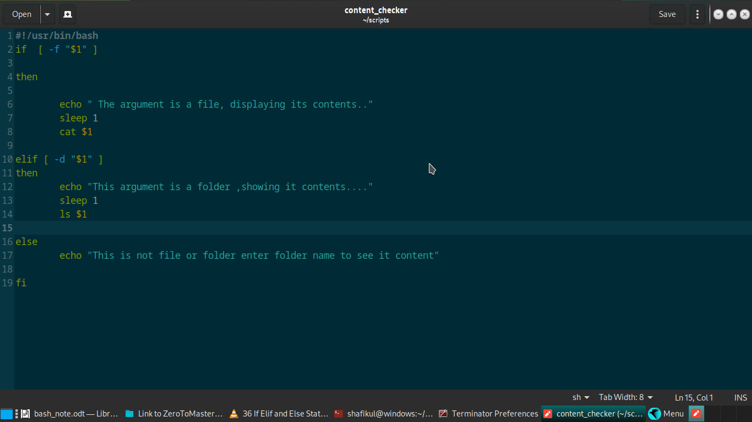

lets learn some keyboard shortcuts of terminator terminal make life a bit easy;
---------------------------------------
to go to net terminal cycle -- ctrl +tab
to go to previous terminal cycle ---- shift + ctrl + tab

quit all terminal process tab ---ctrl +shift +q

create new window in this current directory process –ctrl +shift +I

quit only current runing window –ctrl +shift +w

make new terminal along tab ---shift +ctrl +t
Ctrl+PageDown
Move to next Tab.

Ctrl+PageUp
Move to previous Tab.

roming the terminal window --- alt + keyboard direction keys
zoom in -----ctrl + +
zoom out ----ctrl + -

Ctrl+Shift+O
Split terminals Horizontally.

Ctrl+Shift+E
Split terminals Vertically.

Ctrl+Shift+T
Open new tab.

Ctrl+Shift+I
Open a new window. (Note: Unlike in previous releases, this win‐
dow is part of the same Terminator process.)
arithmetic comparison:-

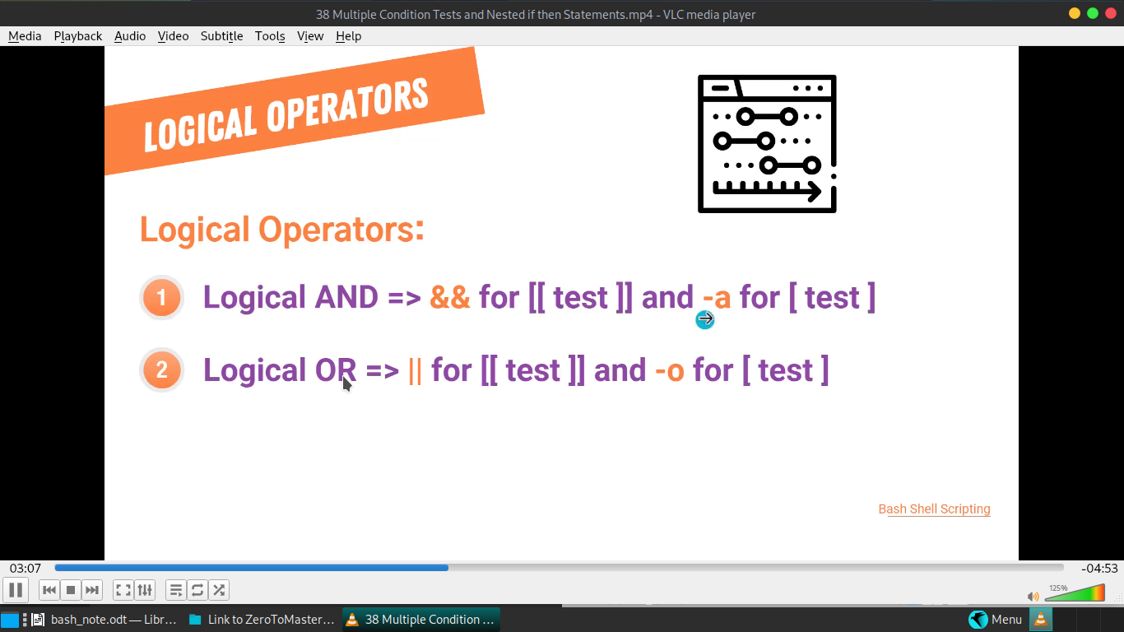
here this project I made: :)
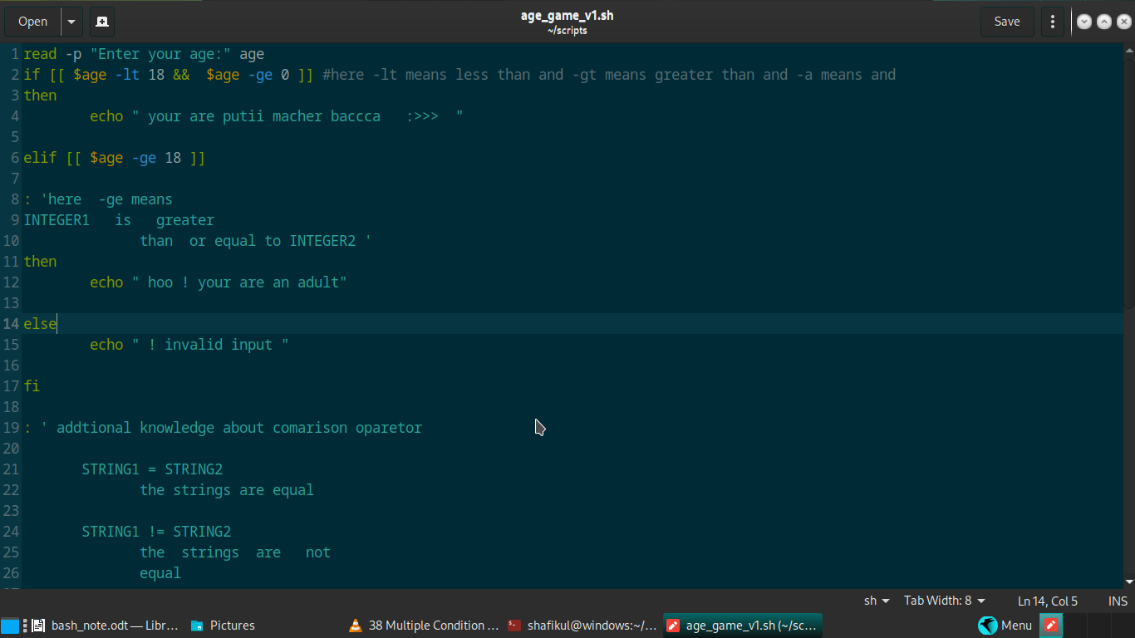
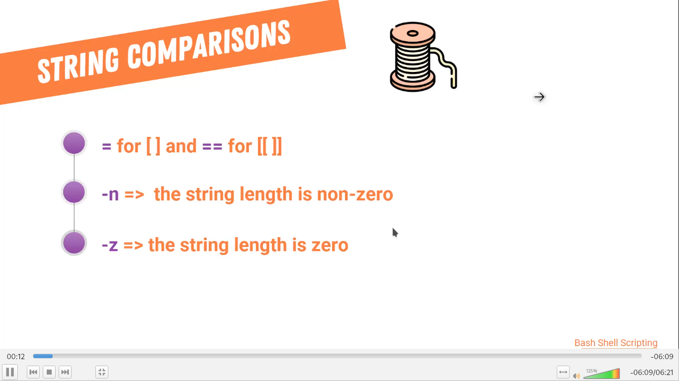

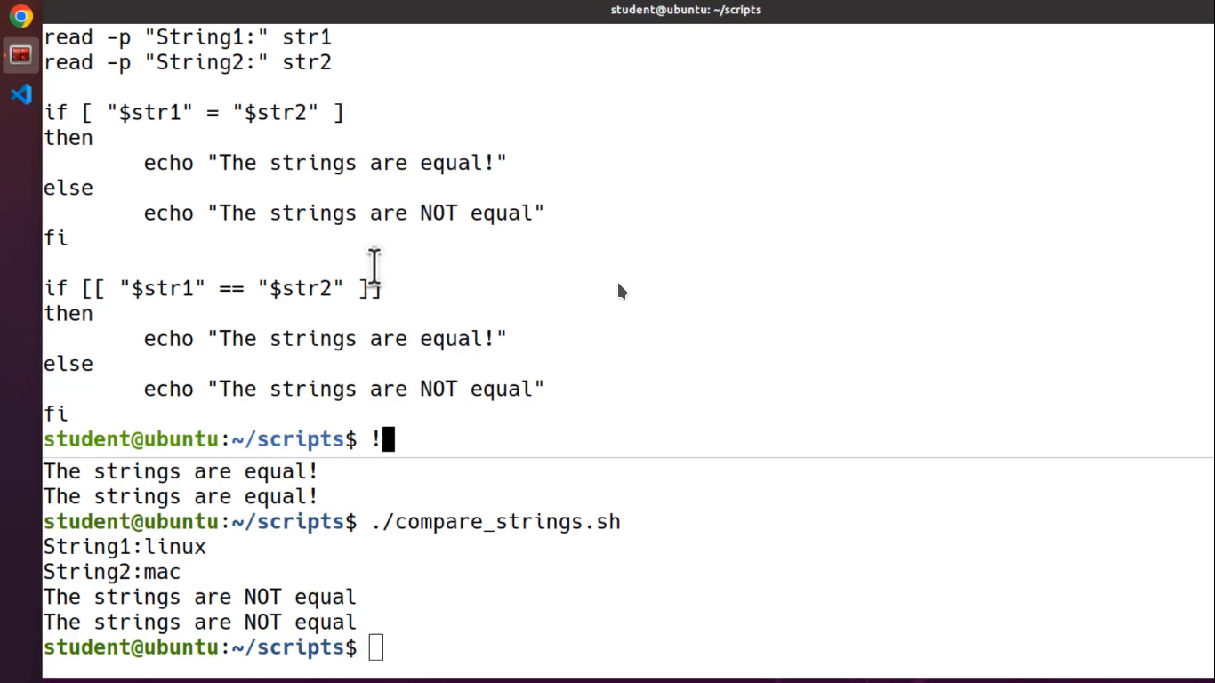

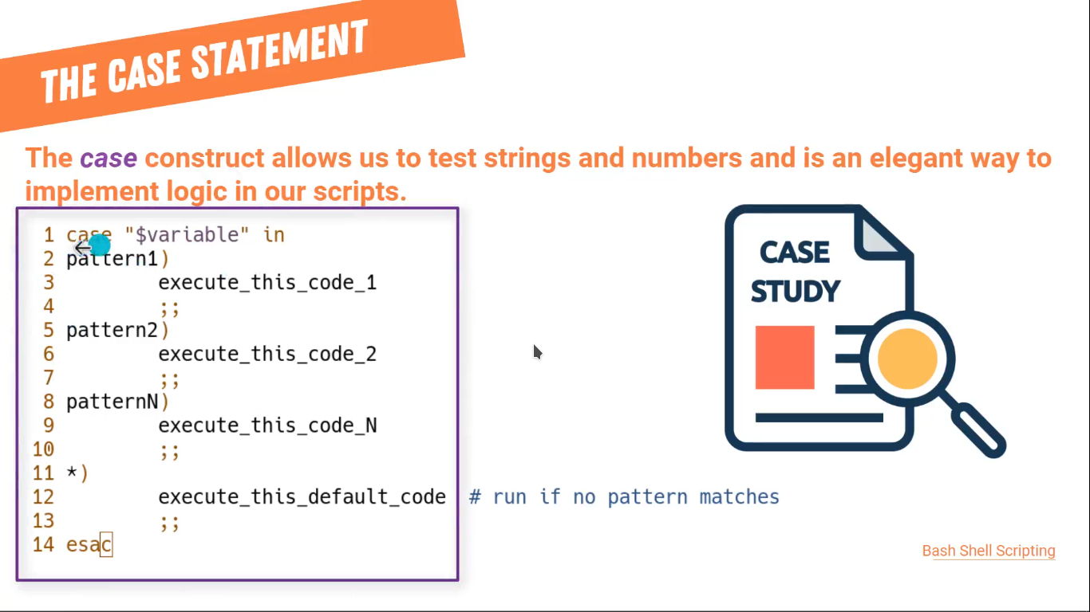

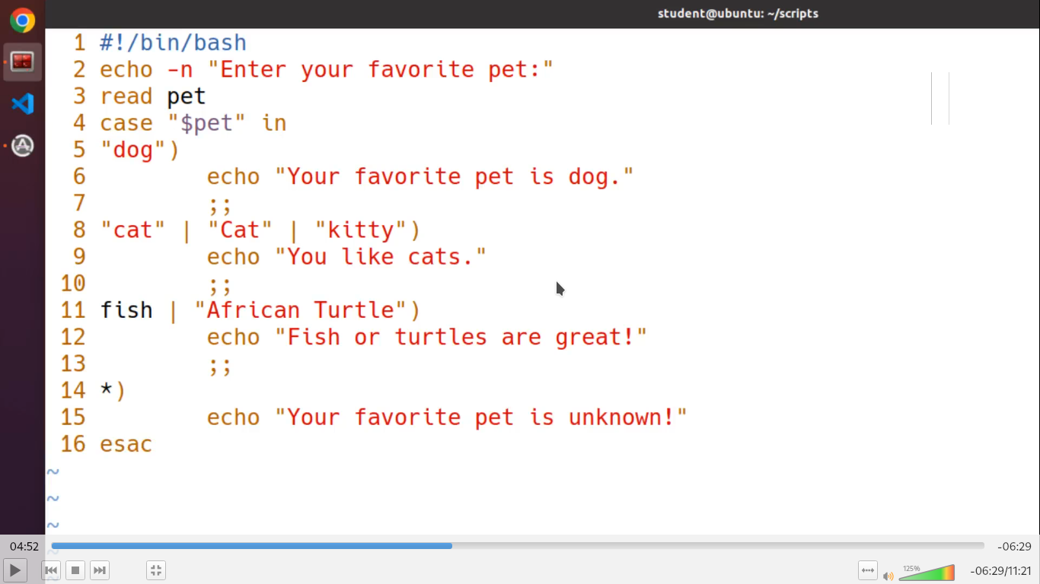
my code:

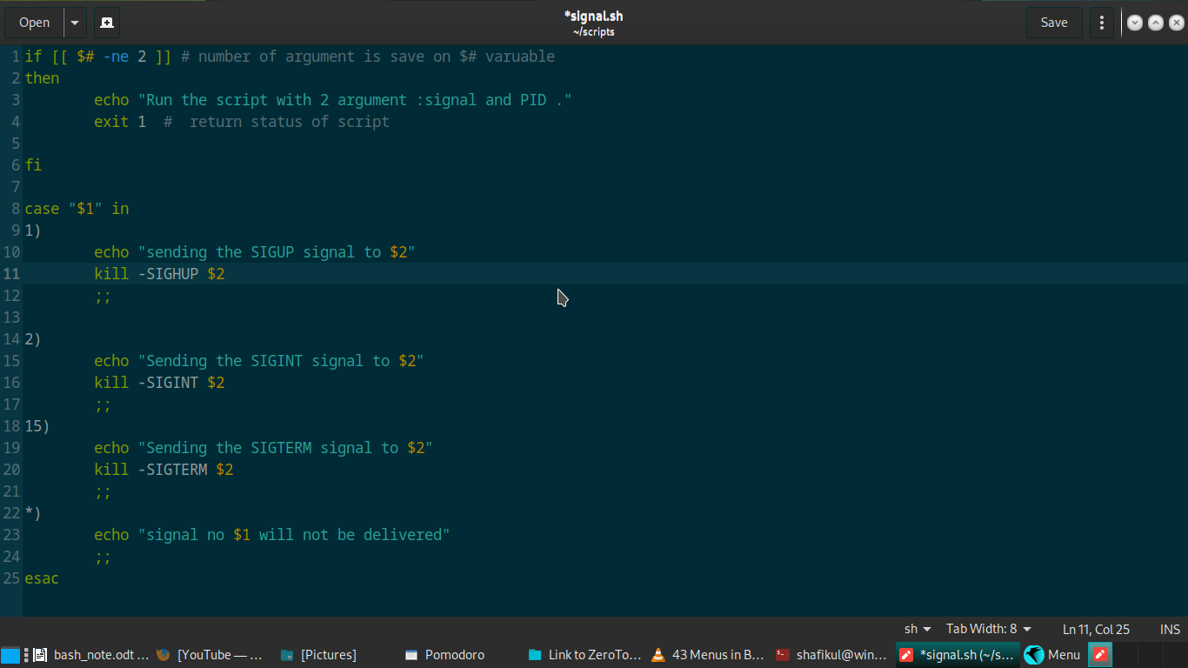

how to make menu in bash ?
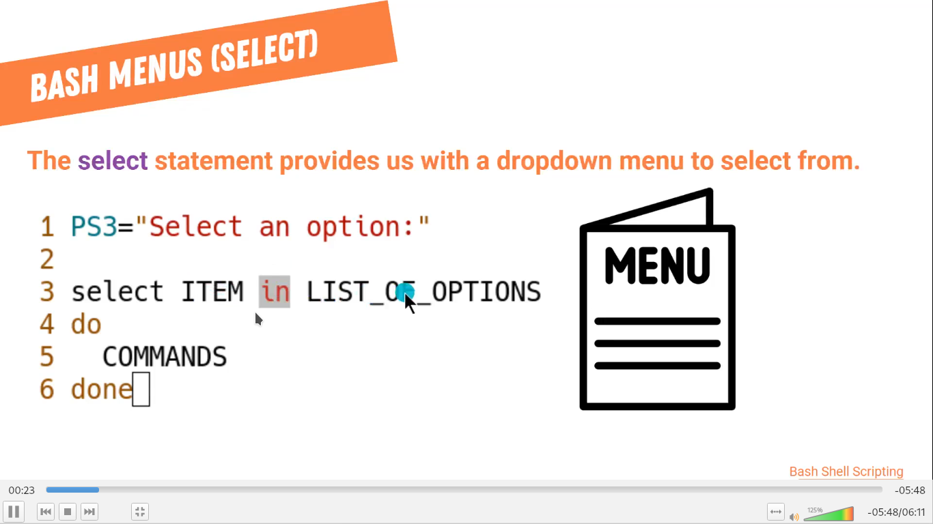
my projects:
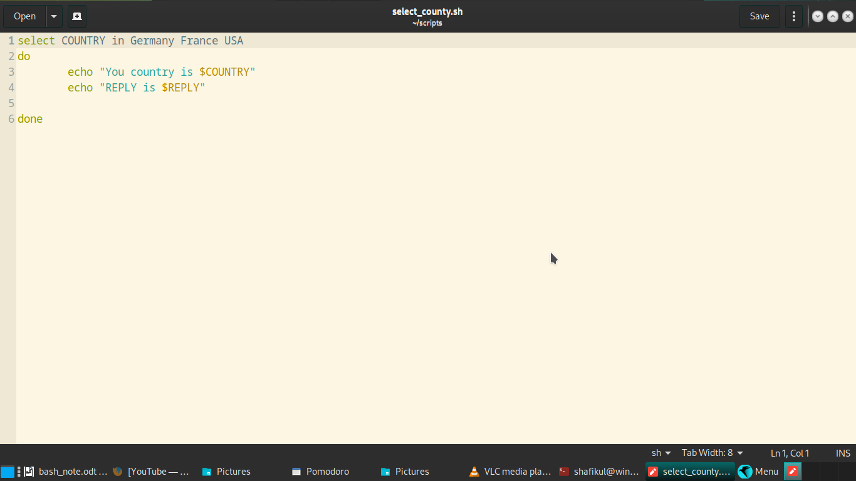

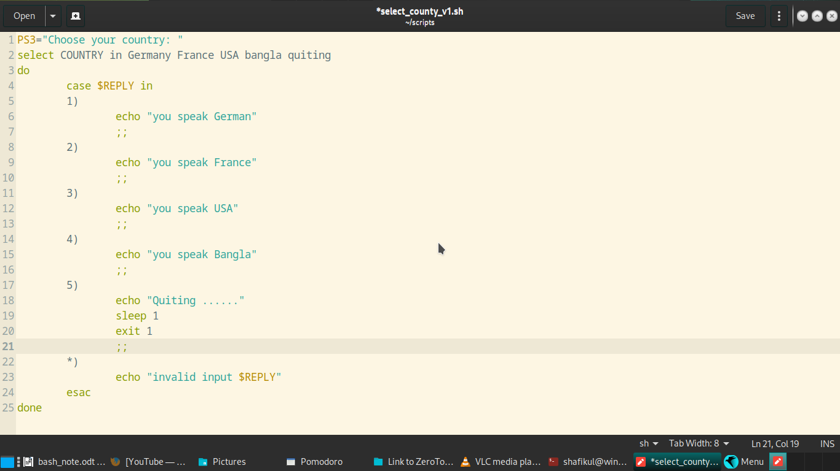
see also my system administration project file to get more understanding



list operators are use for to run multiple command ..

command& -- to run command in back ground …

commnad 1 && command 2 for secuencial command runing

ls ./root || echo “failure command” # it only work when the first commnad fail..

---------------------
fork bomb ..we willl learn it ..

$0 && $0 & #save it on ./bomb.sh but don’t run it on main pc … run on vm..

to prevent your linux pc from fuckup user this command on
file ---

#<domain> <type> <item> <value>

yourusername hard nproc 2000 #adding this line below this :/etc/security/limits.conf

-===== hooo reee --- your are now immune to this allack

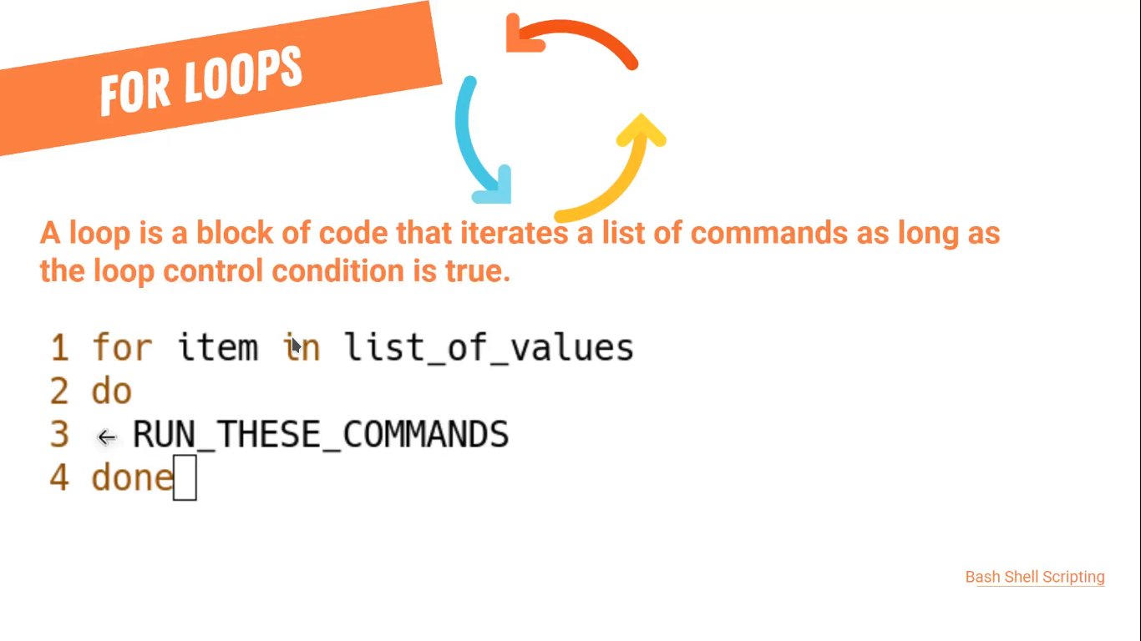

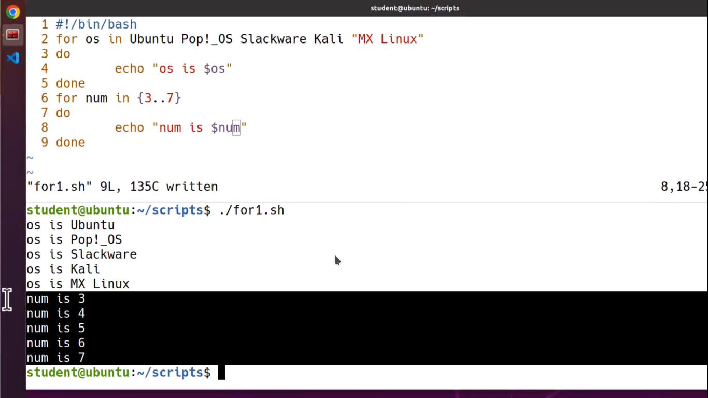

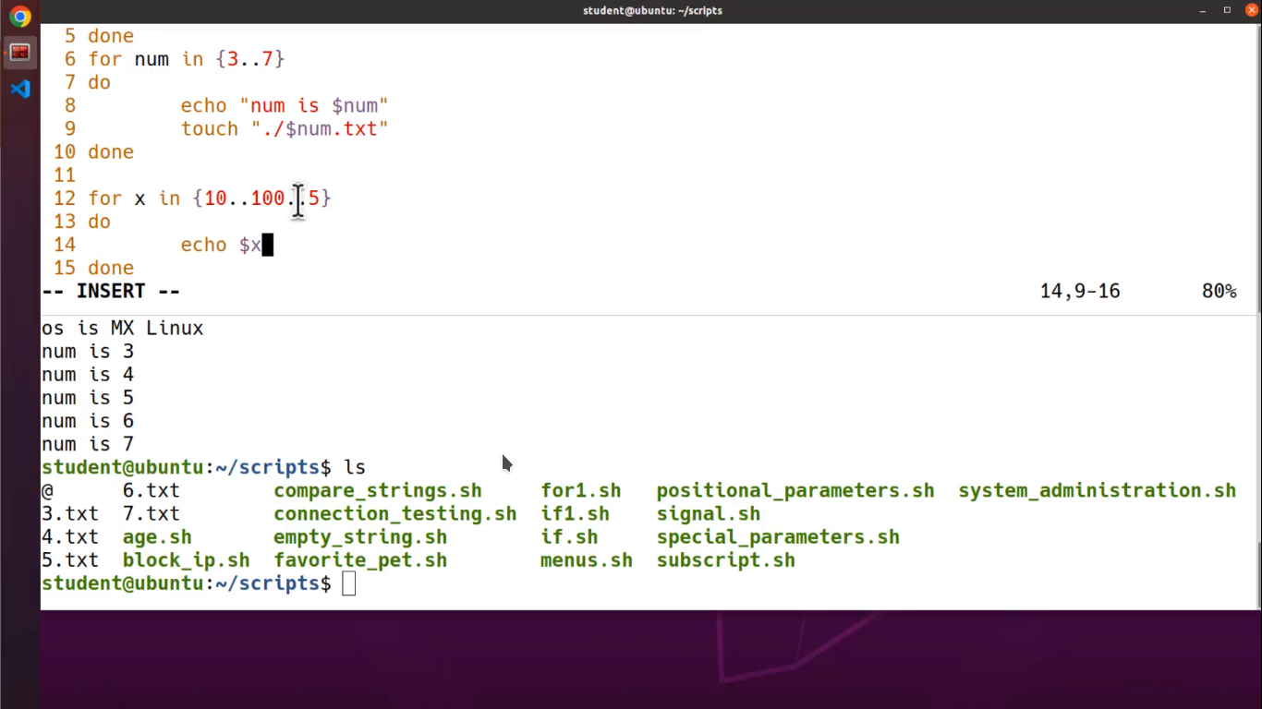

grep command with examples:
Command | Description | Example | Explanation
grep "pattern" file | Search for a simple pattern in a file | grep "hello" file.txt | Searches for the word "hello" in file.txt
grep -i "pattern" file | Case insensitive search | grep -i "hello" file.txt | Searches for "hello" in any case (e.g., Hello, HELLO, hello)
grep -r "pattern" directory | Search recursively in a directory | grep -r "hello" /path/to/directory | Searches for "hello" in all files within /path/to/directory and its subdirectories
grep -n "pattern" file | Show line numbers with matches | grep -n "hello" file.txt | Displays matching lines with line numbers in file.txt
grep -o "pattern" file | Show only matching part of lines | grep -o "hello" file.txt | Shows only the word "hello" for each match in file.txt
grep -c "pattern" file | Count number of matches | grep -c "hello" file.txt | Counts occurrences of "hello" in file.txt
grep -v "pattern" file | Invert match (show non-matching lines) | grep -v "hello" file.txt | Shows lines that do not contain "hello" in file.txt
grep "^pattern" file | Match lines that start with pattern | grep "^hello" file.txt | Finds lines starting with "hello" in file.txt
grep "pattern$" file | Match lines that end with pattern | grep "hello$" file.txt | Finds lines ending with "hello" in file.txt
grep "p.ttern" file | Match lines with any single character in place of dot | grep "h.llo" file.txt | Matches "hello", "hallo", etc., in file.txt
`grep -E "pattern1 | pattern2" file` | Match either pattern1 or pattern2 (extended regex) | `grep -E "hello
grep "pa*tern" file | Match lines with zero or more of the preceding element | grep "he*llo" file.txt | Matches "hllo", "hello", "heello", etc., in file.txt

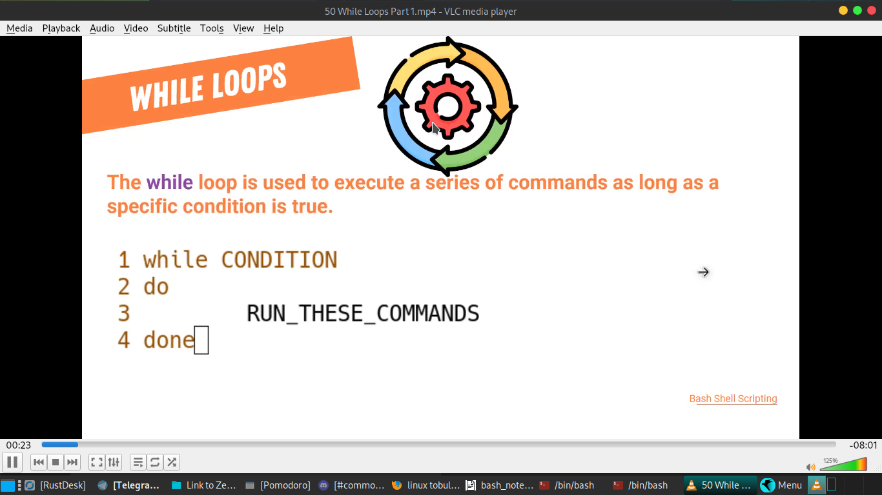

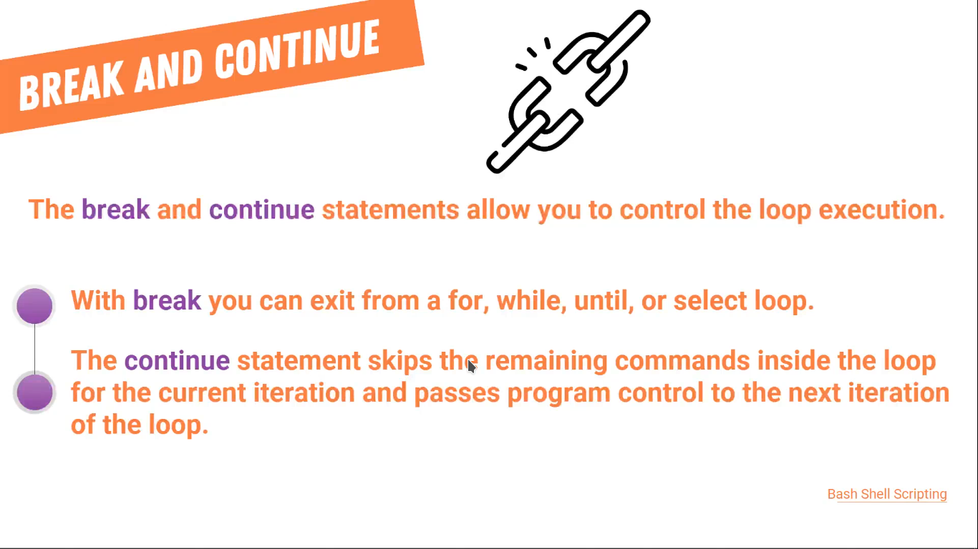

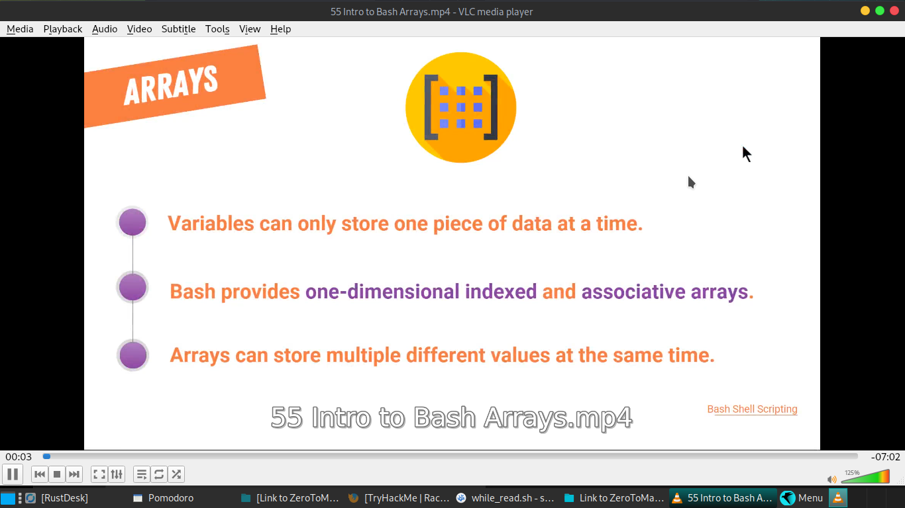
Here is a table summarizing the basic operations for working with arrays in Bash:
Operation | Syntax | Example | Explanation
Define Array | array_name=(element1 element2 element3 ...) | fruits=("apple" "banana" "cherry") | Creates an array named fruits with three elements.
Access Element | ${array_name[index]} | echo ${fruits[0]} | Prints the first element of the fruits array.
Add Element | array_name+=(new_element) | fruits+=("date") | Adds "date" to the end of the fruits array.
Remove Element | unset array_name[index] | unset fruits[1] | Removes the element at index 1 of the fruits array.
Loop Through Elements | for element in "${array_name[@]}"; do ... done | for fruit in "${fruits[@]}"; do echo $fruit; done | Loops through each element in the fruits array.
Get Array Length | ${#array_name[@]} | echo ${#fruits[@]} | Prints the number of elements in the fruits array.
Access All Elements | ${array_name[@]}  ${array_name[*]} | echo ${fruits[@]} | Prints all elements in the fruits array.

Declare -a newarray #declare new array
newarrya[0]=”tanbir”
]
# Print the indices of the array echo ${!Ages[@]} # Output: 0 1 2 3

------
array in depth:
years =(2018 2019 2020 2021 2022)
years+=(2023) #adding array
years+=(2024 2025 2026)

echo ${years[@]:2} # it will stating at 2 index rather than 0 index

#echo ${years[@]:starting point:how many numbers}
echo ${years[@]:2:5} #it will start at 2 index number and show only 5 numbers

associative array like dictonay in other programing language…
declare -A userdata #to make accociative array
userdata[username]=”youradmin”
userdata[password]=”fdas”
userdata[uid]=100
echo ${userdata[@]} # is will show value
echo ${!userdata[@]} #showing key value
userdata+=([shell]=”Bash” [admin]=”false”) #adding multiple

#we learn read-only array which can’t change:
$declare -r -A heros=([superman]="strongest" [england]="the beatels") # making read only array

readarray command ---- read anthing and make it in array
readarray months< <(cat months.txt)
echo ${months[@]}
echo ${months[@]@Q} # SEE if there is any new trailing line here (\n)
readarray -t months< <(cat months.txt) # -t will remove new trailing line (\n)

collecting all the list of the user:
readarray users< <(cut -d: -f1 /etc/passwd) #we will learn more details when we get back here

readarray -t files< <(ls /etc) # it will redirect all the etc file name in this files name array

