- Experiment Name: Design and implementation of a network using Switch and Router.
- Introduction:

In this experiment, our objective is to create and simulate simple computer networks using Cisco Packet Tracer. The purpose is to show how multiple end devices can be interconnected and exchange data in two distinct configurations — one that uses a switch and another that involves a router. By performing this experiment, we can understand how switches and routers function in data transfer and how proper IP addressing makes communication between devices possible.

- Objectives:
- Creating a network between two PCs and a switch with transferring message.
- Creating a network between two PCs and a router and successfully transfer message.

- Tools Required:
- A laptop or desktop.
- Cisco Packet Tracer (8.2.2 Windows 64bit).

- Simulation:
  - Network using switch

Step 1: Set two PCs and a switch.
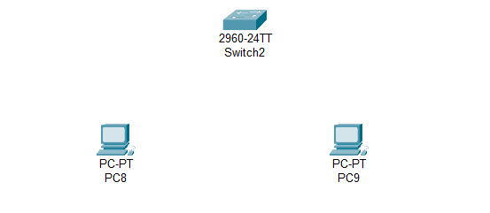

` Figure 2.1: Set PCs and switch.

- Experiment Name: Design and implementation of a network using router.
- Introduction:
In this experiment, our objective is to create and simulate simple computer networks using Cisco Packet Tracer. The purpose is to show how multiple end devices can be interconnected and exchange data in configurations that uses a router. By performing this experiment, we can understand how routers function in data transfer and how proper IP addressing makes communication between devices possible.

- Objective:
- Creating a network between two PCs and a router and successfully transfer message.

- Tools Required:
- A laptop or desktop.
- Cisco Packet Tracer (8.2.2 Windows 64bit).

- Simulation:
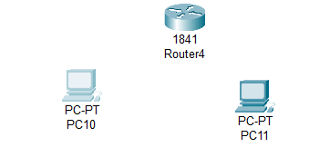
Step 1: Set two PCs and a router
Figure 3.1: Set PCs and router

Step 2: Connecting PCs with router via copper cross over.
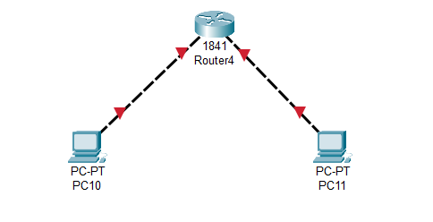 Figure 3.2: Set PCs and router.

Step 7: Status of transferring message from PC10 to PC11.
Figure 3.7: Status of transferring message.

- Description:
In the network using router, PCs have been connected properly. Message has been successfully transferred after giving proper IPv4 address (10.0.1.1 and 10.0.2.1) to PCs and default gateway.

- Discussion and Conclusion:
In this experiment, we have successfully implemented the design of network between two PCs using router. Router can connect end devices in different network. From this simulation, we obtained hands-on knowledge of the roles of routers in transferring data, the significance of IP addressing, and the way different network components work together to establish communication.

