- Experiment name: VLAN Basic Configuration Using CLI.

- Introduction: In this experiment, we connect four PCs to a switch and configure them so that two PCs can communicate with each other but cannot communicate with the other two PCs, and vice versa.

- Objectives:
- To understand the concept and purpose of Virtual Local Area Networks (VLANs).
- To configure and verify VLANs and ensure proper communication between devices within the same VLAN.

- Tools Required:
- A laptop or desktop.
- Cisco packet tracer.

- Simulation:
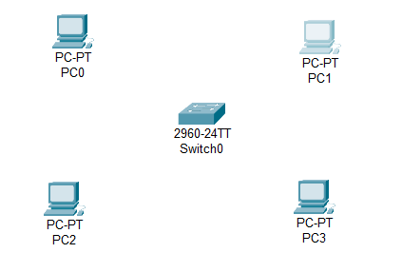
Step 1: Set 4 PCs and one switch.
Figure 10.1: Set all PCs and switch.

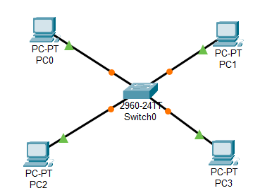
Step 2: Connect the PCs with Switch0 via copper straight through.
Figure 10.2: Connect PCs with switch.

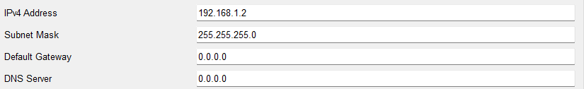
Step 3: Set all the PCs IP address.
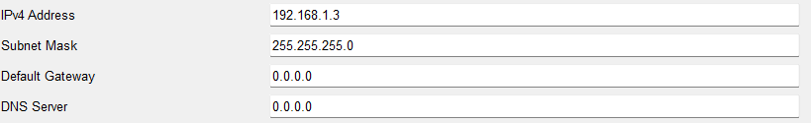
Figure 10.3: Set IP for PC0.
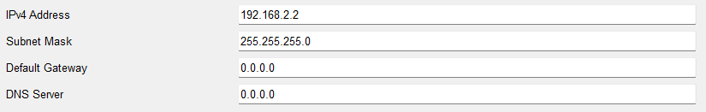
Figure 10.4: Set IP for PC1.
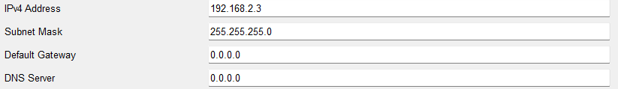
Figure 10.5: Set IP for PC2.
Figure 10.6: Set IP for PC3.

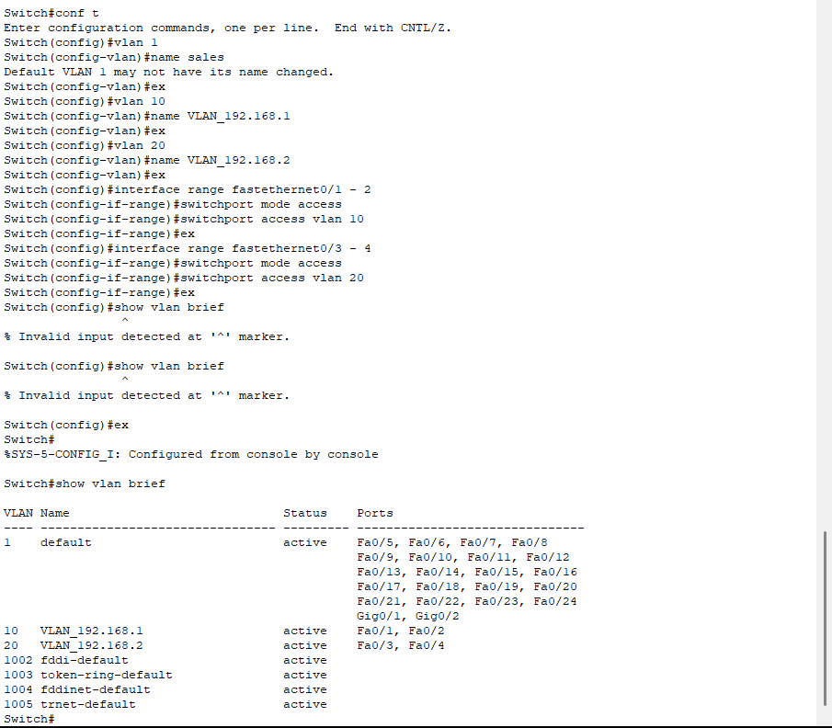
Step 4: Configure VLAN for Switch0 and show VLAN brief.
Figure 10.7: Configure VLAN for switch0 and showing VLAN brief.

Step 5: Packet passing status.
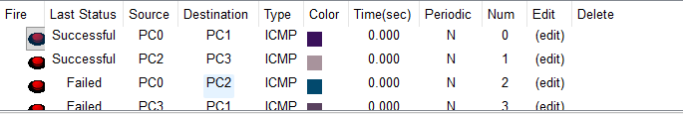
Figure 10.8: Packet passing status.

- Conclusion: In conclusion, the experiment showed that VLANs work as expected. Devices in the same VLAN, like PC0 and PC1 and PC2 and PC3, could communicate without any problem, while devices in different VLANs could not communicate with each other. This proves that the VLAN setup successfully separated the network traffic.

