- Experiment Name: Configuring and Passing Packets/Messages for OSPF Protocol to Establish Communication between Different Networks.

- Introduction: In this experiment, three routers will be configured, where two routers will connect multiple PCs. The goal is to interconnect the networks so that PCs can communicate with each other. After completing the configuration, messages should be successfully transferred between PCs across different networks using the shortest path, ensured by the OSPF routing protocol.

- Objectives:
- To implement routing with OSPF.
- Ensure successful communication between different networks.

- Tools:
- A laptop or desktop.
- CISCO packet tracer 9.0.0.

- Simulation:
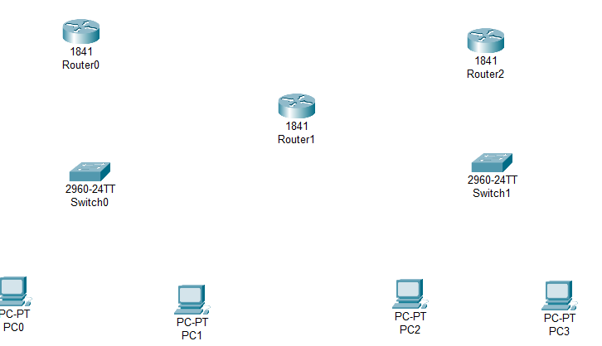
Step 1: Set 4 PCs, 2 switches and 3 routers.
Figure 8.1: Set all PCs, switches and routers.

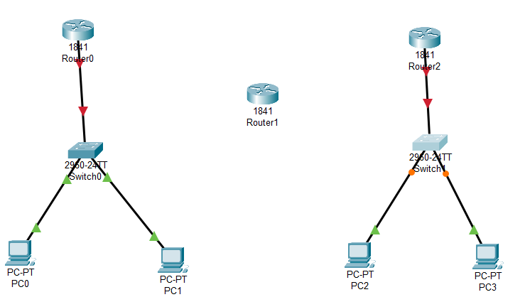
Step 2: Connect the PCs with corresponding switches via copper straight through, and all switches with corresponding routers via copper straight.
Figure 8.2: Connect all PCs with switches and two routers with corresponding switches.

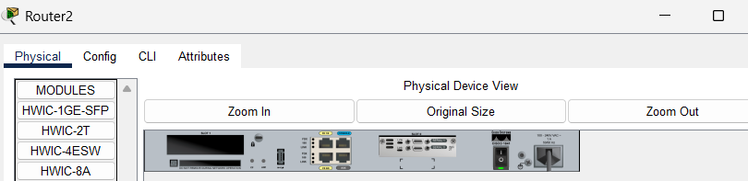
Step 3: For every router turn off the router, add WIC-2T and restart the router.
Figure 8.3: Add WIC-2T to router2.

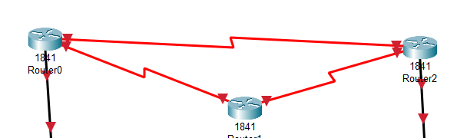
Step 4: Connect a serial DTE cable between Router0 (Serial0/0/0) and Router1 (Serial0/0/0). Next, connect another serial DTE cable between Router1 (Serial0/0/1) and Router2 (Serial0/0/0). Finally, connect a third serial DTE cable between Router0 (Serial0/0/1) and Router2 (Serial0/0/1).
Figure 8.4: Connecting routers via serial dte.
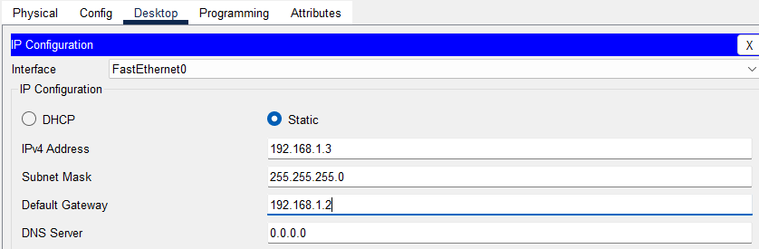
Step 5: Configure all the PCs with IP address and default gateway.
Figure 8.5: Configure IP address and default gateway.

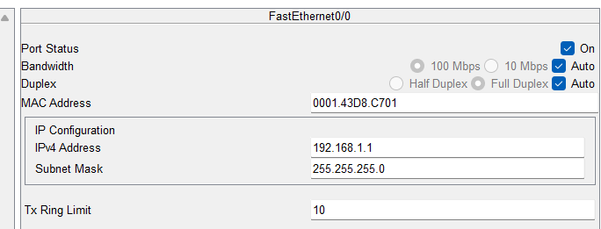
Step 6: Configure Router0’s FastEthernet0/0, Serial0/0/0 and Serial0/0/1.
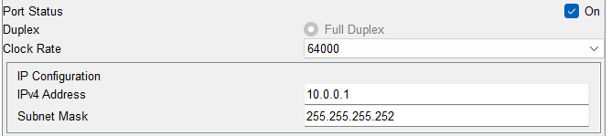
Figure 8.6: Configure Router0’s FastEthernet0/0.
Figure 8.7: Configure Router0’s Serial0/0/0.

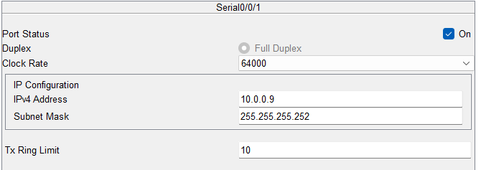
Figure 8.8: Configure Router0’s Serial0/0/1.

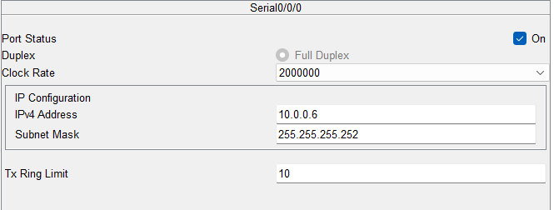
Step 7: Configure Router1’s Serial0/0/0 and Serial0/0/1.
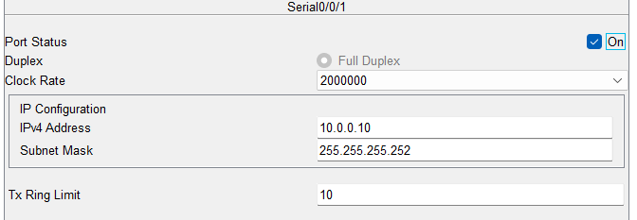
Figure 8.9: Configure Router1’s Serial0/0/0.
Figure 8.10: Configure Router1’s Serial 0/0/1.

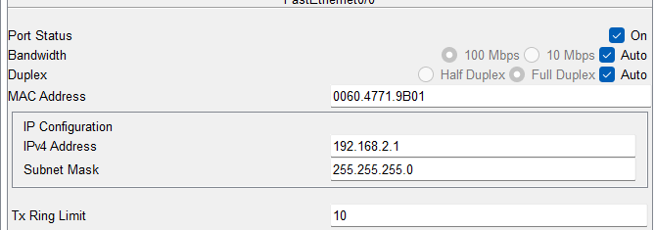
Step 8: Configure Router2’s FastEthernet0/0, Serial0/0/0 and Serial0/0/1.
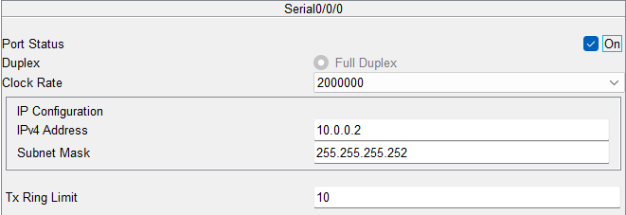
Figure 8.11: Configure Router2’s FastEthernet 0/0.
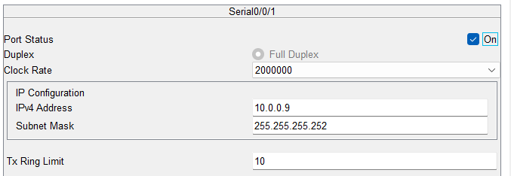
Figure 8.12: Configure Router2’s Serial0/0/0.
Figure 8.13: Configure Router2’s Serial0/0/1.

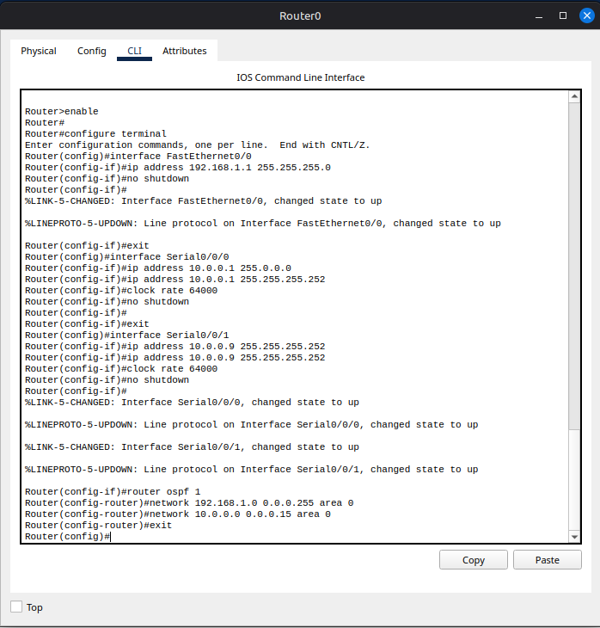
Step 9: Configure OSPF for all routers via CLI.
Figure 8.14: Configuration for router0.
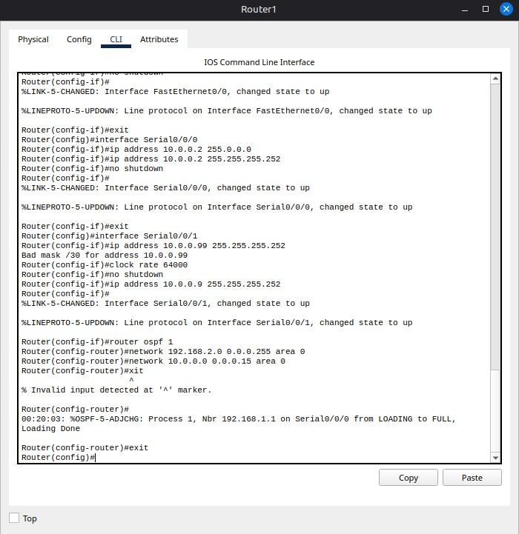
Figure 8.15: Configuration for router2

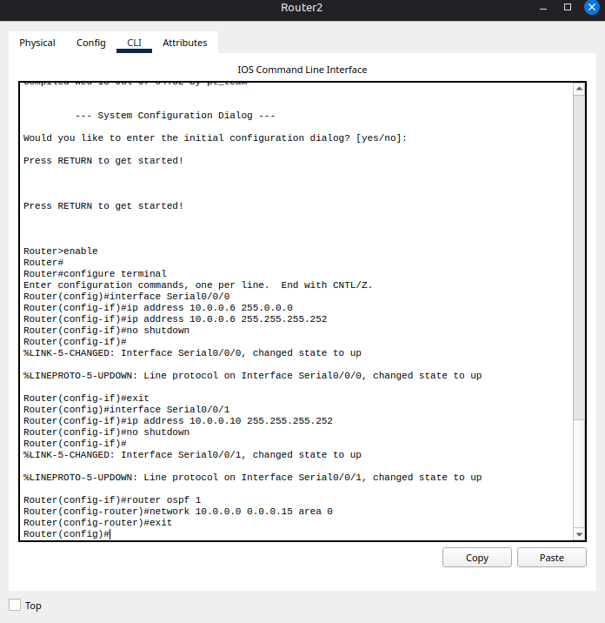
Figure 8.16: Configuration for router1.

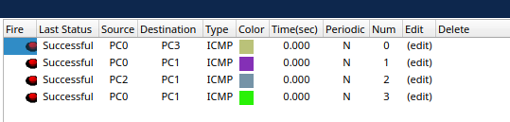
Step 10: Packet passing status check.
Figure 8.17: Packet passing status.

- Conclusion:
The experiment demonstrated successful connection between two networks using OSPF. Message transfer from one network to another was completed without errors, and routing occurred through the shortest path. We also learned how to configure OSPF using the CLI.

