- Experiment name: Routing Between Autonomous Systems Using BGP.

- Introduction: In this experiment, we aim to configure two routers, each connecting multiple PCs, and interconnect the networks. After successful configuration, message transmission between PCs belonging to different networks will be achieved through BGP routing.

- Objectives:
- To understand the concept of Autonomous Systems (AS) and configure inter-AS routing using the Border Gateway Protocol (BGP).
- To establish and verify BGP neighbor relationships for successful routing between different Autonomous System networks.

- Tools required:
- A laptop or desktop.
- Cisco packet tracer.

- Simulation:
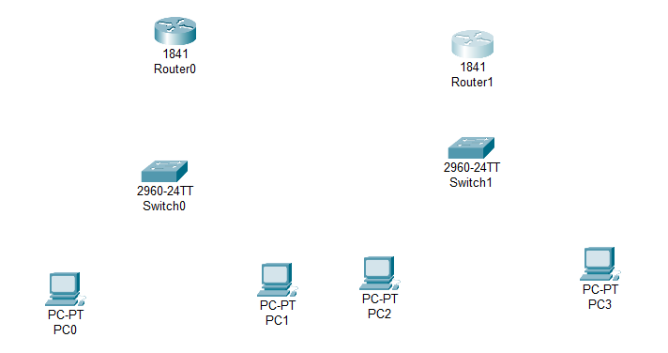
Step 1: Set 2 routers, 2 switches, 4 PCs.
Figure 9.1: Set all PCs, routers and switches.

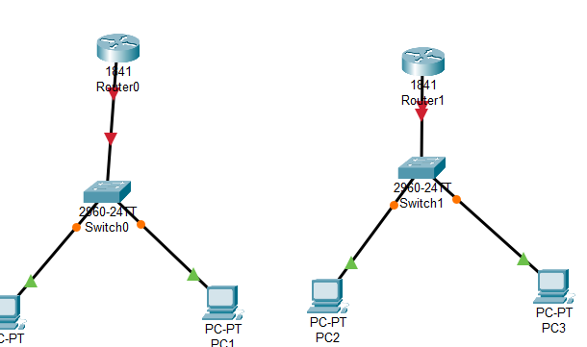
Step 2: Connect the PCs with corresponding switches via copper straight through, and all switches with corresponding routers with the same.
Figure 9.2: Connect PCs with switches and switches with corresponding routers.

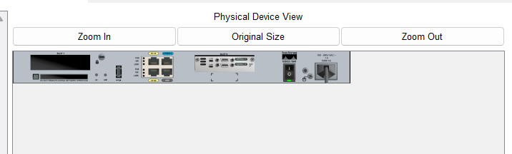
Step 3: For router0 and router1 set WIC-2T port.
Figure 9.3: Set WIC-2T port.

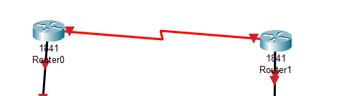
Step 4: Connect a serial dte to router0’s Serial0/0/0 and router1’s Serial0/0/0.
Figure 9.4: Connect router0 with router1 via serial dte.

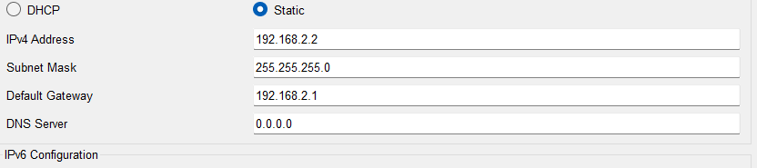
Step 5: Set IPv4 address and default gateway for all the PCs corresponding their network.
Figure 9.5: Set IPv4 address and default gateway for all PCs.

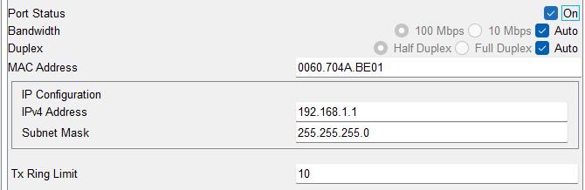
Step 6: Configure router0’s FastEthernet0/0 and Serial0/0/0.
Figure 9.6: set IP address for router0’s FastEthernet0/0.
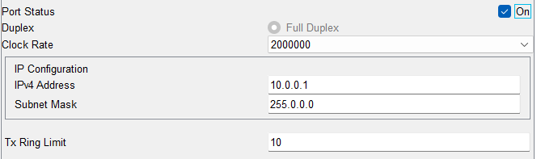
Figure 9.7: Set IP for router0’s serial0/0/0.
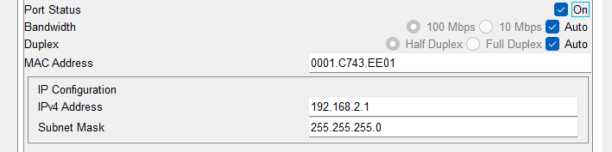
Step 7: Configure router1’s FastEthernet0/0 and Serial0/0/0.
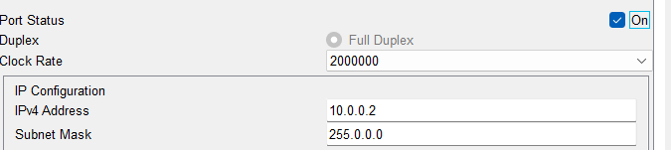
Figure 9.8: Set IP for router1’s FastEthernet0/0.
Figure 9.9: Set IP for router1’s serial0/0/0.

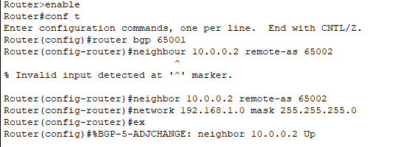
Step 8: Configure BGP for both routers via CLI.
Figure 9.10: Configuration for router0.

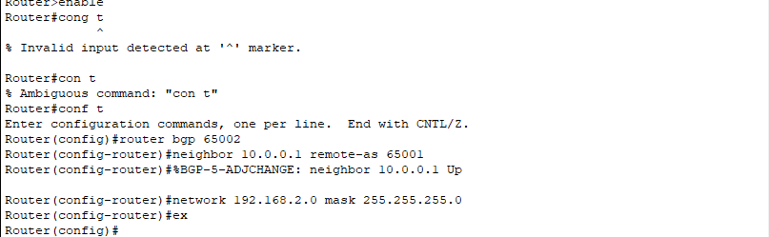
Figure 9.11: Configuration for router1.

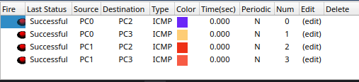
Step 9: Check status of packet passing.
Figure 9.12: Status of passed packets.

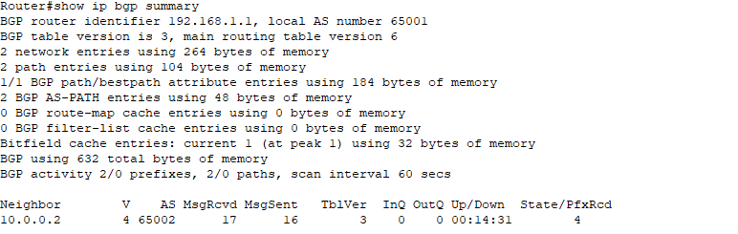
Step 10: BGP summary showing for router0.
Figure 9.13: BGP summary.

- Conclusion:
This experiment successfully connected two networks using BGP. Messages were transferred correctly from one network to another. Through this experiment, we learned about Autonomous Systems and how they are connected using BGP.

