- Experiment Name: Design and implementation of a network using Switch.

- Introduction:
In this experiment, our objective is to create and simulate simple computer networks using Cisco Packet Tracer. The purpose is to show how multiple end devices can be interconnected and exchange data in configurations that uses a switch. By performing this experiment, we can understand how switches function in data transfer and how proper IP addressing makes communication between devices possible.

- Objective:
- Creating a network between two PCs and a switch with transferring message.

- Tools Required:
- A laptop or desktop.
- Cisco Packet Tracer (8.2.2 Windows 64bit).

- Simulation:
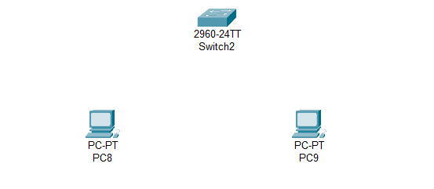
Step 1: Set two PCs and a switch.

Figure 2.1: Set PCs and switch.

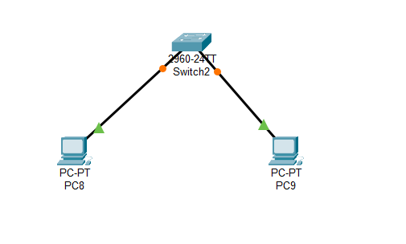
Step 2: Connecting PCs with switch via copper straight.

Figure 2.2: Connecting PCs with switch.

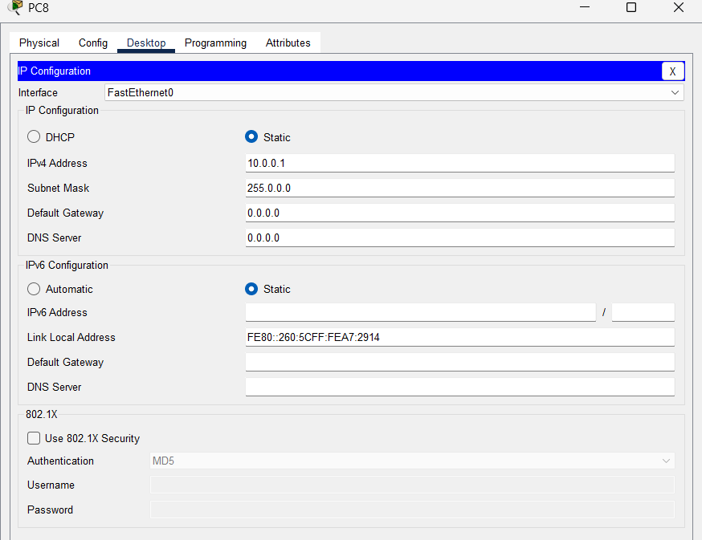
Step 3: Set IPv4 address as 10.0.0.1 for PC8.
Figure 2.3: Set IPv4 address for PC8.
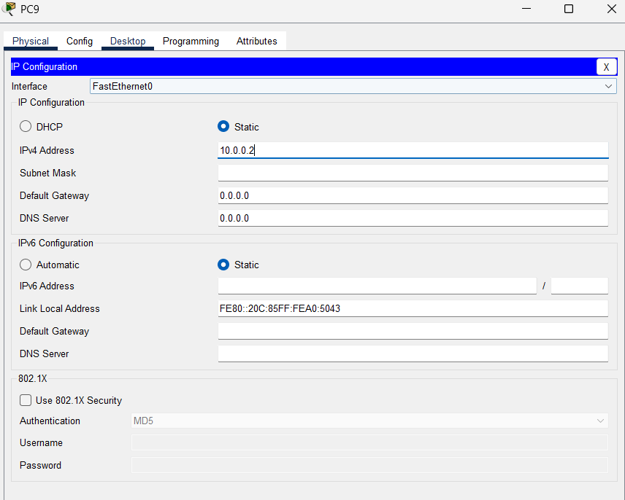
Step 4: Set IPv4 address as 10.0.0.2 for PC9.
Figure 2.4: Set IPv4 address for PC9.

Step 5: Status of transferring message from PC8 to PC9.
Figure 2.5: Status of passing message.

- Description:
In switch network, PCs got connected. Message has been successfully transferred after giving the proper IPv4 address (10.0.0.1 and 10.0.0.2) to PCs.

- Discussion and Conclusion:
In this experiment, we have successfully implemented the design of network between two PCs using switch. Switch can connect the end devices in same network. From this simulation, we obtained hands-on knowledge of the roles of switches in transferring data, the significance of IP addressing, and the way different network components work together to establish communication.

