- Experiment Name: Enabling router password in CLI mode.

- Introduction:
In this experiment, our objective is to enabling router password in CLI mode using Cisco Packet Tracer. The purpose is to show how routers can be configured and setup password using CLI.

- Objective:
- Configuring router for setup password in CLI mode.

- Tools Required:
- A laptop or desktop.
- Cisco Packet Tracer (8.2.2 Windows 64bit).

- Simulation:
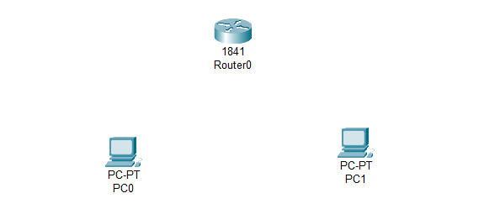
Step 1: Set two PCs and a router.
Figure 4.1: Set PCs and switch

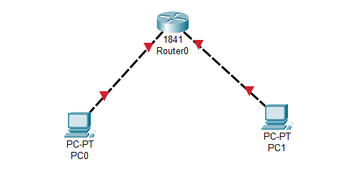
Step 2: Connecting PCs with router via copper cross-over.
Figure 4.2: Connecting PCs with switch.

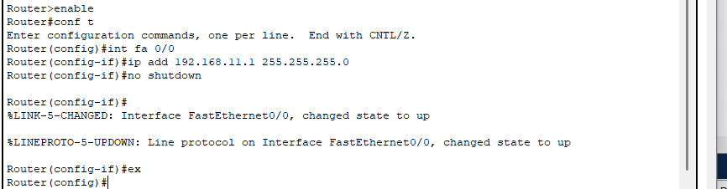
Step 3: Enabling router and configuring for PC0 (0/0 FastEthernet), set IP 192.168.11.1 with subnet mask 255.255.255.0 and then set for no shutdown.
Figure 4.3: Set IPv4 address and subnet mask for PC0.

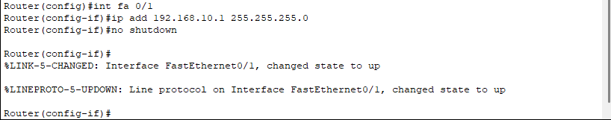
Step 4: Enabling router and configuring for PC1 (0/1 FastEthernet), set IP 192.168.10.1 with subnet mask 255.255.255.0 and then set for no shutdown.
Figure 4.4: Set IPv4 address and subnet mask for PC1.

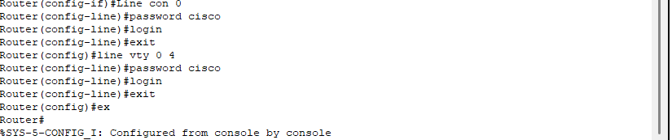
Step 5: Password setup.
Figure 4.5: Configuring for Password.
Step 6: After re-opening CISCO packet tracer password is needed to configure router again.
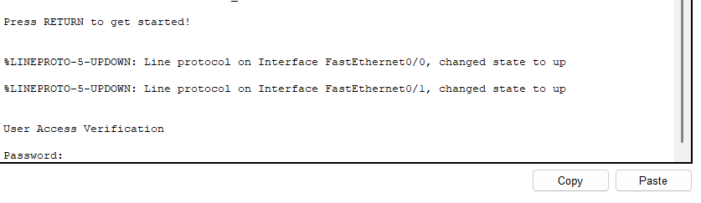
Figure 4.6: Password is must to configure router.

- Description:
In CLI mode PC0 and PC1 are configured using IPV4 192.168.11.1 ad 192.168.10.1 respectively with subnet mask 255.255.255.0. Password has been set using CLI.

- Discussion and Conclusion:
In this experiment, we have successfully configured network between two PCs using CLI mode in router. Router can connect the end devices in different network. So, we have set the IPV4 address of different network for PC0(192.68.11.1) and PC1(192.168.10.1). From this simulation, we obtained hands-on knowledge of configuring IP address and setup password using CLI mode to establish communication.

