- Experiment Name:

Configure router using RIP routing technique.

- Introduction:

In this practical task, our goal is to set up three separate networks, each containing several PCs, and connect them so they can communicate with one another. After finishing the setup correctly, any computer in one network should be able to send messages to computers located in the other networks without any issues.

- Objectives:

- To set up three individual networks by utilizing a set of three routers and three switches.
- To enable message exchange between PCs located in different networks through the use of RIP routing.

- Tools Required:

- A laptop or desktop.
- Cisco Packet Tracer (8.2.2 Windows 64bit).

- Simulation:

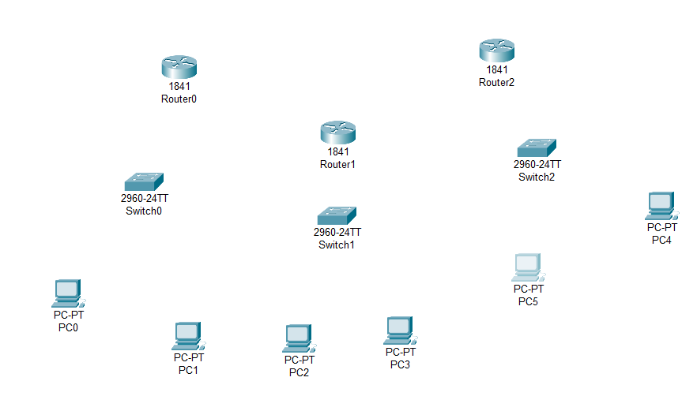
Step 1: Set 6 PCs, 3 switches and 3 routers.
Figure:6.1: Set PCs, switches and routers.

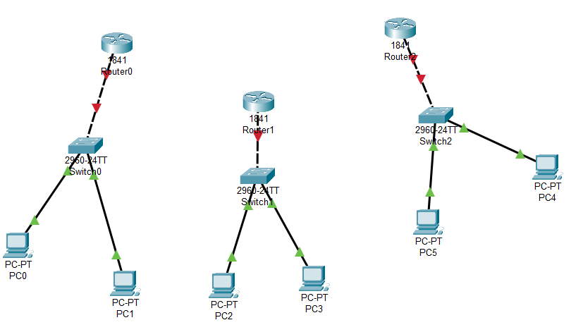
Step 2: Connect all the PCs with corresponding switches by copper cross-through and connect routers with switches by copper cross-over.
Figure:6.2: Connect PCs with switches and switches with routers.

Step 3: Turn off every router and attach WIC-2T, then start.
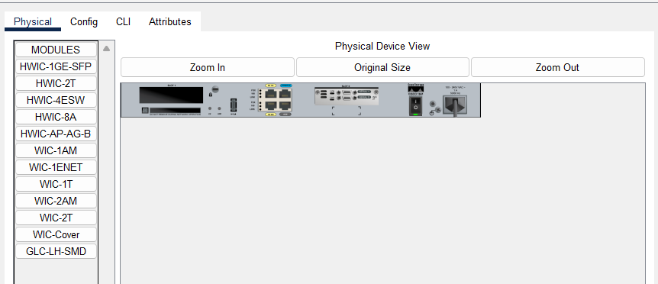
Figure:6.3: Attach WIC-2T with router.

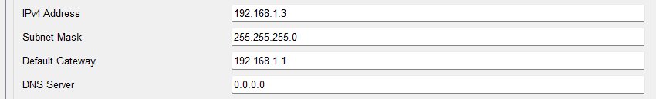
Step 4: Set IPv4 address for all the PCs and their corresponding default gateway.
Figure:6.4: Set IPv4 address and default gateway.

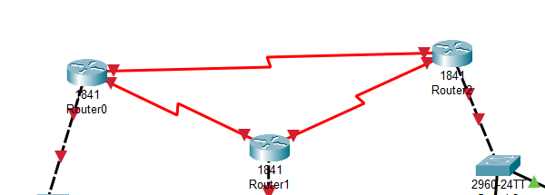
Step 5: Connect all routers via serial dte.
Figure:6.5: Connect routers.

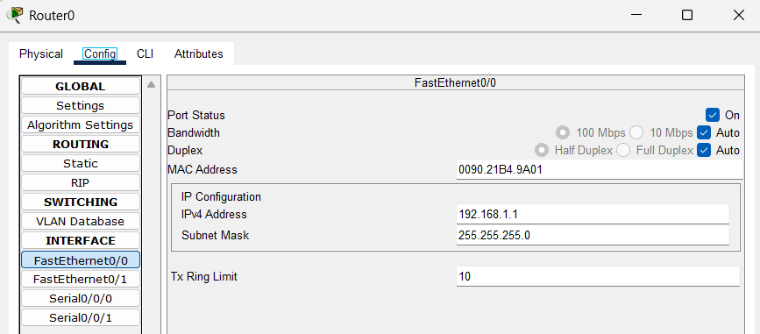
Step 6: Set IPv4 address for FastEthernet0/0.
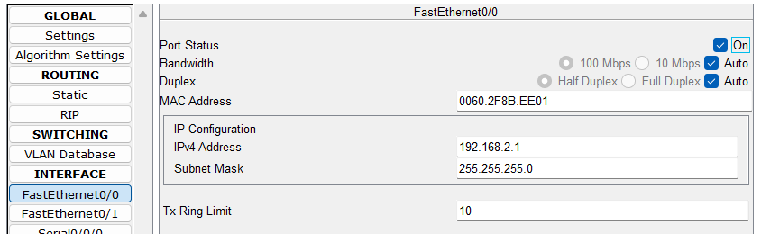
Figure:6.6: Set IP address for FastEthernet0/0 router0.
Figure:6.7: Set IP address for FastEthernet0/0 router1.
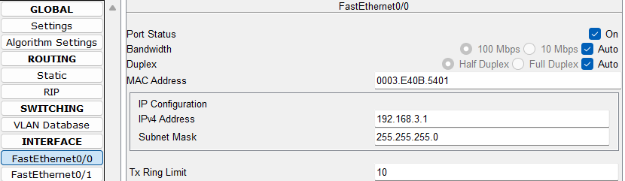
Figure:6.8 Set IP address for FastEthernet0/0 of router2.

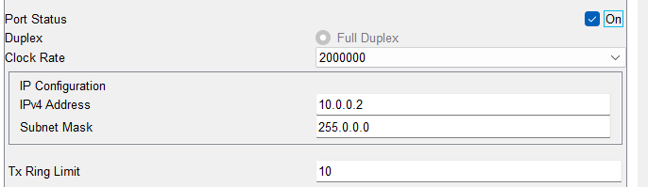
Step 7: Set IPv4 for Serial0/0/0 and Serial0/0/1 of router0.
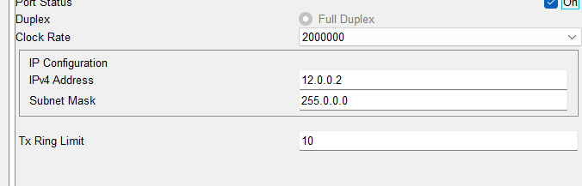
Figure:6.9 Set IP address for Serial0/0/0 router0.
Figure:6.10 Set IP address for Serial0/0/1 router0.

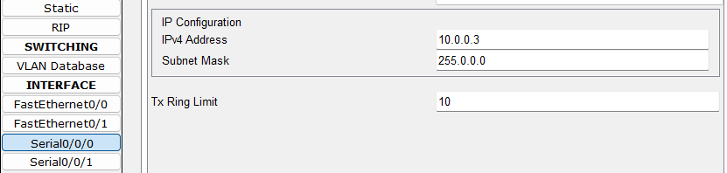
Step 8: Set IPv4 for Serial0/0/0 and Serial0/0/1 of router1.
Figure:6.11 Set IP address for Serial0/0/0 router1.
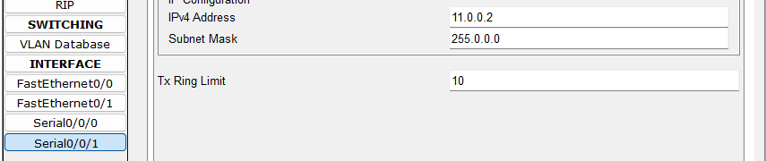
Figure:6.12 Set IP address for Serial0/0/1 router1.

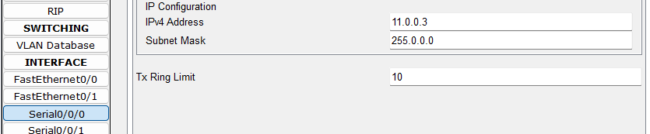
Step 9: Set IPv4 for Serial0/0/0 and Serial0/0/1 of router2.
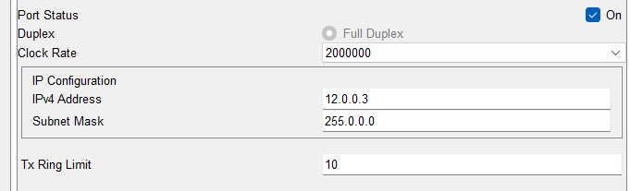
Figure 6.13: Set IP address for Serial0/0/0 router2.
Figure 6.14: Set IP address for Serial0/0/1 router2.
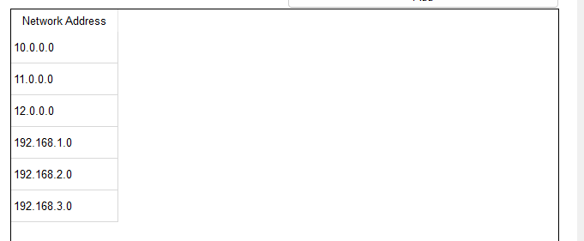
Step 10: Configure RIP for router0, router1 and router2.
Figure 6.15: Configure RIP for routers.

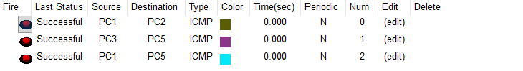
Step 11: Check packet passing status from different network to different network.
Figure 6.16: Status of packet passing.

- Conclusion:

In this experiment, we have successfully transferred packet between end-devices from different network. Packet passing route has been configured using RIP routing technique.

