- Experiment Name:

Configure static routing using CLI command.

- Introduction:

In this task, our goal is to set two separate networks, each containing several PCs, and connected them so they can communicate with one another using CLI. After finishing setup any end device in the network should be able to communicate any other end devices.

- Objectives:

- To set up two networks by two routers, two switches and four end devices.
- To enable message exchange between PCs located in different networks through the use of static routing technique that has to be configured in CLI.

- Tools Required:

- A laptop or desktop.
- Cisco Packet Tracer (8.2.2 Windows 64bit).

- Simulation:

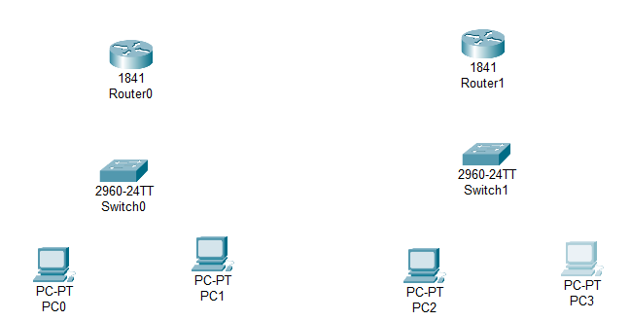
Step 1: Set 4 PCs, two switches and two routers.
Figure 7.1: Set PCs, switches and routers

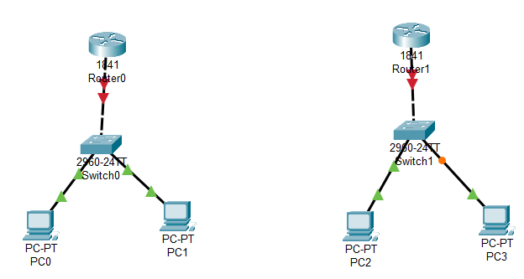
Step 2: Connect all the PCs with corresponding switches by copper cross-through and connect routers with switches by copper cross-over.
Figure 7.2: Connect PCs with switches and switches with routers.

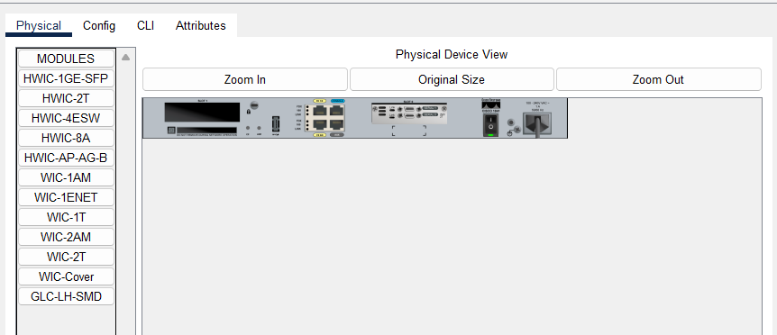
Step 3: Turn off every router and attach WIC-2T, then start.
Figure 7.3: Attach WIC-2T with router.

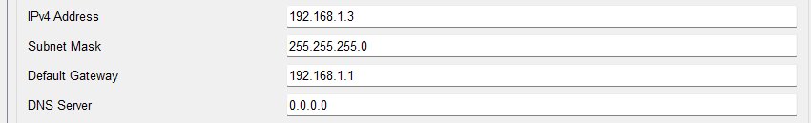
Step 4: Set IPv4 address for all the PCs and their corresponding default gateway.
Figure 7.4: Set IPv4 address and default gateway.
Step 5: Connect all routers via serial dte.
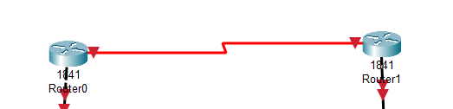
Figure 7.5: Connect routers.

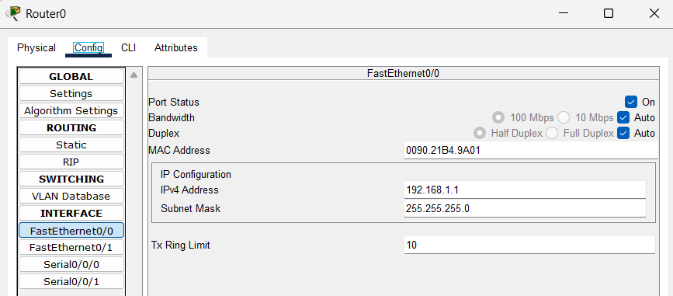
Step 6: Set IPv4 address for FastEthernet0/0.
Figure 7.6: Set IP address for FastEthernet0/0 router0.
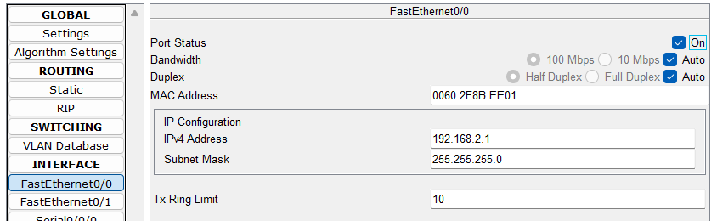
Figure 7.7: Set IP address for FastEthernet0/0 router1.

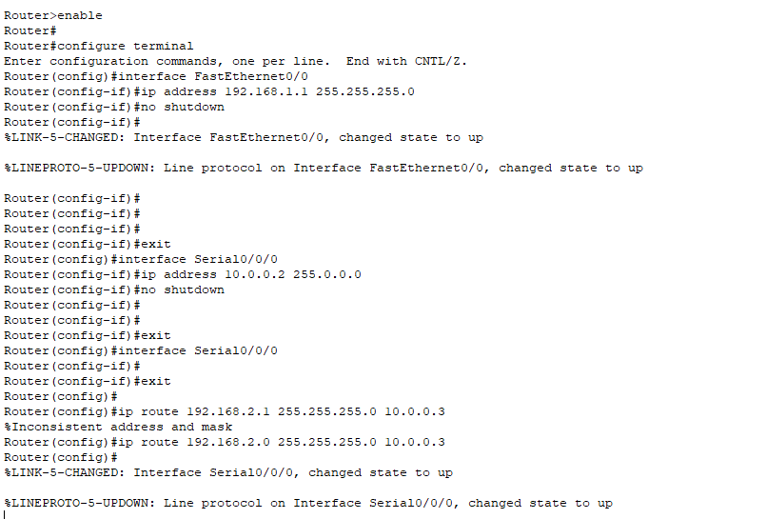
Step 7: Configure static routing for router0 using CLI.
Figure 7.8: Configure route0 using CLI.

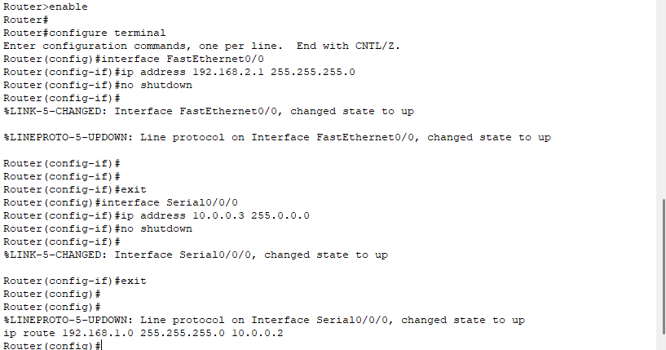
Step 8: Configure static routing for router0 using CLI.
Figure 7.9: Configure route0 using CLI.

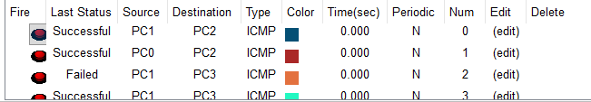
Step 9: Checking status of packet passing.
Figure 7.10: Packet passing status.

- Conclusion:
In this experiment we have learned how can configure static routing using CLI. We have successfully configured routers and able to pass packet from different network to different network.

