- Experiment Name: Design and implementation of a network using Switch and Router.
- Introduction:
In this experiment, our objective is to create and simulate simple computer networks using Cisco Packet Tracer. The purpose is to show how multiple end devices can be interconnected and exchange data in two distinct configurations — one that uses a switch and another that involves a router. By performing this experiment, we can understand how switches and routers function in data transfer and how proper IP addressing makes communication between devices possible.
- Objectives:
- Creating a network between two PCs and a switch with transferring message.
- Creating a network between two PCs and a router and successfully transfer message.

- Tools Required:
- A laptop or desktop.
- Cisco Packet Tracer (8.2.2 Windows 64bit).

- Simulation:
  - Network using switch
Step 1: Set two PCs and a switch.
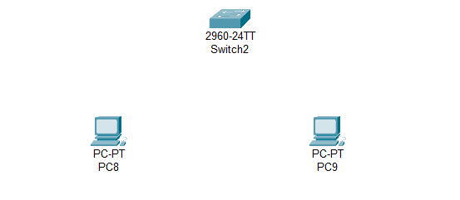

` Figure 2.1: Set PCs and switch.

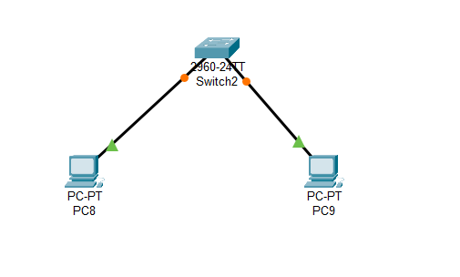
Step 2: Connecting PCs with switch via copper straight.

Figure 2.2: Connecting PCs with switch.

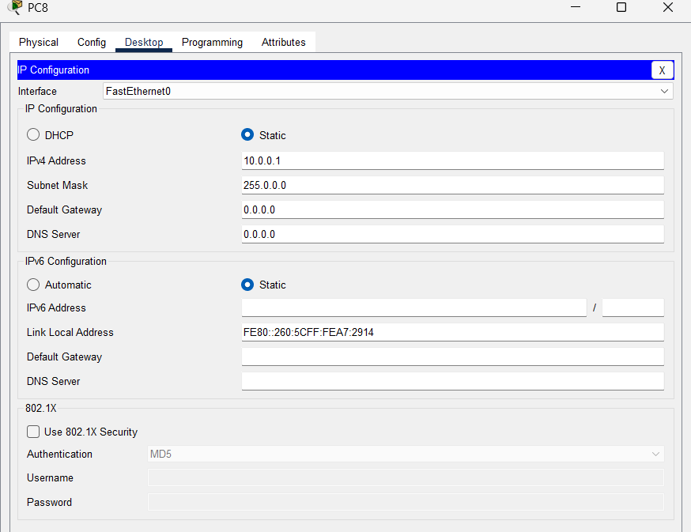
Step 3: Set IPv4 address as 10.0.0.1 for PC8.
Figure 2.3: Set IPv4 address for PC8.

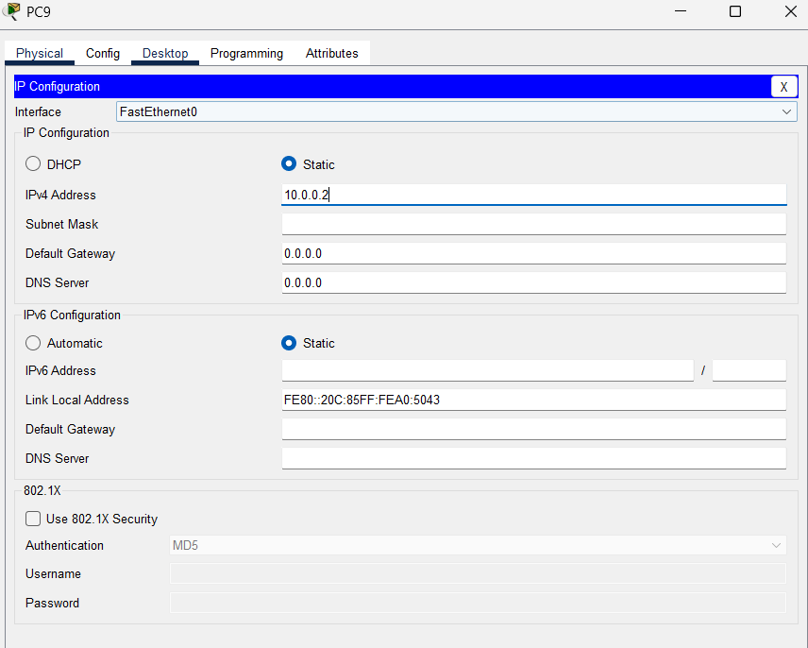
Step 4: Set IPv4 address as 10.0.0.2 for PC9.
Figure 2.4: Set IPv4 address for PC8.

Step 4: Status of transferring message from PC8 to PC9
Figure 2.5: Status of passing message.

  - Network using router
Step 1: Set two PCs and a router
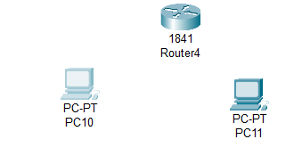

Figure 2.6: Set PCs and router.
Step 2: Connecting PCs with router via copper cross over.
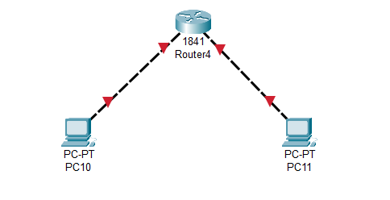
Figure 2.7: Set PCs and router.

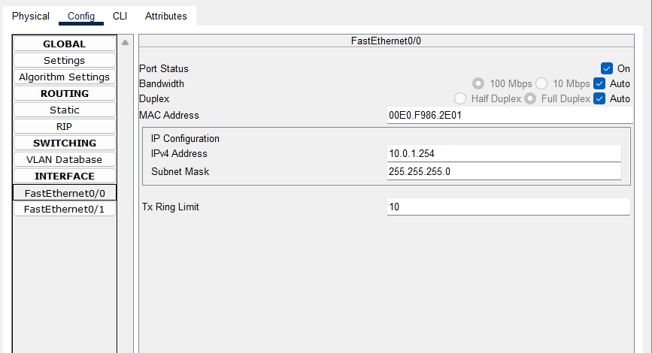
Step 3: Set IPv4 as 10.0.1.254 and subnet mask as 255.255.255.0. Turn port status to “on” for FastEthernet0/0 in router.
Figure 2.8: Set up for FastEthernet0/0 in router.
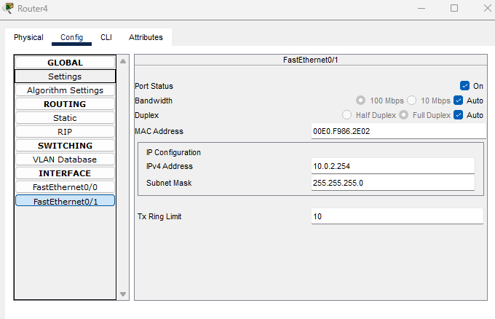
Step 4: Set IPv4 as 10.0.2.254 and subnet mask as 255.255.255.0. Turn port status to “on” for FastEthernet0/1 in router4.
Figure 2.9: Set up for FastEthernet0/1 in router.

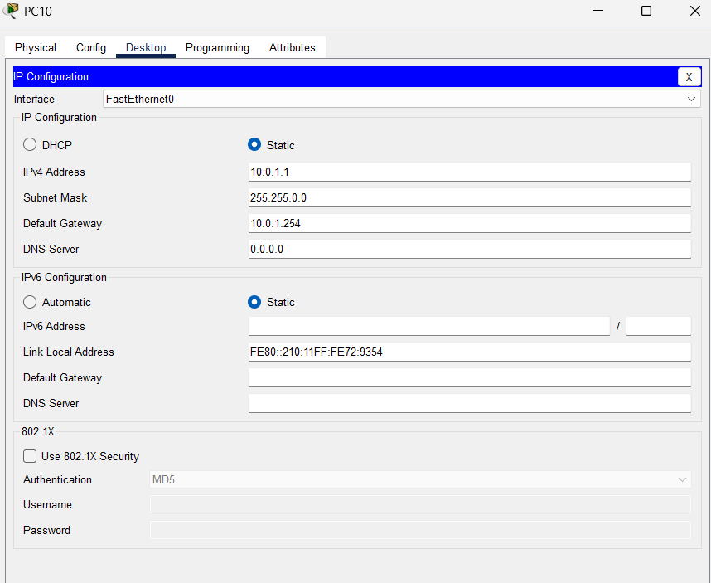
Step 5: Set IPv4 as 10.0.1.1, subnet mask as 255.255.0.0, default gateway 10.0.1.254 for PC10.
Figure 2.10: Configuration of PC10.
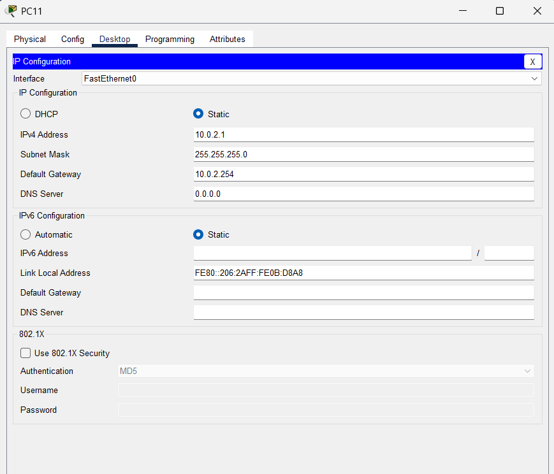
Step 6: Set IPv4 as 10.0.2.1, subnet mask as 255.255.0.0, default gateway 10.0.2.254 for PC11.
Figure 2.11: Configuration of PC11.

Step 7: Status of transferring message from PC10 to PC11.
Figure 2.12: Status of transferring message.

- Description:
In switch network, PCs got connected. Message has been successfully transferred after giving the proper IPv4 address (10.0.0.1 and 10.0.0.2) to PCs.
In the network using router, PCs have been connected properly. Message has been successfully transferred after giving proper IPv4 address (10.0.1.1 and 10.0.2.1) to PCs and default gateway.

- Discussion and Conclusion:
In this experiment, we have successfully implemented the design of network between two PCs using switch and another two PCs using router. Switch can connect the end devices in same network. Router can connect end devices in different network. From this simulation, we obtained hands-on knowledge of the roles of switches and routers in transferring data, the significance of IP addressing, and the way different network components work together to establish communication.

