Experiment name: Downloading and Installing Cisco Packet Tracer
- Objectives:
The main goals of this experiment were to:
- Visit the official Cisco Networking Academy website.
- Download the Cisco Packet Tracer software successfully.
- Install and set up Packet Tracer on the computer
- Tools Required:
- Computer: A laptop or desktop that supports Windows, macOS, or Linux.
- Internet Connection: A stable internet connection is needed to visit the official website and download the software.
- Cisco NetAcad Account: A valid account (created through an instructor or the Skills for All platform) is required to log in and access the download.
- Simulation:
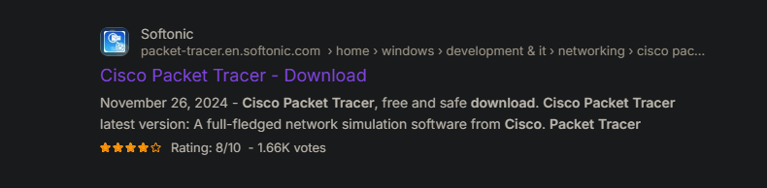
Step 1: Go to the Link.
Figure 1.1: Search for cisco packet tracer in browser.

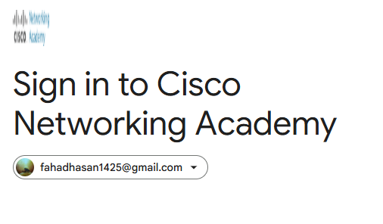
Step 2: Sign in to Cisco Networking Academy.
Figure 1.2: Sign in to Cisco NetAcad.
Step 5: Final Installation Process.
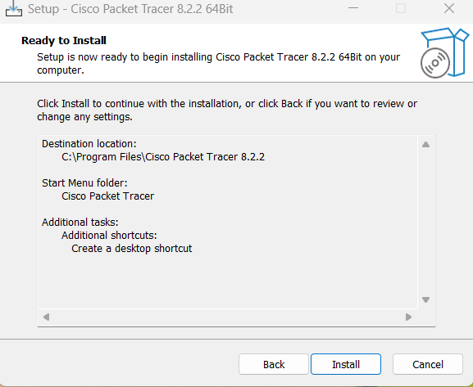

Figure 1.5: Final Installation.

Step 6: Sign in Cisco Packet Tracer for using the app.
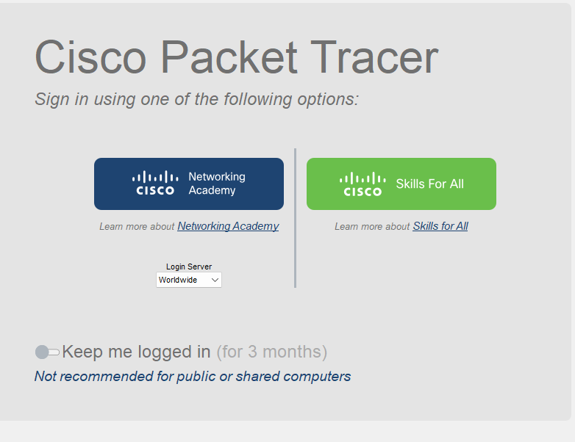

Figure 1.6: Sign in Cisco Packet Tracer.

- Experiment Name: Design and implementation of a network using Switch.

- Introduction:
In this experiment, our objective is to create and simulate simple computer networks using Cisco Packet Tracer. The purpose is to show how multiple end devices can be interconnected and exchange data in configurations that uses a switch. By performing this experiment, we can understand how switches function in data transfer and how proper IP addressing makes communication between devices possible.

- Objective:
- Creating a network between two PCs and a switch with transferring message.

- Tools Required:
- A laptop or desktop.
- Cisco Packet Tracer (8.2.2 Windows 64bit).

- Simulation:
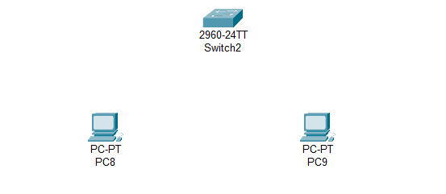
Step 1: Set two PCs and a switch.

Figure 2.1: Set PCs and switch.

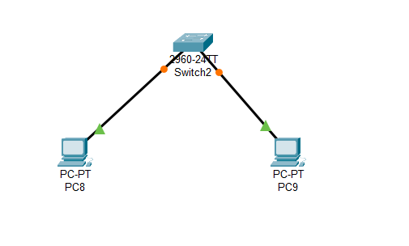
Step 2: Connecting PCs with switch via copper straight.

Figure 2.2: Connecting PCs with switch.

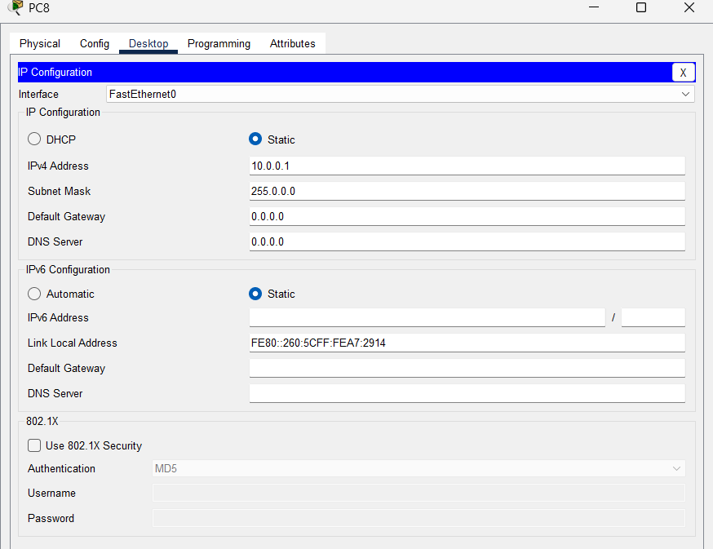
Step 3: Set IPv4 address as 10.0.0.1 for PC8.
Figure 2.3: Set IPv4 address for PC8.

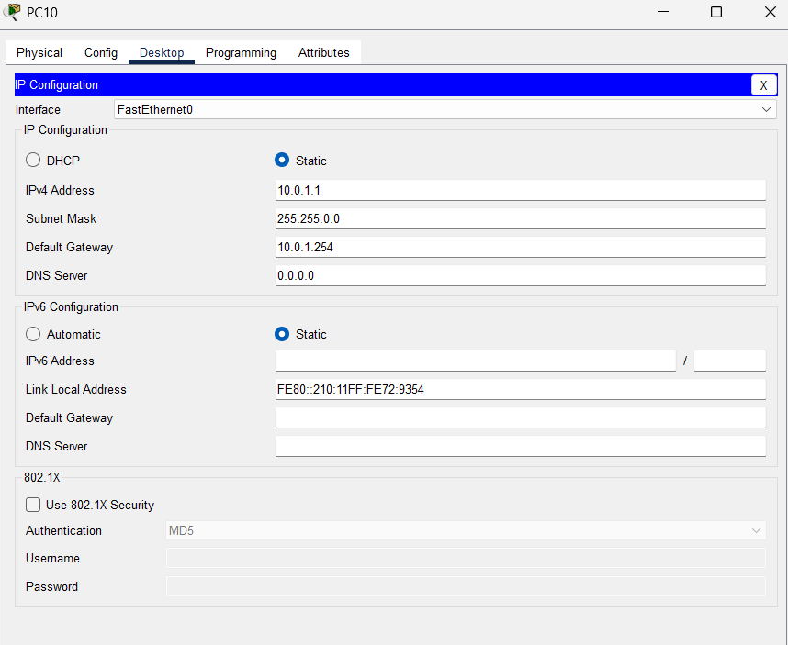
Step 5: Set IPv4 as 10.0.1.1, subnet mask as 255.255.0.0, default gateway 10.0.1.254 for PC10.
Figure 3.5: Configuration of PC10.

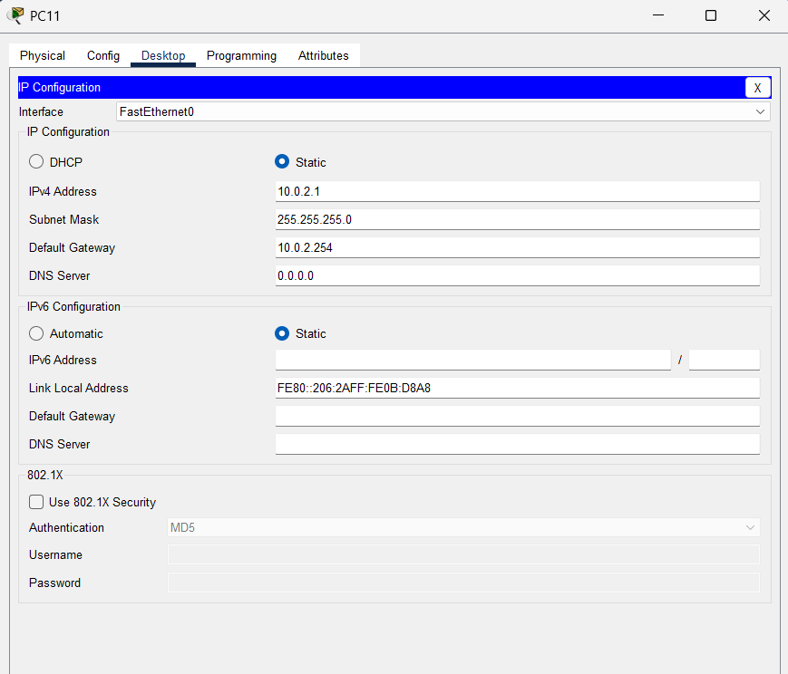
Step 6: Set IPv4 as 10.0.2.1, subnet mask as 255.255.0.0, default gateway 10.0.2.254 for PC11.
Figure 3.6: Configuration of PC11.

