Problem 01: Find waiting time, turn-around time for each process and average waiting time
Using Priority Scheduling algorithm.
Source Code:
#pragma GCC optimize("Ofast")
#include <bits/stdc++.h>
using namespace std;

using ll = long long;

struct tpl{
int p, bt, prio;
};

void Solve()
{
int n;
cin >> n;
cout << "Total Process: " << n << "\n";
vector<tpl> proc(n);
for(int i=0; i<n; i++){
cin >> proc[i].bt >> proc[i].prio;
proc[i].p = i+1;
}

sort(proc.begin(), proc.end(), [&](auto &a, auto &b){
return a.prio < b.prio;
});

vector<int> tat(n), wt(n);
int time = 0;
double avgwt = 0;

for(int i=0; i<n; i++){
time += proc[i].bt;
tat[i] = time;
wt[i] = tat[i] - proc[i].bt;
avgwt += wt[i];
}

cout << "P BT PRIO TAT WT\n";
for(int i=0; i<n; i++){
cout << proc[i].p << " " << proc[i].bt << " " << proc[i].prio << " "
<< tat[i] << " " << wt[i] << "\n";
}

cout << fixed << setprecision(2);
cout << "Average Waiting Time: " << avgwt / n << "\n";
}

int32_t main()
{
ios_base::sync_with_stdio(0), cin.tie(0), cout.tie(0);
ll t = 1;
// cin >> t;
while (t--)
Solve();
return 0;
}

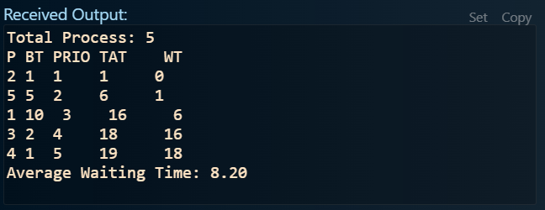
Output:
Figure 1: Output of problem 01.

Problem 02: Find waiting time, turn-around time for each process and average waiting time
Using Round Robin algorithm.
Source Code:
#pragma GCC optimize("Ofast")
#include <bits/stdc++.h>
using namespace std;

using ll = long long;

struct tpl {
int p, bt;
};

void Solve()
{
int n, q;
cin >> n >> q;
cout << "Total Process: " << n << "\n";
vector<tpl> proc(n);
int pid, bt;
for(int i=0; i<n; i++){
cin >> pid >> bt;
proc[i].p = pid;
proc[i].bt = bt;
}

vector<int> rem(n), tat(n), wt(n);
for(int i=0; i<n; i++) rem[i] = proc[i].bt;

int time = 0;
bool done = false;

while(!done){
done = true;
for(int i=0; i<n; i++){
if(rem[i] > 0){
done = false;
if(rem[i] > q){
time += q;
rem[i] -= q;
} else {
time += rem[i];
tat[i] = time;
rem[i] = 0;
}
}
}
}

double avgwt = 0;
for(int i=0; i<n; i++){
wt[i] = tat[i] - proc[i].bt;
avgwt += wt[i];
}

cout << "P | BT | TAT | WT\n";
for(int i=0; i<n; i++){
cout << proc[i].p << " | " << proc[i].bt << " | " << tat[i] << " | " << wt[i] << "\n";
}

cout << fixed << setprecision(2);
cout << "Average Waiting Time: " << avgwt / n << "\n";
}

int32_t main()
{
ios_base::sync_with_stdio(0), cin.tie(0), cout.tie(0);
ll t = 1;
// cin >> t;
while (t--)
Solve();
return 0;
}

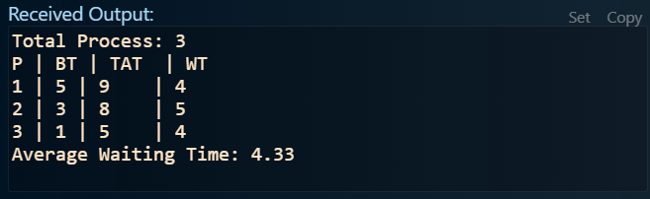
Output:
Figure 2: Output of problem 02.

